Supplement 2
a. Study discontinuations
 | 25 mg | 5 mg
Discontinuation | 61 (65%) | 74 (78%)
- due to progressive disease | 27 (29%) | 42 (45%)
- due to AE | 27 (29%) | 26 (28%)
- due to death | 3 (3%) | 1 (1%)
- due to refusal | 4 (4%) | 5 (5%)
Median time (range) until EOT [months] | 26.8 (0.5 – 87) | 22.9 (0.3 – 69)

b. Dose reductions
Causes for dose reduction | N = 337
Neutropenia | 187 (56)
Thrombocytopenia | 31 (9)
Constitutional symptoms | 24 (7)
Infection | 17 (5)
Dermatological AEs | 14 (4)
New primary malignancy | 13 (4)
Neurological AEs | 13 (4)
Patient request | 9 (3)
Anemia | 9 (3)
Renal AEs | 6 (2)
GastrointestinaI + Liver AEs | 5 (2)
Death | 4 (1)
Pulmonal AEs | 3 (1)
Cardiac AEs | 2 (1)
Bleeding | 0 (0)

Abbreviations: AE: adverse event, EOT: end of treatment

c. Periods on and off study drug
Group A (25 mg)
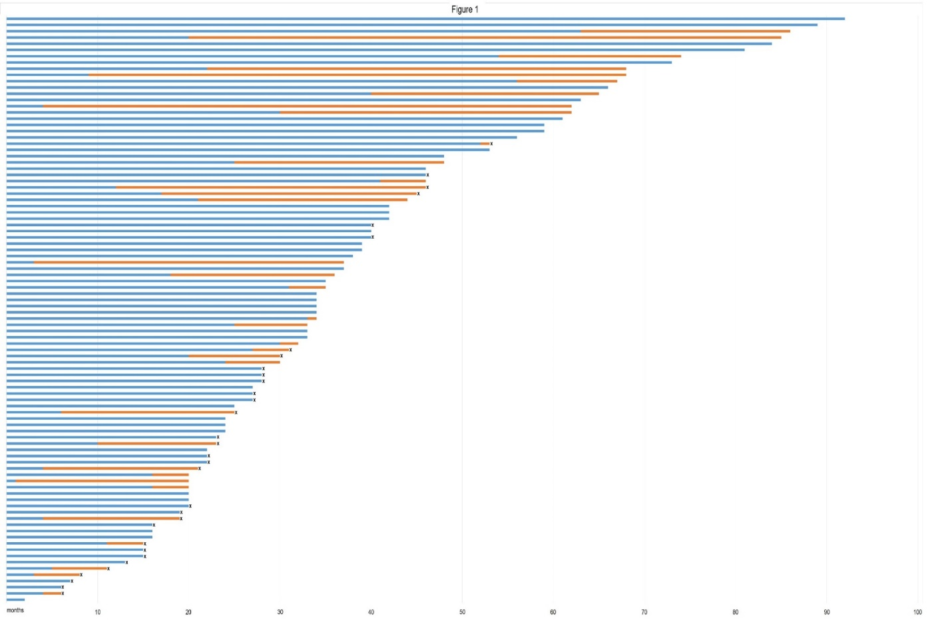
Group B (5 mg)
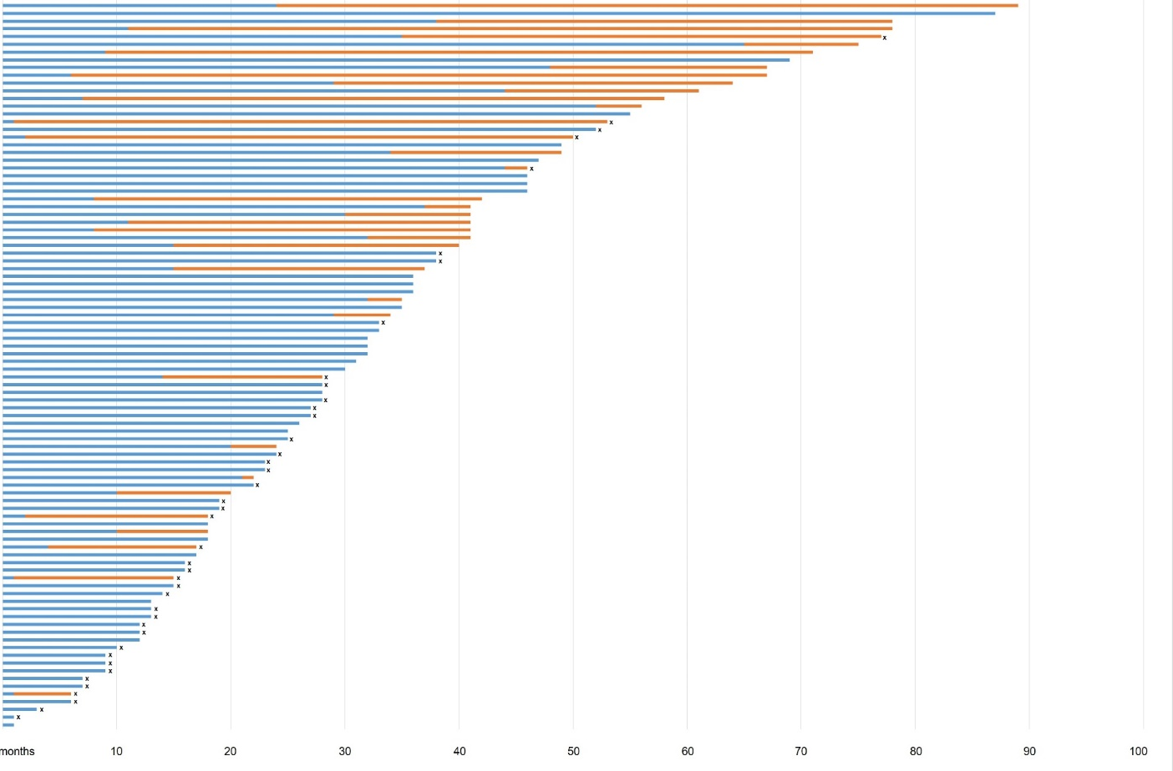
Blue bars show duration of remission on study drug, orange bars show duration of remission off study drug, X mark disease progression, bars ending without X = remission at last follow-up

