token | Enrichment Score TRAILshort
severe_dengue | 323
dengue_fever | 274.1124
clear_cell_renal_carcinoma | 109.0092
papillary_renal_cell_carcinoma | 88.88715
prostate_adenocarcinoma | 75.94247
ductal_carcinoma | 75.83678
cervical_squamous_cell_carcinoma | 72.38082
squamous_cell_carcinoma | 68.17859
diarrhea | 64.0066
lung_squamous_cell_carcinoma | 62.43683
lobular_carcinoma | 36.71969
Ltbi (latent tuberculosis infection) | 36.7162
renal_cell_carcinoma | 23.36674
asthmatic | 21.58051
influenza | 19.54017
breast_cancer | 17.8911
ulcerative_colitis | 15.7166
glioblastoma | 15.7166
hepatocellular_carcinoma | 15.7166
endometrial_adenocarcinoma | 14.59189
oral_squamous_cell_carcinoma | 14.28489
prostate_cancer | 13.5306
brucellosis | 12.04984
systemic_lupus_erythematosus_sle | 10.69982
lupus | 10.185

Supplemental Table S1. Results of TRAILshort enrichment scores in Gene Expression Omnibus datasets by natural language processing derived disease term. To determine disease enrichments for each transcript, the top expressing samples were compared to the lowest expressers for disproportionate representation of disease phenotypes. The final output was an enrichment score (reported as -log(p-val)) for each disease phenotype. Represented are the disease phenotypes with a TRAILshort enrichment score >10.

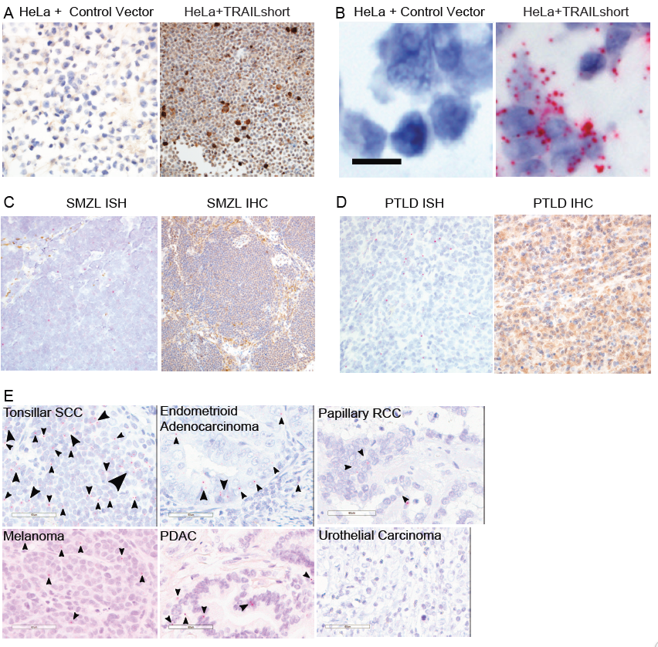
Supplemental Figure S1. Primary human malignancies express TRAILshort protein and contain TRAILshort mRNA. The indicated tissues were stained by immunohistochemistry (IHC) for TRAILshort protein expression (brown staining), or by in situ hybridization (ISH) for TRAILshort mRNA expression (red dot-like staining with black arrowheads). (A) Parental HeLa cells were negative for TRAILshort protein by IHC (left, 400X original magnification), whereas transfected HeLa cells show strong expression of TRAILshort protein (right, 200X original magnification). (B) RNA ISH within the TRAILshort transfected HeLa cells (right, 400X original magnification). Cells transfected with the empty EGFPC1 vector (left, 200X original magnification) are negative. (C-D) Primary samples of splenic marginal zone lymphoma (SMZL) and post-transplant lymphoproliferative disorder (PTLD) tissue reveal TRAILshort message by ISH and TRAILshort protein by IHC. (E) Tonsillar squamous cell carcinoma, melanoma, papillary renal cell carcinoma, endometrioid endometrial carcinoma and pancreatic ductal adenocarcinoma (PDAC) all were positive for TRAILshort mRNA. Red dots indicate TRAILshort mRNA within the various neoplastic cells. In contrast, the representative urothelial carcinoma was negative for TRAILshort mRNA. Scale bar = 60 µm for all panels. (F) TRAILshort mRNA expression was positive by ISH in two representative hematologic malignancies.

Tumor Type | Number of Cases Tested by ISH | Positive Cases for TRAILshort RNA ISH
Pancreatic Ductal Adenocarcinoma | 9 | 5
Hepatocellular Carcinoma | 15 | 1
Oropharyngeal Squamous Cell Carcinoma | 7 | 5
Tonsil Squamous Cell Carcinoma | 3 | 3
Melanoma | 6 | 2
Peripheral T Cell Lymphoma, NOS | 4 | 3
Angioimmunoblastic T Cell Lymphoma | 3 | 1
Follicular Lymphoma | 4 | 2
Mantle Cell Lymphoma | 3 | 1
Chronic Lymphocytic Leukemia | 1 | 1
Marginal Zone Lymphoma | 4 | 1
Burkitt Lymphoma | 2 | 1
Classic Hodgkin Lymphoma | 5 | 0
Cervical Carcinoma, Invasive SCC | 4 | 2
Endometrioid Adenocarcinoma | 4 | 2
Papillary Renal Cell Carcinoma | 3 | 1
Urothelial Carcinoma | 3 | 0
Gastric Carcinoma | 2 | 0
Invasive Intestinal Adenocarcinoma | 1 | 0
Malignant Mullerian Mixed tumor(carcinsarcoma) | 1 | 0
Ovarian, serous carcinoma | 1 | 0

Supplemental Table S2. Results of TRAILshort ISH in human tissue sections.

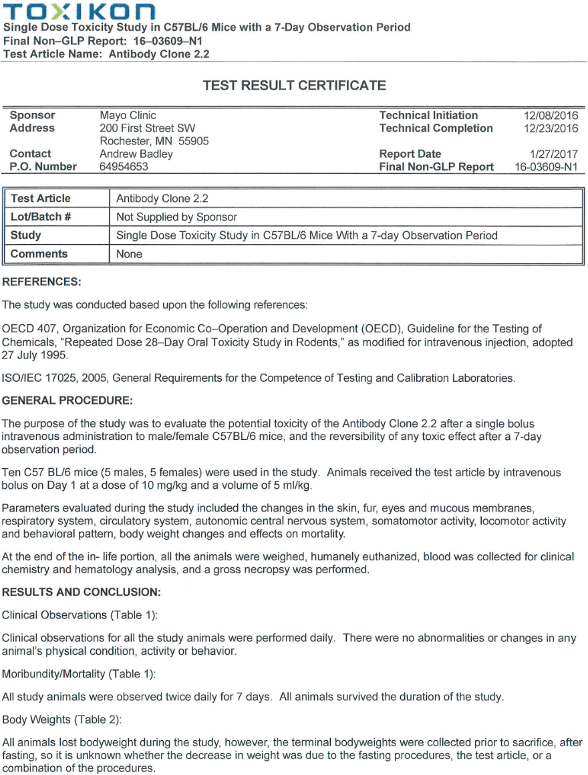
Supplemental Document S1. Report of safety evaluation of TRAILshort antibody administered to mice and followed for 7 days.

Supplemental Figure S2. Single dose anti-TRAILshort antibody in combination with a TRAIL agonist has antitumor effects in a Jurkat T cell xenograft model (supplemental). Non-obese diabetic, severe combined-immunodeficient, common γ-chain deficient (NSG) mice were implanted with Jurkat human T leukemia cells expressing luciferase by IV injection, and tumors were allowed to become established. Mice were then administered a single injection of mouse anti-TRAILshort antibody (clone 2.2) followed 24 hours later by a single injection of anti-TRAIL-R2 antibody, and imaged twice weekly. Whole mouse imaging on day 45 shown.

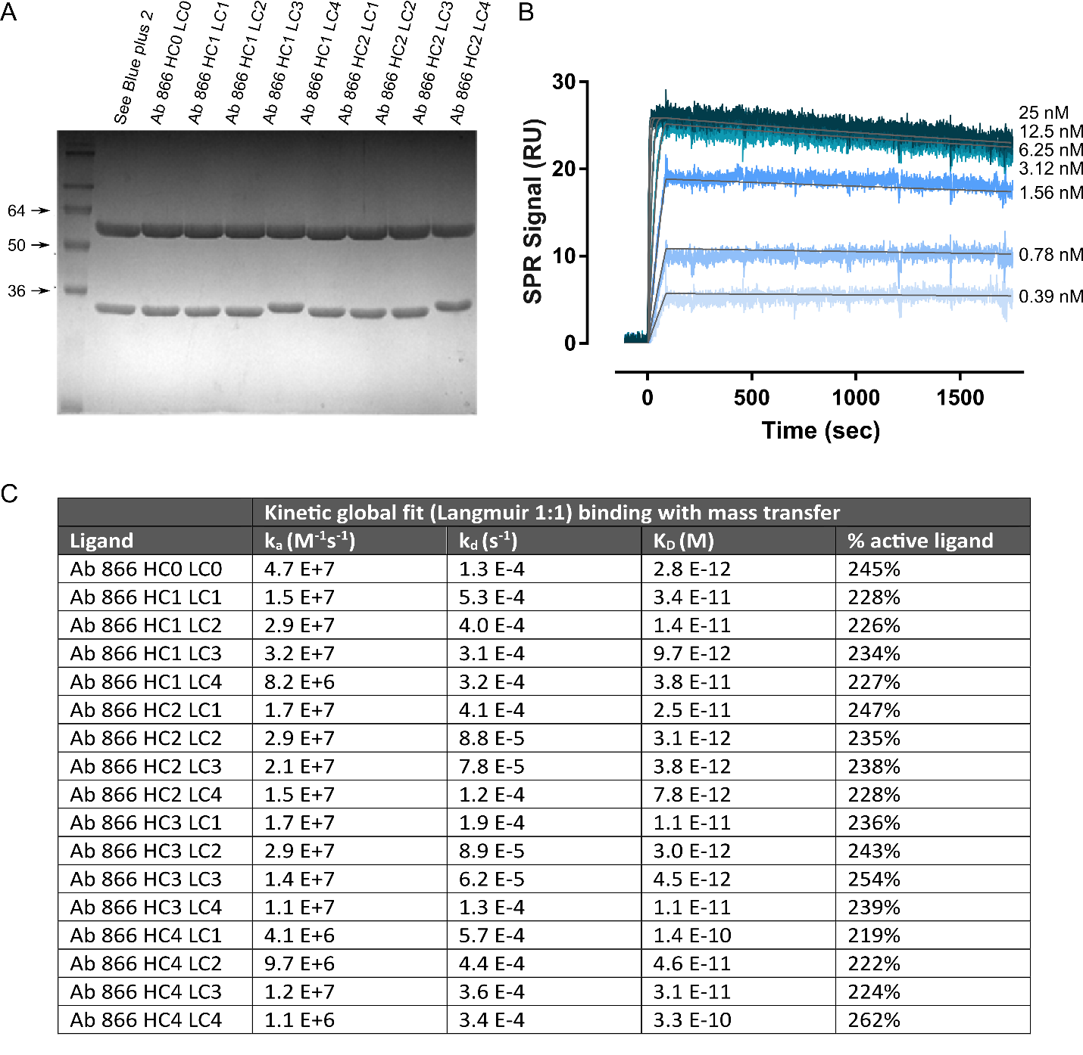
Supplemental Figure S3. Characterization of humanized anti-TRAILshort antibodies. (A) Comassie stain of different humanized anti-TRAILshort variants, (B) surface plasmon resonance (SPR) profile of HC2LC3 antibody binding to TRAILshort, and (C) affinity data for different humanized anti-TRAILshort variants.

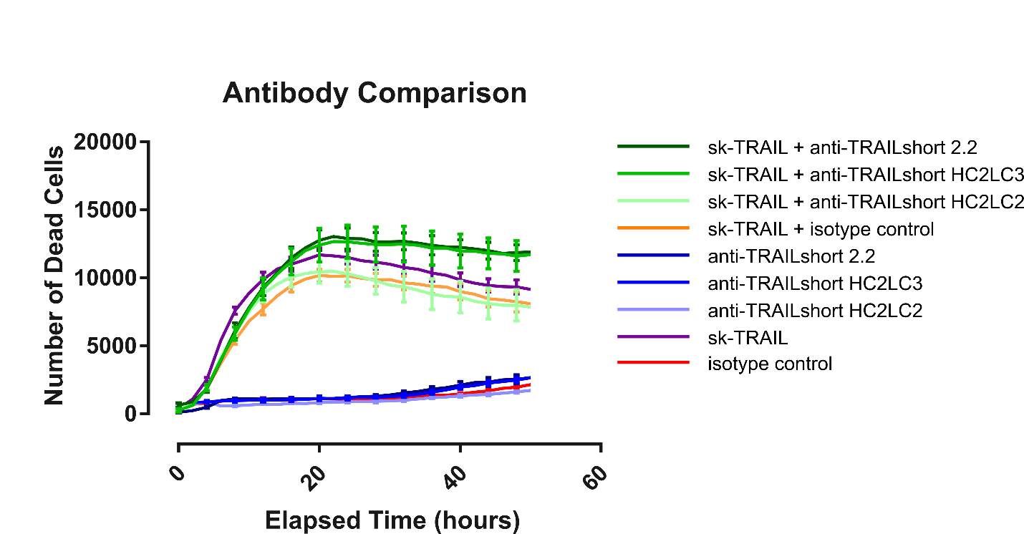
Supplemental Figure S4. Comparison of anti-tumor effect of mouse anti-TRAILshort 2.2 versus humanized anti-TRAILshort HC2LC2. Functional effect of mouse anti-TRAILshort clone 2.2, humanized anti-TRAILshort clone HC2LC2, and humanized anti-TRAILshort clone HC2LC3 on Jurkat cell survival with and without sk-TRAIL. Data are represented as mean ± SE.

Diagnosis | Responsive to sk-TRAIL + anti-TRAILshort | Responsive to Anti-TRAILshort | Fold Increase in Number of Dead cells | P-value | TRAILshort RNA-ISH
Non Hodgkin Lymphoma B cell lineage Cyclin D1 Positive | Yes | Yes | 1.19 | 0.019 | Positive
Splenic diffuse small B cell lymphoma | Yes | Yes | 1.98 | 0.014 | Positive
Mantle Cell lymphoma | Yes | Yes | 1.21 | 0.029 | Negative
Mantle cell Lymphoma | No | No | 1.28 | 0.182 | Negative
EBV associated lymphoproliferative disorder | Yes  (dose dependent) | No | 1.68 | 0.006 | Positive
Burkitt Lymphoma | Yes | No | 2.46 | 0.002 | Positive
Angioimmunoblastic T-cell Lymphoma | Yes | No | 1.83 | 0.009 | Negative
Follicular Lymphoma | Yes | No | 2.68 | 0.002 | Negative
Follicular Lymphoma | Yes | Yes | 1.38 | 0.05 | Positive
Follicular Lymphoma | Yes | No | 1.37 | 0.045 | N/A
Splenic marginal zone lymphoma | No | No | 1.28 | 0.217 | Negative
Splenic marginal zone lymphoma | No | No | 0.95 | 0.727 | Negative
Splenic marginal zone lymphoma | No | No | 0.96 | 0.822 | N/A
Splenic marginal zone lymphoma | No | No | 0.98 | 0.875 | N/A
Splenic marginal zone lymphoma | No | No | 0.81 | 0.316 | N/A
Classic Hodgkin Lymphoma, nodular sclerosis | No | No | 0.95 | 0.794 | Negative
Classic Hodgkin Lymphoma, nodular sclerosis | No | No | 0.85 | 0.193 | N/A
Hodgkin's Lymphoma no | No | No | 1.24 | 0.159 | N/A
CLL/SLL | No | No | 1.05 | 0.558 | Positive
CLL/SLL | No | No | 0.96 | 0.771 | N/A
Recurrent large B-cell lymphoma with extensive T-cell infiltrate | No | No | 1.16 | 0.437 | N/A
Reactive Follicular Hyperplasia | No | No | 1.33 | 0.092 | N/A
Reactive Follicular Hyperplasia | No | No | 0.92 | 0.560 | N/A
Non-lymphoma ITP | No | No | 0.93 | 0.673 | N/A
Non-lymphoma ITP | No | No | 1.25 | 0.348 | N/A
Non-lymphoma | No | No | 1.04 | 0.823 | N/A
Supplemental Table S3. Summary of effects of anti-TRAILshort antibody HC2LC3 on primary human tumors. Response of primary splenocytes from human subjects with and without malignant diagnoses to cell killing induced by humanized anti-TRAILshort plus sk-TRAIL, or humanized anti-TRAILshort antibody alone, TRAILshort as measured by in situ hybridization.

