**Supplementary Figure S4.** 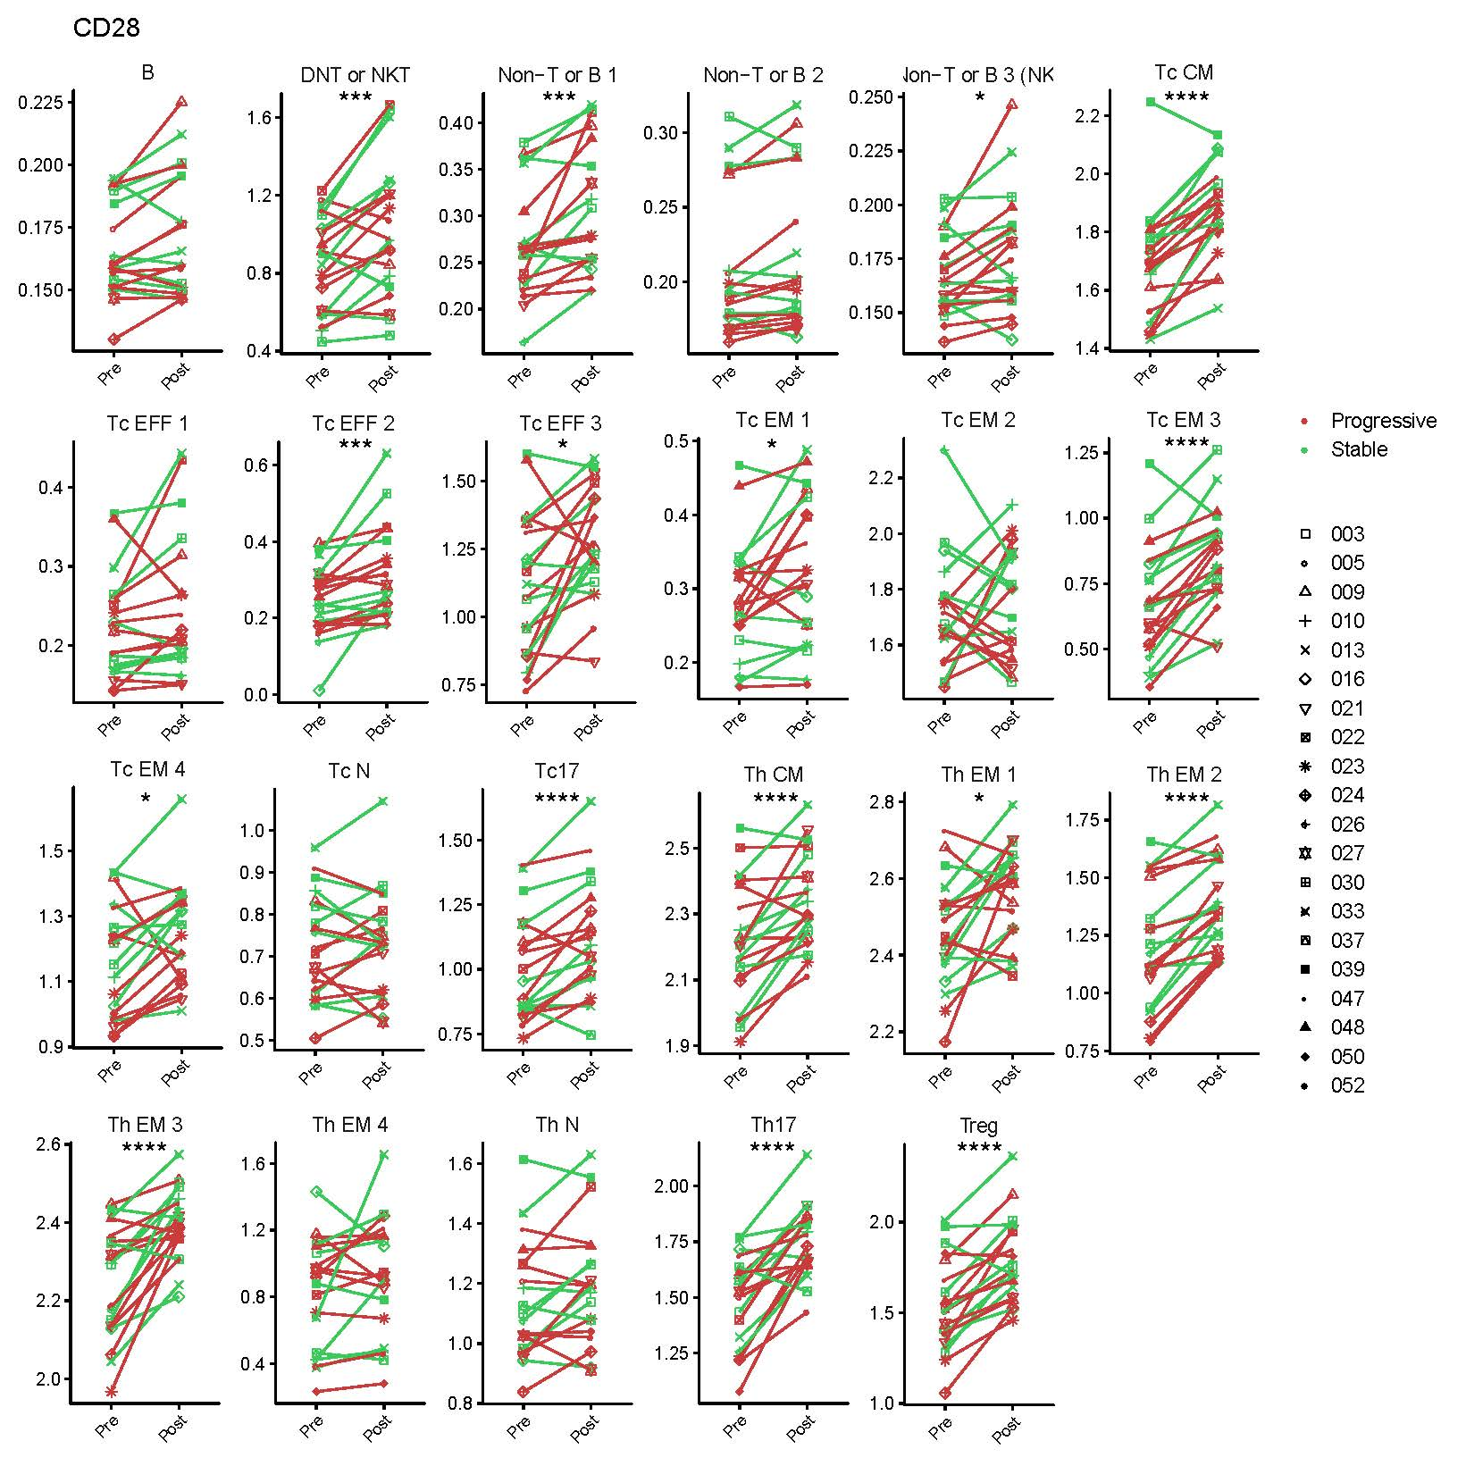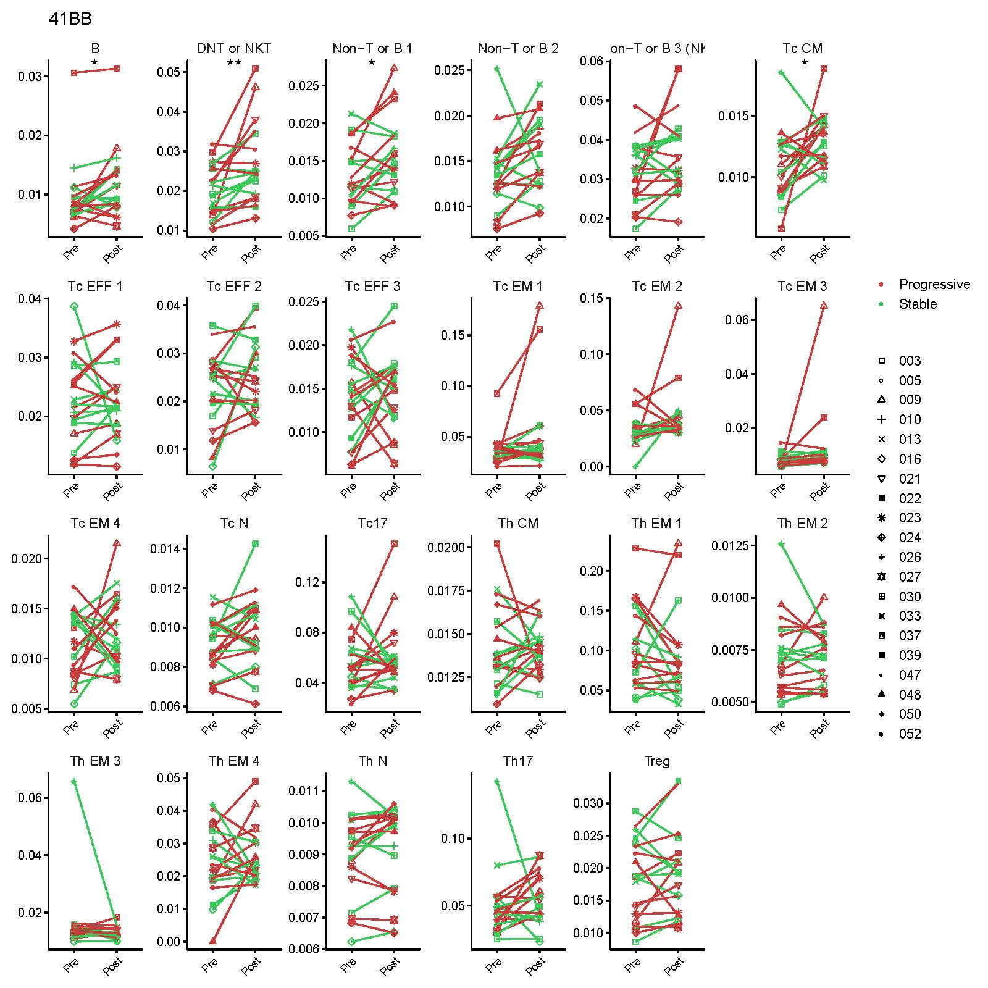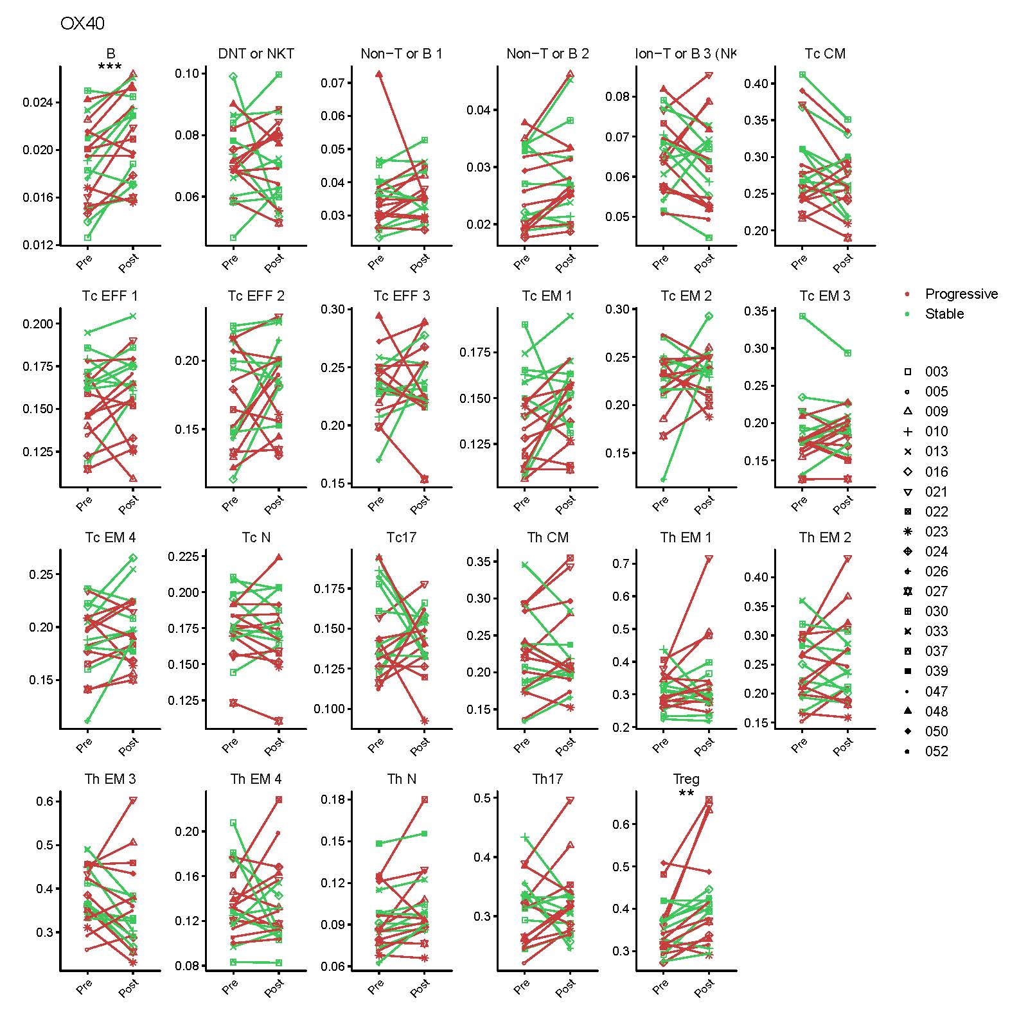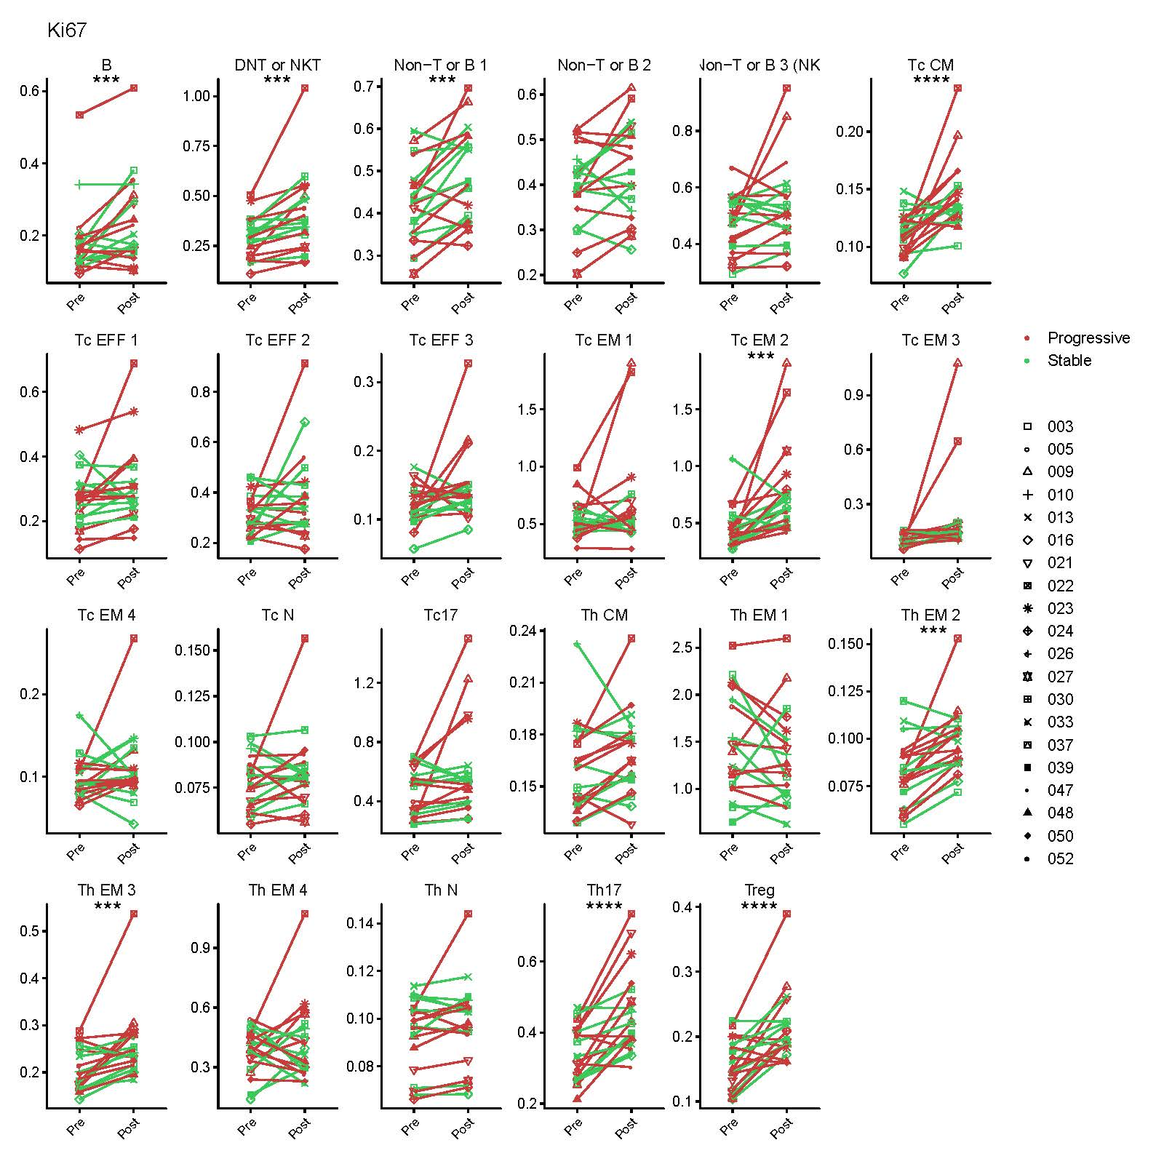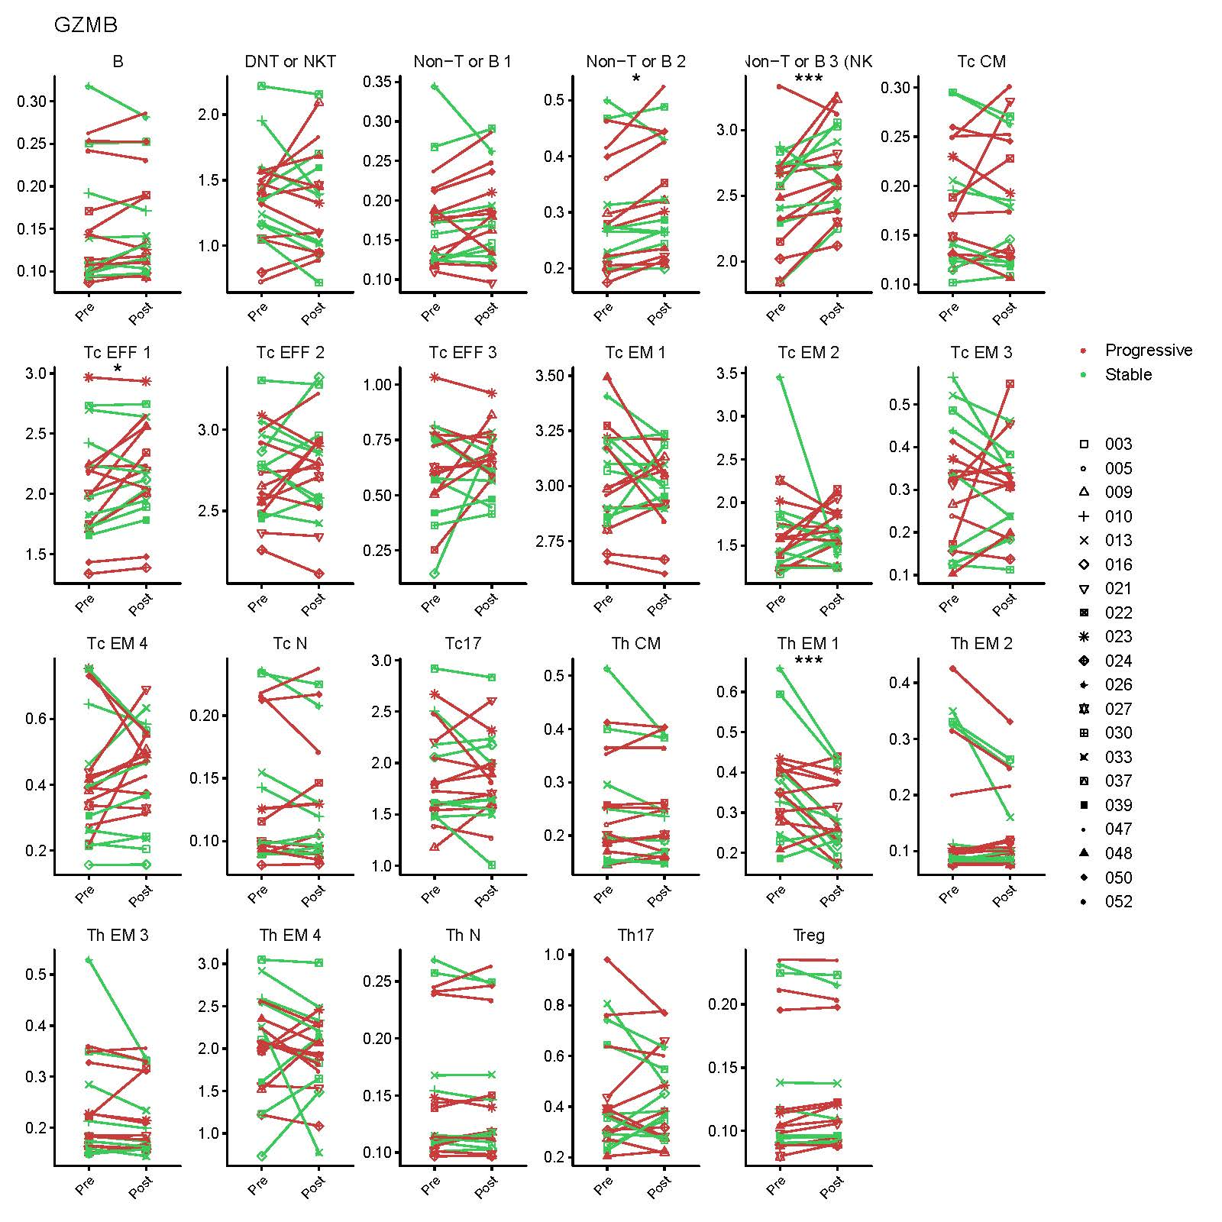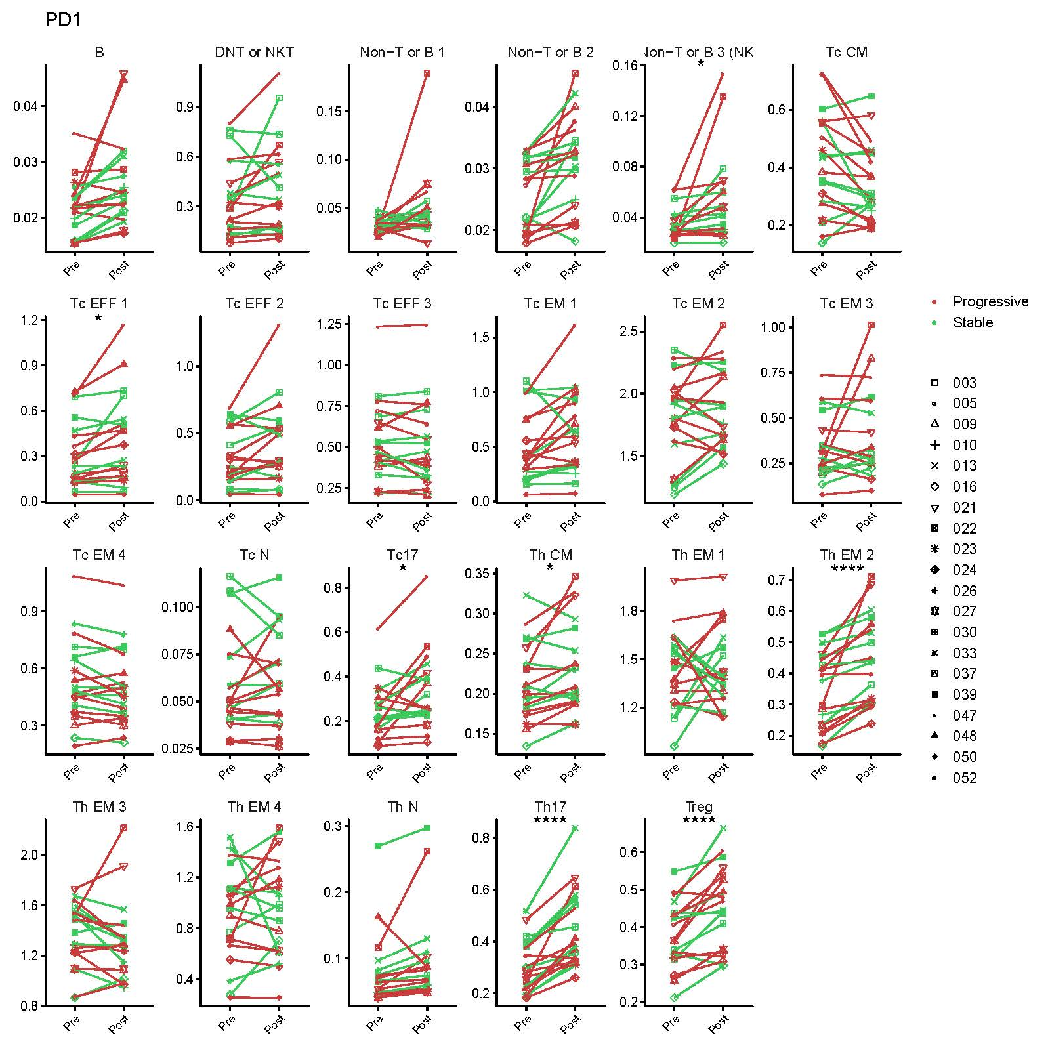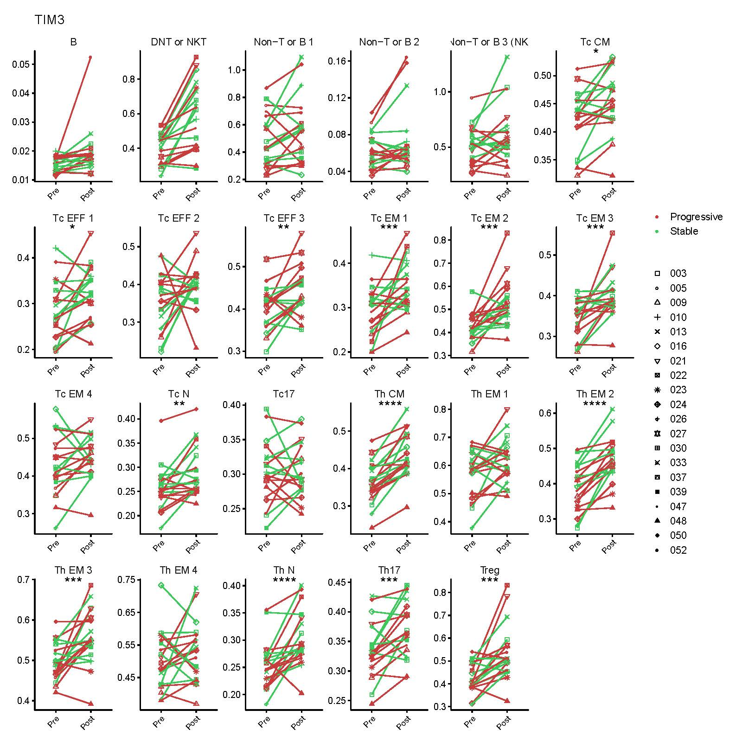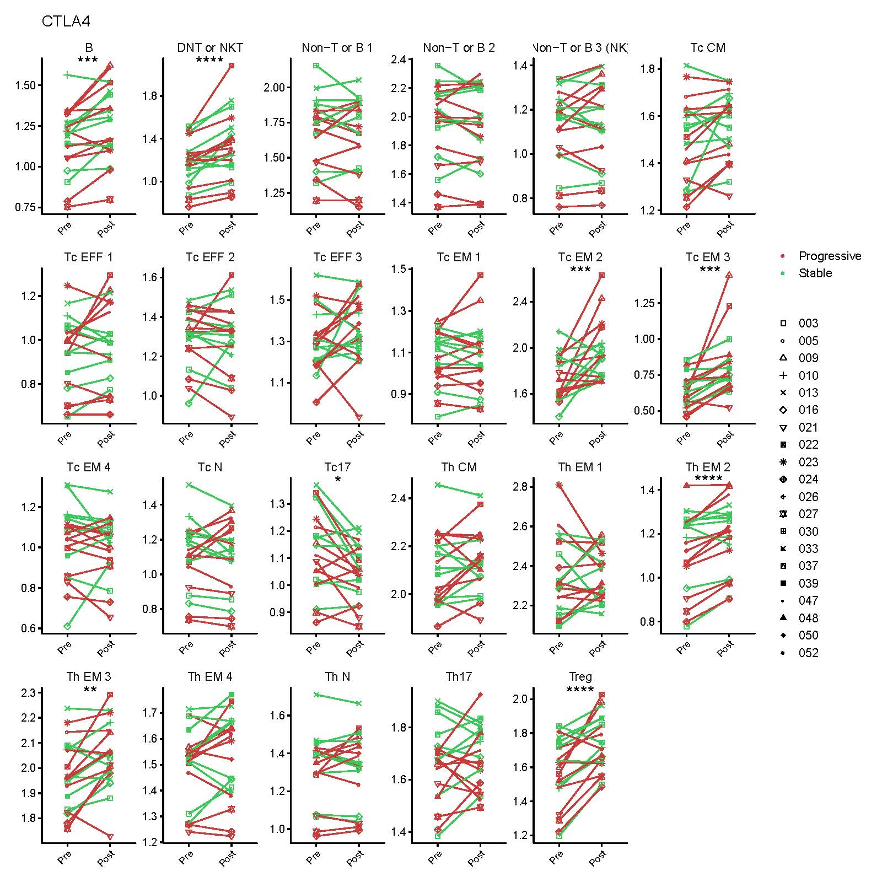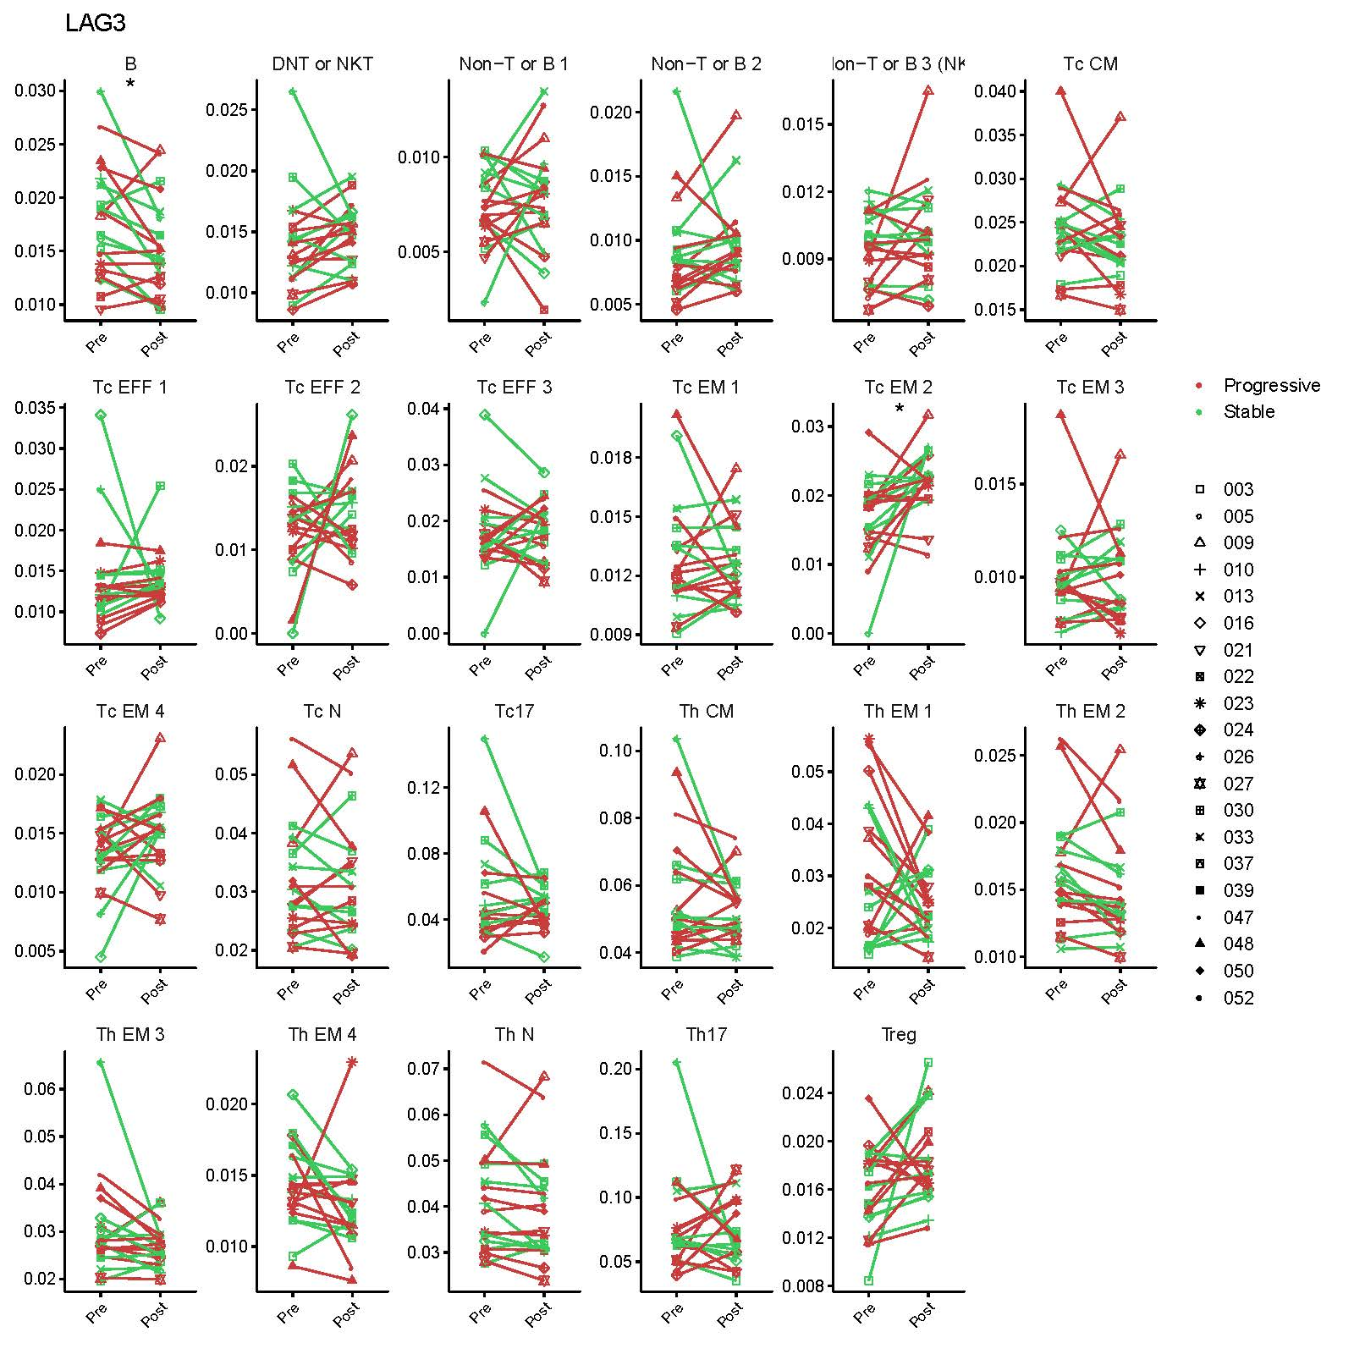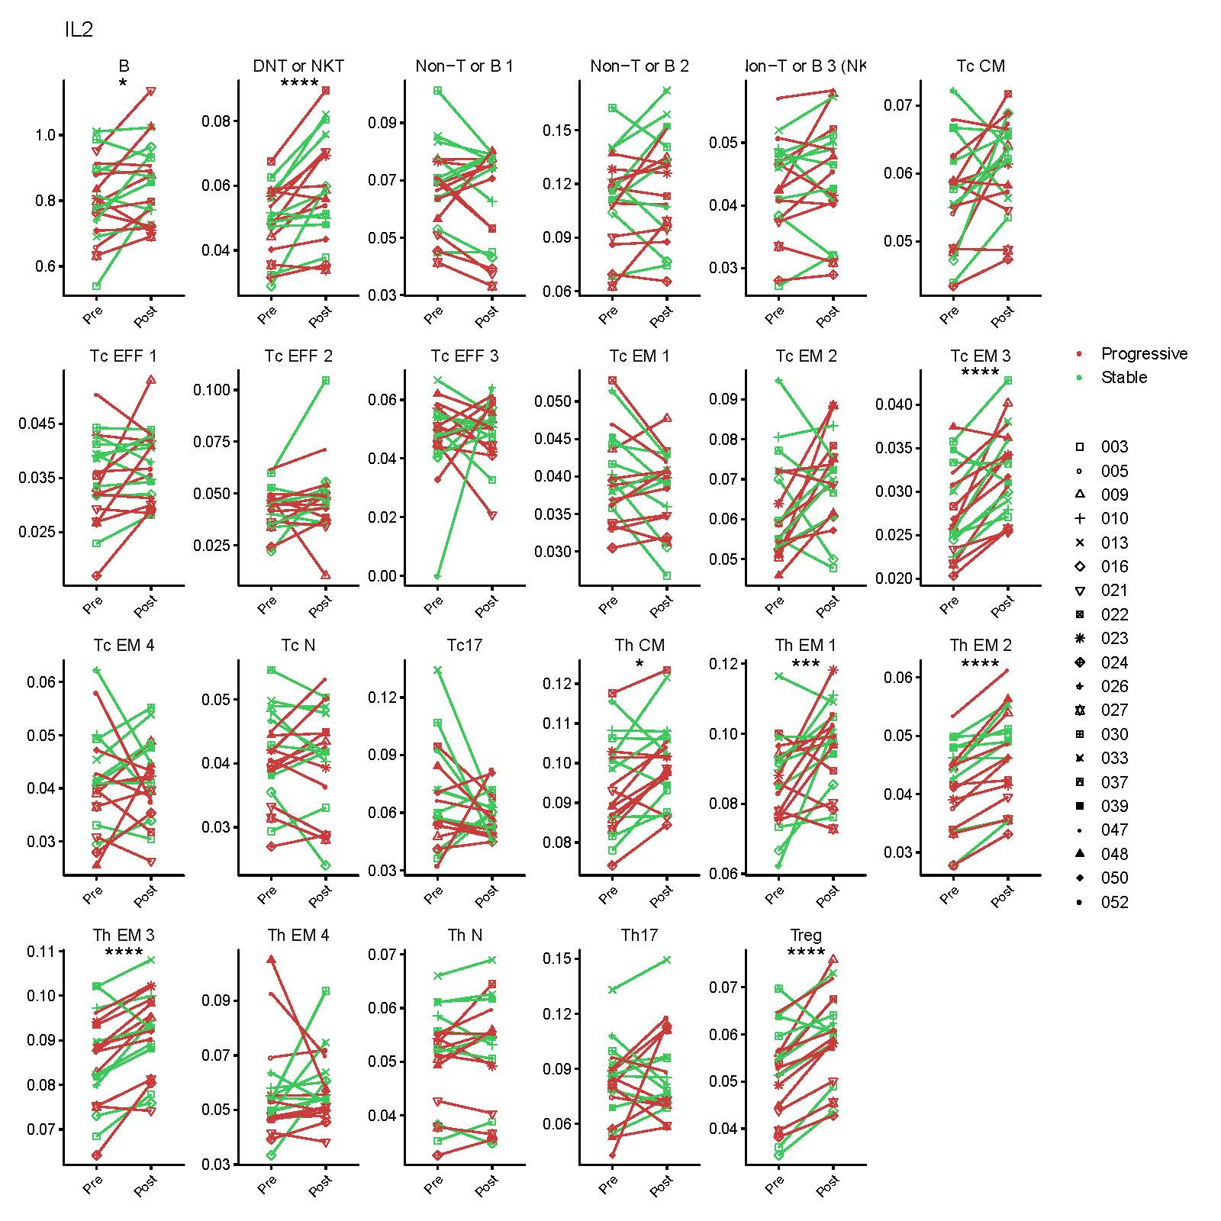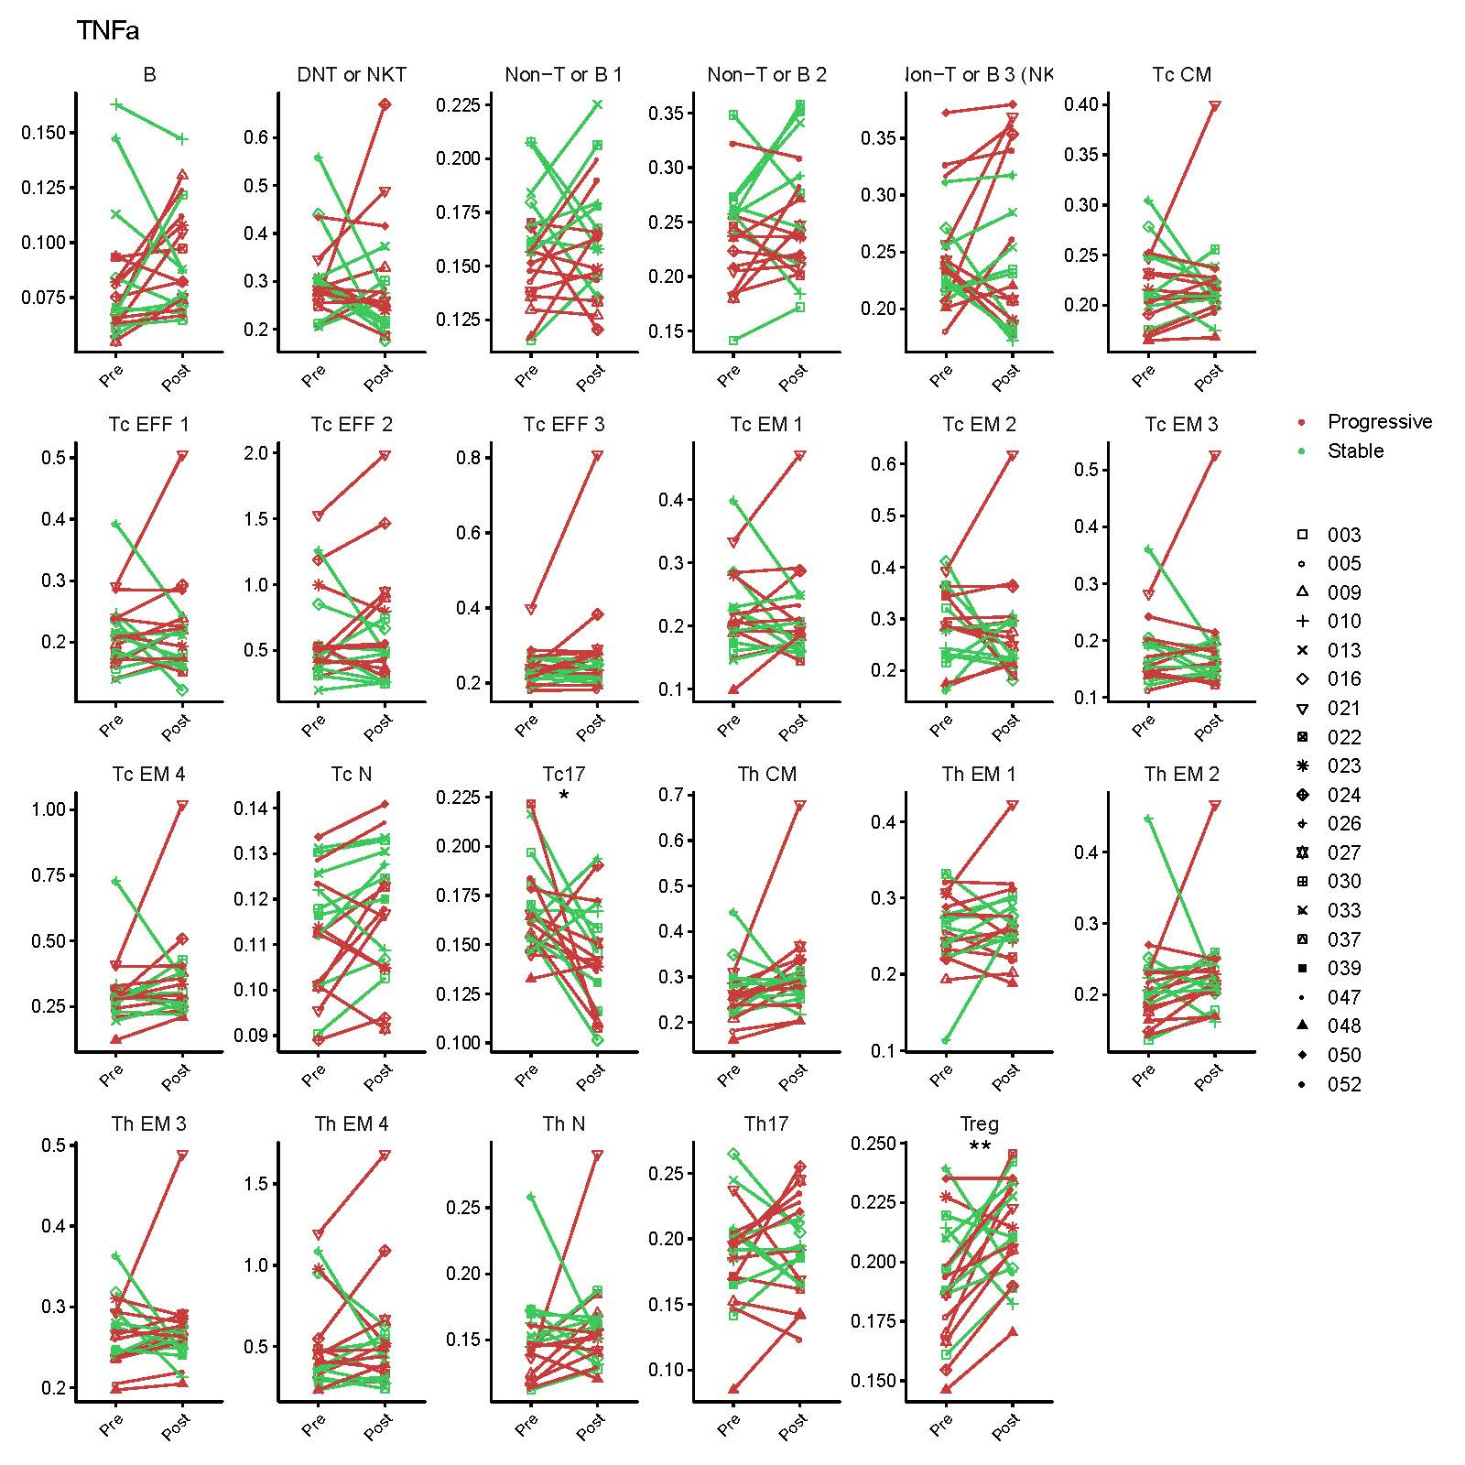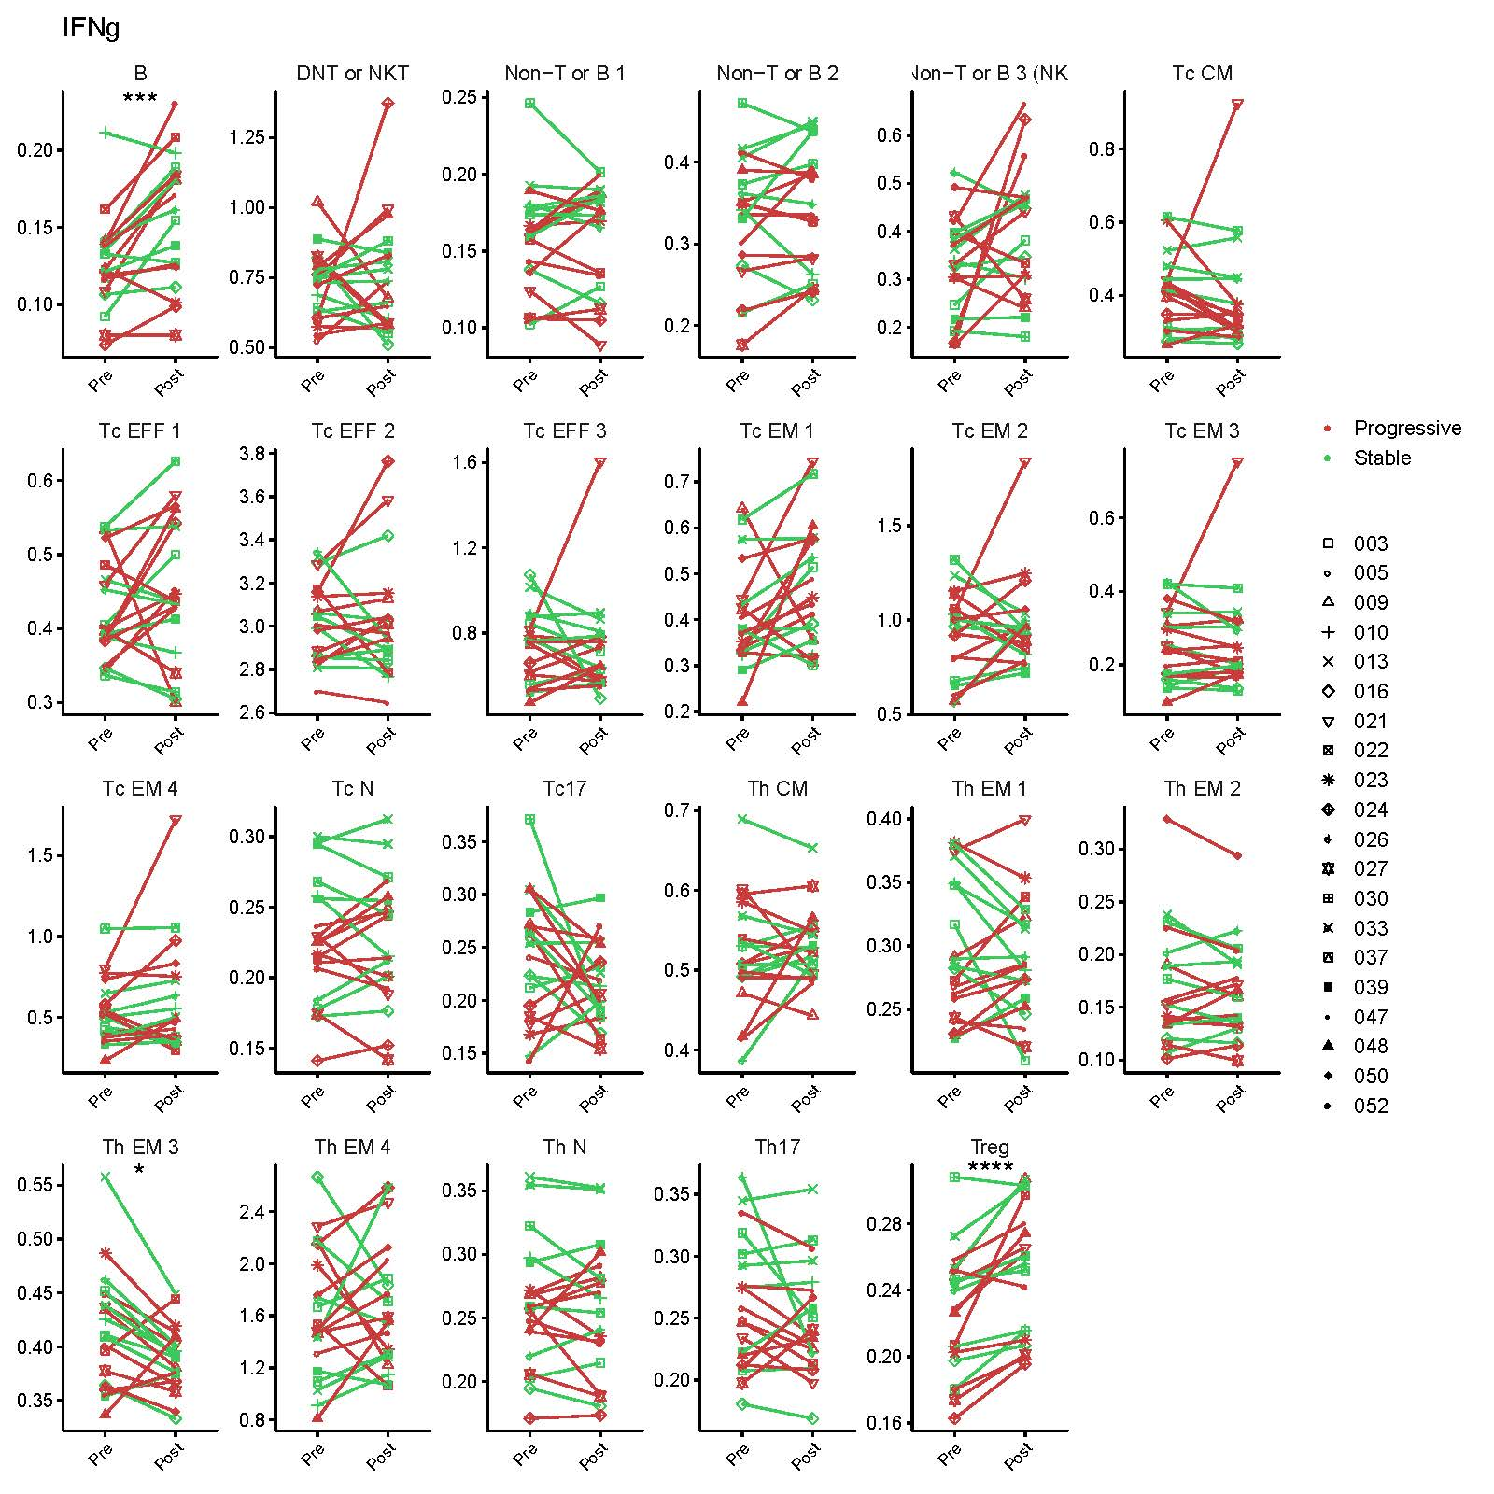

**Changes in the functional markers within each cluster with GVAX + IPI.**

Alteration in the mean mass intensity of each of the 12 markers, specified by the title of each panel, for every cell cluster upon therapy are shown in line plots connecting baseline (“Pre”) and after treatment (“Post”) conditions. Each of the 20 patients is denoted by a unique marker shape. Patients are also stratified by “Progressive” (red) and “Stable” (green). FDR-adjusted p values when comparing pre- and post-treatment time points using linear mixed modeling: *<0.05, **<0.01, ***<0.005, ****<0.0005.