Phase I trial of expanded, activated autologous natural killer (NK) cell infusions with trastuzumab in patients with human epidermal receptor (HER)2-positive cancers
Soo-Chin Lee^{1,2}, Noriko Shimasaki³, Joline SJ. Lim^{1,2}, Andrea Wong^{1,2}, Kritika Yadav², Wei Peng Yong^{1,2}, Lip Kun Tan¹, Liang Piu Koh¹, Michelle LM Poon¹, Sing Huang Tan⁴, Samuel GW Ow¹, Lavina Bharwani⁵, Yoon Sim Yap⁶, Mabel ZQ Foo², Elaine Coustan-Smith³, Raghav Sundar¹, Hon Lyn Tan¹, Wan Qin Chong¹, Kumarakulasinghe Nesaretnam¹, Jedidah LM Lieow¹, Priscillia Koe¹, Boon Cher Goh^{1,2}, Dario Campana^{1,3}

¹Department of Hematology-Oncology, National University Cancer Institute, Singapore; ²Experimental Therapeutics Programme, Cancer Science Institute, Singapore; ³Department of Paediatrics, Yong Loo Lin School of Medicine, National University of Singapore, Singapore; ⁴Oncocare Cancer Centre, Singapore; ⁵Department of Medical Oncology, Tan Tock Seng Hospital, Singapore; ⁶Department of Medical Oncology, National Cancer Centre, Singapore

Supplementary Material

(Supplementary Methods; Tables S1 and S2, Figures S1 and S2)

Supplementary Methods
Patient selection criteria
Inclusion criteria: Age 18-75; histologically confirmed diagnosis of HER2-positive breast or gastric cancer or other refractory HER2-positive solid tumors (defined as IHC 3+ or HER2 FISH amplification ratio >2.2); metastatic disease with presence of measurable or non-measurable tumour by RECIST 1.1 criteria; for HER2-positive breast cancer, patient must have failed at least two lines of anti-HER2 based therapy (documented relapse while receiving adjuvant or neoadjuvant trastuzumab for HER2 positive breast cancer is considered one prior line). For HER2-positive gastric cancer, patient must have failed at least one line of anti-HER2 based therapy, or have failed standard therapies for other refractory HER2 positive solid tumors (non-breast, non-gastric); at least two weeks since receipt of any biological therapy, chemotherapy, and/or radiation therapy; left ventricular ejection fraction ≥50%; adequate organ function (ANC ≥1500/µL, platelet count ≥100,000/µL, creatinine clearance ≥60 ml/minute, total bilirubin ≤1.5x upper limit normal (ULN) AST ≤ 2 x ULN, ALT ≤ 2 x ULN, ECOG performance status of 0-1); life expectancy of at least 60 days; negative serum or urine pregnancy test result within 14 days prior to enrolment for women who are of childbearing potential; ability to provide informed consent. Otherwise, a legally authorized representative must be present throughout the consent process and is allowed to give consent on the patient’s behalf; patients with reproductive potential must agree to use an approved contraceptive method; ability to comply with study procedures.

Exclusion criteria: Treatment within the last 30 days with any investigational drug; concurrent administration of any other anti-cancer therapy, including cytotoxic chemotherapy, hormonal therapy, and immunotherapy; major surgery within 28 days of study drug administration; active infection that in the opinion of the investigator would compromise the patient’s ability to tolerate therapy; lactating or pregnant; serious concomitant disorders that would compromise the safety of the patient or compromise the patient’s ability to complete the study, at the discretion of the investigator; serious cardiac illness or medical conditions including but not limited to patients with dyspnea at rest, history of documented congestive heart failure, high risk uncontrolled arrhythmias, angina pectoris requiring a medicinal product, clinically significant valvular disease, evidence of transmural infarction on ECG, poorly controlled hypertension; second primary malignancy that is clinically detectable at the time of consideration for study enrolment; symptomatic brain metastases; receipt of steroids during time period of 3 days prior to expanded NK cell infusion to 30 days after infusion (i.e. day -3 to day +30).

NK cell expansion
NK cell expansion was performed at the Tissue Engineering and Cell Therapy (TECT) facility at the National University Health System, Singapore. TECT is an academic facility located in the campus of the National University Hospital/National University of Singapore; it is GMP-certified by the Singapore Health Science Authority. K562-mb15-41BBL cells were originated from a Master Cell Bank made at St Jude Children’s Research Hospital (Memphis, TN) compliant with the requirements set by the US Food and Drug Administration and Singapore Health Science Authority. The cell line was tested for expression of membrane-bound IL-15 and 4-1BBL, capacity to stimulate NK cell expansion, as well as sterility, mycoplasma, adventitious viruses, and retroviral infectivity (expression of membrane-bound IL-15 and 41BBL genes was achieved by transduction with a murine stem cell virus (MSCV) retroviral vector(1). K562-mb15-41BBL cells from a Working Cell Bank prepared at the National University of Singapore from the Master Cell Bank were thawed and expanded in 1 L of RPMI-1640 with 10% fetal bovine serum in G-Rex100M chambers (Wilson Wolf, Saint Paul, MN) at 37ºC in 5% CO₂ for 10 ± 2 days. Expanded K562-mb15-41BBL cells were placed in 600 mL transfer bags (Terumo, Tokyo, Japan) at 6-9 x 10⁸ cells in 250 ml of culture medium per bag and irradiated at 120 Gy using a linear particle accelerator (Elekta Synergy, Stockholm, Sweden) operated by staff of the Radiation Oncology Department at the National University Hospital of Singapore. The irradiated K562-mb15-41BBL cells were then cryopreserved in culture medium containing 10% DMSO. Sterility, mycoplasma, endotoxin level and expression of membrane-bound IL-15 and 4-1BBL were tested on each batch of irradiated cells. The irradiated cells were tested for absence of cell growth. To this end, in addition to bulk cultures and cultures of small number of cells (10-100) distributed in the wells of a 96-well microtiter plate, we performed a cell proliferation assay in which cells were incubated with 5-ethynyl-2'-deoxyuridine (EdU) and EdU-positive cells (i.e., cells that enter S phase) were monitored by EdU staining (Click-iT assay) and FxCycle Violet DNA staining (both from Thermo Fisher Scientific, Waltham, MA). Only when all tests confirmed the lack of detectable dividing K562-mb15-41BBL cells, a batch was certified for use.

The day before initiation of the co-culture with peripheral blood mononucleated cells, the certified irradiated K562-mb15-41BBL cells were thawed; 3 x 10⁷ cells were placed in 2-8 G-Rex100 chambers (Wilson Wolf) in 200 mL of SCGM medium (CellGenix, Freiburg im Breisgau, Germany). On the same day, a leukapheresis was collected from the patient. On the following day, mononucleated cells were separated from the leukapheresis by centrifugation on a Ficoll gradient, washed and resuspended in SCGM; 200 mL of the cell suspension was added to each G-Rex100 chamber containing irradiated K562-mb15-41BBL cells. The cell concentration was adjusted to achieve 3 x 10⁶ CD56+ CD3- NK cells per chamber, producing a NK: K562-mb15-41BBL ratio of 1:10.

To sustain NK cell expansion, low-dose (40 IU/mL) IL-2 (Proleukin; Novartis, Basel, Switzerland) was added to the tissue culture medium as soon as the co-culture of peripheral blood mononucleated cells and K562-mb15-41BBL cells was initiated. The co-culture at 37ºC, 5% CO₂ lasted 10 ± 1 days. Every other day, IL-2 was added to cultures to maintain a concentration of 40 IU/mL. At the same time, an aliquot of supernatant was collected to measure glucose levels. If these dropped below 5.5 mM, half of the SCGM medium in the chambers was replaced. The NK cell expansion was monitored in a parallel small-scale culture. The sterility of cells in culture was assessed 2-4 days before infusion.

At the end of the culture, cells were collected, washed three times in saline solution containing 5% human serum albumin, and resuspended in the same solution at a concentration of 5 x 10⁷/mL or less for infusion. No cell selection or T-cell depletion was performed. The infused cell volume was determined based on phenotype and cell viability. Cell immunophenotyping was performed by staining with anti-CD56 conjugated to phycoerythrin (PE), anti-CD3 allophycocyanin (APC), anti-CD16-fluorescein isothiocyanate (FITC), and anti-CD45-peridinin-chlorophyll protein (PerCP) (all from BD Biosciences, San Jose, CA), and analyzed with a BD FACSCanto II flow cytometer (BD Biosciences) after gating on CD45+ viable cells. Cell viability was measured by staining with 7-amino-actinomycin (7-AAD; BD Biosciences). Cell counting was performed with a Coulter Ac•T diff Hematology Analyzer (Beckman Coulter, Brea, CA). Absence of K562-mb15-41BBL, which are green fluorescent protein (GFP)-positive, in the infused product was also determined by flow cytometry. After infusion, sterility including mycoplasma, endotoxin level, and ADCC were tested.

NK cell immunophenotyping
Peripheral blood mononucleated cells were separated on a density gradient and washed twice in phosphate buffered saline containing 0.2% bovine serum albumin and 0.2% sodium azide (PBSA). They were labelled with the following antibodies: anti-CD45-APC-H7, anti-CD3 PerCP, anti-CD56-PE-Cy7 (all from BD Biosciences, San Jose, CA), anti-CD16-BV421 and anti-CD14-PE/Dazzle 594 (both from BioLegend, San Diego, CA). After further washing in PBSA (x 2), cells were fixed in 0.5% formaldehyde and analyzed with a LSRII flow cytometer (BD Biosciences). Percentages of NK cell subpopulations in peripheral blood before and after infusion were calculated among cells with light scattering properties of viable lymphoid cells and CD45 expression, after doublet exclusion. Absolute numbers were calculated by using these percentages and the absolute number of peripheral blood lymphoid cells as determined with a Coulter Ac•T diff Hematology Analyzer.

Testing of antibody-dependent cell cytotoxicity (ADCC)
ADCC testing was performed as previously described(2). Briefly, NK cells were cultured with luciferase-labelled SK-BR-3 with or without trastuzumab (10 μg/mL) in triplicate. After 4 hours, BrightGlo (Promega, Fitchburg, WI) was added to the wells and luminescence from viable SK-BR-3 cells was measured using a Flx 800 plate reader (BioTek, Winooski, VT).

DNA Extraction, Nested PCR and Sanger’s sequencing
Germline DNA was extracted using Masterpure DNA purification Kit for Blood Version II (Illumina, San Diego, CA) according to manufacturer’s instructions. Nested PCR was carried out with forward and reverse primers shown in Table S1. Each PCR reaction consisted of 2.5μl Faststart PCR Mastermix (Roche, Basel, Switzerland), 10 μM of each primer, 10mM of dNTP solution mix (New England Biolabs, Ipswich, MA), 0.4 μl of Taq DNA Polymerase (Roche) and 10 ng of DNA in a total volume of 25 μl. The following PCR conditions were used: denaturation for 5 minutes at 95°C, followed by 34 cycles of denaturation at 95°C for 30 seconds, primer annealing at 60°C for 30 seconds, and primer extension at 72°C for 1 minute. Upon completion of cycling steps, a final extension at 72°C for 5 minutes was done and the reaction product was stored at 4°C. PCR reaction products from the first reaction were visualized by agarose gel electrophoresis and stained with Florosafe DNA stain (Base Asia, Singapore, Singapore); 1.5% agarose gel was prepared in 1x TBE buffer and 4 μl Florosafe DNA stain (Base Asia). DNA was added to the appropriate amount of 6x loading buffer (Base Asia) and loaded together with size markers (100bp and 1kb ladders; Base Asia). Gel was run at 100V for 1 hour. DNA was visualised under UV light on a transilluminator and excised using QIAquick gel extraction (Qiagen, Hilden, Germany) kit according to manufacturer’s instructions; 1 μl of product from gel extraction was taken for a second PCR reaction. Second PCR reaction reagents and conditions were the same as previously, but a different reverse primer was used instead. Second PCR reaction products were purified. Each purification reaction consisted of Exonuclease (4x dilution) (GE Healthcare, Chicago, IL), shrimp alkaline phosphatase (2x dilution) (GE Healthcare), 1.5 μl of second PCR product in a total reaction volume of 4.5 μl. Purification was done at 37°C for 30 min and 80°C for 15 seconds. Purified products were sent for Sanger’s Sequencing (Base Asia), and results were analysed by 4 peaks DNA sequence trace viewer (Nucleics, Sydney, Australia).

Immunohistochemistry (IHC)
Eight pairs of pre- and post-NK cell infusion tissue biopsies were received in 10% neutral buffered formalin and processed to paraffin blocks. Multiple 4 μm thick sections were cut from the blocks and mounted on poly-L Lysine coated glass slides. Hematoxylin and Eosin (H&E) staining was done in all cases. Subsequently, single IHC was performed on Leica Bond Max automated platform (Leica Biosystems, Nussloch, Germany) with bond polymer refine detection kit (DS9800, Leica Biosystems) containing diaminobenzidine (DAB) chromogen producing a brown precipitate. Briefly, the sections were deparaffinised and dehydrated followed by antigen retrieval with citrate buffer antigen (AR9961, Leica Biosystems) at pH 6.0. Slides were incubated with primary antibodies CD56, Cleaved Caspase 3, CD3 and CD20. Counterstaining with haematoxylin was done. Information on the antibody dilution, clone and the commercial supplier are provided in Table S2. Double sequential IHC with CD4 and CD8 antibodies was also done using bond polymer refine detection kit (DS9800, Leica Biosystems) and bond polymer refine red detection kit (DS9390, Leica Biosystems) with antigen retrieval using EDTA buffer (AR9640, Leica Biosystems) at pH 9.0.

Microscopic analysis was done by a trained pathologist (KY) using Olympus BX43 and digital images were acquired using Olympus cellSens (Olympus, Tokyo, Japan). Entry imaging software. H&E was done to identify the tumor cells and assess the type of immune cells infiltration. Under low power of the microscope, the tumor content was estimated as a percentage of the entire biopsy (number of tumor cells in relation to the total number of cells including tumor cells, stromal cells, benign epithelial cells and immune cells). In IHC stained slides, the number of CD56+ NK cells were counted manually in 5 high power fields (HPF; 400x) and the average was expressed as mean cell count in 5 HPF (Mean ± SD). CD56+ tumor cells and macrophages, were excluded from the analysis based on morphology. Apoptotic index was calculated as percentage of tumor apoptotic cells and bodies per all tumor cells marked by cleaved caspase 3. Percentage of CD3+ T lymphocytes and CD20+ B lymphocytes were also assessed in 5 HPF in sections stained with CD3 and CD20. In slides stained double sequentially with CD4 (colour-red) and CD8 (colour-brown), 100 immune cells that showed positive staining were counted and ratio of CD8+ cytotoxic T cells and CD4+ helper T cells was determined.
Table S1: Primers used for PCR and sequencing
663 | Forward | PCR, 1st and 2nd | CGTTCGTACGAGAATCGCTAGGGTGGCACATGTCTCAC
664 | Reverse | PCR, 2nd | GGTACGTGGCCCCTTCAC
731 | Reverse | PCR, 1st | CTTAGAAACCACGAATTGCCAGG
FCGR3A-F sequence | Forward | Sequence | CTTCTACATTCCAAAAGCC
FCGR3A-R sequence | Reverse | Sequence | GTACGAGAATCGCTAGGGTG

Table S2: Details of primary antibodies for IHC
Antibody | Dilution | Clone | Supplier | Cellular localization
CD56 | 1:50 | 123C3 | DAKO | Membrane
Cleaved Caspase 3 | 1:150 | D3E9 | Cell Signalling | Cytoplasm/nuclear
CD3 | 1:300 | SP7 | Abcam | Membrane
CD20 | 1:400 | L26 | Abcam | Membrane
CD4 | 1:200 | EPR6855 | Abcam | Membrane
CD8 | 1:50 | 4B11 | Novocastra | Membrane

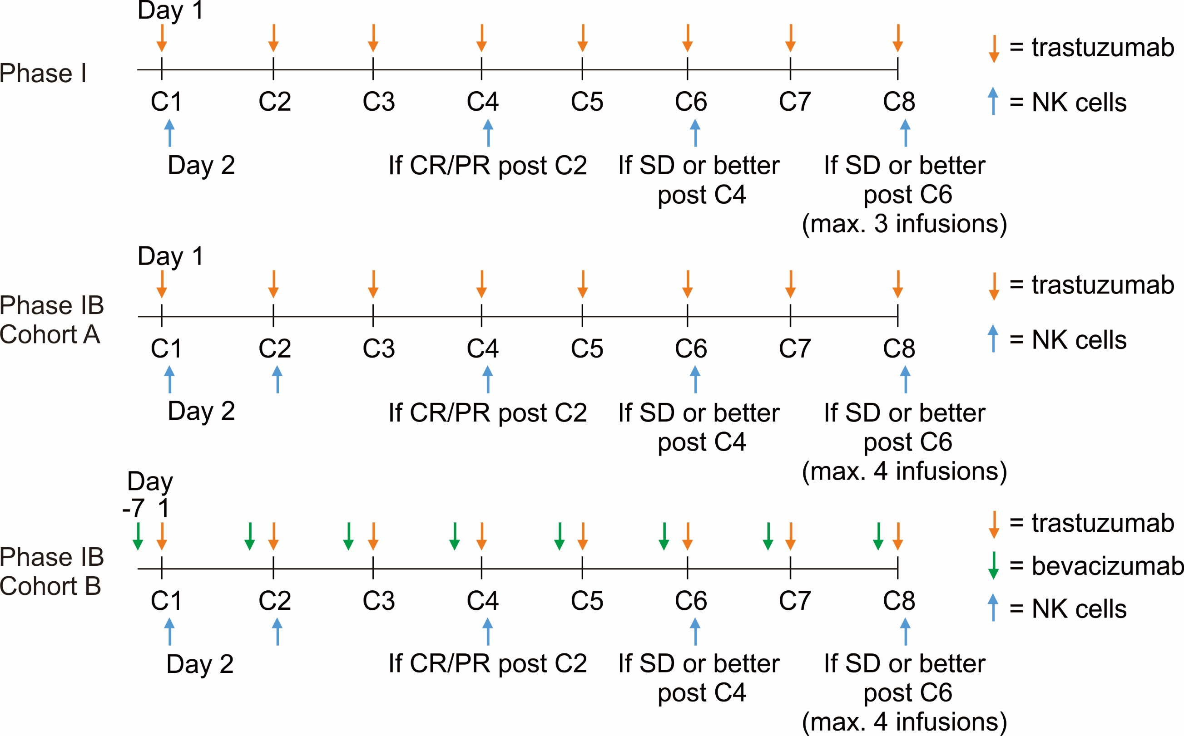

Figure S1. Outline of the treatment protocol. In Phase I, subjects received trastuzumab (orange arrows) on day 1 of each cycle, followed by NK cell infusion (blue arrows) on day 2, repeated in cycles (“C”) 4, 6 and/or 8, if at least a partial response (PR) was achieved after C2 or there was sustained stable disease (SD) or better after C4 or C6. An additional NK cell infusion was given at cycle 2 in phase IB cohort A and B. In Phase I cohort B, bevacizumab (green arrow) was given 7 days prior to trastuzumab and NK cell therapy.

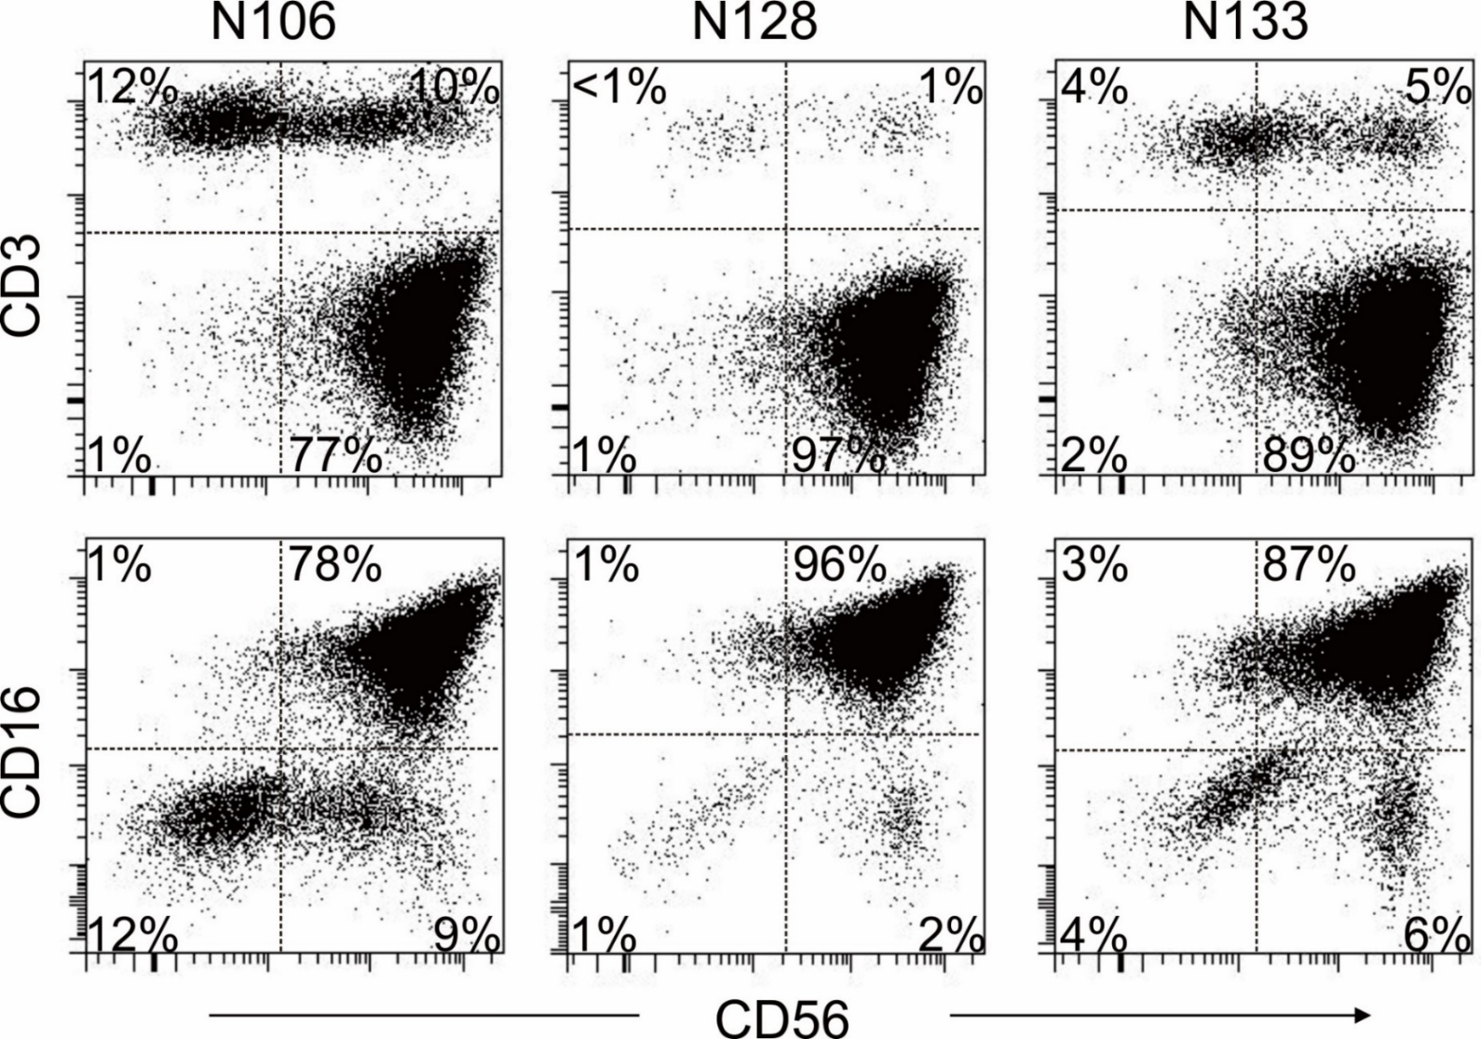

Figure S2. Immunophenotypic features of the infused cell products. Flow cytometric dot plots illustrate staining of viable CD45+ cells with anti-CD3 APC and anti-CD56 PE (top row), and with anti-CD16 FITC and anti-CD56 PE (bottom row; all from BD Biosciences) in 3 representative cell products immediately prior to infusion, after NK cell expansion. Antibody staining was analysed with a FACSCanto II flow cytometer and DIVA software (BD Bioscience). Quadrants were drawn based on the results of staining the same samples with isotype-matched non-reactive antibodies (from BD Biosciences). The percentage of viable CD45+ cells expressing the marker is shown.

REFERENCES

1. Imai C, Iwamoto S, Campana D. Genetic modification of primary natural killer cells overcomes inhibitory signals and induces specific killing of leukemic cells. Blood. 2005;106(1):376-83.
2. Imamura M, Shook D, Kamiya T, Shimasaki N, Chai SM, Coustan-Smith E, et al. Autonomous growth and increased cytotoxicity of natural killer cells expressing membrane-bound interleukin-15. Blood. 2014;124(7):1081-8.

