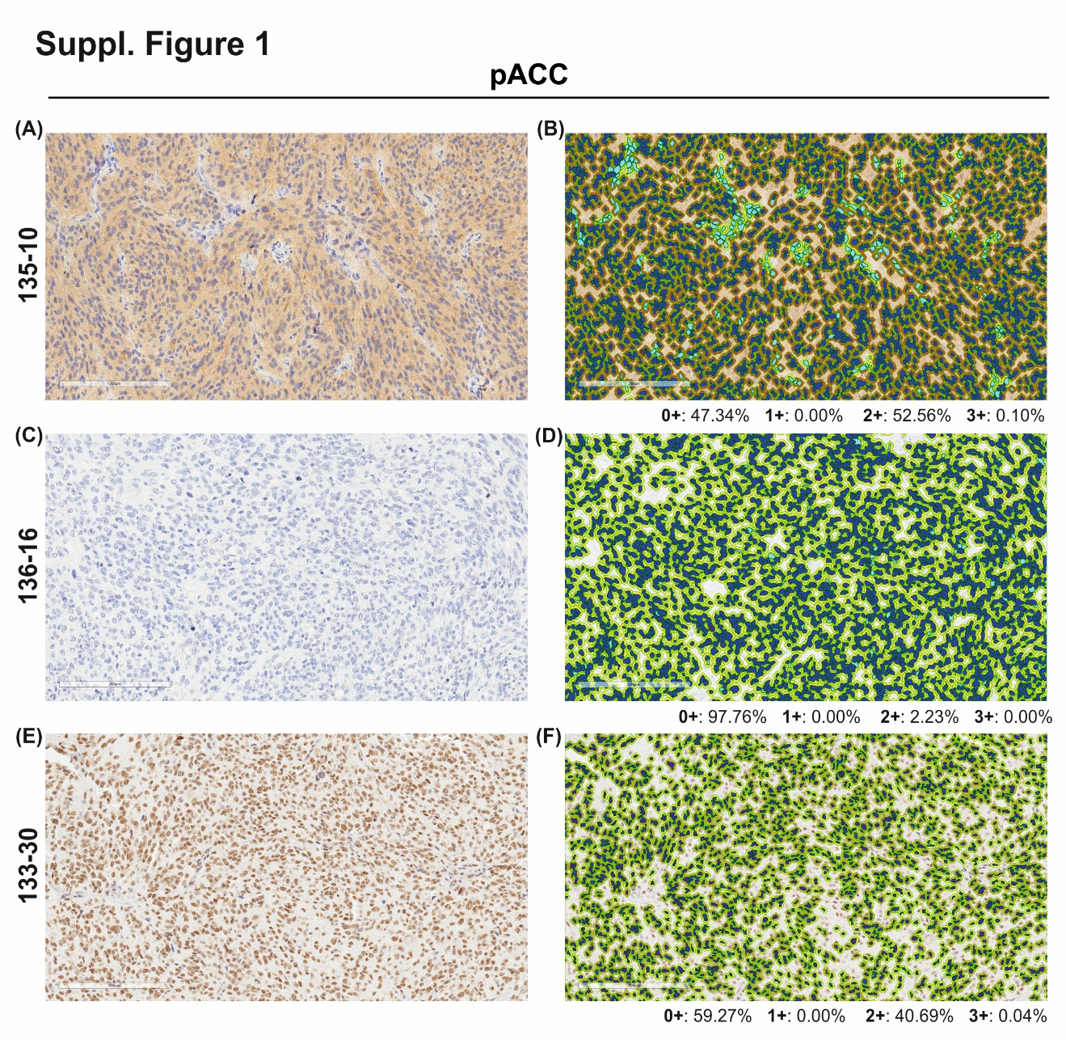

Supplementary figure 1. Immunohistochemical staining of pACC in three representative GBM samples: (A) positive pACC cytoplasmic expression, (C) negative pACC cytoplasmic expression, (E) positive pACC nuclear expression. Haematoxylin-Eosin counterstain. Visualization of final mark-up of the same analyzed tissue by the Aperio Cytoplasmic Algorithm to quantify pACC expression in tumor. The algorithm used automatically detects and classifies cytoplasmic expression as positive (2+/brown) (B) or as negative (0+/yellow) (D). Image (F) shows quantification of nuclear positivity. Original magnification 10X.

