Appendix Figure 2. Changes from Baseline in the SPD for Target Lesions vs Best Overall Response as Assessed by IRC
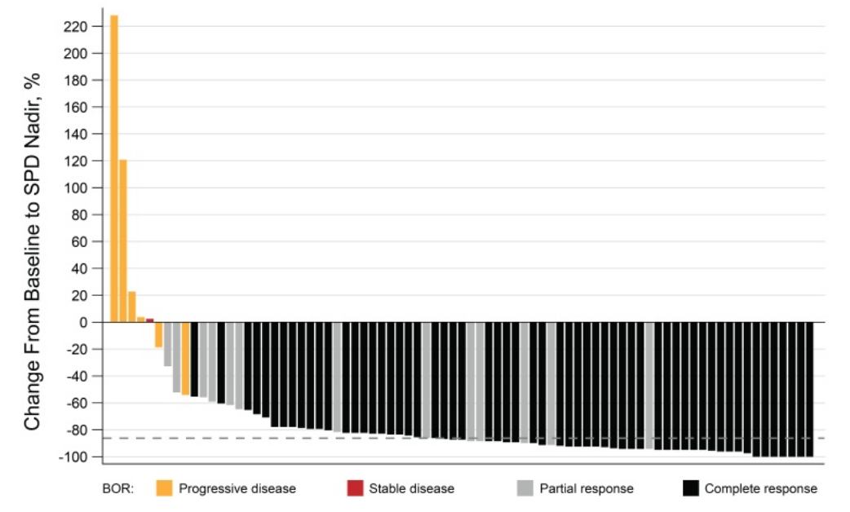
Note: Dashed line denotes median reduction in SPD (-87.0%).

BOR, best overall response; IRC, independent review committee; SPD, sum of product of perpendicular diameters

