Protocol- Study 1 (CG1001)

This trial protocol has been provided by the authors to give readers additional information about their work

**A Pilot Clinical Study of Chimeric Antigen Receptor-Engineered GPC3 T Cells in the Treatment of Hepatocellular Carcinoma**

**Principal Investigator (PI):** Zonghai Li, MD, PhD  
Renji Hospital

Shanghai Jiao Tong University School of Medicine

**Co-Principal Investigator (Co-PI):** Zhai Bo, MD, PhD

Renji Hospital

Shanghai Jiao Tong University School of Medicine

**Technical Support:** Bizhi Shi, Associate Research Scientist

Hua Jiang, Associate Scientist

Huiping Gao, Assistant Scientist

Renji Hospital

Shanghai Cancer Institute

Shanghai Jiao Tong University School of Medicine

**Medical Advisor:** Jianren Gu, Professor

**Statistical Support:** Yongbing Xiang, Professor

**Quality Assurance:** Hongxia Zhao

**CAR-T Cell Manufacturer:** Huamao Wang, PhD, CARsgen Therapeutics

09-Sep-2015

Confidentiality

This document is confidential, which cannot be distributed, copied, published or used without the written authorization of the company. This document is a clinical trial protocol. The study must be conducted according to China and international Good Clinical Practice, applicable regulations.

**Table of Contents**

List of Abbreviations 5

Protocol Synopsis 6

1 Introduction 10

1.1 Background 10

1.2 Study drug 13

1.3 Preclinical data 14

1.3.1 Expression of GPC3 in normal tissues 14

1.3.2 The expression of GPC3 in HCC tissues 14

1.3.3 Expression of GPC3 in HCC cell lines 15

1.3.4 In vitro toxicity 16

1.3.5 Release of cytokines in vitro 17

1.3.6 In vivo antitumor activity of CAR-GPC3 T cells against hepatocellular carcinoma 18

1.4 Current clinical data 18

1.5 Dose rationale and risk/benefit 22

2 Study objectives 23

2.1 Primary objective 23

2.2 Secondary objective 23

3 Study design 24

3.1 Overall design 24

3.2 Safety, feasibility and persistency endpoint 24

3.3 Secondary objectives and endpoints 25

4 Subject selection and withdrawal 25

4.1 Inclusion criteria 25

4.2 Exclusion criteria 26

4.3 Subject recruitment and screening 27

4.4 Early withdrawal 28

4.4.1 When and how to discontinue subjects 28

4.4.2 Data collection for withdrawn subjects 29

5 Study drug 29

5.1 Introduction 29

5.2 Treatment plan 29

5.2.1 Preparation 29

5.2.2 Pre-infusion medication 29

5.2.3 Fever 29

5.2.4 Contamination 30

5.2.5 Administration 30

5.3 Subject compliance 30

5.4 Pre-treatment and concomitant treatments 30

5.5 Packaging 30

5.6 Return and destruction of study drug 31

6 Study procedure 31

6.1 Pre-treatment evaluation 31

6.2 Enrollment and baseline measurement 31

6.3 Leukapheresis 32

6.4 Lymphodepletion prior to CAR-T infusion 32

6.5 Disease staging re-evaluation 33

6.6 Post-infusion laboratory examination for the evaluation of cell implantation and persistence 33

6.7 Tumor response evaluation 33

7 Statistical analysis plan 33

7.1 Study endpoint 33

7.1.1 Primary endpoint 33

7.1.2 Secondary endpoints 34

7.2 Sample size 34

7.3 Safety 34

7.4 Efficacy 34

7.5 Study population for analysis 35

7.6 Statistical analysis 35

8 Safety and adverse events 35

8.1 Safety definitions 35

8.2 Recording of AEs 37

8.3 Reporting of SAEs and unexpected issues 37

8.3.1 Reporting of SAEs to study sponsor 37

8.3.2 Reporting of SAEs to site IEC 38

8.4 Patient termination and study discontinuation 39

8.4.1 Criteria for termination or temporary interruption of study 39

8.4.2 Risk management 39

8.4.3 Criteria for study discontinuation 40

8.5 Protocol deviation 40

8.6 Medical Monitoring 41

8.6.1 Independent Data and Safety Monitoring Committee 41

8.6.2 Clinical monitor 41

9 Data processing and record archiving 42

9.1 Confidentiality 42

9.2 Source documents 42

9.3 Case report form 42

9.4 Record archiving 42

9.5 Early termination 42

10 Study monitoring, audit, and inspection 43

10.1 Study monitoring plan 43

10.2 Audit and inspection 43

11 Ethics 43

12 Conflict of interest 44

13 Publication plan 44

14 References 45

# List of Abbreviations

|  |  |
| --- | --- |
| AE | Adverse events |
| CAR-GPC3 T cells | Chimeric antigen receptor T cells targeting glypican-3 |
| CAR | Chimeric antigen receptor |
| CD3ζ | CD3-ζ chain (also known as zeta chain) |
| CFDA | China Food and Drug Administration |
| CRF | Case report form |
| CRS | Cytokine release syndrome |
| CTCAE | Common Toxicity Criteria for Adverse Events |
| CTL | Cytotoxic T cell |
| CVPF | Clinical Cell and Vaccine Production Facility |
| DCR | Disease control rate |
| DFS | Disease-free survival |
| DSMB | Data safety and monitoring committee |
| EBV | Epstein-Barr virus |
| EDC | Electronic data capture |
| GCP | Good Clinical Practice |
| GMP | Good Manufacturing Practice |
| IEC / IRB | Independent Ethics Committee / Institutional Review Board / |
| IRR | Infusion-related reactions |
| ITAM | Immunoreceptor tyrosine-based activation motif |
| MedDRA | Medical Dictionary for Drug Regulatory Activities |
| MTD | Maximum tolerated dose |
| PBMC | Peripheral blood mononuclear cells |
| NCI CTC | National Cancer Institute Common Toxicity Criteria |
| PD | Progressive disease |
| RCL | Replication-competent lentivirus |
| scFv | Single-chain variable fragment |
| TAA | Tumor-associated antigen |
| TCR | T cell receptor |
| Tcm | Central Memory T lymphocytes |
| TEAE | Treatment emergent adverse event |
| Tem | Effective Memory T lymphocytes |
| Treg | Regulatory T lymphocyte |
| WOCBP | Women of childbearing potential |

# Protocol Synopsis

|  |  |  |  |
| --- | --- | --- | --- |
| Title | | A Pilot Clinical Study of Chimeric Antigen Receptor-Engineered GPC3 T Cells in the Treatment of Hepatocellular Carcinoma | |
| Investigational drug | | CAR-GPC3 T cells | |
| Principal Investigator: | | Professor Zonghai Li, Renji Hospital | |
| Co-Principal Investigator | | Bo Zhai, Chief-physician | |
| Protocol No. | | CG1001 | |
| Protocol version and date | | V2.0, 09-Sep-2015 | |
| Study design | | Open-label, prospective study | |
| Study objectives | | Primary objective: | |
| To observe and identify the safety, tolerability and in vivo survival of lentivirus vector-transduced CAR-GPC3 T cells (CAR T cells targeting GPC3) | |
| CAR T cell | |
| Secondary objectives: | |
| To observe the efficacy of CAR-GPC3 T cells in the treatment of hepatocellular carcinoma by the following parameters: | |
| Time to progression (TTP) | |
| Disease control rate (DCR) and Objective response rate (ORR) | |
| Symptom resolving rate | |
| Treatment indication | | Hepatocellular carcinoma | |
| Main eligibility criteria | | * IHC GPC3-positive hepatocellular carcinoma * At least one target lesion ≥ 10 mm * Without alternative treatment option * Aged > 18 years old * Estimated life expectancy > 12 weeks | |
| Treatment plan | | The total dose of CAR-GPC3 T cells is approximately 1×105–2×109 CAR-T cells/kg body weight. The first subject will start from 1×105 CAR T cells/kg, intravenously. Repeated intra-patient dose-escalation is allowed. The next dose and dosing time of the same subject will be decided based on the subject’s response to previous dose. The dose of the next subject is based on the response from the previous subject.  The lymphodepletion regimen will be decided based on the subject's clinical parameters before the CAR-T infusion. Recommended lymphodepletion regimen: fludarabine, 30 mg/m2/day × 4 days; cyclophosphamide, 500 mg/m2/day × 2 days; fludarabine in combination with cyclophosphamide is given on Day 1 to Day 2, and fludarabine only is given on Day 3 to Day 4. Cyclophosphamide 500 mg/m2/day × 2 days alone can be considered. The detailed regimen and dosage will be adjusted according to the subject’s condition and the physician’s judgment. | |
|  | |  | |
| Safety measurement | Treatment-related adverse events (AEs) defined as: laboratory toxicities and clinical events possibly, probably or definitely related to treatment which occur within 24 weeks after cell infusion, including lymphodepletion related toxicities and any CAR-GPC3 T cells related toxicities. AE will be classified according to NCI CTCAE criteria.  Including but not related to:   * Fever * Chills * Nausea, vomiting and various symptoms related to stomach discomfort * Fatigue * Hypotension * Respiratory distress * Tumor lysis syndrome * Cytokine release syndrome * Neutrophil decrease, platelet decrease * Liver and kidney dysfunction * Other toxicities | | |
|  |  | |
|  |  | |



Figure 1. Study overview

Table 1. Schedule of Events

|  | **Screening Period** | **Treatment period** | | | | | | | | | | | | | | | | | **Follow-up period** | | | | | | | | | | | |
| --- | --- | --- | --- | --- | --- | --- | --- | --- | --- | --- | --- | --- | --- | --- | --- | --- | --- | --- | --- | --- | --- | --- | --- | --- | --- | --- | --- | --- | --- | --- |
| **Visit Week** |  |  | W1-W2 | | | | | | | | | | | | | | W3 | W4 | W6 | W8 | W10 | W14 | W18 | W22 | W26 | W30 | W42 | W54 | W78 | W 102 |
| **Visit Day** | D-22~ D‑12 | D-9~ D-4 | D-2~ **D0** | D1 | **D2** | D3 | **D4** | D5 | **D6** | D7 | **D8** | D9 | **D10** | D11 | **D12** | D13 |  |  |  |  |  |  |  |  |  |  |  |  |  |  |
| **Window** |  | LD | Base­line | ±2 | | | | | | | | | | | | |  |  | ±7 | ±7 | ±7 | ±7 | ±7 | ±7 | ±7 | ±7 | ±7 | ±7 | ±7 | ±7 |
| Sign ICF | X |  |  |  |  |  |  |  |  |  |  |  |  |  |  |  |  |  |  |  |  |  |  |  |  |  |  |  |  |  |
| Check inclusion/ exclusion criteria | X |  |  |  |  |  |  |  |  |  |  |  |  |  |  |  |  |  |  |  |  |  |  |  |  |  |  |  |  |  |
| Collect tumor tissue samples | X |  |  |  |  |  |  |  |  |  |  |  |  |  |  |  |  |  |  |  |  |  |  |  |  |  |  |  |  |  |
| Apheresis collection | X |  |  |  |  |  |  |  |  |  |  |  |  |  |  |  |  |  |  |  |  |  |  |  |  |  |  |  |  |  |
| Lymphodepletion |  | X |  |  |  |  |  |  |  |  |  |  |  |  |  |  |  |  |  |  |  |  |  |  |  |  |  |  |  |  |
| Split CAR T-cell infusion1 |  |  | X |  | X |  | X |  | X |  | X |  | X |  | X |  |  |  |  |  |  |  |  |  |  |  |  |  |  |  |
| Chest CT2 and abdomen MRI | X |  | X |  |  |  |  |  |  |  |  |  |  |  |  | X |  |  | X |  | X | X | X | X | X | X | X | X | X | X |
| Tumor markers: AFP,CEA,CA199,etc. | X | X | X |  |  |  |  |  |  |  |  |  |  |  |  | X | X | X | X | X | X | X | X | X | X | X | X | X | X | X |
| Blood collection |  |  | **\*** | **\*** | **\*** | **\*** | **\*** | **\*** | **\*** | **\*** | **\*** | **\*** | **\*** | **\*** | **\*** | **\*** | **\*** | **\*** | **\*** | **\*** | **\*** | **\*** | **\*** | **\*** | **\*** | **\*** | **\*** | **\*** | **\*** | **\*** |
| Serum cytokines and chemokines |  |  | **\*** | **\*** | **\*** | **\*** | **\*** | **\*** | **\*** | **\*** | **\*** | **\*** | **\*** | **\*** | **\*** | **\*** | **\*** | **\*** | **\*** | **\*** | **\*** | **\*** | **\*** | **\*** | **\*** | **\*** | **\*** | **\*** | **\*** | **\*** |
| CAR T cell copy number monitoring |  |  | **\*** | **\*** | **\*** | **\*** | **\*** | **\*** | **\*** | **\*** | **\*** | **\*** | **\*** | **\*** | **\*** | **\*** | **\*** | **\*** | **\*** | **\*** | **\*** | **\*** | **\*** | **\*** | **\*** | **\*** | **\*** | **\*** | **\*** | **\*** |
| Demographics | X |  |  |  |  |  |  |  |  |  |  |  |  |  |  |  |  |  |  |  |  |  |  |  |  |  |  |  |  |  |
| Medical history and treatment history | X |  |  |  |  |  |  |  |  |  |  |  |  |  |  |  |  |  |  |  |  |  |  |  |  |  |  |  |  |  |
| Concomitant diseases and concomitant medications | X |  |  |  |  |  |  |  |  |  |  |  |  |  |  |  |  |  |  |  |  |  |  |  |  |  |  |  |  |  |
| Physical examination | X | X | X | X | X | X | X | X | X | X | X | X | X | X | X | X | X | X | X | X | X | X | X | X | X | X | X | X | X | X |
| Vital signs | X | X | X | X | X | X | X | X | X | X | X | X | X | X | X | X | X | X | X | X | X | X | X | X | X | X | X | X | X | X |
| Height/weight | X | X | X | X | X | X | X | X | X | X | X | X | X | X | X | X | X | X | X | X | X | X | X | X | X | X | X | X | X | X |
| ECOG scoring | X | X | X | X | X | X | X | X | X | X | X | X | X | X | X | X | X | X | X | X | X | X | X | X | X | X | X | X | X | X |
| Blood routine, urine routine | X | X | X | X | X | X | X | X | X | X | X | X | X | X | X | X | X | X | X | X | X | X | X | X | X | X | X | X | X | X |
| Hepatic and renal functions | X | X | X | X | X | X | X | X | X | X | X | X | X | X | X | X | X | X | X | X | X | X | X | X | X | X | X | X | X | X |
| Electrolytes | X | X | X | X | X | X | X | X | X | X | X | X | X | X | X | X | X | X | X | X | X | X | X | X | X | X | X | X | X | X |
| Bleeding and coagulation | X | X | X | X | X | X | X | X | X | X | X | X | X | X | X | X | X | X | X | X | X | X | X | X | X | X | X | X | X | X |
| hs-CRP | X | X | X | X | X | X | X | X | X | X | X | X | X | X | X | X | X | X | X | X | X | X | X | X | X | X | X | X | X | X |
| Hepatitis B panel, HBV-DNA, HCV, HIV | X | X | X |  |  |  |  |  |  |  |  |  |  |  |  |  | X | X | X | X | X | X | X | X | X | X | X | X | X | X |
| Syphilis and other infectious diseases panel | X |  |  |  |  |  |  |  |  |  |  |  |  |  |  |  |  |  |  |  |  |  |  |  |  |  |  |  |  |  |
| Pregnancy test (WOCBP) | X |  |  |  |  |  |  |  |  |  |  |  |  |  |  |  |  |  |  |  |  |  |  |  |  |  |  |  |  |  |
| Adverse events and concomitant medications |  | X | X | X | X | X | X | X | X | X | X | X | X | X | X | X | X | X | X | X | X | X | X | X | X | X | X | X | X | X |
| Check diary card |  | X | X | X | X | X | X | X | X | X | X | X | X | X | X | X | X | X | X | X | X | X | X | X | X | X | X | X | X | X |

AFP = alpha-fetoprotein, CA199 = carbohydrate antigen 19-9, CEA = carcinoembryonic antigen, CT = computed tomography, ECOG = Eastern Cooperative Oncology Group, HBV = hepatitis B virus, HCV = hepatitis C virus, HIV = human immunodeficiency virus, hs-CRP = high-sensitivity C-reactive protein, ICF = informed consent form, MRI = magnetic resonance imaging

*Denotes the detection will be conducted in the laboratory of CARsgen Therapeutics.

1. The actual number of infusions may be adjusted according to the availability of subject’s cell product and clinical response.

2. Chest CT can be chosen if the investigator considers it necessary.

Cell subset percentage, CAR T cell attachment, CAR T cell phenotype, VSVG DNA and residual beads, will be performed for each batch of GPC3 CAR-T product in CARsgen Therapeutics’ laboratory.

# Introduction

## Background

Glypican-3 (GPC3), alias as DGSX, GTR2-2, MXR7, OCI-5, SDYS, SGB, SGBS or SGBS1, is a therapeutic target for hepatocellular carcinoma (HCC). The GPC3 gene encodes a 70-kDa precursor protein, which can be cleaved by furin to produce a soluble N-terminal peptide (40-kDa) that can enter blood circulation and a membrane-bound C-terminal peptide (30-kDa) that contains two heparan sulfate carbohydrate chains. The GPC3 protein is a member of the heparan sulfate protein polysaccharide family, anchored on the cell membrane through glycosylphosphatidylinositol (GPI) [1]. This cell surface antigen is highly expressed in fetal tissues and is gradually decreased during development. Recently, GPC3 was found in various tumors including squamous cell lung carcinoma, liver cancer, cervical cancer and melanoma [2]. Notably, GPC3 is known as a carcinoembryonic antigen and not expressed in normal adult tissues, which makes GPC3 an ideal candidate target for immunotherapy.

It has been reported that an anti-GPC3 antibody can be used for liver cancer detection and applied as a study treatment by the antibody-dependent cell-mediated cytotoxicity or complement-dependent cytotoxicity mechanisms [2]. The C-terminal of GPC3 protein is recognized by the antibody for therapeutic use. However, antibody therapy is restricted by its half-life in circulating blood, and the half-life of most antibodies is within 23 days. Therefore, continuous dosing and/or an increased dose is required for antibody therapy, which increases the therapeutic cost and may lead to the termination of therapy in some situations. Also, as a heterologous protein, the therapeutic antibody can result in allergic reactions and the possible generation of anti-drug antibodies.

Based on the important function of T lymphocytes in tumor immune response and the advantages in overcoming drawbacks of antibody therapy, immunotherapy using adoptive T cell therapy has emerged as a novel treatment for some tumors. However, the efficacy of adoptively transferred T cells is still not able to meet the need for solid tumors. T cell receptors (TCRs) expressed on cytotoxic T lymphocytes (CTL) can recognize a specific antigen on the target cells. Therefore, researchers have engineered chimeric antigen receptors (CARs), which use a single-chain fragment variable (scFv) from the tumor-associated antigen (TAA) antibody fused with intracellular activation signals such as CD3ζ or FcεRIγ of the TCR. The CARs are incorporated into a lentiviral vector and expressed on the surface of T lymphocytes. Such CAR-T lymphocytes are not major histocompatibility complex (MHC) restricted and can selectively target and kill tumor cells. CAR T lymphocytes represent a new strategy for tumor immunotherapy.

Chimeric antigen receptors include an extracellular domain, a transmembrane domain and an intracellular signal domain. Usually, the extracellular domain contains an scFv that specifically recognizes the TAA. The transmembrane domain is derived from CD8, CD28, and other molecules. The intracellular signal domain contains the immunoreceptor tyrosine-based activation motif (ITAM) CD3ζ or FcεRIγ, and costimulatory signals, such as CD28, CD137 or CD134. The intracellular signal domain of first-generation CAR T cells only contained ITAM, and the components of this chimeric antigen receptor were linked as scFv-TM-ITAM. The first-generation CAR-T cells were enabled with antitumor cytotoxic capability, but could only produce limited cytokines, and the antitumor effect did not last for a long time.

In the second generation of CAR-T cells, CD28 or CD137 (also named 4-1BB) was subsequently added to the intracellular signal domain, and components of their chimeric antigen receptor were linked as scFv-TM-CD28 -ITAM or scFv-TM-/CD137-ITAM. The costimulatory effect of B7/CD28 or CD137 from the intracellular signal domain led to the persistent proliferation of T cells, promoted T cells to secrete cytokines like IL-2 and IFN-γ, and simultaneously prolonged the survival period of CAR T in vivo and enhanced their antitumor effects [3].

The third generation of CAR-T cells was developed in recent years. The components of the CAR are linked as scFv-TM-CD28-CD137-ITAM or scFv-TM-CD28-CD134-ITAM, which further prolongs the persistence of CAR-T cells in vivo and enhances their antitumor effects [4]. The CD28 molecule plays an important role in the regulation of lymphocyte proliferation and survival and the establishment of effector and memory T cells. The generation of such effects is due to the recruitment of PI3K, Grb2 and Lck, which regulate the activity of key transcription factors as NFκB and enhance the expression of Bcl-xL and the secretion of IL-2. The receptor CD137 belongs to the tumor necrosis factor (TNF) family and provides the costimulatory signal for T cell response, playing a key role in T cell survival and establishing memory T cells. These receptors recruit adaptors of TNF receptor-associated factor 1 (TRAF1) and TRAF2, and activate downstream signal pathways of JNK, p38, MAPK and NFκB.

Currently, more CARs targeting various tumor surface biomarkers are being developed [5]. The first exciting result of CARs for cancer treatment came from Brenner’s team, using diasialoganglioside-2 (GD2)-targeted CAR-T cells to treat childhood neuroblastoma [6]. In this trial, Epstein-Barr virus (EBV)-specific T cells were transduced with GD2-CAR. Under physiological conditions, endogenous CD3+ T cells were able to recognize EBV-positive cells and become activated, which increased their in vivo survival time and enhanced antitumor response mediated by anti-GD2-CAR T cells. Clinically, EBV-specific CAR T cells were still detected in patient peripheral blood at 6 weeks after infusion; meanwhile, the non-EBV-specific T cells only lasted 1 week. Six out of 11 treated patients showed tumor shrinkage and necrosis at 6 weeks after treatment. Recently the Rosenberg team from NCI reported one case of a lymphoma patient treated with anti-CD19 CAR which contained CD28 and ζ chain as the costimulatory domain [7]. The patient showed remission of CD19+ lymphoma. Two phase I clinical trials for the second generation of autologous CAR-T cells with CD19-specific CARs have been initiated to treat the patients with refractory chronic lymphocytic leukemia (CLL) and relapsed acute lymphocytic leukemia (ALL). Up to now, 8 patients have received the treatment; among 3 patients with relapsed CLL, both of 2 extremely refractory patients who failed multiple prior lines of therapy achieved complete response. Two pediatric patients with relapsed CLL achieved complete response [8,9].

In one recent clinical trial of 17 patients who were treated with HER2-targeted T cells, none of the patients showed serious toxic side effects, and some patients showed the elimination of tumor lesions. In a recent HER2-targeted treatment for glioblastoma multiforme (GBM), 5 of 15 patients had objective response; among them 1 patient’s tumor shrunk by 62%, 1 patient gained stable disease of 4 months, and the other 3 patients gained stable disease who still survived after follow-ups of 18 to over 24 months [10,11]. In the CAR T clinical trial targeting mesothelin through mRNA transduction technology, 6 pancreatic patients did not experience serious toxic side effects; among them 2 patients achieved stable disease and 1 patient’s hepatic metastatic lesion disappeared [12].

Although CAR-T cells have demonstrated promising perspectives in tumor immunotherapy, some potential risks should also be considered. For example, due to low expression of some specific antigens in some normal tissues that can be recognized by a CAR, CAR-T cells may cause damage to such normal tissues. The first case of off-target effects was reported in a CAR-T cell therapy that targeted the antigen carbonic anhydrase IX (CAIX) on a renal cell carcinoma tumor. The patient experienced grade 2-4 hepatic toxicity after multiple infusions of CAR-T cells. The reason was attributed to the low expression of CAIX on epithelial cells of the hepatic duct, and the clinical trial was forced to be discontinued, excluding any efficacy evaluation [13]. Among the above-mentioned ALL and CLL patients treated with CAR-T cells, all of them had grade 3-4 toxicities; 1 of 2 pediatric ALL patients had severe cytokine release syndrome (CRS) and B cell dysplasia, and the other had immune escape leading to relapse. On the other side, the threshold required for effector cell activation can be decreased by too many costimulatory signals in genetically modified T cells; they are activated even with low level of antigens or without antigen stimulation, which results in the release of a large amount of cytokines called “cytokine storm.” Such signal leakage will lead to off-target toxicity and nonspecific tissue injury. For example, third-generation CAR-T cells targeting HER2 were used for the treatment of a patient with advanced colon cancer with liver and lung metastases; cytokine storm induced by the low expression of HER2 in normal lung tissues caused the sudden death of the patient [14].

For the first case in a HER2-targeted CAR-T-cell clinical trial, the patient experienced fatal side effects However, during a separate clinical trial of second-generation HER2-targeted CAR-T cells that enrolled 17 subjects, none of the subjects experienced serious toxicity, and targeted lesions were eliminated in some subjects. The death in the first case was probably due to the application of lymphodepletion with high dose of third-generation CAR-T cells, which resulted in the damage to the HER2-expressing pulmonary tissue and led to respiratory failure. In contrast, less than 1×108 cells of the second-generation CAR-T cells were given to the other trial’s 17 subjects, and no lymphodepletion regimen was given.

The depletion of lymphocytes including regulatory T cells by chemotherapy such as cyclophosphamide can make some cytokines (e.g. IL-7, IL-15) work better in antitumor activity [15]. This hypothesis has been proved in the regular therapy of patients with refractory metastatic melanoma. It was reported that the application of cyclophosphamide (60 mg/kg × 2 days) and fludarabine (25 mg/m2 × 2 days) to eliminate lymphocytes in myeloma patients before adoptive T-cell infusion improved the antitumor efficacy of adoptive T cells [16,17].

Although many subjects experience CRS, these side effects resolve after the administration of corticosteroids or the anti-IL-6R antibody, tocilizumab. According to most recent studies, CAR‑T cells targeting CD19 can bring very good clinical effects to patients. As shown in Maude et al.’s clinical trial, 30 patients with relapsed ALL were treated with CAR-T cells targeting CD19; 90% of patients achieved complete response, with 67% of patients attaining event-free survival in 6 months [18]. In the present prospective phase 1 study, we explored the safety and potential efficacy of CAR-GPC3 T-cell therapy in adult Chinese patients with advanced GPC3+HCC.

## Study drug

The study drug in this trial is the CAR T cells targeting GPC3, named CAR-GPC3 T cells. CAR-GPC3 T cells are genetically engineered autologous T lymphocytes transduced with the lentiviral vectors expressing CAR-GPC3 transgene.

The clinical-grade lentiviral vector expressing CAR-GPC3 is developed and manufactured in the Clinical Cell and Vaccine Production Facility (CVPF) at CARsgen Therapeutics. The detailed preparation process is shown in Figure 2. The cells are cryopreserved after the completion of production.



Figure 2. The manufacturing process for CAR-GPC3 T cells.

## Preclinical data

### Expression of GPC3 in normal tissues

We have tested the expression of GPC3 by immunohistochemical staining in normal adult tissues including heart, liver, lung, kidney, stomach, pancreas, prostate, intestine, esophagus, brain, cerebellum, brain stem, bladder, testis, thyroid, appendix, skin, trachea, striated muscle, aorta, tongue and other normal tissues. No obvious expression of GPC3 was found. GPC3 is not expressed in normal kidney and stomach tissues, as shown in Figure 3.

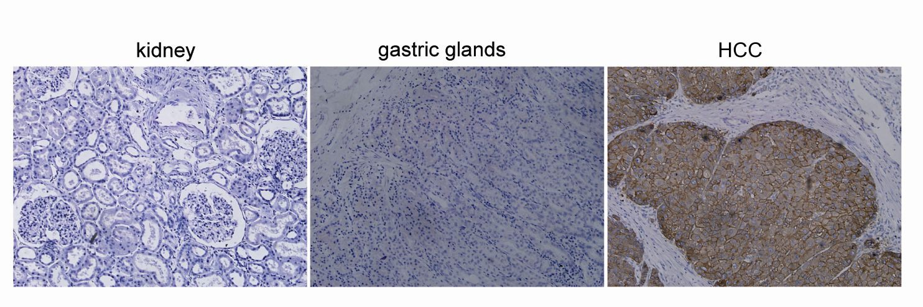

Figure 3. The detection of GPC3 in normal kidney and stomach tissues by immunohistochemistry. Anti-GPC3 antibody (1G12) was used for staining tissue sections from normal kidney (10 cases) and stomach (10 cases). GPC3-positive HCC tissues were used as the positive control (200×).

### The expression of GPC3 in HCC tissues

The expression of GPC3 was tested in 75 HCC tissue samples. The results showed that 54.6% of HCC tissues were highly positive for GPC3 expression with the staining intensities of ++ and +++, and 16.1% of HCC tissues had weak expression of GPC3. High GPC3 expression homogeneity was shown in the tissues with high levels of GPC3 expression, with an average of 88% GPC3-positive cells (Figure 4).

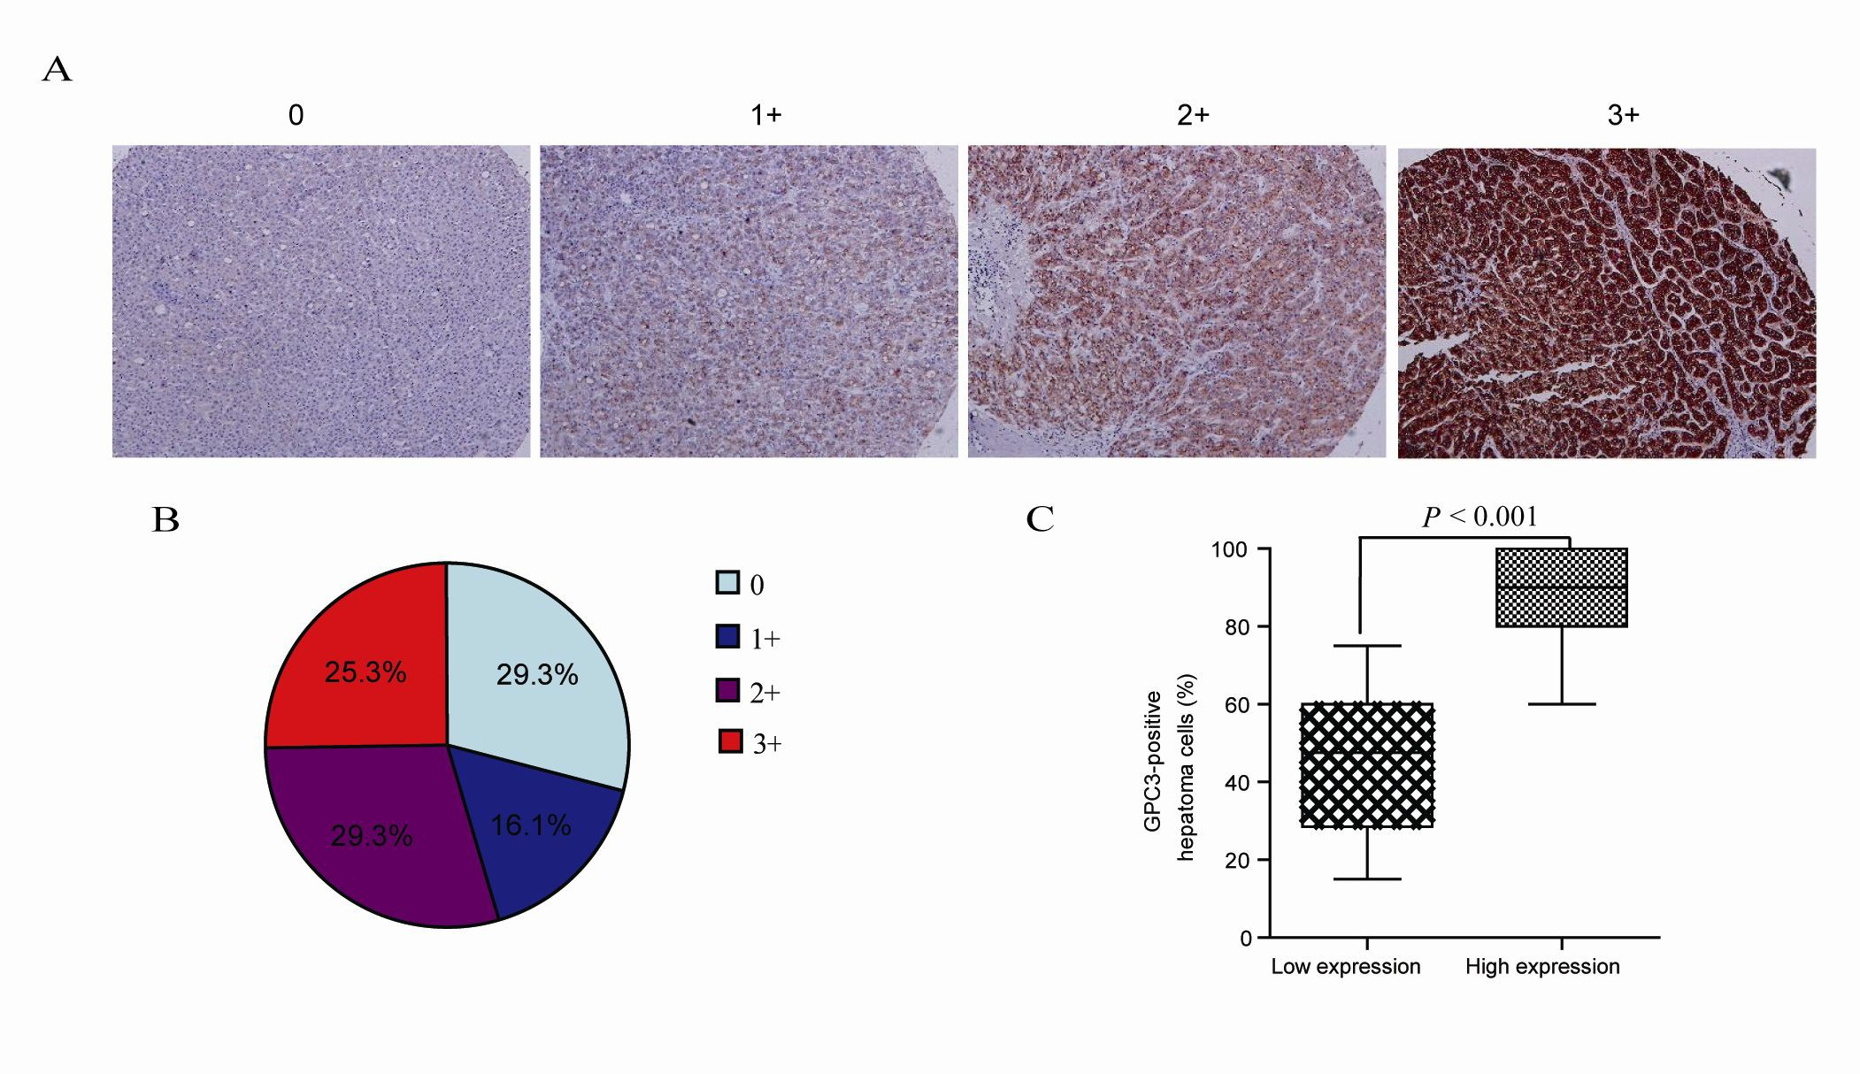

Figure 4. The expression and homogeneity of GPC3 in human primary HCC tissues (n=75). (A) The expression level of GPC3 was evaluated by an experienced pathologist. 0 point means no expression of GPC3; +, ++ and +++ mean weak, medium and strong expression of GPC3, respectively. (B) The proportion of GPC3 expression with different staining intensities; (C) The proportion of GPC3-positive HCC cells (88%) in the strong positive staining group (++ and +++) was significantly higher than that in the low expression group (+) (46%) (P < 0.001).

### Expression of GPC3 in HCC cell lines

The expression of GPC3 in several HCC cell lines was further analyzed, and the results from fluorescence activated cell sorting (FACS) and western blotting were consistent: high expression of GPC3 was detected in Hep3B, Huh-7 and HepG2 cell lines, while low expression was detected in the PLC/PRF/5 cell line. The SK-Hep-1 cell line was negative for GPC3 expression (Figure 5).

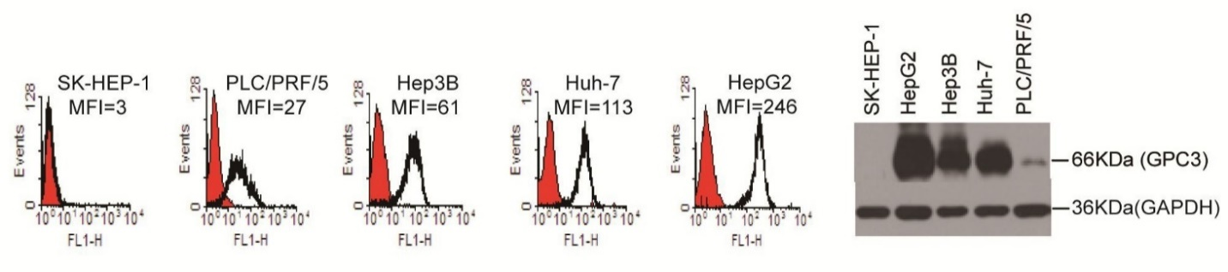

Figure 5. The expression of GPC3 in various hepatocellular carcinoma cell lines, analyzed by FACS (left) and western blot (right).

### In vitro toxicity

The transduction rate in CAR-GPC3 T cells was 60.1% by FACS after T cells were transduced with lentivirus (Figure 6).

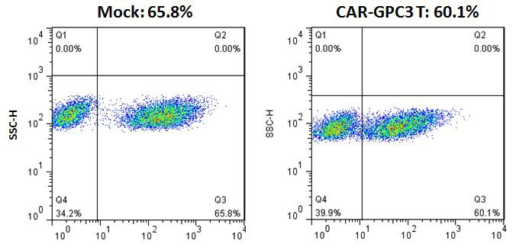

Figure 6. The transduction rate in CAR-GPC3 T cells.

We tested the in vitro killing efficacy of CAR T cells against GPC3-positive HCC cell lines (HepG2, Huh-7, PLC/PRF/5, Hep3B) and the GPC3-negative cell line (SK-HEP-1). We tested the effector to target (E:T) ratios of lymphocytes expressing mock or CAR-GPC3 CAR-T cells to the tumor cells at 1:3, 1:1, and 3:1. After co-culturing for 18 hours, the in vitro killing effect against GPC3 positive cells was strong at the E:T ratio of 3:1, but there was no effect against the GPC3-negative cell line SK-HEP-1 (Figure 7). The data showed CAR-GPC3 T cells can specifically kill GPC3-positive cells, and the killing effect was positively correlated with the E:T ratio.

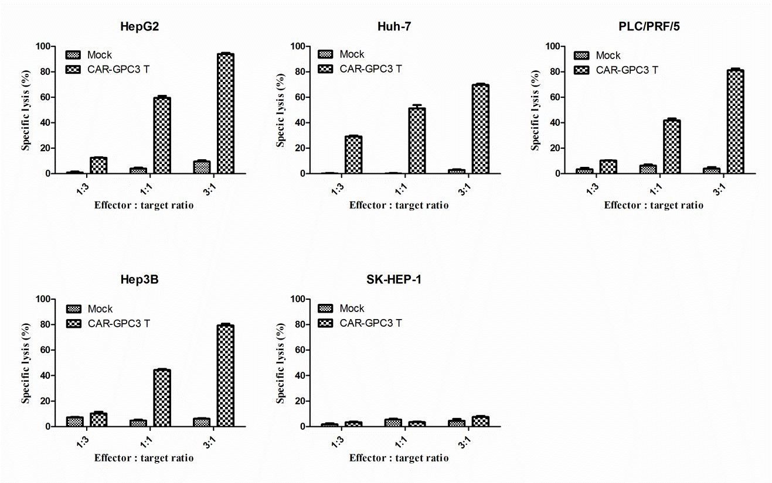

Figure 7. CAR-GPC3 T cells specifically killed GPC3-positive cancer cells.

### Release of cytokines in vitro

Activation of lymphocytes results in production and secretion of cytokines. When GPC3-positive tumor cell lines, HepG2 and Huh-7, and GPC3-negative cell line, SK-HEP-1, were co-cultured with CAR-GPC3 T cells at the E:T ratio of 3:1 for 24 hours, GPC3-positive tumor cells effectively activated CAR-GPC3 T cells. Then we collected supernatant to detect the IL-2, TNF-α and IFN-γ secreted by CAR T cells. The results showed, compared to the mock group, CAR-GPC3 T cells produced higher levels of IL-2, TNF-α, and IFN-γ when stimulated with HepG2 and Huh-7 cell lines. On the contrary, only minimum amounts of IL-2, TNF-α and IFN-γ were detected when co-cultured with GPC3-negative SK-HEP-1 cell line (Figure 8).

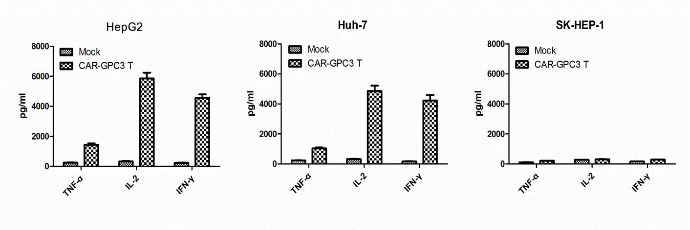

Figure 8. The cytokine release in the co-culture of CAR-GPC3 T cells and tumor cells at the E:T ratio of 3:1 for 24 hours.

### In vivo antitumor activity of CAR-GPC3 T cells against hepatocellular carcinoma

To further test the antitumor activity of CAR-GPC3 T cells, we established a xenograft model by subcutaneously implanting Huh-7 cells in NOD/SCID mice. When the average tumor volume in mice reached 200-300 mm3, 200 mg/kg of cyclophosphamide was injected intraperitoneally to the NOD/SCID mice, in order to mimic the lymphodepletion that occurs before adoptive transfer of T lymphocytes in humans. On the next day, 1×107 CAR-GPC3 T cells were injected through caudal vein and we observed the tumor growth of subcutaneous xenografts, with mock T cells and normal saline as the control groups.

The results demonstrated that CAR-GPC3 T cells significantly suppressed the growth of Huh-7 tumor xenograft, and the tumors shrunk in 3 out of 6 mice, with an inhibition rate of 93.8%. Compared with the mock group, the volumes of residual tumors in mice were significantly smaller (***P < 0.001; Figure 9).

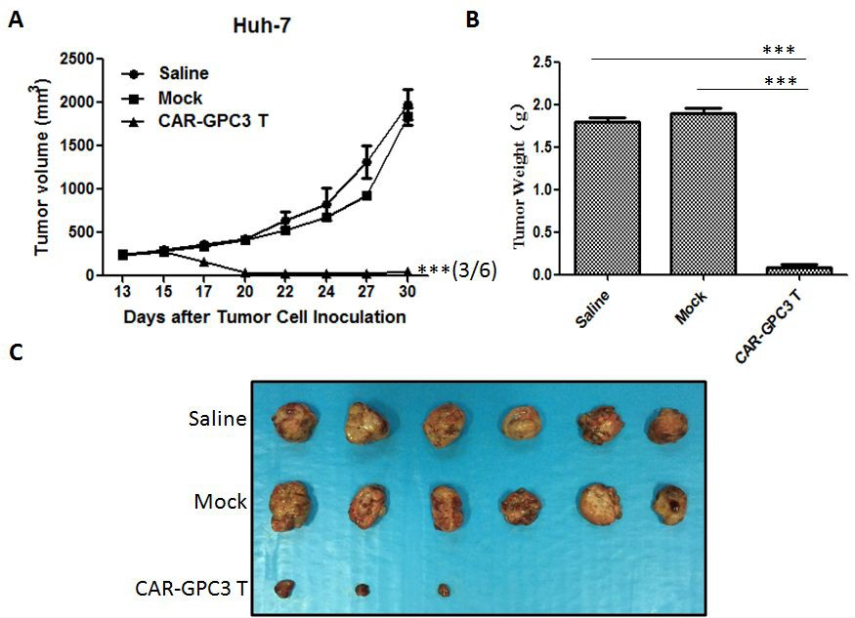

Figure 9. CAR-GPC3 T cells suppressed tumor growth in Huh-7 hepatocellular carcinoma xenografts.

## Current clinical data

Although there are no reported clinical trials targeting GPC3, CAR-T cell therapy has been applied in the clinical trials for the treatment of different cancers, and part of the data is presented below:

Autologous T cells targeting carboxy anhydride IX (CAIX T cells) for the treatment of renal cell carcinoma. Lamers and colleagues recently reported their interim result for treating metastatic renal cell carcinoma by incorporating murine monoclonal antibody (G250) into a retroviral vector. The G250 antibody recognizes an epitope on CAIX that is overexpressed in clear cell carcinoma and expressed on the bile duct epithelial cells [13].

The autologous T cells were transduced with retrovirus vector carrying the G250 transgene, which can be expressed on the surface of these transduced T cells. Intravenous injection of T cells by dose escalation was applied in this clinical study: 2×107 T cells on Day 1; 2×108 T cells on Day 2; 2×109 T cells on Day 3-5 (treatment cycle 1); 2×109 T cells on Day 17-19 (treatment cycle 2); in combination with human IL-2 subcutaneously, at 5×105 IU/m2, twice daily administered at Days 1 to10 and Days 17 to 26. At the beginning, G250 T cells were well tolerated, however, grade 2-4 liver toxicity developed after 4 to 5 infusions according to the National Cancer Institute Common Toxicity Criteria. Therefore, the treatment for Patients 1 and 3 were adjusted; Patient 1 was treated with corticosteroids, and the maximum dose of T cells was decreased for Patients 2 and 3. Between 37 and 100 days after T cell treatment, all 3 patients had low levels of antibody for scFv (G250) and elevated liver enzymes. Between 32 and 53 days after infusion, the G250 T cells were able to be detected in the peripheral blood and their antitumor activity was confirmed. According to the author’s analysis, such liver toxicity is likely attributed to the expression of the target antigen on normal liver tissues. This is one example of “on-target” and “off-tumor” toxicity.

CD8 cells expressing α-CD20-ζ for the treatment of follicular lymphoma. Till et al reported a dose escalation clinical trial of genetically modified CD8 T cells by molecular marker CD20 targeting B cells in combination with CD3ζ activation domain prepared by electrotransfection for the treatment of relapsed follicular lymphoma and mantle cell lymphoma [19]. Seven patients were enrolled in the study, and each received 3 infusions of CD20-specific CAR T cells by dose escalation; 1×108 cells/m2, 1×109 cells/m2 and 3.3×109 cells/m2 were administered at an interval of 2-5 days. The survival of first 3 patients was poor, and the subsequent 4 patients received human IL‑2 subcutaneous injection (5×105 IU/m2), twice daily for 14 days, which improved the T cells’ in vivo persistence. After infusion, the immune response against the infused T cells was not detected by chromium release assay against scFv and the product of neomycin-resistant gene, and there was no anti-CD20 antibody detected via enzyme-linked immunosorbent assay (ELISA). Although the chimeric antigen receptor did not contain murine Fc fragment, two patients presented with human anti-murine antibody (HAMA) positivity between 3-6 months after infusion. The HAMA positivity possibly reflected the immune reconstitution and the response to previous therapy. The clinical response was mild, without grade 4 toxicity. The toxicity was limited to the 4 patients who received IL-2 therapy, attributed to the influenza-like symptoms induced by IL-2.

T cells expressing anti-α-folate receptor-Fcγ for the treatment of ovarian cancer. Kershaw et al evaluated the clinical trial of T cells expressing CAR targeting α-folate receptor and fused Fcγ signal domain for the treatment of 14 subjects [20]. In this trial, the patients were divided into 2 groups, and the first group received three cycles of dose-escalation treatment of T cells in combination with IL-2, with the doses of 3×109, 1×1010 and 3–5×1010 cells. The second group received 1-2 cycles of treatment by using T cells stimulated with allogenic PBMCs and expanded with supplemental IL-2. The dose range was 2–4×109 cells, and 2 out of 6 patients received 2 cycles. The cells were genetically modified by the clinical-grade retroviral vectors that contained neomycin-resistant gene, and the cells were selected by culture in G418 after transduction. In the first group, grade 3-4 side effects occurred because the patients were not given IL-2. There were no serious side effects after the infusion of CAR T cells. The survival of genetically modified T cells was poor, as they persisted for less than 3 weeks. This was possibly due to the production of an inhibitory factor in the serum against the infused T cells. No antitumor effect was detected by imaging and CA125 antigen.

CAR T clinical trials targeting HER2: One patient died in the first study of CAR-T cells targeting HER2 [14]. The death in this first case was probably due to the application of lymphodepletion with large amount of third-generation CAR T cells, which resulted in the damage to the normal HER2-expressing pulmonary tissue and led to respiratory failure. However, in another clinical trial using second-generation CAR T cells targeting HER2 with 17 subjects, none of the subjects experienced serious toxic side effects, and tumor lesion elimination was seen in some subjects [10]. In contrast with the first study, less than 1×108 cells of the second-generation CAR T cells were given to the trial’s 17 subjects, and no lymphodepletion regimen was given. In a recent HER2-targeted treatment for GBM, 5 of 15 patients showed objective response, and tumor shrunk by 62% in one patient, 1 patient achieved stable disease of 4 months, and other 3 patients achieved stable disease who were still alive followed for more than 18 months [11].

In the CAR T clinical trial targeting mesothelin by mRNA transduction, 6 pancreatic patients did not experience serious toxic side effects, and among them 2 patients achieved stable disease and a hepatic metastatic lesion disappeared in one patient [12].

For recent clinical trials of CAR T cells targeting CD19, although there was one fatal case, most trials showed acceptable safety profiles. Although many subjects experienced cytokine release syndrome (CRS), these side effects were resolved after the administration of corticosteroids or the anti-IL-6R antibody, tocilizumab. According to most reports, CAR T cells targeting CD19 were able to achieve very good clinical effects for patients. As shown in Maude et al.'s clinical trial, 30 patients with relapsed ALL were treated with CAR T cells targeting CD19, and 90% of patients achieved complete response, with 67% of patients reaching event-free survival in 6 months [18].

Clinical experience with lentivirus vector. A large amount evidence has showed that the application of retrovirus vectors for expression in human T cells was safe; however, it was not safe for application in human stem cells [21,22]. From the perspective of insertion mutation, lentivirus was safer than retrovirus, with higher efficiency for the genetic modification of human T cells [23-25].

The study of GPC3 as a therapeutic target in the clinic. Ideally, the target antigen should be carefully selected when antibody or CAR-T cells are used for anti-cancer therapy, and the optimal candidates are those only expressed on the surface of malignant cells and not on normal cells. It was reported that GPC3 is highly expressed on 66% of liver cancer cells, but only on a few normal tissues, including gastric gland (3/7 [43%]), kidney tubules (9/17 [53%]) and testis germ cells (2/16 [13%]) [26]. In addition, a current phase I clinical trial of cytotoxic T lymphocytes induced by a GPC3 polypeptide vaccine for the treatment of liver cancer demonstrated overall safety and tolerability [27]. However, it was noted that grade I or II creatinine increases were observed after the application of GPC3 polypeptide vaccine in some patients (it was not known if this was related to the expression of GPC3 on kidney tubules). The liver impairment seen in some patients was possibly attributed to disease progression, not to the vaccination. The side effects during the clinical trial of GPC3 vaccine are shown in Table 2 below:

Table 2. The incidence of adverse events in a GPC3 polypeptide vaccine trial [27]

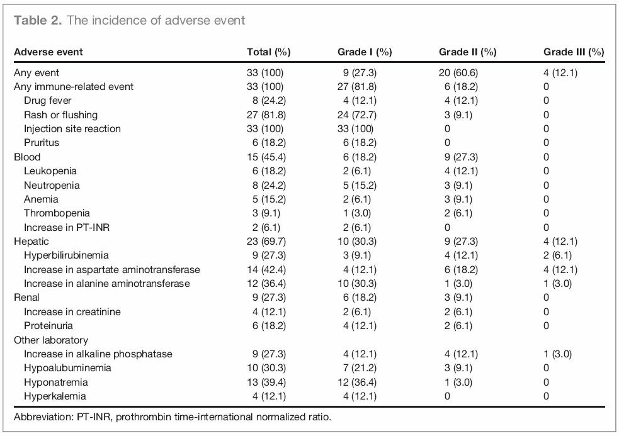

In addition, a phase I trial for the monoclonal antibody targeting GPC3 has been completed, showing all patients could tolerate treatment with anti-GPC3 antibody. Also, the maximum tolerated dose was not reached as the highest dose of 20 mg/kg did not cause dose-limiting toxicities [2].

The adverse events for administration of anti-GPC3 antibody are shown in Table 3 below:

Table 3. The incidence of adverse events in an anti-GPC3 monoclonal antibody trial [2].

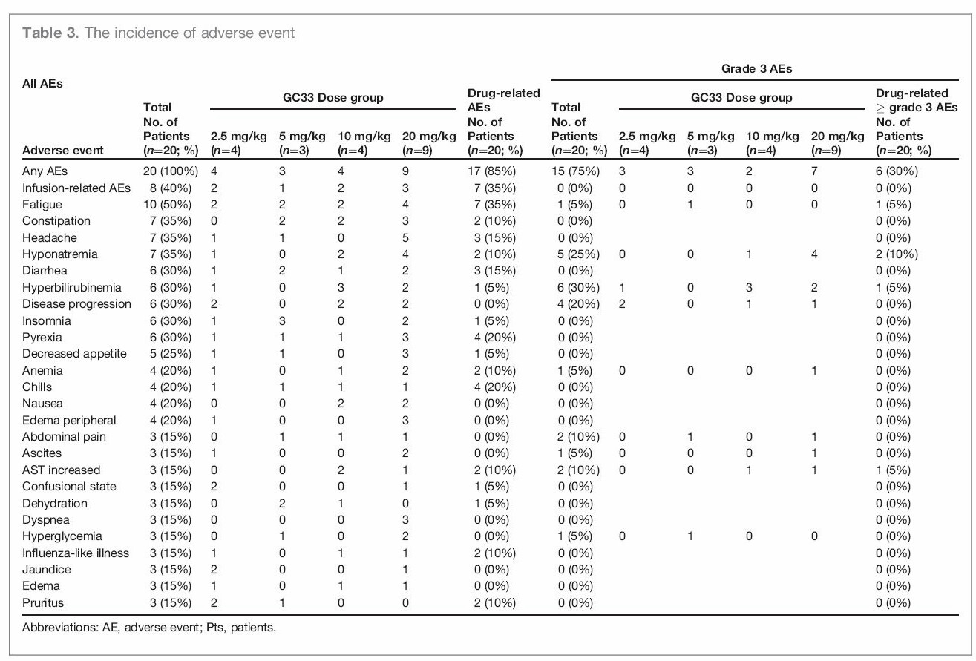

In conclusion, GPC3 is a safe target for immunotherapy, and kidney toxicity should be carefully watched during the study.

## Dose rationale and risk/benefit

The primary objective of this study is to observe the safety and feasibility of administering CAR-GPC3 T cells for the treatment of advanced relapsed hepatocellular carcinoma. The secondary objective of this study is to confirm antitumor activity of CAR-GPC3 T cells.

According to published studies and the preclinical in vivo study, the effective dose was approximately 1×107 CAR T cells in mice, which is equivalent to 1×1010 cells in human patients. Considering safety, the total starting dose will be set as 1×105 CAR T cells/kg body weight, administered intravenously by dose escalation. The next dose and the interval between dosing will be decided based on the subject’s response to the last dose. The dose for the next subject will be decided by the previous subject's response. The maximal permissible dose will be 2×109 CAR T cells/kg body weight if the manufacture allows.

The lymphodepletion regimen will be completed at 1-2 days before T-cell infusion. The lymphodepletion regimen will be decided before CAR-T infusion based on the subject's clinical parameters. Recommended lymphodepletion regimen: fludarabine, 30 mg/m2/day × 4 days; cyclophosphamide, 500 mg/m2/day ×2 days. Fludarabine in combination with cyclophosphamide is given on Day 1 to Day 2, and fludarabine only is given on Day 3 to Day 4. Cyclophosphamide 500 mg/m2/day × 2 days alone can be considered. The detailed regimen and dosage will be adjusted according to the subject’s clinical condition and the physician’s judgment.

**Feasibility analysis**: In this trial, the feasibility of cell manufacture will not be a major obstacle. As shown in Figure 2, we expect that the combination of in vitro cell culture and lentivirus vector technology can generate enough cells for most patients to receive one treatment cycle.

**Risk/benefit:** Subjects in this study will be administered genetically engineered autologous CAR-GPC3 T cells. Based on previous CAR-T clinical studies, although there was one fatal report, most recent clinical trials showed acceptable safety profiles. CRS and related side effects were manageable after the administration of corticosteroids or the anti-IL-6R antibody, tocilizumab. According to most recent studies, CAR-T cells targeting CD19 showed significant clinical benefits to the patients in most of the studies. As shown in Maude et al.'s clinical trial, 30 patients with relapsed ALL were treated with CAR T cells targeting CD19, 90% of patients achieved complete response, with 67% of patients attaining event-free survival in 6 months [18].

# Study objectives

## Primary objective

To observe and identify the safety, tolerability and pharmacokinetics of lentivirus-transduced CAR-GPC3 T cells.

## Secondary objective

To observe the efficacy of CAR-GPC3 T cells in the treatment of hepatocellular carcinoma by the following parameters:

* Time to progression (TTP)
* Disease control rate (DCR) and objective response rate (ORR)
* Symptom resolving rate

# Study design

## Overall design

This is an open-label study to confirm the safety, tolerability and implantation potential of CAR-GPC3 T cells in the treatment of patients with GPC3-positive HCC. The study overview is shown in Figure.1. All subjects will receive the infusion of CAR-GPC3 T cells.

Considering safety, the total dose will be set as 1×105~2 ×109 CAR-T cells/kg body weight, administered by dose escalation. Ten subjects will be treated, and intra-patient dose escalation is allowed. The first subject will start from 1×105 CAR T cells/kg body weight administered intravenously. The next dose and dosing time will be decided based on the previous subject’s response to the assigned dose. Ten additional subjects may receive the cells via hepatic artery injection with the dose and dosing schedule details determined by the investigator, the first subject will start from 2×106 CAR T cells/kg body weight.

Lymphodepletion regimen will be completed at 1-2 days before CAR T cell infusion: fludarabine, 30 mg/m2/day × 4 days; cyclophosphamide, 500 mg/m2/day × 2 days; fludarabine in combination with cyclophosphamide is given on Day 1 to Day 2, and fludarabine only is given on Day 3 to Day 4. The investigator will decide if lymphodepletion is needed according to the clinical condition of the subject.

Autologous PBMCs should be obtained from the patients, which will be transduced with a lentivirus vector expressing CAR-GPC3 transgene and expanded in vitro to produce large numbers of CAR-GPC3 T cells and cryopreserved for intended use. Tumor burden should be re-evaluated after lymphodepletion, and CAR-GPC3 T cells will be thawed at bedside for infusion.

Within 4 weeks after infusion, the safety, implantation and survival of CAR-GPC3 T cells will be evaluated by blood test (See Table 1 for details). At various time points after infusion, T cell subsets including CAR-GPC3 T cells will be examined and compared with baseline sample.

## Safety, feasibility and persistency endpoint

Primary safety, feasibility and persistency endpoints include:

1. Treatment-related adverse event, defined as: NCI CTC Grade >3 symptoms, laboratory toxicities and clinical events possibly related or related to treatment which occur within 24 weeks after cell infusion, including infusion-related toxicities and any CAR-GPC3 T cell related toxicities, including but not related to:

* Fever
* Rash
* Decrease of neutrophil and platelet counts, anemia, aplastic anemia
* Liver dysfunction
* Pulmonary invasive toxicity or other toxicities
* Renal function impairment (including creatinine increase, proteinuria)
* Hyponatremia
* Nausea
* Vomiting

1. The feasibility of lymphocyte isolation for the preparation of CAR-GPC3 T cells. The manufactured products that do not meet the specifications of vector transduction efficiency, T cell purity, viability, sterility and tumor contamination are considered as “production failure.”
2. The persistent survival of CAR-GPC3 T cells in vivo, defined as “implantation.” The first implantation endpoint of the cells is the copy number of CAR-GPC3 detected by q-PCR in the peripheral blood at 4 weeks after first infusion; the same qPCR detection will be conducted at 24 hours, 4 weeks, and 6 months (every 3 months) after infusion, until any two consecutive test results are negative, which will be recorded as the time at which CAR-GPC3 T cells became undetectable.
3. New occurrence of secondary malignant tumors.

## Secondary objectives and endpoints

Secondary endpoints include:

1. Describe the antitumor activity of infused CAR-GPC3 T cells;
   1. For subjects, the classic criteria of partial response (PR) or complete response (CR) or progressive disease (PD) will be defined
2. Describe overall survival and the cause of death
3. For subjects with residual and metastatic tumor cells, to confirm if the in vitro killing effect of CAR-GPC3 T cells is related to clinical response.
4. To confirm if there is cellular and humoral immunity of anti-GPC3 scFv and evaluate its relevance with the loss of detectable CAR-GPC3 T cells.
5. To analyze the CAR-GPC3 DNA copy number in whole blood by qPCR, to confirm the in vivo survival of CAR-GPC3 T cells.

# Subject selection and withdrawal

## Inclusion criteria

Inclusion criteria will include the subjects with GPC3-positive HCC. The patients with GPC3-positive HCC who do not have effective treatment, and have limited survival (survival < 2 years) after current available treatment, both male and female:

1. Patients between 18- and 70- years -old who have refractory HCC that has relapsed at least twice within two years and without effective treatment methods
2. Tumor tissue sample tests positive for GPC3 expression by immunohistochemistry (IHC)
3. Life expectancy > 12 weeks
4. At least one measurable tumor lesion (≥ 10 mm)
5. Liver cirrhosis condition: Child-Pugh A, or B with a score of 7
6. ECOG score is 0-1 or Karnofsky Performance Status (KPS) score >80
7. Have venous accesses for leukapheresis or blood sampling, and have no other contraindications for cell collection;
8. WBC ≥ 2.5×109/L, PLT ≥ 60×109/L, Hb ≥ 9.0g/dL, LY ≥ 0.7×109/L,
9. Serum Alb ≥ 28 g/L
10. Serum lipase and amylase <1.5 ULN
11. Serum creatinine ≤ 2.5 mg/dL
12. ALT and AST ≤5 ULN
13. Serum total bilirubin ≤ 3.0 mg/dL
14. PT:INR＜1.7 or prolonged prothrombin time <4 s than normal.

All laboratory results should be stably within the ranges above without continuous supportive treatments.

## Exclusion criteria

1. Tumor tissue sample tests negative for GPC3 expression by the investigator
2. Positivity of T cells after transduction <10%, or expansion of T cells in response to αCD3/CD28 stimulation <5 fold, which considered product manufacture failure.
3. Pregnant or lactating women. The safety of this treatment in unborn infants is unknown; a female subject’s pregnancy status is evaluated by serum or urine pregnancy test within 48 hours prior to infusion.
4. HIV/AIDS positive
5. Any uncontrollable active infection
6. Current systemic use of steroids. Those who recently used or currently use inhaled steroids are not excluded.
7. Previous treatment with any gene therapy product
8. Allergic to immunotherapy and related drugs
9. Previous or present hepatic encephalopathy
10. The patient has active ascites that requires treatment
11. Active heart diseases requiring treatment or poorly controlled high blood pressure
12. Unstable or active ulcers and gastrointestinal hemorrhage
13. Patient with a history of organ transplantation or waiting for organ transplantation
14. Hyponatremia, with serum sodium <125 mmol/L
15. Baseline serum potassium <3.5 mmol/L (supplement of potassium is allowed, and the patients who recover to above this limit are not excluded)
16. Patient who requires anti-coagulation therapy (e.g. warfarin or heparin)
17. Patient who requires long-term anti-platelet therapy (aspirin with dose > 300 mg/day; clopidogrel with dose > 75 mg/day)
18. Patient who received radiotherapy within 4 weeks prior to the start of study (leukapheresis)

## Subject recruitment and screening

Subject recruitment will be confirmed by the investigators. Enough starting material to manufacture the CAR-GPC3 T cells should be obtained from the subjects. Peripheral blood could be obtained at first screening visit to ensure the quantity and quality of PBMCs.

The purpose of screening is to exclude some subjects who meet our inclusion criteria, but whose T cell proliferation ability is poor after some intervention methods (e.g. chemotherapy), which would result in a failure to produce enough CAR-GPC3 T cells for the infusion. Women of childbearing potential: women who have menstruated within the previous 24 months or have not undergone sterilization procedures [hysterectomy or bilateral oophorectomy] should undergo blood and urine pregnancy test within 48 hours before enrollment.

According the high risk of this study, all subjects should agree to avoid conception activities during the trial (e.g. actively try to become pregnant through unprotected sexual intercourse, intrauterine injection of sperm, or in vitro fertilization). In addition, subjects enrolled in the trial should agree to apply appropriate contraception methods in the remaining study period.

Acceptable birth control includes a combination of two of the following approaches:

* Condom (male or female), with or without spermicide
* The contraceptive diaphragm or cervical cap with spermicide
* Intrauterine device (IUD)
* Hormonal contraceptives

There is no need for contraception for those who have documented lack of fertility (women who have been menopausal for 24 months or have had a hysterectomy, fallopian tube or bilateral oophorectomy, or a man who has been recorded as infertile). Acceptable recording of sterilization, infertility and menopause is as below:

Any of the written documents given by clinical physician or personnel of physician:

* The report or letter from physician
* Surgery record or files of other resources (for laboratory report of infertility, the successful tubal ligation should be recorded)
* Discharge abstract
* The laboratory report of infertility
* Measurement of follicle-stimulating hormone increased to the range for menopause

## Early withdrawal

### When and how to discontinue subjects

The subjects who do not complete the whole study will be considered as early discontinuation. The reason for early discontinuation (such as voluntary withdrawal, toxicity, death) should be recorded. Final evaluation will be completed when the study ends, and the reasons for early discontinuation may include:

1. The death of subject
2. Serious disease condition making the subject unable to continue the study according to the investigator’s judgment
3. Subjects who are enrolled by mistake (do not meet eligibility criteria)
4. Pregnancy
5. Voluntary withdrawal, subjects can withdraw at any time based on their own will
6. Rapid disease progression, which requires chemotherapy, radiotherapy or surgery, including but not limited to central nervous system (CNS) metastasis
7. Occurrence of grade 3-4 toxicities possibly related or probably related to this study, or serious side effects which require the subjects to withdraw
8. GPC3 CAR-T manufacture failure
9. Study terminated by principal investigator, regulators, sponsor, ethical committee or regulatory agency
10. Lost to follow-up

### Data collection for withdrawn subjects

We plan to continue data collection, including (1) whether the existence of infused T cells confers long-term risk to the subject (until no more transduced T cells can be detected); (2) DFS until progressive disease; (3) overall survival before death; (4) until subjects do not agree to accept data collection.

Subjects from other institutes outside of Shanghai Jiao Tong University, according to priority and geography issues are evaluated through local physicians and/or telephone follow-up. One example is a subject transferred from one place to another site for medical care. We will get the evaluation on toxicity and other clinical parameters from the treating physicians to follow-up subjects. To obtain survival data, we should make every effort to contact each lost subject. For the subjects who cannot be followed, the efforts should be made for at least 3 telephone calls (in different days or different day time) and registered mail.

A lost subject will be excluded from DFS evaluation for the following situations: (1) lack of efficacy evidence, disease relapsed or progressed after 6 months of follow-up, or (2) the subject requires new treatment regimen at any time (such as traditional chemotherapy). The death of subject will be excluded from survival evaluation.

# Study drug

## Introduction

CAR-GPC3 T cells are genetically engineered autologous T lymphocytes transduced with the lentiviral vectors expressing CAR-GPC3 transgene.

## Treatment plan

### Preparation

CAR-GPC3 T cells will be prepared in a clinical-grade manufacture facility and will not be released until they meet all release criteria for the infusion including cell viability, cell purity, average copy number/cell, etc. After release, the cells will be transported to the clinical site. The infusion method of the sample is labeled on the bag.

### Pre-infusion medication

The side effects experienced after CAR T infusion include short-term pyrexia, chills and/or nausea. Before the infusion of CAR-GPC3 T cells, subjects are advised to take oral acetaminophen of 650 mg or oral/intravenous diphenhydramine hydrochloride of 25-50 mg as prophylaxis. These drugs can be administered repeatedly every 6 hours as needed.

### Fever

If subjects still experience pyrexia after prophylactic acetaminophen, non-steroid anti-inflammatory drugs may be prescribed. Except in life-threatening emergencies, patients are not recommended to receive systemic steroids such as hydrocortisone, prednisone, prednisolone or dexamethasone at any other time because of their significantly inhibitory effects on T cell proliferation. If a steroid, such as hydrocortisone, is used to treat an acute infusion reaction, the recommended starting dose is 100 mg.

### Contamination

If any contamination is suspected, the samples stored in CVPF will be retested or discarded.

### Administration

CAR T cells are subject to intravenous injection at approximately 5 mL/min through a blood transfusion device in the clinic. Infusion will last for about 10 minutes. One or two bags of CAR-GPC3 T cells will be sent to the bed on ice and administered to the patient under cold condition. Each bag of the cells will be labeled with “only for autologous T cell infusion” and two unique identifiers such as subject initials and study number. Before infusion, two persons should independently verify all information to confirm the CAR T cells are correctly matched with the subject.

During the infusion, emergency medical device will be used for allergic reactions or serious hypertensive crisis or any other infusion-related reactions. Vital signs (body temperature, respiratory frequency, pulse rate and blood pressure) will be monitored every 15 minutes within 1 hour before and after infusion, until the patient becomes stable. Subjects are not allowed to leave, unless clinical physicians consider they are safe to be discharged.

## Subject compliance

This clinical study will be supervised by the Ethics Committee of the study center to guarantee the subjects’ right to know, to ensure the fairness of the screening of participants, and to assess the safety and efficacy of the study drug. The Ethics Committee enhances patient safety by providing guidance and training to investigator and study personnel in the areas of ethics, research integrity, data and security monitoring, side effect reporting, and GCP.

## Pre-treatment and concomitant treatments

At the visits within 30 days before screening, all prescription drugs and over-the-counter (OTC), vitamins, herbals and supplementals given to subjects should be recorded. Follow-up visits within the 24 weeks after the first dose will be documented on the medical record and the CRF. Supplements, discontinuation or changes of any drugs should be recorded.

## Packaging

Each infusion bag contains 10–50 mL of 1×106 to 1×109 CAR-GPC3 T cells. Each bag will contain 0.9% sodium chloride + 50 mg/mL human serum albumin, or equivalent cryopreservation medium, consisting of the following solution (%/v): 31.25 multiple electrolytes injection solution, 31.25 glucose (5%), 0.45 sodium chloride, no more than 7.5% DMSO, 1% dextran 40, 5% human serum albumin.

## Return and destruction of study drug

There are multiple reasons for CAR-GPC3 T cells to return to CVPF, including but not limited to: (1) A product with a wrong label; (2) The patient is under conditions unsuitable for the infusion; (3) The patient refuses the infusion. Any unused CAR-GPC3 T cells will be returned to CARsgen Therapeutics and destroyed.

# Study procedure

**Overview**

Study procedure includes: (1) Screening; (2) Intervention/treatment, including leukapheresis, chemotherapy and infusion of CAR-GPC3 T cells; (3) Follow-up. The schedule of events for evaluation and infusion is shown in Table 1.

## Pre-treatment evaluation

Before any study-specific activities or procedures, the appropriate written informed consent form (ICF) must be signed. All subjects shall meet all eligibility criteria. After signing the ICF and completion of HIV detection, blood samples will be sent to CVPF to confirm the feasibility of T cell production. Around 1 week later, CVPF will give the feedback if subject has sufficient PBMCs to be used for the large-scale preparation of CAR-GPC3 T cells.

## Enrollment and baseline measurement

The following documents will be provided for the enrolled subjects in this study:

* Complete screening documents (include previous medical history, laboratory examinations, radiology report, ICF, physical examinations, concomitant medications and other supportive files for subjects meet eligibility criteria)
* Signed ICF

After signing the informed consent form and the availability of enough preliminary evaluation results, the patients will receive routine assessment of hepatocellular carcinoma stage, including:

1. Medical history (including previous antineoplastic treatment, and current medications)
2. Physical examination
3. Vital signs, including heart rate, blood pressure and body temperature
4. Body measurement, including height and weight
5. Examine the medications taken by the subjects and the adverse reactions that occurred
6. Electrocardiogram
7. Assessment of hepatocellular carcinoma tumor by CT or PET-CT or MRI. Evaluation is performed according to RECIST
8. Blood sample collection:
9. Blood samples before screening and enrollment (8-10 mL of peripheral blood)
10. Routine blood test and peripheral blood classification
11. Biochemistry: liver function, renal function, amylase, lipase, electrolytes
12. Coagulation
13. Detection of HIV infection (AIDS), hepatitis B and hepatitis C, syphilis and other infectious diseases
14. Pregnancy test (for women of childbearing potential)

## Leukapheresis

Leukapheresis will be conducted according to standard operation procedure at the study site. At least 1 ×109 cells need to be collected via leukapheresis. After leukapheresis, the blood sample will be transported to the laboratory of CARsgen Therapeutics under 2~8℃, and PBMCs must be isolated by Ficoll for the manufacture of CAR-GPC3 T cells. Extra PBMCs will be cryopreserved for the need of retrospective analysis and inspection required by the China Food and Drug Administration (CFDA).

## Lymphodepletion prior to CAR-T infusion

In order to improve the survival, stability, and antitumor effects of the autologous transfused CAR-GPC3 T cells in patients, the lymphodepletion regimen is applied before infusion. Lymphodepletion will be completed at 1-2 days before CAR-GPC3 T cell infusion, and the regimen is initially designed as follows:

Cyclophosphamide (Cy) with or without fludarabine (Flu): cyclophosphamide 500 mg/m2/day ×2 days, fludarabine 30 mg/m2/day ×4 days. For the combination of Cy / Flu, the subject will receive Flu infusion for 4 days and Cy infusion on the first and second day of lymphodepletion.

Calculate the subject’s body surface area according to Stevenson’s formula: body surface area (m2) = 0.0061 × height (cm) + 0.0128 × weight (kg) - 0.1529

The individual chemotherapy regimen will be considered by the physician according to the subject's pre-existing diseases and previous treatment. Before and after lymphodepletion, the physician is advised to closely monitor the routine blood tests (closely observe the change of white blood cells and lymphocytes after lymphodepletion), serum biochemistry parameters and urinalysis; in case of oliguria, please implement the annotated hydration and alkalization regimen, and make the notes.

Both clinicians and subjects are advised to wear protective equipment, such as wearing masks, reducing the personnel contact with the subjects, to reduce the chance of opportunistic infections. The infusion of CAR T cells can be conducted 1 to 2 days after the subject completes the lymphodepletion.

## Disease staging re-evaluation

Staging re-evaluation should be performed after chemotherapy in order to provide baseline for tumor burden measurement, including imaging by radiologist, physical examinations, and measurable residual disease evaluation. Before infusion, subjects should be tested: physical examination, adverse event recording, hematology, biochemistry, and pregnancy tests (if applicable).

## Post-infusion laboratory examination for the evaluation of cell implantation and persistence

At various time points after the first infusion of CAR-GPC3 T cells, subjects should be hospitalized, and peripheral blood should be tested for cytokine levels and the persistence of CAR-GPC3 T cell in vivo by qPCR.

During the following 2 weeks, subjects should come back every week for these examinations: physical examination, adverse event recording, hematology, biochemistry, persistence of CAR-GPC3 T cells and other laboratory examinations.

## Tumor response evaluation

Within 2 years after CAR-GPC3 T cell infusion or until other therapies are needed for the subject, the subject should receive tumor response assessment every 3 months according to standard care. Tumor assessment is based on the following items:

|  |  |  |  |
| --- | --- | --- | --- |
| **Disease** | **Routine examinations** | **(Enhanced) CT or MRI scanning** | **Tumor biopsy**  **(as appropriate)** |
| HCC | + | +/– | GPC3 +/-  CAR T cells +/- |

# Statistical analysis plan

## Study endpoint

### Primary endpoint

1. Any adverse events “possibly related,” “probably related,” or “definitely related” to study treatment which occur from the first day of study treatment to Week 24 (defined as Grade ≥3 symptoms/signs, laboratory toxicities and clinical events).
2. The feasibility of preparation of CAR-GPC3 T cells from peripheral blood. The number of prepared products which do not meet the specifications of transduction efficiency, T cell purity, viability, sterility and tumor contamination (defined as “production failure”).
3. The persistent survival of CAR-GPC3 T cells in vivo, defined as “implantation.” At 24 hours after infusion, CAR-GPC3 vector sequence will be detected by PCR and repeated 4 times every week, 6 times every month, until the results of any two consecutive tests are negative, which will be recorded as the disappearance of CAR-GPC3 T cells.
4. New occurrence of malignant tumors.

### Secondary endpoints

1. Describe the antitumor activity of infused CAR-GPC3 T cells. For subjects with active disease, the classic criteria of partial response (PR) or complete response (CR) will be defined. If only a few subjects receive treatments, the confirmation of antitumor response can only be “descriptive.”
   1. For subjects in remission, describe progression-free survival (PFS).
2. Describe overall survival and the cause of death.
3. Evaluate the formation of immunity to anti-GPC3 antibody and its relevance with the disappearance of CAR-GPC3 T cells (the disappearance of implantation).
4. Monitor the in vivo survival and proliferation of CAR-GPC3 T cells, and the infiltration of CAR-GPC3 T cells in tumor tissues if applicable.

## Sample size

The sample size of this study is up to 20 subjects.

## Safety

The incidence of toxicity can be estimated preliminarily for the evaluation of confidential interval (CI); the 95% CI for the incidence of toxicity of 10 subjects is listed in the table below. For example, if there are 10 evaluable subjects, the actual toxicity rate is 20%, and the probability that no adverse events are observed is 11%. When the actual toxicity rate is 30%, the probability that no adverse events are observed decreases to 3%.

|  |  |
| --- | --- |
| **Observed toxicity ratio for evaluable subjects (N=10)** | **95% CI** |
| 0% (0/10) | (0%, 31%) |
| 10% (1/10) | (0%, 45%) |
| 20% (2/10) | (3%, 56%) |
| 30% (3/10) | (7%, 65%) |

## Efficacy

Antitumor activity is the secondary endpoint. In subsequent studies, the antitumor efficacy of CAR-GPC3 T cells will be evaluated.

## Study population for analysis

The study population analyzed for the primary and secondary endpoints includes all subjects who received CAR-GPC3 T cells. Secondary study population will include all enrolled subjects who did not receive CAR-GPC3 T cells.

The reason why subjects do not receive infusion may include: (1) the transduction efficiency of autologous T cells is not satisfactory; (2) rapid disease deterioration during enrollment and infusion, and/or death; (3) subject withdrawal.

The enrolled subject number and infused subject number will be described, to evaluate the feasibility of this method in the treatment of various malignant tumors.

## Statistical analysis

All adverse events shall be recorded, and the 95% CI of overall incidence and incidence in major categories of adverse events will be calculated. Wilcoxon signed-rank test will be applied for comparison of paired data, to calculate the change of CAR-GPC3 T cells over time. Compared with *t*-test, this test will be a very effective nonparametric test (>95%) if the data are shown as a normal distribution. Other secondary endpoint analyses, such as the analysis of antitumor activity, will also be preliminarily described, probably including the pooled statistical data, such as mean and standard deviation or Kaplan-Meier survival curve.

# Safety and adverse events

During each visit for each subject, treatment emergent adverse events (TEAEs) will be monitored and recorded by Common Toxicity Criteria version 3.0. Possible treatment emergent adverse events will be detected by the monitoring of medical history, physical condition, and lab tests.

## Safety definitions

**Adverse event (AE)** refers to the deterioration of any clinical signs or symptoms during the study. Progression of cancer disease is not adverse event. Abnormal lab results during the study are considered adverse events, if:

* Accompanied by serious adverse event
* Accompanied by clinical sign or symptoms
* Leading to additional therapy or diagnosis test
* Investigator considers as clinical significance

**Serious adverse event (SAE).** Serious adverse event meets the conditions below:

1. Death
2. Life-threatening
3. Requires or prolongs hospitalization
4. Results in persistent disability/incapacity
5. Is a congenital anomaly/birth defect
6. Other important medical events

**Important medical events** may not be immediately life-threatening to the subject, but clinically significant. They may jeopardize the patient or may require medical or surgical intervention to prevent one of the other outcomes listed in the above definition. These events include intensive treatment in an emergency room for allergic bronchospasm or developed drug dependency or drug abuse.

All adverse events that do not meet any criteria for seriousness should be considered as **non-serious adverse events**.

**Dose-limiting toxicity (DLT).** DLT is defined as Grade 3 or 4 toxicity that does not recover on time after the treatment. In addition, the autoimmune toxicity or allergy of Grade 2 occurring after repetitive treatment is considered as DLT.

**The reporting period of adverse events.** The AE reporting period is defined as the duration from the start of the study to the end of follow-up, and any AEs occurring during this period should be reported. In this study, the follow-up of study treatment is defined as 2 years after the last administration of study treatment.

**Pre-existing disease.** The diseases that already exist at the beginning of the study are defined as pre-existing disease. If the frequency, severity or symptoms of the disease deteriorates during the study, the existent disease should be recorded as an adverse event.

**General physical examination result.** At screening, any clinically significant abnormality should be recorded as existent disease. When the study completes, any new clinically significant result that meets the criteria of the adverse event should be recorded as an adverse event.

**Adverse events after study completes.** The investigator should follow all adverse events until the events are resolved; if the subject is lost to follow-up, the adverse event should be explained since the event cannot be resolved.

During the last scheduled visit, the investigator should advise every subject to report any subsequent clinical signs and symptoms, regardless of whether the subject or subject’s physician considers them possibly related to the participation in this study. After the subject withdraws from the study or the study completes, if any time a death related adverse event in the study occurs, the investigator should inform the study applicants about this information. If the investigator believes the participation in the study leads to cancer or malformation, he/she should inform the study applicant.

**Hospitalization or prolonged hospitalization.** Any adverse events leading to hospitalization or prolonged hospitalization should be recorded as serious adverse events.

Hospitalization or prolonged hospitalization are not reported as adverse events under the following situations:

1. The diagnosis of pre-existing disease or selective surgical operation leads to hospitalization or prolonged hospitalization.
2. Requires hospitalization or prolonged hospitalization to check treatment effects.
3. The purpose of hospitalization or prolonged hospitalization is to treat residual target disease unless the investigator judges it as disease deterioration or increase of hospitalization frequency.

## Recording of AEs

At every contact with the subject, the investigator should collect information of adverse events through specific questions and adequate examinations. All adverse events should be recorded in the source file and case report form (CRF) module immediately. Efforts shall be made to record individual clinical signs, symptoms and abnormal lab results under one diagnosis.

All adverse events during the study should be recorded. The clinical course of every event should be followed until the event is resolved, when the situation becomes stable, or it is confirmed as not caused by study therapy.

## Reporting of SAEs and unexpected issues

The investigator and study sponsor should report SAEs immediately, and the report should at least include the information below:

* Causality to the study product;
* Expected and unexpected;
* Unexpected risk for the subject and others.

(Definitions are described in Section 8.1)

### Reporting of SAEs to study sponsor

Any SAE should be reported to study sponsor within 24 hours from the start of event. When reporting such events, the investigator should complete the serious adverse event (SAE) form, which will be faxed to the study sponsor within 24 hours. At the study site, the investigator will keep one copy of the SAE form.

When the event is first reported, the information below should be provided:

* Study identification number
* Whether the study treatment is discontinued
* Subject number
* The criteria for seriousness
* Description of event
* Onset of event
* Investigator’s assessment on the causality
* Current situation and outcomes

The investigator should provide further information about the events in written form within 48 hours. A copy of the completed SAE form and any other helpful information about diagnosis should be included.

Important new information related to an ongoing SAE should be provided in timely follow-up reports.

### Reporting of SAEs to site IEC

The study site IEC requires that study personnel provide the following report within 10 days of knowing the event:

* **Death report:** If death occurs during the study, it should be reported more rapidly according to the IEC of study site;
* While the unexpected death puts the subject and others into high risk, it should be reported within 24 hours.
* Other fatal events should be reported within 72 hours, regardless of the causality to study participation. The fatal events should be reported to the IEC of study site through the chairman or vice-chairman of IEC.

After the initial death report, the detailed follow-up report form should be submitted.

**Other adverse events and issues that shall be reported:** For clinical trials, the following events can also be reported to the IEC of study site.

1. Any unexpected SAE that seldom occurs without drug exposure and has not been analyzed in detail (e.g. agranulocytosis, hepatonecrosis, Stevens-Johnson syndrome).
2. Any AE that may result in the modification of investigator's brochure, study protocol or ICF to inform the study subject and study team.
3. Information indicating the change of risk or the severity or frequency of potential benefits, such as:
   1. According to the interim analysis, the rate of response to treatment is lower than expected.
   2. According to safety monitoring, one specific AE is more serious or more frequent than expected.
   3. According to the publication of other groups, the study treatment has no potential therapeutic benefit.
4. Violation of privacy policy
5. The change of study protocol without IEC’s approval, which may place the conduct of the study at immediate risk.
6. Other major protocol deviations.

Simultaneously, the SAE report should be submitted to the sponsor within 24 hours of learning of the event, in addition to the CFDA and the IEC of the study site. Fax for SAE receiving: 021-54489926-802, email address: safety@carsgen.com.

## Patient termination and study discontinuation

The early termination of the clinical trial may be attributed to the decision of the regulatory authority, requests from IEC, or safety concerns regarding the GPC3 CAR-T cell product.

### Criteria for termination or temporary interruption of study

This study may be terminated due to the following situations:

* Any subject experiences uncontrolled T cell proliferation.
* The study can be early discontinued due to significant safety concerns in study subjects.
* The study can be terminated if the study sponsor decides to stop the study.
* Patient death

### Risk management

During the manufacture of CAR-GPC3 T cells or after the product is infused to the patient, the lentivirus has potential reproducibility. However, replication-competent lentivirus (RCL) is unlikely to be produced during the manufacturing, since the genetically modified vector system has minimized the ability of vector recombination to produce RCL. RCL will be tested before the release of the product for infusion. However, in theory, RCL reproduction is still possible after CAR-T-cell infusion. Although there is no known recombination occurring in subjects who received lentiviral transduced T cells, such event could be possible. Therefore, the exclusion of HIV-infected subjects from this study will decrease this possibility to the largest extent. In addition, developed RCL is highly infectious to the subjects and their close contacts; therefore, RCL should be monitored during the trial.

The investigator should have a treatment plan if RCL is confirmed. Nonetheless, the probability and characteristics of RCL remain unknown, and there is no suitable guideline for reference at present.

HIV gag DNA: Positive results of HIV DNA examination should be reported to the investigator, and the subject should be repeatedly tested for HIV DNA. If the result of repeated test is still positive, the infusion will be temporarily interrupted. The subject will be tested to isolate HIV in the cells. The virus will be sequenced and the sequences of its transfection vector, packaging structure and obtained HIV should be compared to identify the virus source. Through the evaluation of the HIV additive genes in packaging structure, such as vif, vpr and vpu, the source of HIV can be easily determined. If the sequence is from wt-HIV, all the subjects can continue to receive an infusion, and the subject will receive anti-HIV therapy. If the virus cannot be isolated from the blood and the virus was suspected to be delivered from the infused vectors, the subjects will be arranged for plasma replacement therapy and comprehensive RCL testing.

Cloning and insertion carcinogenesis: Three patients experienced AEs due to the insertion of mutant genes after the gene therapy for X-linked SCID, therefore, such a problem may happen while this technology is applied clinically. Up to now, the mutation of clinically inserted genes due to the application of engineered T cells has not occurred. Due to various reasons, the risk of carcinogenesis caused by the lentiviral vector is lower than that from the retrovirus. T cells are analyzed by flow cytometry, and T cell cloning reproduction is monitored by complete blood count (CBC) testing. If the number of chimeric immune receptor T cells continuously increases after 6 weeks, Vβ analysis will be performed to evaluate cloning; if abnormal T cell number is found by CBC analysis, Vβ analysis should be performed earlier. If the component of Vβ family is monoclonal or oligoclonal, the insertion type of vector in T cells will be evaluated. If the insertion type is convenient for the formation of point insertion, the clinical trial will be temporarily discontinued and acceptable dose re-evaluated. The persistence of a clone in the subject will be further evaluated within 3 months, and the subject will be monitored for malignant hematological disease. Insertion site sequencing shall be tested to confirm if there is a correlation between insertion site and cancer.

Uncontrolled T cell proliferation. The proliferation of CAR-GPC3 T cells is not controlled by the normal homeostasis mechanism. In the preclinical study, CAR-GPC3 T cells could only proliferate in response to a physiological signal or exposure to GPC3 antigen. In this protocol, T cells may proliferate due to the signal of malignant tumor cells or normal B cells. Whether it is favorable depends on the extent of proliferation. The adoptive transfer of T cell clone zone is related to tumor reduction during adoptive transfer test. If any subject experiences over-expansion of CAR-GPC3 T cells and caused the unwanted result, glucocorticoids will be given to reduce the infused cells. Autologous T cell infusion-related toxicity can be managed through the administration of immunosuppressants. Systemic toxicity is related to the individual response to glucocorticoids. In case of uncontrolled T cell proliferation and Grade 3 or 4 CAR-GPC3 T cell-related toxicity, the subjects will receive treatment with steroids, and the treatment plan will be managed by the investigator according to the medical practice.

### Criteria for study discontinuation

* If the subject enrolls in the study but is excluded from CAR-GPC3 T cell treatment before infusion, the subject will be off the study. This will be judged by the investigators, due to the reasons such as the necessity of administration of systemic immunosuppressors for disease intervention.
* Other situations for early discontinuation are described in Section 4.4.1.

## Protocol deviation

Any significant protocol deviation listed below should be reported to the sponsor:

* Violation of patient eligibility.
* Dose modification.
* Subject early discontinuation.

All significant protocol deviations should be reviewed and signed by the principal investigator (or co-investigator) and submitted to IEC of the study site.

## Medical Monitoring

It is the principal investigator’s responsibility to monitor the safety at his/her site. Safety monitoring will include the serious evaluation of the above-mentioned AEs and the preparation/supplement of site data and safety monitoring plan (See Section 10 “ Monitoring, Audit and Inspection”). Medical monitoring will include periodic evaluation of the number and type of SAEs.

### Independent Data and Safety Monitoring Committee

The data and safety monitoring committee (DSMB) consists of 4 members, including the physician with experience in oncology and/or gene transfer, who will conduct safety monitoring on this study.

DSMB will provide suggestions to the investigators and may consult with study applicants as needed. DSMB will evaluate subject safety based on data safety and monitoring plan.

If necessary, a DSMB meeting will be held for safety issues as an unscheduled meeting.

### Clinical monitor

The clinical monitor should routinely monitor the study center and regularly review all CRFs and source documents for each subject during and after the study. During the monitoring of the study center, the monitor should determine that the study-related files are appropriately documented, provide training and GCP guidance for the investigators and other staff in the study, and determine that there are appropriate facilities and adequate professional staff.

During the study, the monitor will conduct central visits to check compliance with the protocol, CRF entry, subjects’ disease history, drug counts, and to confirm that the study is carried out in accordance with the relevant regulatory requirements. The CRF entries will be checked against the original data. The medical history check will be carried out in such a way that protects the subject’s privacy.

Regular monitoring during the study process provides an opportunity for the investigator to assess the progress and understand potential problems in the study. The monitor should ensure that the data submitted are accurate and in accordance with the source documents; review the study products and properly preserve them; obtain the informed consent form signed by the subjects correctly and archive them; confirm that the subjects enrolled in the study meet the criteria for inclusion and exclusion of the study, and determine and preserve all the necessary documents according to GCP requirements.

The integrity and clarity of CRF entry should be checked and compared with the original data to monitor the study process. Furthermore, regulatory authorities, IEC / IRB and/or the sponsor’s clinical quality assurance department may check the original data and/or go to the center for on-site audit or inspection. During the audit or inspection, original data will be directly accessed; parties with direct access should ensure the data and medical confidentiality

# Data processing and record archiving

## Confidentiality

The information about study subject will be confidential, and the information below will not be disclosed without the subject’s consent:

* Which of the subject’s health information will be collected during the study
* Who has the right to obtain this information and for what reasons
* Who will use or disclose this information

## Source documents

Source data refer to the original medical records with all patient information, clinical findings and observations, and other necessary clinical evaluations. Original documents and record include hospitalization records, clinical and office tables, laboratory notes, memorandum, subject diary or evaluation list, dispensing record, data recorded by automated machines, copies or recordings which are validated accurate and complete, microfiche, negatives, film or discs, X-rays, subject files, records of pharmacy and clinical laboratory.

## Case report form

The case report form (CRF) is a major data collection method during the study. All data required by the CRF should be recorded. All missing data should be explained. If some parts of CRF are left blank since some procedures are not conducted or some issues are not consulted, fill with “N/D”. If one item does not apply to the subject, fill with “N/A”. All writings should be in clear black ink. For any mistakes when filling, cross with one line and write correct data in the field above. All record changes should be signed with a date. Do not erase the mistaken records. For all illegible or uncertain writings, print with clear items, and sign with a date.

## Record archiving

The investigator should keep the clinical study materials until 2 years after the application for marketing is approved, or until 2 years after the termination of the development of study product.

The investigator should keep the file for a longer time per request by the study applicant. When these documents are no longer needed, the study applicant has the responsibility to inform the investigator.

## Early termination

If the investigator, the sponsor, or medical inspector is aware that certain conditions or events may endanger the subject if he/she continues to carry out the study, the study may be terminated. Even without the above findings, the sponsor can decide to terminate the study ahead of schedule.

Early termination of the study can be done for the reasons including, but not limited to:

* Unexpected, significant or unacceptable risks for enrolled subjects
* Slow enrollment
* The sponsor decides to suspend or stop the development of drugs

# Study monitoring, audit, and inspection

## Study monitoring plan

The study will be monitored according to the clinical monitoring plan. The investigator should arrange enough time to cooperate with monitoring activities. The investigator should also ensure that the monitor or other quality assurance reviewer will have access to all relevant study documents and study-related facilities (such as pharmacies, diagnostic laboratories, etc.) and have sufficient space for field monitoring.

## Audit and inspection

The investigator should allow the study-related ethics committee, sponsor, government regulatory agencies and quality assurance team to monitor, review and examine all study-related documents (such as source documents, regulatory documents, data collection tools, research data, etc.). The investigator should ensure the ability of study-related facilities, such as pharmacies, diagnostic laboratories, etc. Participants in the study should accept the examinations by government regulatory agencies and relevant quality assurance offices.

# Ethics

This study protocol and protocol amendments will be submitted to the appropriate independent institutional review board (ethics committee) in compliance with the law for official approval. The ethics committee’s decision on the study will be notified in writing to the investigator and a copy will be provided to the sponsor before the study begins. The investigator should provide the sponsor with a list of the members of the ethics committee and their work units.

The informed consent form (ICF) will be provided to all subjects to describe this study with detailed information for their written decisions. This ICF will be submitted to the IEC along with the protocol for review and approval. The approved ICF by ethics committee should be obtained before the subject enters any study procedure. This ICF should be signed both by the subject and investigator’s representative.

# Conflict of interest

Any investigator who has a conflict of interest with the study (patent, franchise, or financial income over permitted) should be reviewed by the conflict of interest committee and recognized management plan before he/she is approved to participate in this study. The study site and investigator will follow the regulations about the conflict of interest of the university.

# Publication plan

The trial results will be released according to the requirements of the study site. Without the consent of the applicant, no complete or partial results of the study or information provided by any applicant should be published or disclosed to any third party concerning the trial protocol. Any investigator involved in the study is obliged to provide the applicant with complete trial results and data.

# References

1. Filmus J, Selleck SB. Glypicans: proteoglycans with a surprise. *J Clin Invest.* 2001;108(4):497-501.

2. Zhu AX, Gold PJ, El-Khoueiry AB, et al. First-in-man phase I study of GC33, a novel recombinant humanized antibody against glypican-3, in patients with advanced hepatocellular carcinoma. *Clin Cancer Res.* 2013;19(4):920-928.

3. Savoldo B, Ramos CA, Liu E, et al. CD28 costimulation improves expansion and persistence of chimeric antigen receptor-modified T cells in lymphoma patients. *J Clin Invest.* 2011;121(5):1822-1826.

4. Carpenito C, Milone MC, Hassan R, et al. Control of large, established tumor xenografts with genetically retargeted human T cells containing CD28 and CD137 domains. *Proc Natl Acad Sci U S A.* 2009;106(9):3360-3365.

5. Kershaw MH, Westwood JA, Darcy PK. Gene-engineered T cells for cancer therapy. *Nat Rev Cancer.* 2013;13(8):525-541.

6. Louis CU, Savoldo B, Dotti G, et al. Antitumor activity and long-term fate of chimeric antigen receptor-positive T cells in patients with neuroblastoma. *Blood.* 2011;118(23):6050-6056.

7. Lee DW, Kochenderfer JN, Stetler-Stevenson M, et al. T cells expressing CD19 chimeric antigen receptors for acute lymphoblastic leukaemia in children and young adults: a phase 1 dose-escalation trial. *Lancet.* 2015;385(9967):517-528.

8. Grupp SA, Kalos M, Barrett D, et al. Chimeric antigen receptor-modified T cells for acute lymphoid leukemia. *N Engl J Med.* 2013;368(16):1509-1518.

9. Porter DL, Levine BL, Kalos M, Bagg A, June CH. Chimeric antigen receptor-modified T cells in chronic lymphoid leukemia. *N Engl J Med.* 2011;365(8):725-733.

10. Ahmed N, Brawley VS, Hegde M, et al. Human Epidermal Growth Factor Receptor 2 (HER2) -Specific Chimeric Antigen Receptor-Modified T Cells for the Immunotherapy of HER2-Positive Sarcoma. *J Clin Oncol.* 2015;33(15):1688-1696.

11. Ahmed NM, Brawley VS, Diouf O, et al. Autologous HER2 CMV bispecific CAR T cells for progressive glioblastoma: Results from a phase I clinical trial. *J Clin Oncol.* 2015;33(15_suppl):3008-3008.

12. Beatty GL, O'Hara MH, Nelson AM, et al. Safety and antitumor activity of chimeric antigen receptor modified T cells in patients with chemotherapy refractory metastatic pancreatic cancer. *J Clin Oncol.* 2015;33(15_suppl):3007-3007.

13. Lamers CH, Sleijfer S, Vulto AG, et al. Treatment of metastatic renal cell carcinoma with autologous T-lymphocytes genetically retargeted against carbonic anhydrase IX: first clinical experience. *J Clin Oncol.* 2006;24(13):e20-22.

14. Morgan RA, Yang JC, Kitano M, Dudley ME, Laurencot CM, Rosenberg SA. Case report of a serious adverse event following the administration of T cells transduced with a chimeric antigen receptor recognizing ERBB2. *Mol Ther.* 2010;18(4):843-851.

15. Klebanoff CA, Khong HT, Antony PA, Palmer DC, Restifo NP. Sinks, suppressors and antigen presenters: how lymphodepletion enhances T cell-mediated tumor immunotherapy. *Trends Immunol.* 2005;26(2):111-117.

16. Laport GG, Levine BL, Stadtmauer EA, et al. Adoptive transfer of costimulated T cells induces lymphocytosis in patients with relapsed/refractory non-Hodgkin lymphoma following CD34+-selected hematopoietic cell transplantation. *Blood.* 2003;102(6):2004-2013.

17. Rapoport AP, Stadtmauer EA, Aqui N, et al. Restoration of immunity in lymphopenic individuals with cancer by vaccination and adoptive T-cell transfer. *Nat Med.* 2005;11(11):1230-1237.

18. Maude SL, Frey N, Shaw PA, et al. Chimeric antigen receptor T cells for sustained remissions in leukemia. *N Engl J Med.* 2014;371(16):1507-1517.

19. Till BG, Jensen MC, Wang J, et al. Adoptive immunotherapy for indolent non-Hodgkin lymphoma and mantle cell lymphoma using genetically modified autologous CD20-specific T cells. *Blood.* 2008;112(6):2261-2271.

20. Kershaw MH, Westwood JA, Parker LL, et al. A phase I study on adoptive immunotherapy using gene-modified T cells for ovarian cancer. *Clin Cancer Res.* 2006;12(20 Pt 1):6106-6115.

21. Hacein-Bey-Abina S, von Kalle C, Schmidt M, et al. A serious adverse event after successful gene therapy for X-linked severe combined immunodeficiency. *N Engl J Med.* 2003;348(3):255-256.

22. Hacein-Bey-Abina S, Von Kalle C, Schmidt M, et al. LMO2-associated clonal T cell proliferation in two patients after gene therapy for SCID-X1. *Science.* 2003;302(5644):415-419.

23. Naldini L, Blomer U, Gallay P, et al. In vivo gene delivery and stable transduction of nondividing cells by a lentiviral vector. *Science.* 1996;272(5259):263-267.

24. Sinn PL, Sauter SL, McCray PB, Jr. Gene therapy progress and prospects: development of improved lentiviral and retroviral vectors--design, biosafety, and production. *Gene Ther.* 2005;12(14):1089-1098.

25. Verhoeyen E, Dardalhon V, Ducrey-Rundquist O, Trono D, Taylor N, Cosset FL. IL-7 surface-engineered lentiviral vectors promote survival and efficient gene transfer in resting primary T lymphocytes. *Blood.* 2003;101(6):2167-2174.

26. Baumhoer D, Tornillo L, Stadlmann S, Roncalli M, Diamantis EK, Terracciano LM. Glypican 3 expression in human nonneoplastic, preneoplastic, and neoplastic tissues: a tissue microarray analysis of 4,387 tissue samples. *Am J Clin Pathol.* 2008;129(6):899-906.

27. Sawada Y, Yoshikawa T, Nobuoka D, et al. Phase I trial of a glypican-3-derived peptide vaccine for advanced hepatocellular carcinoma: immunologic evidence and potential for improving overall survival. *Clin Cancer Res.* 2012;18(13):3686-3696.