Supplementary Methods
Lentivirus production
As described previously (1), a lentiviral vector containing a CAR consisting of a humanized anti-GPC3 single-chain variable fragment, CD8α hinge domain, CD28α transmembrane domain, CD28 intracellular domain, and CD3ζ intracellular signaling domain that were linked sequentially was transduced in 293T cells. The lentiviral supernatant was collected after culture for 48 hours, purified via chromatography, and stored at -80°C. Tests of the purified lentiviral vector were completed prior to lot release for the manufacturing of Y035 CAR-GPC3 T cells.

Leukapheresis for PBMC collection
PBMCs were obtained from all participating patients using a standard leukapheresis process. The target PBMC collection was at least 1 × 10⁹ cells.

Generation of Y035 CAR-GPC3 T cells
Y035 CAR-GPC3 T cells were generated according to current Good Manufacturing Practices guidelines. Briefly, T cells were activated and transduced with the above-mentioned lentiviral vector encoding Y035 CAR-GPC3. The CAR-GPC3 T cells were expanded in a bioreactor, formulated in preserved solution (Figure 1), and stored in vapor-phase liquid nitrogen. Analyses of the CAR T cells’ immunophenotypes and GPC3-specific cytotoxicity were also performed. After confirmation that the dose met specifications required for release, the CAR-GPC3 T cells were ready for infusion.

Figure 1.
Y035 CAR-GPC3 T-cell manufacturing process. CBC, complete blood count; D, day.
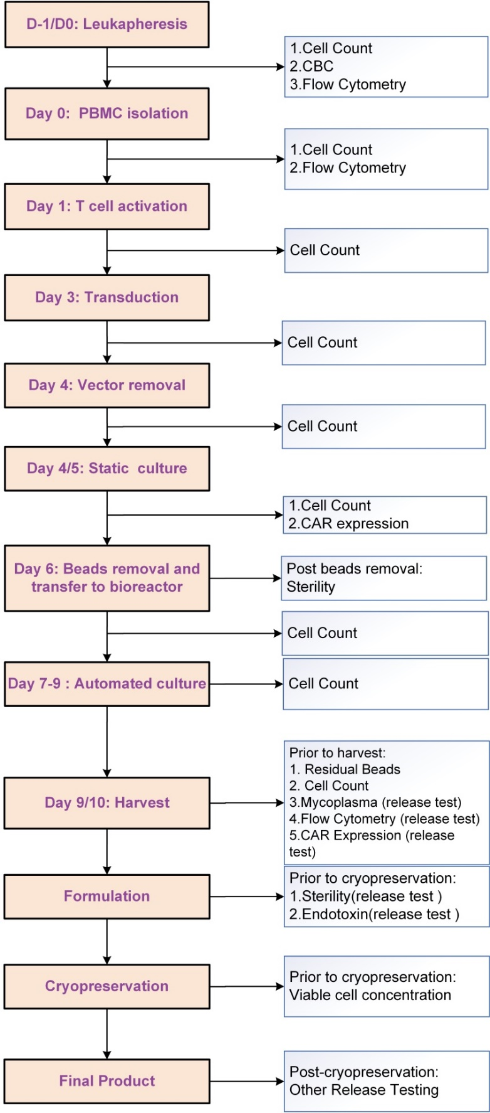
Thawing and administration of Y035 CAR-GPC3 T cells
Frozen Y035 CAR-GPC3 T cells were transported in vapor-phase liquid nitrogen to each patient’s bedside and thawed by rinsing a whole vacuum pack of 10-50 mL in a water bath maintained at approximately 37-38°C. Only one pack was thawed at a time. The pack was gently massaged until the cells were thawed and no frozen clumps were left. The thawed cells were immediately infused.
The study number and the patient’s initials were listed on the Y035 CAR-GPC3 product label to identify the patient. Each infusion pack was affixed with a drug label stating “FOR AUTOLOGOUS USE ONLY.” Prior to infusion, two individuals independently verified that the information was correctly matched to the patient. The Y035 CAR-GPC3 T-cell dose was administrated via intravenous infusion at a flow rate of 3-5 mL per minute. The duration of each infusion was about 5-10 minutes per pack. The infusion could be paused or continued at a lower rate in the event of an infusion-related reaction. The infusion time including starting time and completion time for each pack were documented in each patient’s chart.

Immunohistochemical staining for GPC3
Formalin-ﬁxed, parafﬁn-embedded HCC samples were immunostained using a mouse anti-GPC3 antibody (1G12; BioMosaics) as described previously (2). Briefly, following deparafﬁnization and rehydration, tumor sections were exposed to 3% H₂O₂ in methanol to eliminate endogenous peroxidase activity. Sections were then heated in citrate buffer (pH 6.0) for 10 minutes for antigen retrieval. Bovine serum albumin (1%) was used to block background noise for 30 minutes at room temperature. The primary antibody was incubated overnight at 4°C. Sections were then rinsed with 1× phosphate-buffered saline buffer and 0.5% phosphate-buffered saline with Tween 20 buffer and incubated with peroxidase-conjugated secondary antibodies (ChemMate Dako EnVision Detection Kit, Peroxidase/DAB, Rabbit/Mouse; Dako) for 45 minutes at room temperature. Sections were visualized using a diaminobenzidine staining kit (Dako) and then counterstained with hematoxylin, dehydrated, cleared, mounted, and photographed. GPC3 expression was evaluated using a four-point scale: 0, no GPC3 expression; 1+, weak GPC3 expression; 2+, medium GPC3 expression; 3+, strong GPC3 expression.

Flow cytometry
The immunophenotypes of the Y035 CAR-GPC3 T-cell products were determined using flow cytometry with fluorescence-labeled anti-human antibodies specific for CD4-PE (BD Biosciences; catalog number 555347) and CD8-PE (BD Biosciences; catalog number 555367). CD3-FITC (catalog number 11-0037-42), CD45RO-PE (catalog number 12-0457-42), CD45RA-PE (catalog number 12-9979-42), CD62L-Percp-eflour-710 (catalog number 46-0629-42), and CCR7-FITC (catalog number 11-1979-42) were purchased from eBioscience and used as described previously (3). CAR-GPC3 T cells were harvested at the end of the culture and stained with these antibodies for 30 minutes at room temperature in the dark. Expression of CAR-GPC3 in T cells was measured to determine the efficiency of transduction of a biotin-labeled fusion peptide of GPC3. Untreated T cells were used as negative controls. Data on immunophenotypes of the Y035 CAR-GPC3 T-cell products were acquired using a MACSQuant Analyzer 10 (Miltenyi Biotec), and the analyses of flow cytometry were performed using FlowJo software (version 10.0).
In vitro cytotoxicity assay
Y035 CAR-GPC3 T cells were co-cultured with the human hepatoma cell line Huh-7 with high GPC3 expression at different ratios for 6 hours to assess the cytotoxic effect of the CAR T cells on the Huh-7 cells using a CytoTox 96 non-radioactive cytotoxicity assay (Promega) following the manufacturer’s instructions as described previously (3).

References
- Yu M, Luo H, Fan M, Wu X, Shi B. Di S, et al. Development of GPC3-specific chimeric antigen receptor-engineered natural killer cells for the treatment of hepatocellular carcinoma. Mol Ther. 2018;26:366-78.
- Gao H, Li K, Tu H, Pan X, Jiang H, Shi B, et al. Development of T cells redirected to glypican-3 for the treatment of hepatocellular carcinoma. Clin Cancer Res. 2014;20:6418-28.
- Ahmed N, Brawley V, Hegde M, Bielamowicz K, Kalra M, Landi D, et al. HER2-specific chimeric antigen receptor-modified virus-specific T cells for progressive glioblastoma: a phase 1 dose-escalation trial. JAMA Oncol. 2017;3:1094-101.

