Supplementary Figure S5
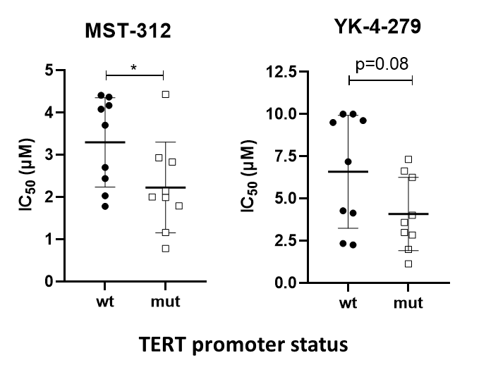

Supplementary Figure S5: Impact of TERT promoter status on sensitivity of MPM cell models against pharmacological telomerase and ETS factor inhibition. Mean IC₅₀ values (± SD) for the telomerase inhibitor MST-312 and the ETS factor inhibitor YK-4-279 as indicated of TERT promoter wild-type (N=9) and mutated (N=9) models were determined by a 72h continuous drug exposure viability assay. IC₅₀ values for each cell line are derived from at least three independent experiments in triplicate. Statistical significance was tested by two-tailed Student`s t test. * = p<0.05

