Supplementary Figure S8
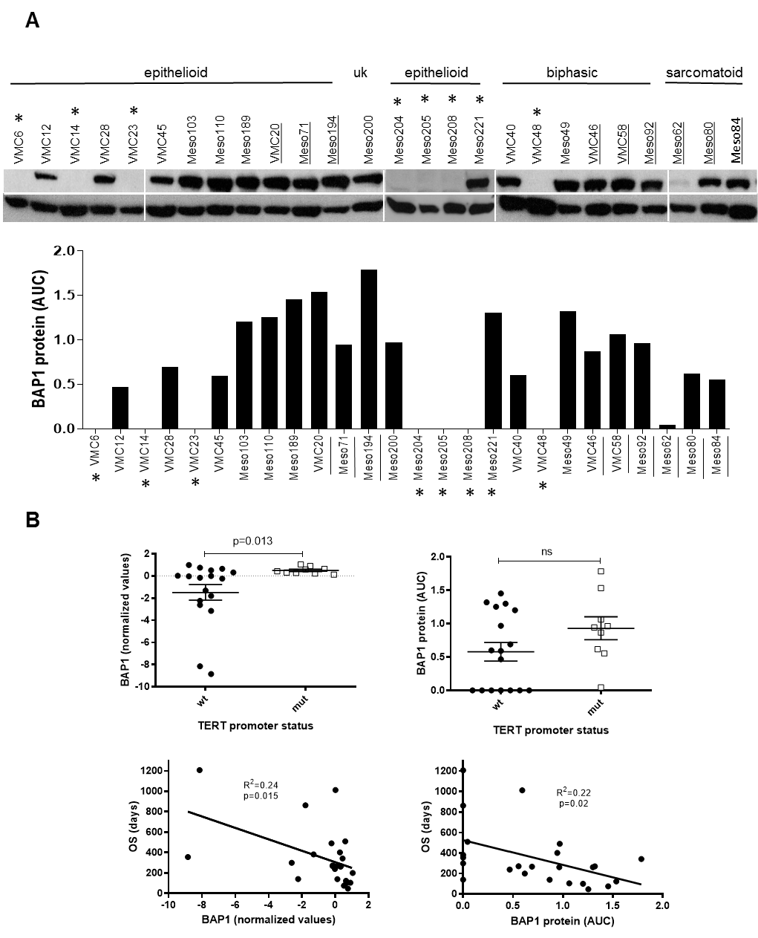

Supplementary Figure S8. BAP1 expression in MPM samples and its relation to TERT promoter status and patient overall survival. (A) Western blot analysis of BAP1 protein levels (upper band) as compared to β-actin (lower band) in total protein lysates of the indicated MPM cell models (N=26) grouped according to histology. TERT promoter mutated samples are underlined. BAP1 mutated/deleted samples according to NGS data are indicated by asterisks. Protein levels were quantified relative to β-actin using ImageJ. (B) BAP1 mRNA expression determined by expression array analysis (left) and protein levels by Western blot analysis (right) in the TERT promoter wild-type (wt, N=17) and mutated (mut, N=9) subgroup (upper panel) are shown. Single samples and mean ± SEM are depicted. Differences were tested for significance by two-tailed Student`s t-test with Welch`s correction and p-values are indicated. Lower panels show linear regression analyses between BAP1 mRNA expression (left) and protein levels (right) with patient overall survival (OS). Correlation coefficient (R²) and p-value are indicated. Uk = unknown histology; AUC = area under the curve.

