**Supplementary Figure S1**

**A**

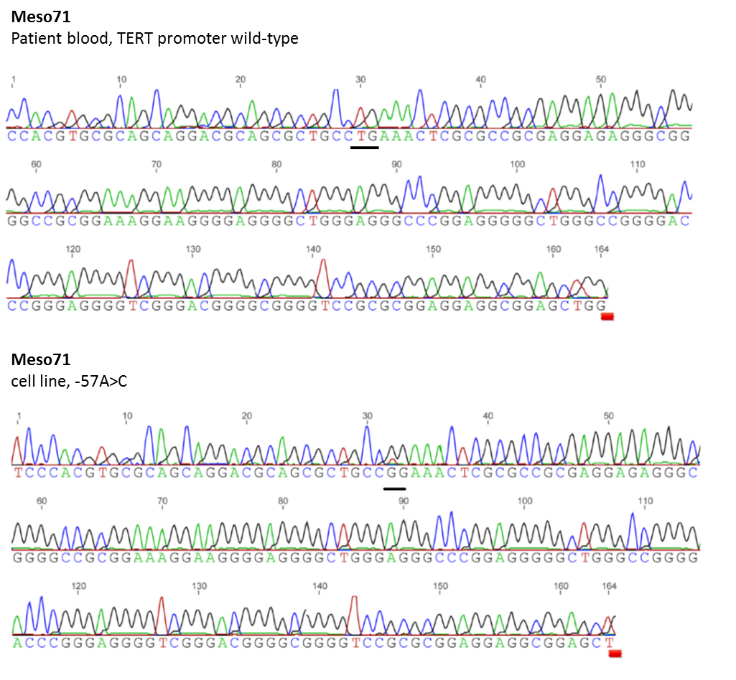

**B**

**Meso80**

Tumor tissue, -124C>T



**Meso80**

Cell line, -124C>T





**C**

**VMC58**

Cell line, -124C>T

**Supplementary Figure S1. Representative sequencing charts of the *TERT* promoter region harboring activating mutations.** Sequence and chromatogram of (A) blood-derived (upper panel) and cell line-derived DNA (lower panel) of one MPM patient (Meso71) harboring a somatic -57A>C mutation. (B) Sequencing chart of tumor tissue-derived (upper panel) and cell line-derived (lower panel) DNA of the identical patient (Meso80) harboring a heterozygous -124C>T mutation. (C) Cell line-derived DNA from a MPM case (VMC58) containing a homozygous -124C>T mutation.