Supplemental Figure 2:
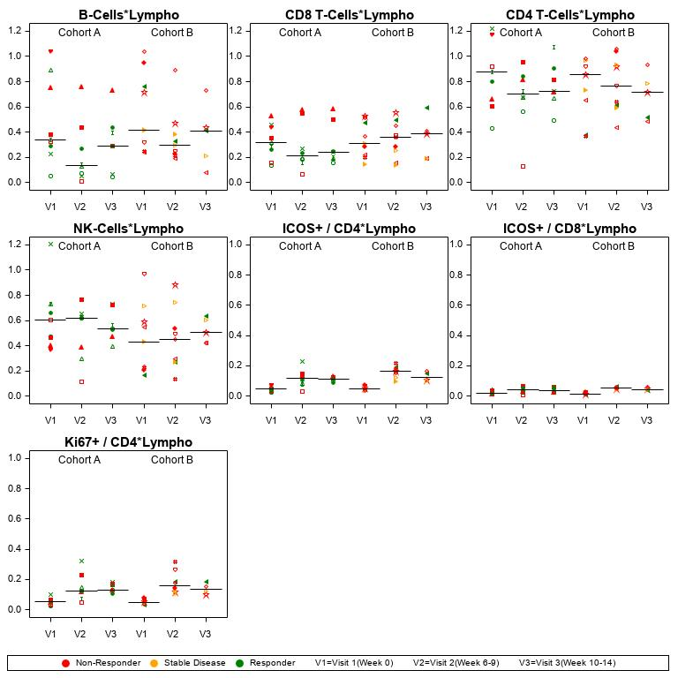
Supplemental Figure 2: Absolute numbers (absolute lymphocyte count * proportion) of designated cell populations at pre-treatment baseline (V1); after the completion of RT/prior to the 3rd dose of immunotherapy (week 6-9, V2); and at the timepoint of first radiographic assessment (Week 10-14, V3). Patients with response (green), stable disease (yellow), and progressive disease (red) outside of the irradiated volume are shown. Symbols reflect unique patients.

