Targeted brain tumor radiotherapy using an Auger emitter
SUPPLEMENTAL MATERIAL

Supplemental material table of contents

Cell-level dosimetry of ¹²³I-MAPi in U251 cells 2
Estimation of time-integrated activities from nuclear uptake 2
Construction of a phantom for cell-level absorbed dose calculation 2
Determination of relative biological effectiveness (RBE) 3
Dosimetry (organ-level/3D) of ¹²³I-MAPi via CED administration 4
Estimation of time-integrated activity coefficients in mouse organs. 4
Estimation of time-integrated activity coefficient for osmotic pump contents. 4
Construction of a CT-derived phantom for dose calculation. 5
Absorbed dose calculation in PARaDIM. 6
Supplemental figures 9
Supplemental Fig 1. 9
Supplemental Fig 2. 10
Supplemental Fig 3. 11
Supplemental Fig 4. 12
Supplemental Fig 5. 13
Supplemental Fig 6. 14
Supplemental Fig 7. 15
Supplemental material references 16

Cell-level dosimetry of ¹²³I-MAPi in U251 cells

Estimation of time-integrated activities from nuclear uptake
In vitro labeling experiments demonstrated saturable uptake of ¹²³I-MAPi over a short time scale of ~1 h, and minimal uptake in the cytoplasm vs. cell nuclei, and therefore, uptake into the cell nuclei was assumed to be instantaneous. Further, the percentage of applied activity accumulating in the cells (nuclei) was assumed to be proportional to the cell number. As the physical half-life of I-123 is short (13.2 h) in comparison to the doubling time for this cell line (~24 h), no cell division was assumed to have taken place during the dose accumulation period. The time-integrated activity for the whole system (comprised of the cells and surrounding media together) Ã_{tot} was calculated as 1.44 × A₀ × t_{1/2} = 1.58E⁹ Bq∙s, and the time integrated activities for the cell nuclei (all nuclei collectively) and surrounding media were calculated as the product of Ã_{tot} and the respective fraction of activity present in each component at saturation (Ã_{Nuclei} = Ã_{tot} × 0.0262%; Ã_{Media} = Ã_{tot} × 99.974%). The time-integrated activity in the cell nuclei was assumed to be distributed uniformly across the all cell nuclei in the population.

Construction of a phantom for cell-level absorbed dose calculation
A surface-mesh cell phantom was constructed in the 3D modeling software Blender (www.blender.org). Individual cells and nuclei were modeled as concentric spheres using the subvision-level 2 icosphere geometric primitive, using the average radii for the nucleus and cell surface as-measured via microscopy. The cell models were semi-randomly arrayed in a monolayer (~800 total cells) in the x-y plane using a combination of Blender’s array, intersection, and noise texture-based displacement modifiers, and were positioned at the base of a cylinder representing the surrounding media. Finally, a 6 well culture plate was modeled to contain the previous structures. The completed phantom (Supplemental Fig. S3A) was converted to tetrahedral mesh format using TetGen, and tetrahedron region labels were re-assigned using an in-house Python program. Finally, the tetrahedral phantom was imported into the PHITS-based dosimetry software PARaDIM, for absorbed dose calculations.

Determination of relative biological effectiveness (RBE)
Dose-response curves were fit via non-linear regression in GraphPad software, with the linear-quadratic (L-Q) model viz: S = exp[-(αD + βD²)], where S is the surviving fraction, D is the absorbed dose to the cell nuclei, and α and β are radiosensitivity coefficients parameterize the total logarithmic dose response into linear and quadratic components, respectively (Fig. S3B). For ¹²³I-MAPi, only the linear component was considered (i.e. β was constrained to zero). Each dose response curve was interpolated to obtain the respective dose corresponding to a 37% survival end-point, D₃₇, and the RBE computed as D_{37,EBIR}/D_{37,I-123} (Supplemental Table 1).

Dosimetry (organ-level/3D) of ¹²³I-MAPi via CED administration

Estimation of time-integrated activity coefficients in mouse organs.
Radiation dose estimates for osmotic pump-based intratumoral administration of ¹²³I-MAPi were obtained under the assumption that biological clearance kinetics of a small impulse of ¹²³I-MAPi are equivalent to those of ¹³¹I-PARPi administered as a single bolus intratumoral injection, and further that the clearance kinetics are not concentration-dependent. Under these assumptions the activity $A\left(r_{S},t\right)$ (MBq) of ¹²³I-MAPi in organ S is given by:

$A\left(r_{S},t\right)=\dot{A}\left(t\right)*a'\left(r_{S},t\right)$ Eqn. 1

where $*$ is the convolution operator, $\dot{A}\left(t\right)$ is the rate of administration (MBq/h), and $a'\left(r_{S},t\right)$ is the time-dependent fraction of injected activity of an impulse of ¹²³I-MAPi in organ S (i.e. that of a single bolus). In the case that the dose integration period $T_{D}$ is taken as infinity (the usual case), the time-integrated activity coefficient for the present case (slow infusion given by $\dot{A}\left(t\right)$) is equivalent to the case of a single bolus injection. Thus, time-integrated activity coefficients for mouse organs were calculated by applying the appropriate decay factor for I-123 to previously-obtained organ time-activity data (1) for intratumorally-injected ¹³¹I-PARPi, and performing trapezoidal integration of the adjusted data for each organ (Table S2). Clearance after the last measured time point was assumed to occur via radioactive decay only.

Estimation of time-integrated activity coefficient for osmotic pump contents.
Under the assumption that the ¹²³I-MAPi is homogeneously distributed within the osmotic pump contents, which occupy an initial volume $V_{0}$ (µL) and are injected at a constant volumetric flow rate $κ$ (µL/h), the activity of the pump contents $A\left(pump,t\right)$ can be expressed as (1):

$A\left(pump,t\right)=H\left(\frac{V_{0}}{κ}-t\right)∙A_{0}\left(1-\frac{κt}{V_{0}}\right)e^{-λt}$ Eqn. 2

where $t$ is the time post-implantation, $A_{0}$ is the initial activity in the implanted pump, and $H\left({V_{0}}/k-t\right)$ is a Heaviside function shifted in time by ${V_{0}}/k$ (i.e. the time the pump becomes empty).
The activity injected $A_{0,inj}\left(t\right)$ can be expressed as:

$A_{0,inj}\left(t\right)=H\left({V_{0}}/κ-t\right)∙\frac{κA_{0}}{λV_{0}}\left(1-e^{-λt}\right)+H\left(t-{V_{0}}/κ\right)∙\frac{κA_{0}}{λV_{0}}\left(1-e^{-{λV_{0}}/κ}\right)$ Eqn. 3

We define the time-integrated activity coefficient for the pump contents as normalized to the activity injected (i.e. delivered through the cannula):

$\tilde{a}\left(pump,t\right)=\frac{\int_{0}^{t}{A(pump,t)dt}}{A_{inj}\left(t\right)}$ Eqn. 4

which for $t$ = $T_{D}→∞$ is:

$\tilde{a}\left(pump\right)=\frac{λκ-κ+{λV}_{0}}{λκ\left(e^{{λV_{0}}/κ}-1\right)}-\frac{κ-λV_{0}}{λκ}$ Eqn. 5

The manufacturer specified values for $κ$ (1 µL/h) and $V_{0}$ (100 µL) were used for estimation of $\tilde{a}\left(pump\right)$ (Fig. 4B, 4C, Table S2).

Construction of a CT-derived phantom for dose calculation.
A computed tomography (CT) scan of a mouse bearing an osmotic pump implanted over the left shoulder was acquired on a NanoSPECT/CT device from Mediso Medical Imaging Systems (Fig. S5C). CT scans were reconstructed with an isotropic voxel size of 0.147 × 0.147 × 0.147 mm using a Feldkamp cone-beam filtered back-projection algorithm (Mediso Ltd.). A combination of manual and semi-automatic segmentation techniques were used to define the osmotic pump, tumor, and major organs within 3D Slicer 4.10 (www.slicer.org); the segments were subsequently converted to triangulated polygonal mesh. Within the mesh-editing software Blender (www.blender.org), the polygon count of each mesh was reduced using an edge-collapse decimation modifier (ratio 0.05-0.10), and small modifications made to correct for any overlapping/non-manifold geometry. Thin wall structures of select organs (e.g. stomach, bladder) were modeled by applying a vertex offset modifier to the corresponding structure defined previously via segmentation. Finally, all surface meshes were merged, exported, and converted to a tetrahedral mesh using TetGen (2). Following definition of the phantom region information (region name, composition, etc.) using an in-house python program, the completed phantom was imported into the PHITS-Based Application for Radionuclide Dosimetry in Meshes (PARaDIM v1.0).

Absorbed dose calculation in PARaDIM.
Absorbed doses were calculated with PARaDIM v1.0 using time-integrated activity coefficients given in Table S2. 1×10⁸ total histories were simulated via PHITS on a HP Z8 workstation (3.6 GHz Intel Xeon 5122 processor, Windows 10 OS, single core calculation). The default settings for physical models and energy cutoff (1 keV for electrons and photons) were used. The material surrounding the phantom was defined as void. An isotropic voxel resolution of 1.0 mm was used for 3D dose calculation.

Supplemental Table 1: Determination of radiobiological parameters for the L-Q model and relative biological effectiveness.
 | Radiobiological parameters
 | α (Gy⁻¹) | β (Gy⁻¹)
¹²³I-MAPi | 19.8 | --
EBIR | 0.269 | 0.0588
 | D₃₇ (Gy)
¹²³I-MAPi | 0.05
EBIR | 2.41
 | Relative biological effectiveness (RBE)
 | RBE at D₃₇ | RBE (α_{I-123}/ α_{EBIR})
¹²³I-MAPi | 48.4 | 73.4

Supplemental Table 2: Time-integrated activity coefficients estimated for intratumoral administration ¹²³I-MAPi via osmotic pump.

Organ or Region | Time-integrated activity coefficient (MBq*h/MBq)
Intestines | 0.399
Liver | 0.208
Pancreas | 0.000886
Stomach contents | 0.0117
Heart contents | 0.00536
Heart wall | 0.00527
Lungs | 0.00640
Brain | 0.000946
Thyroid | 0.000699
Skeleton | 0.0597
Tumor | 0.0597
Kidneys | 0.00617
Remaining organs | 0.139
¹²³I-MAPi solution (pump contents) | 81.5
Osmotic pump (container portion) | 0

Supplemental figures

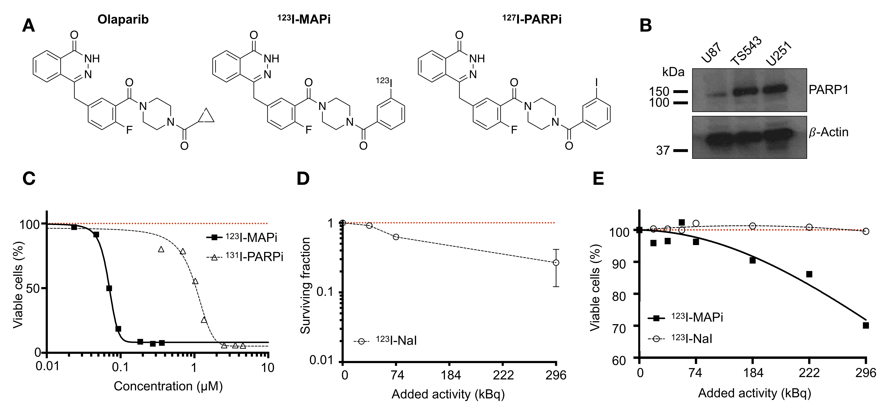
Supplemental Fig 1. Molecular structures, target expression, clonogenic assay and viability assay in vitro. (A) Molecular structure of Olaparib, ¹²³I-MAPi, and ¹²⁷I-PARPi, ¹²³I-MAPi isotopologue. (B) Western Blot of PARP1 in glioblastoma cell lines with 𝛽-actin control. (C) Alamar Blue assay comparing ¹²³I-MAPi and ¹³¹I-PARPi at equal molar concentrations. ¹²³I-MAPi EC₅₀ = 69 nM, ¹³¹I-PARPi EC₅₀ = 1148 nM. Nonlinear fit four parameters variable slope. (D) Clonogenic assay and E. Almar Blue viability assay of ¹²³I-MAPi vs. sodium iodine-123 in U251 GBM cells.

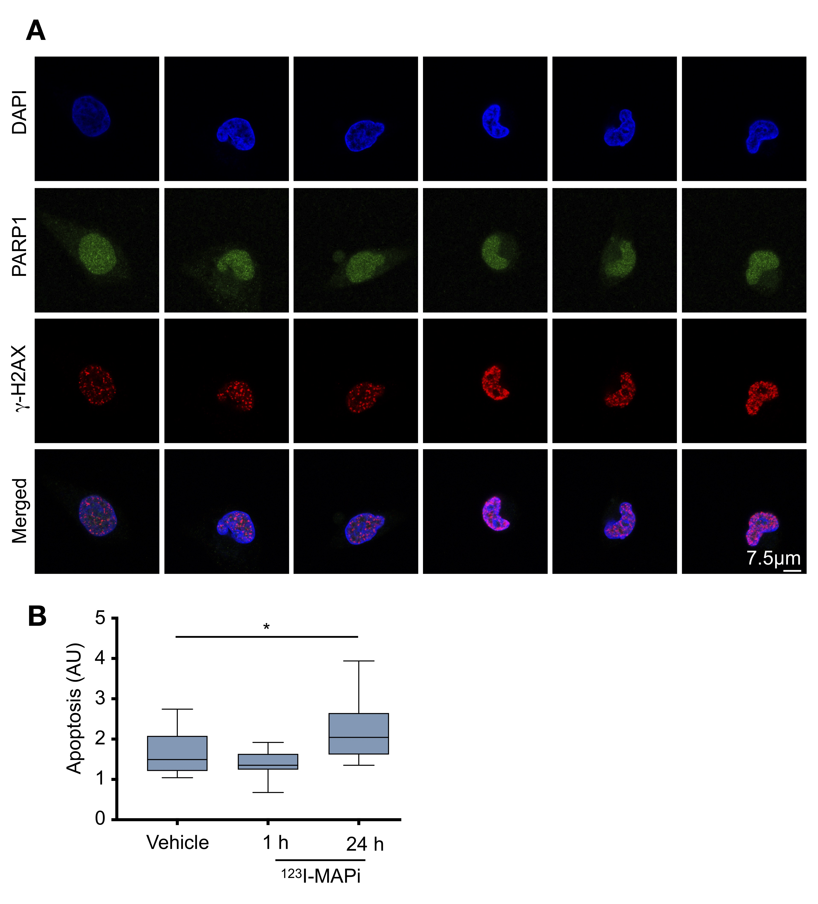
Supplemental Fig 2. Assessment of ¹²³I-MAPi DNA damage in vitro. (A). Images showing immunofluorescence of γ-H2AX (red), DAPI nuclear staining (blue), PARP1 expression (green), and merged images after treatment with ¹²³I-MAPi (n = 85). (B) Result of TUNEL assay looking at apoptosis levels at 1 h and 24 h post ¹²³I-MAPi treatment. *p-value < 0.05.

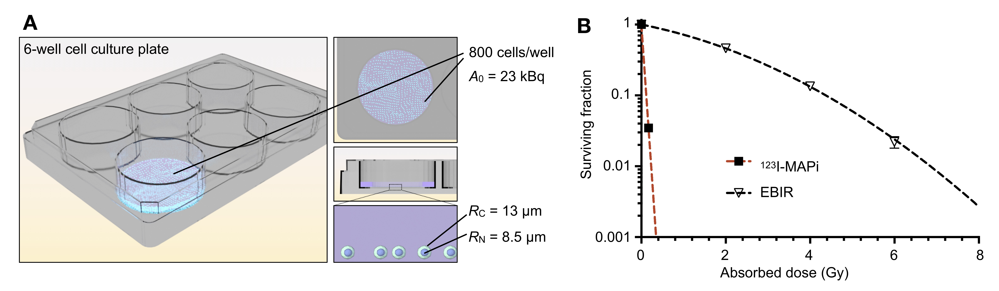
Supplemental Fig 3. Assessment of ¹²³I-MAPi DNA damage in vitro. (A) Survival of U251 cells following in vitro ¹²³I-MAPi labeling and incubation/colony formation, in comparison to external irradiation. (B) Tetrahedral mesh cell phantom utilized for Monte Carlo dose calculation in PARaDIM software.
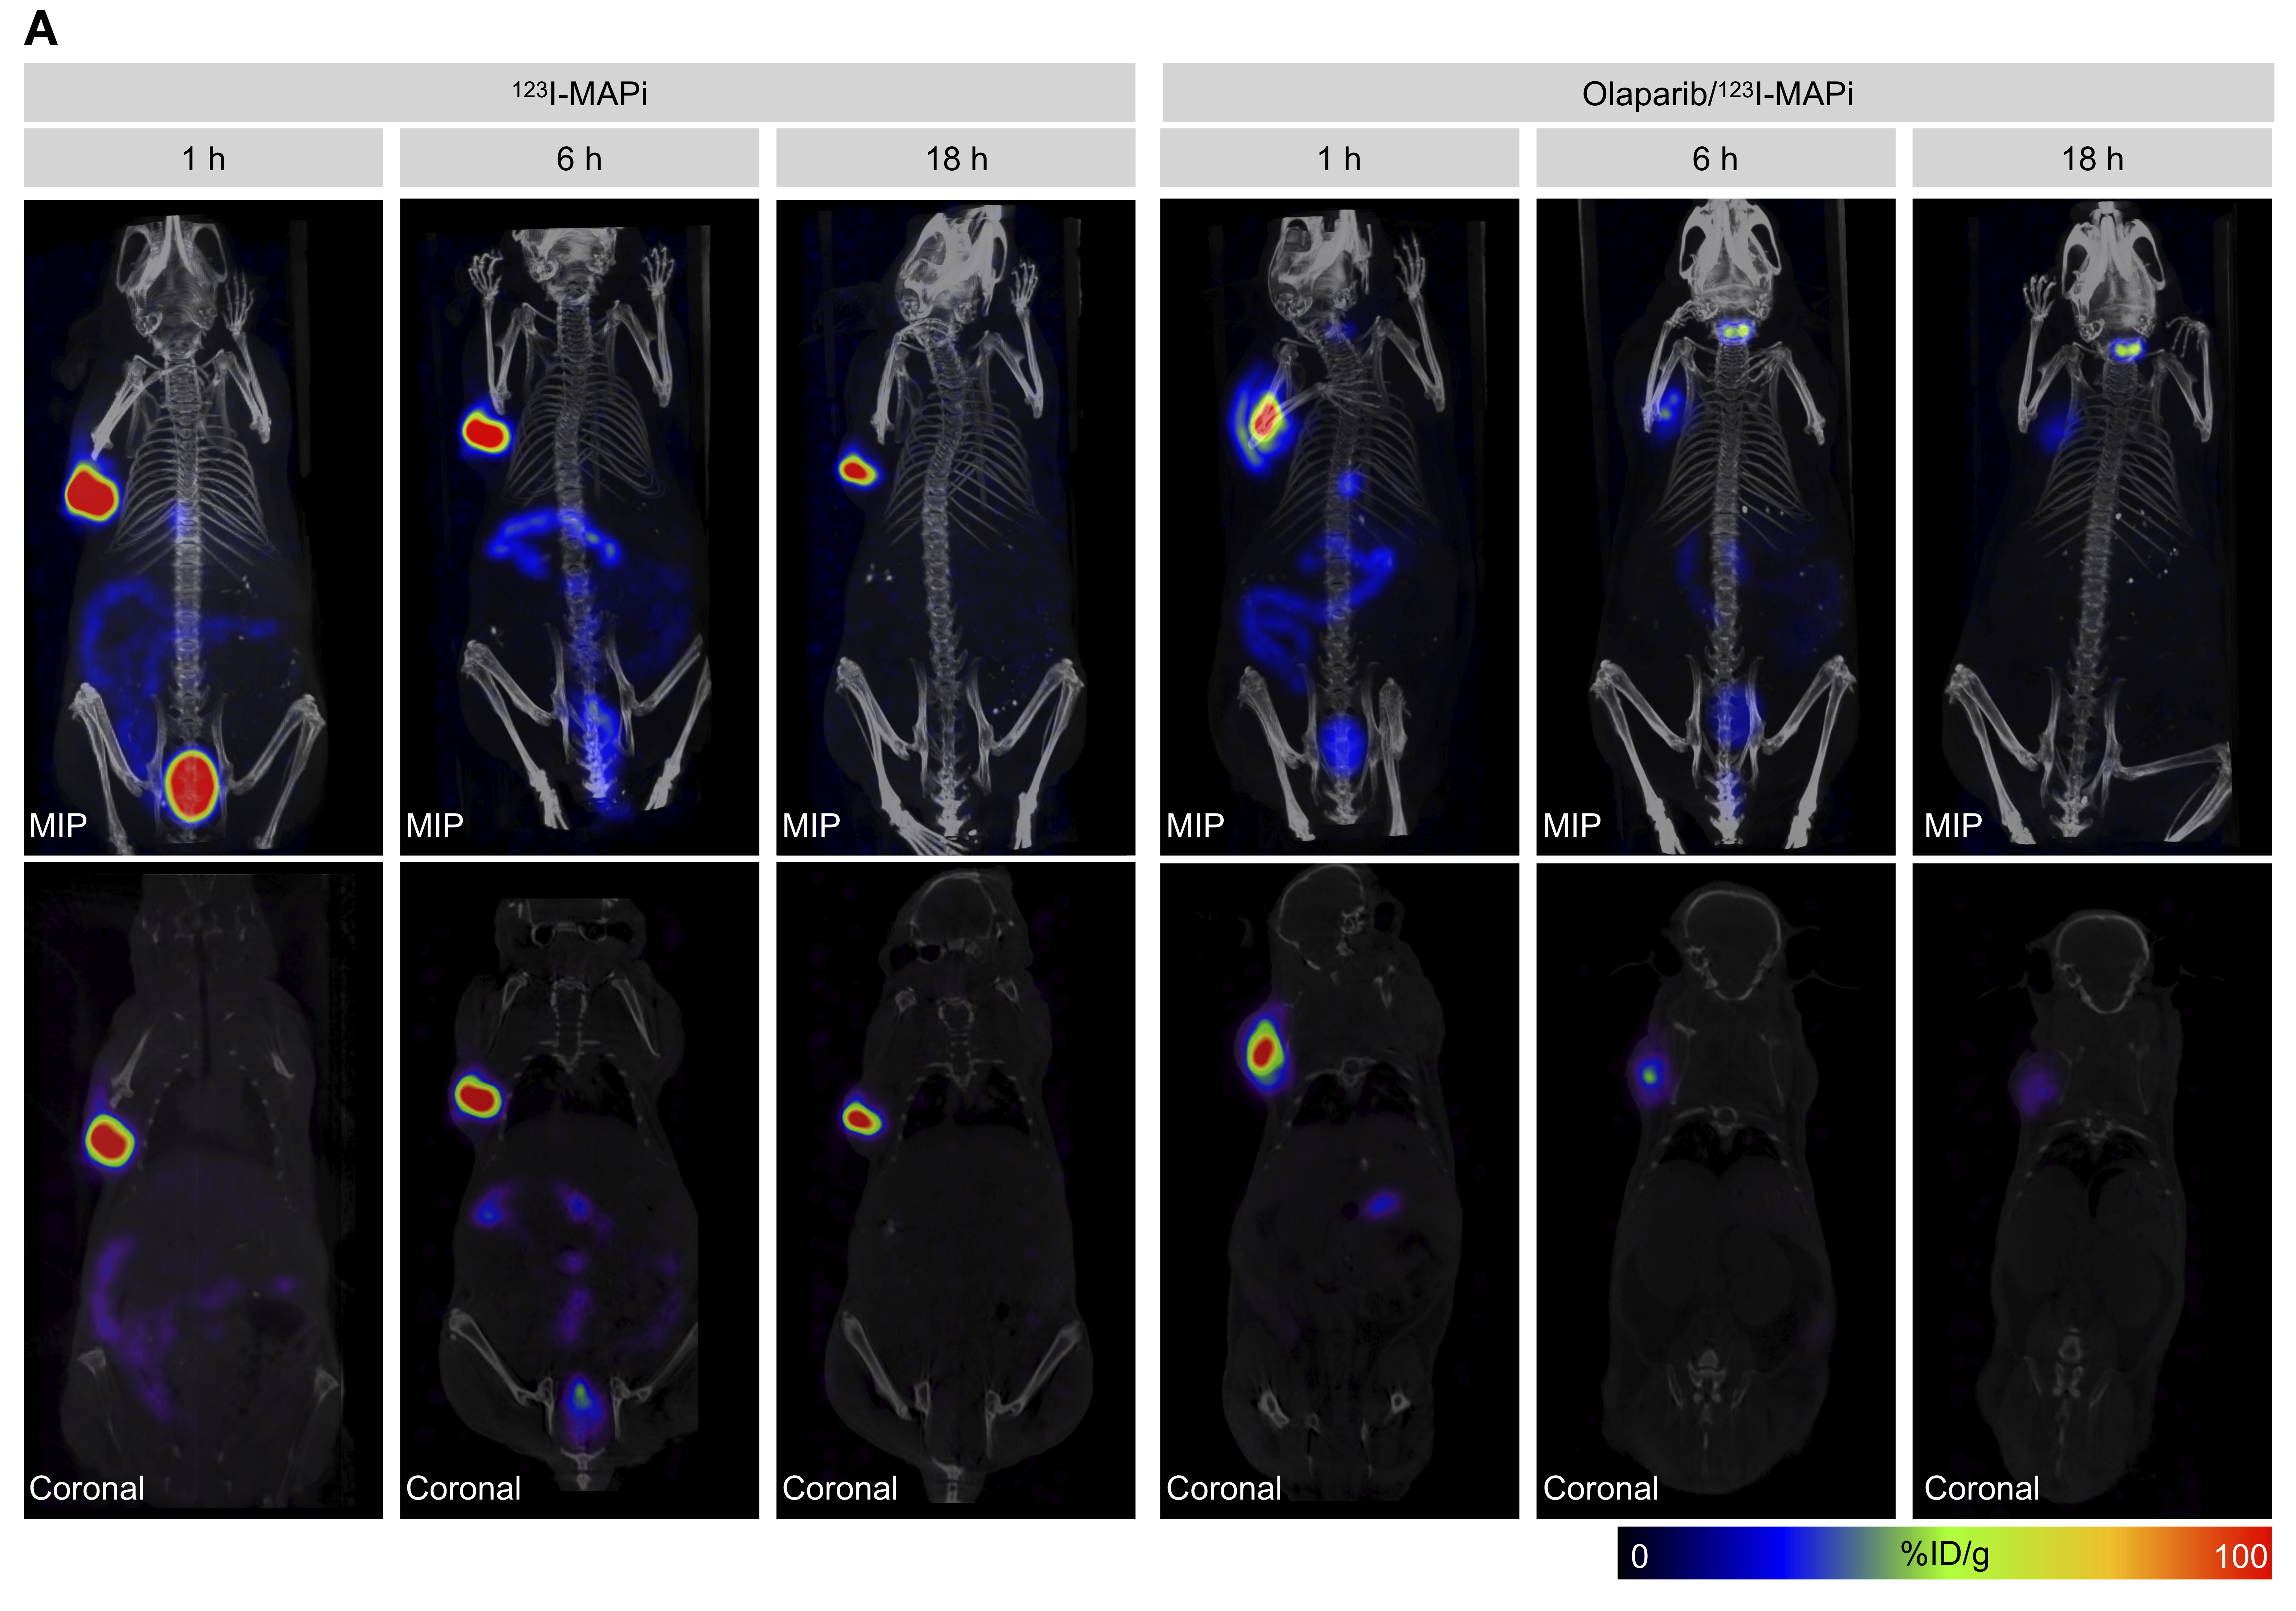
Supplemental Fig 4. In vivo SPECT-CT of ¹²³I-MAPi in Subcutaneous TS543 model. (A) MIPS (top row) and corresponding quantified coronal slices (bottom row) at selected time points after intratumoral injection of ¹²³I-MAPi with or without intravenous blocking with Olaparib.
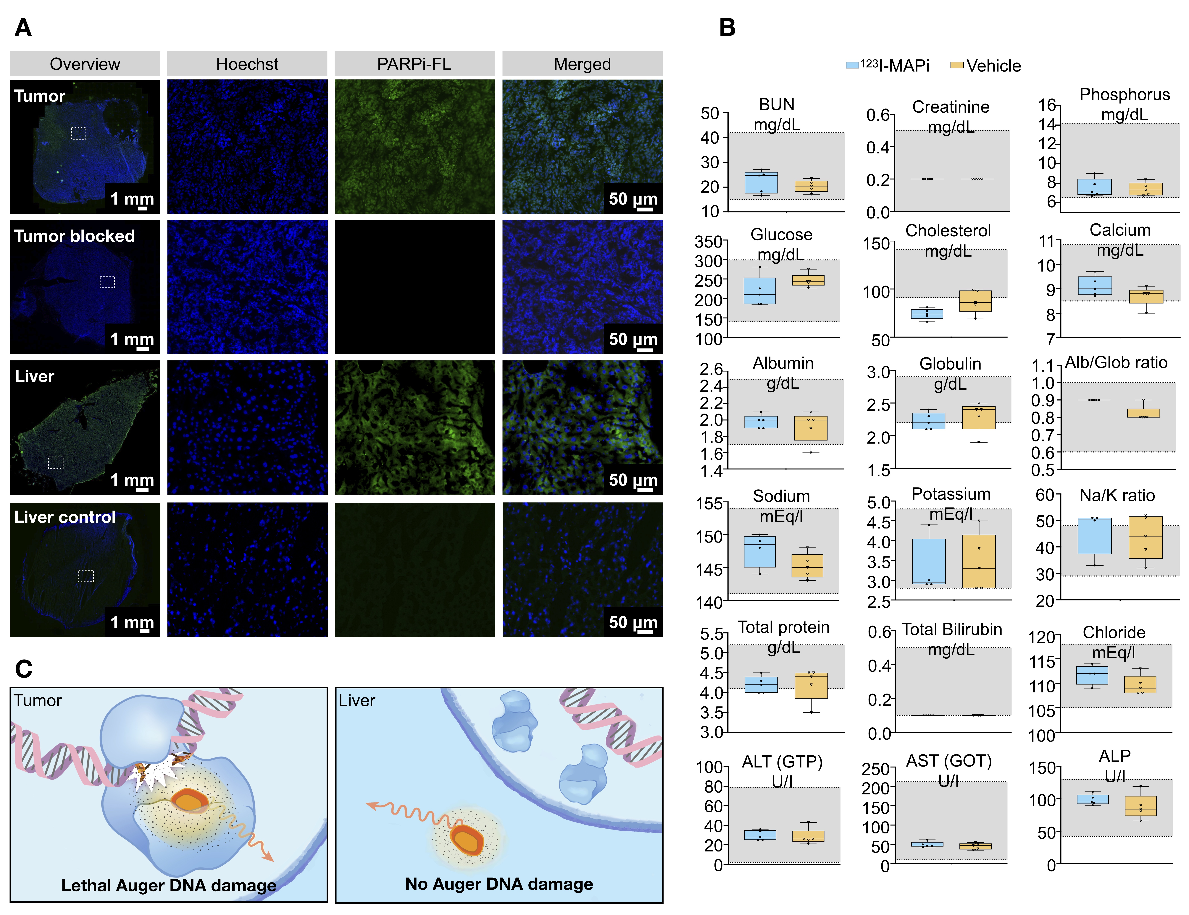
Supplemental Fig 5. Subcellular localization study for ¹²³I-MAPi. (A) Tissue from mice injected with PARPi-FL and Hoechst. PARPi-FL uptake was blocked in tumors by injection of 100-fold excess dose Olaparib 1 h prior to injection of PARPi-FL. Liver control was performed injecting vehicle IV. (B) Liver enzyme analysis of ¹²³I-MAPi treated mice (n = 5) and vehicle control mice (n = 5). Grey band represents expected value range for healthy female mice. (C) A suggested mechanism of radiation protection for liver cells is that Auger radiation specific toxicity depends on the isotope being in the proximity of the target DNA, which doesn’t happen in these cells.
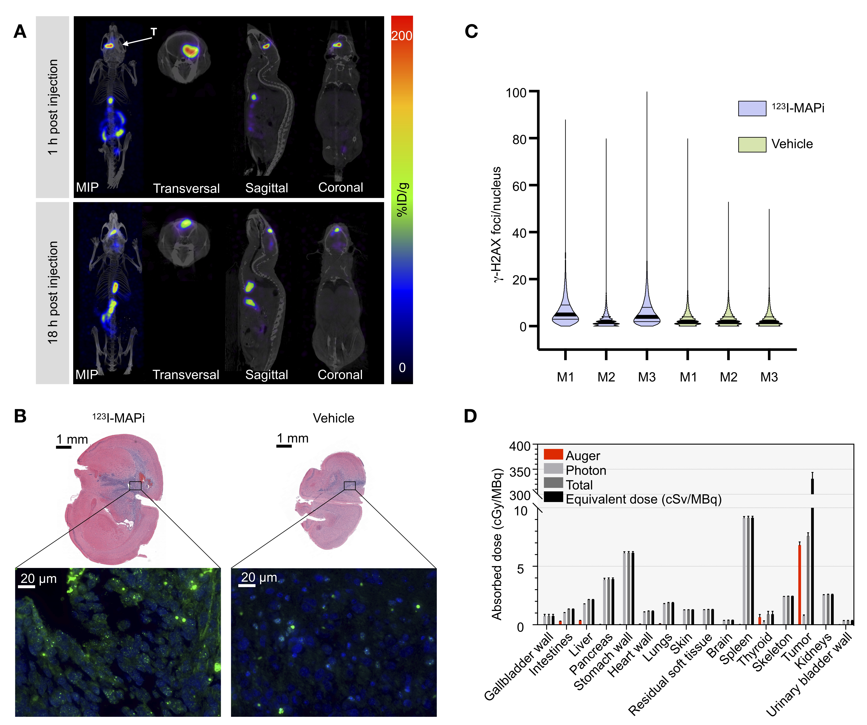
Supplemental Fig 6. In vivo SPECT-CT of ¹²³I-MAPi in orthotopic TS543 model. (A) Quantified coronal slices at 1 h and 18 h post local injection of ¹²³I-MAPi. ¹²³I-MAPi was injected intratumorally using the same stereotactic coordinates as for tumor implantation. The animal was imaged in a nanoSPECT/CT at the indicated time points post injection. (B) In vivo characterization of induced DSB. H&E was used to confirm tumor presence and γ-H2AX staining to investigate DSB formation at 1-hour post injection of ¹²³I-MAPi or vehicle as a control. (C) Quantification of the number of γ-H2AX foci within the tumor region after intracranial injection of ¹²³I-MAPi. Kruskal-Wallis test ****p-value < 0.0001 (D) Complete biodistribution of 3D dosimetry estimates calculated by Monte Carlo simulation for subcutaneous pump administration.
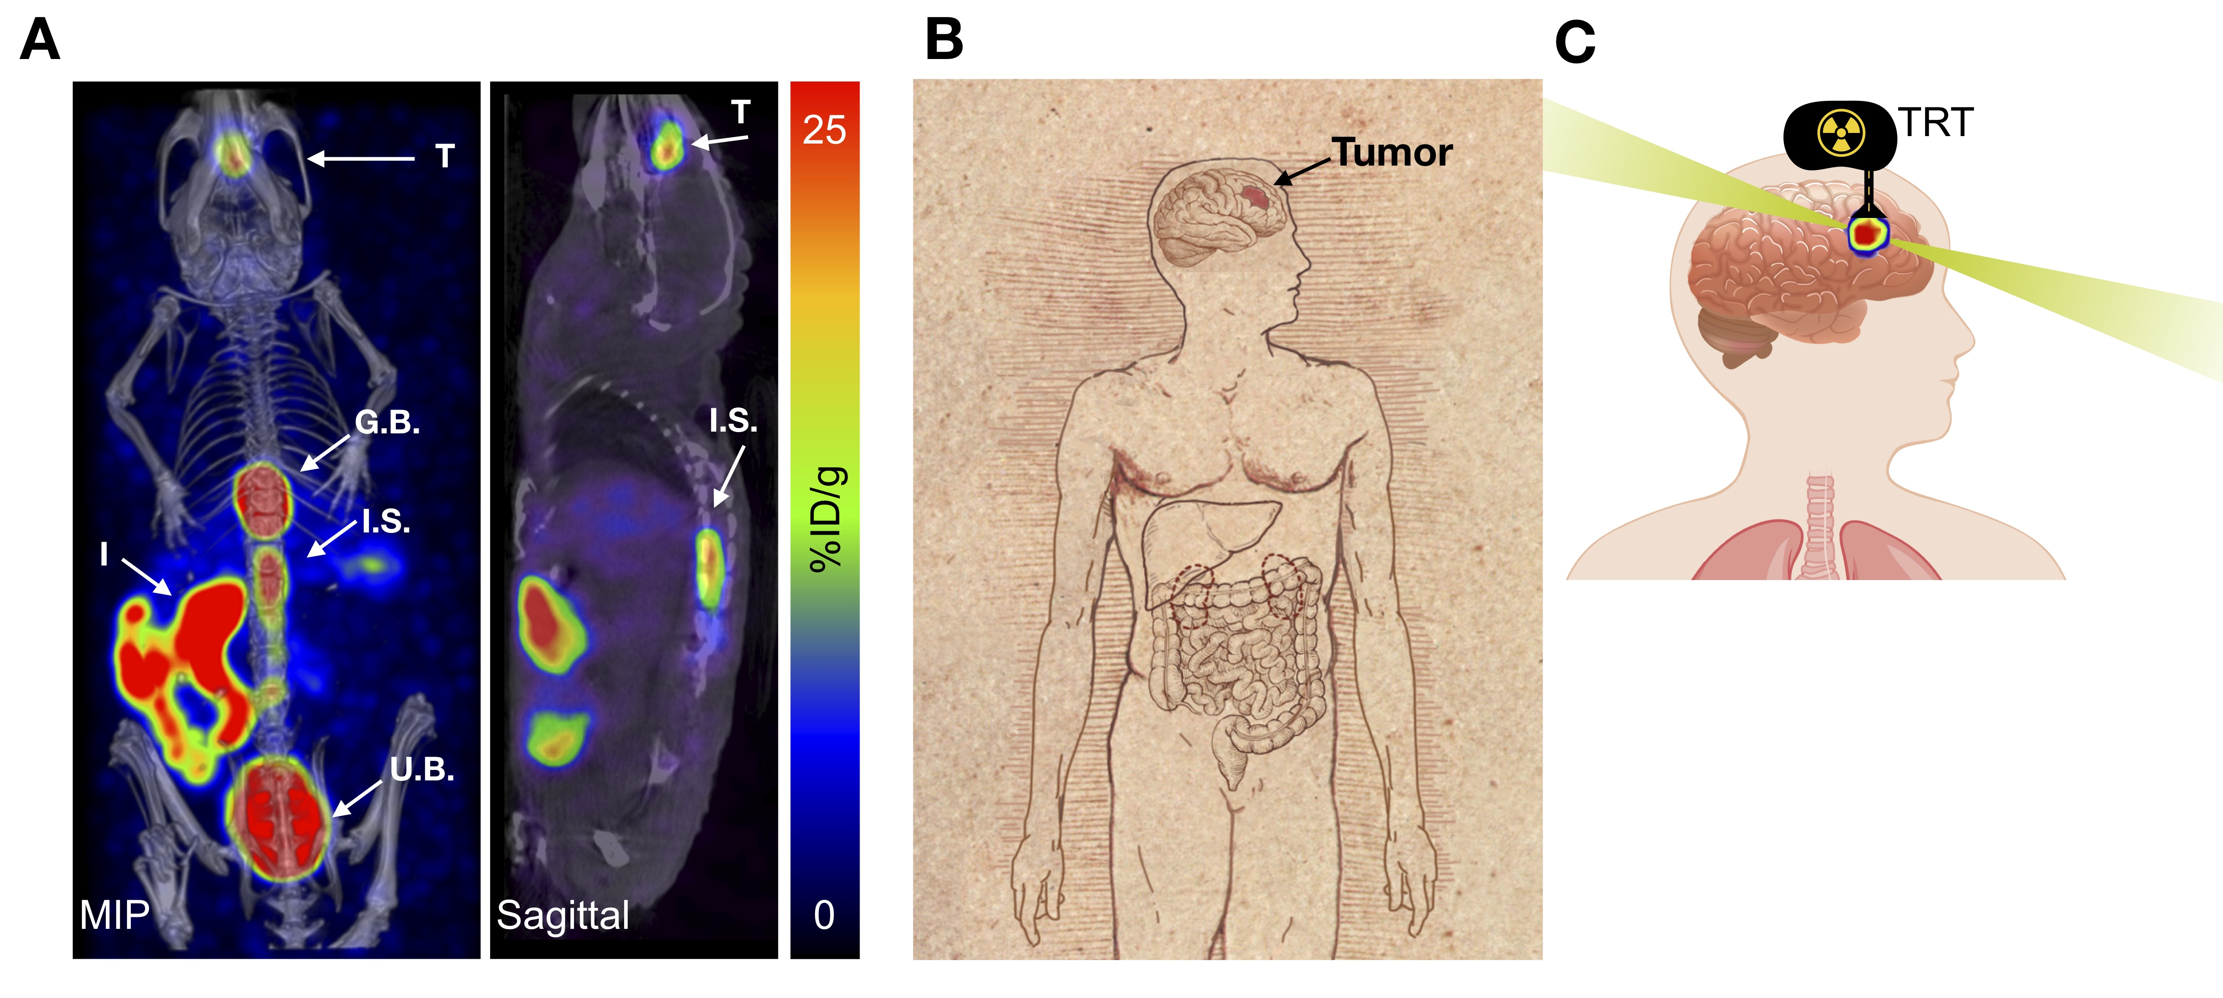
Supplemental Fig 7. Translation potential of ¹²³I-MAPi. (A) SPECT/CT imaging of ¹²³I-MAPi administered intrathecally, 1 h post injection. T: tumor; I.S.: injection site; G.B.: gallbladder; I: intestine; U.B.: urinary bladder. (B) We speculate that the different delivery methods characterized can show clinical potential for a reduced patient’s stress and improved tumor accumulation. Biodistribution of ¹²³I-MAPi in the cytosol of non-target cells limits unspecific toxicity and clinical side effects, preserving clearance organs. (C) Theranostic clinical application of ¹²³I-MAPi in a CED settings.

Supplemental material references
- Jannetti SA et al. (2018) PARP-1-Targeted Radiotherapy in Mouse Models of Glioblastoma. J Nucl Med 59(8):1225–1233.
- Si H., (2015) TetGen, a Delaunay-Based Quality Tetrahedral Mesh Generator. ACM Trans Math Softw 41(1):1–36.

