**Supplementary Figures**

**A) B)**

 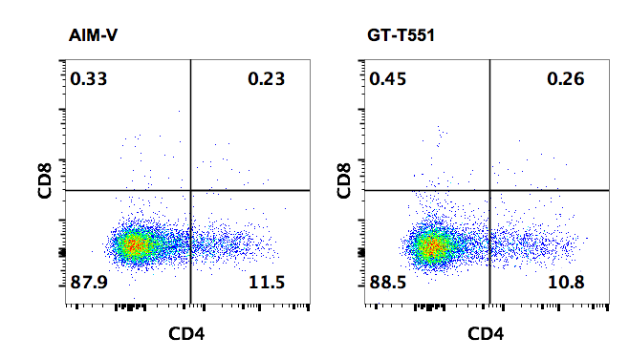

**C)**



**Figure S1. Characterization of healthy donor (HD) DNT expansion using GMP-grade reagents*.*** DNTs were expanded e*x vivo* with GMP-grade reagents including two types of animal-serum free media (AIM V and GT-T551). **(A** and **B)** Expansion profile (A) and purity (B) of DNTs from the same donor using two different culture media. **C)** Cytotoxicity of DNTs expanded using two types of media against OCI/AML3 and MV4-11. The results are representative of 3 experiments using 3 HDs. *, p<0.01

**A)** **B)**

 

**Figure S2. Mixing of DNTs from two different donors retains anti-leukemic function without alloreactivity against each other. A)** *In vitro* flow cytometry basedkilling assay conducted against AML cell line using HLA-A2- DNTs, HLA-A2+ DNTs, and the two donor DNTs mixed at 1:1 ratio. **B)** % dead DNTs from each donor with or without mixing was determined by flow cytometry after 2-hour co-incubation. The results are representative of two separate experiments using two different sets of HD DNTs.



**Figure S3. Co-engrafted allogeneic CD8+ T cells are not cytotoxic against DNTs.** Sublethally irradiated mice were infused with HLA-A2+ PBMC and HLA-A2- DNTs. Four weeks post PBMC infusion, mice were sacrificed and cells from spleens were pooled and HLA-A2+ CD8+ T cells were isolated. Isolated CD8+ T cells were used as effector cells against the HLA-A2- DNTs originally used for xenograft experiment in an *in vitro* killing assay at 4:1 CD8:DNT for 14 hours. Flow plots show the viability of HLA-A2- DNTs with or without coculture with HLA-A2+ CD8+ T cells. Result shown is representative of two separate experiments.