SUPPLEMENTARY FIGURES

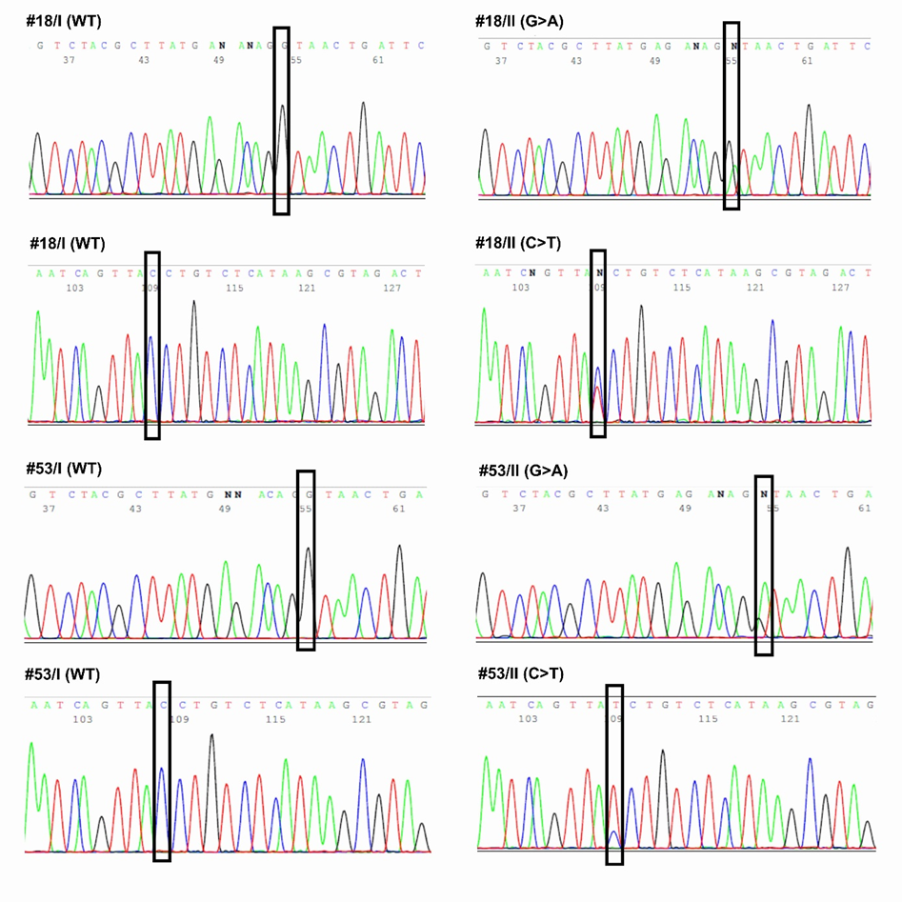
Supplementary Figure S1. Validation by Sanger sequencing of the c.3438+1G>A* MSH6 variant
Detection of the exon-skipping mutation in the MSH6 negative recurrent GBM tumors (#18/II, #53/II) in both strands (forward, upper panel; reverse, lower panel) compared to their matched primary counterpart (#18/I, #53/I), which stained positive for MSH6.

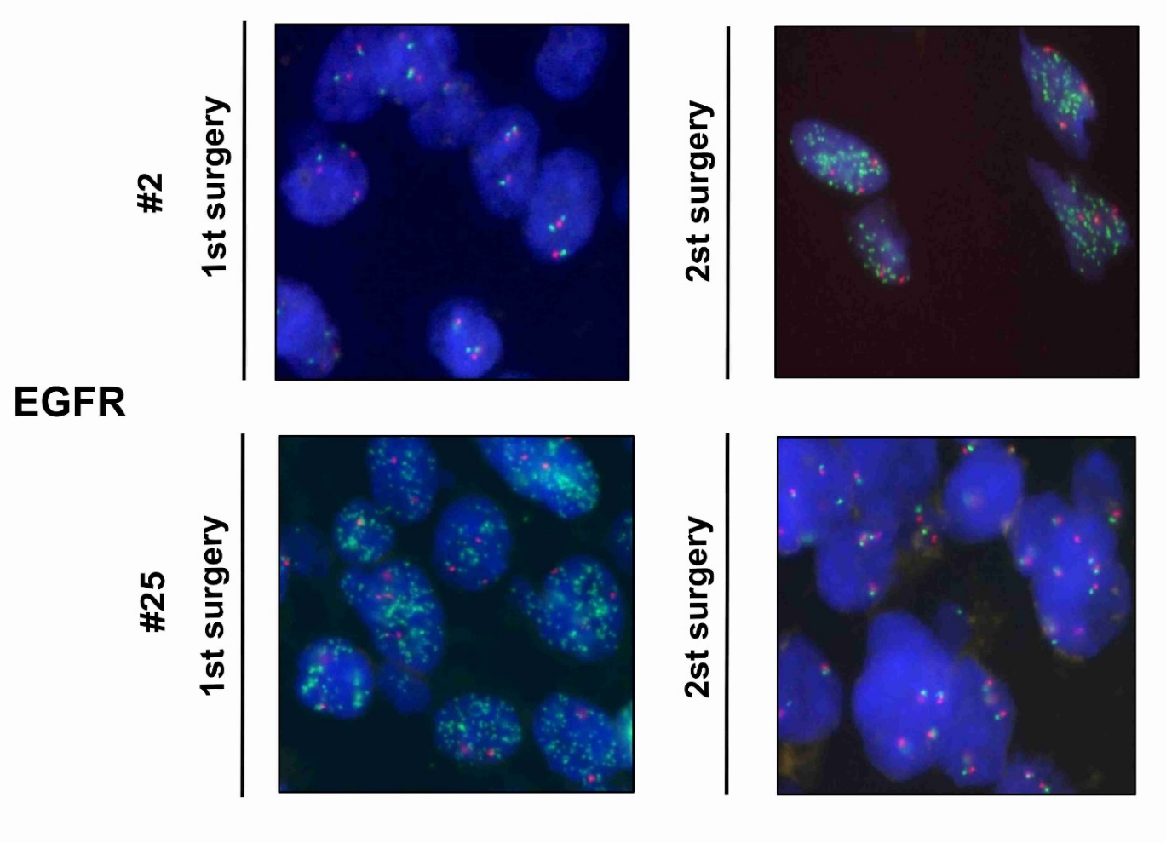

Supplementary Figure S2. EGFR amplification by FISH analysis
Two representative cases illustrating loss of EGFR amplification at relapse (#25) or gain of EGFR amplification at relapse (#2) are shown.

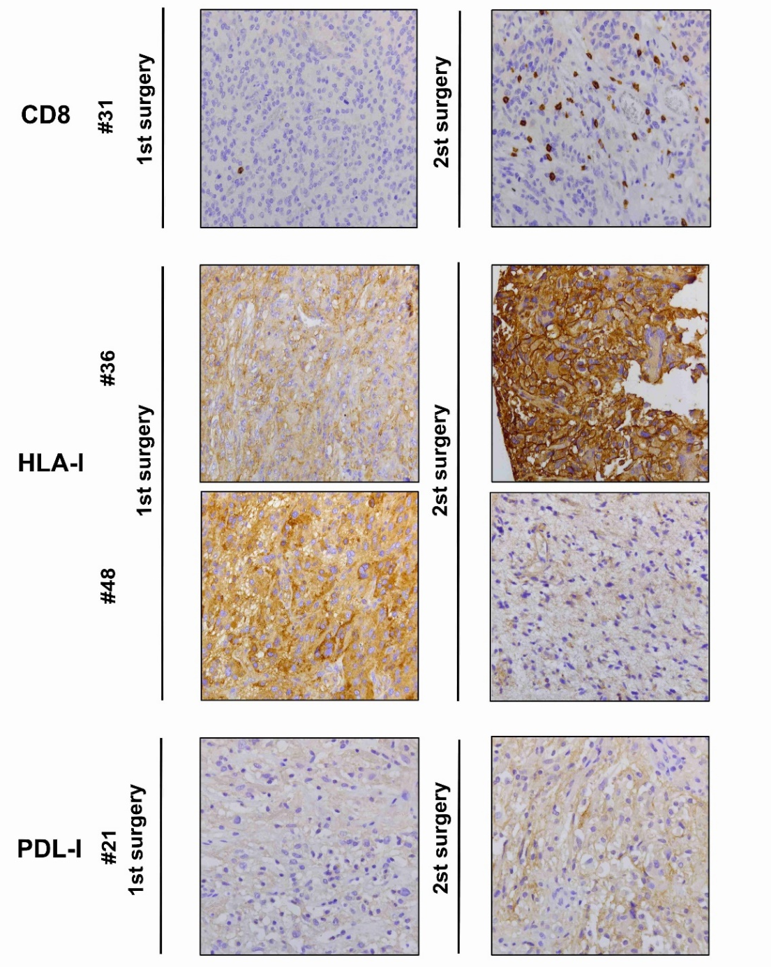

Supplementary Figure S3. Immunological markers in relapsed GBM
Representative images of CD8+ cells, HLA class I and PD-L1 expression in GBM samples. Magnification x20 was used.

Supplementary Figure S4. Kaplan-Meier survival curves, calculated from first surgery (top panel) or second surgery (bottom panel).
Supplementary Figure S5. Kaplan-Meier survival curves according to MMR status, calculated from relapse.

Supplementary Figure S6. Kaplan-Meier survival curves according to MGMT status, calculated from relapse.

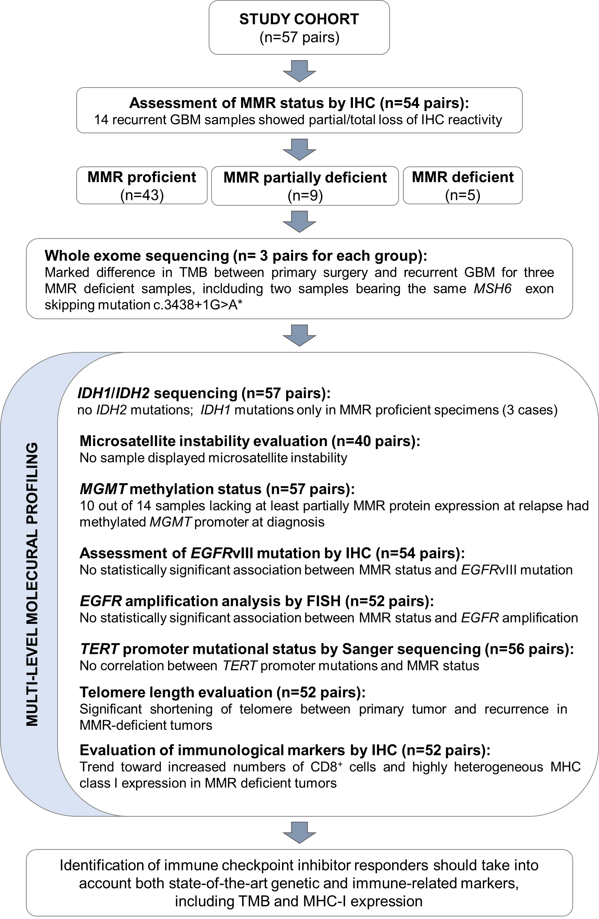

Supplementary Figure S7. Multilevel profiling workflow and overview of the main findings of the study. MMR= mismatch repair; IHC = immunohistochemistry; TMB = tumor mutational burden; EGFRvIII = epidermal growth factor receptor variant III; FISH = fluorescence in situ hybridization; MHC-I = Major Histocompatibility Complex, class I.

