A Novel Engineered Small Protein for Positron Emission Tomography Imaging of Human Programmed Death Ligand-1: Validation in Mouse Models and Human Cancer Tissues

Arutselvan Natarajan¹, Chirag B. Patel^{1,2,&}, Sindhuja Ramakrishnan^{1,&}, Paramjyot S Panesar¹,

Steven R. Long³, Sanjiv S. Gambhir^{1,4,5,*}

Supplementary information

Supplementary Table S1
Summarizes the demographic and pathology characteristics of patients from who the human tissue specimens were obtained.

Supplementary Figure S2
Measurement of DOTA chelates per FN3_{hPD-L1} molecule by mass spectrometry. Representative MALDI-TOF MS spectra of FN3_{hPD-L1} (unmodified), and DOTA-FN3_{hPD-L1} (modified). The conjugation reaction was performed with FN3_{hPD-L1} and DOTA-NHS in a 1:5 ratio. The intensity peaks in the 12 kDa region occurred at 11824 Da and 13071 Da for FN3_{hPD-L1} and DOTA-FN3_{hPD-L1}, respectively.

Supplementary Video S3
Three-dimensional microPET-CT visualization of hPD-L1 expressing CT26 syngeneic tumor-bearing mice [CT26/hPD-L1-nblk and CT26-hPD-L1-blk] at 1 h post-injection of ⁶⁴Cu-FN3_{hPD-L1}. Nblk = No pre-blocking with non-radioactive FN3_{hPD-L1} prior to radiotracer injection. Blk = Pre-blocking with non-radioactive FN3_{hPD-L1,} 2 h prior to the tracer administration. White arrow indicates the location of the tumor implanted into the left shoulder (please see video online).

Supplementary Figure S4
Human cancer tissue hPD-L1 expression at the time of biopsy based on results from an FDA-approved send-out lab, and at the time of surgical resection based on validated antibodies of two hPD-L1 clones (SP263 and E1L3N) and the FN3_{hPD-L1} binder.

Supplementary Figure S5
(A) ⁶⁴Cu-FN3_{hPD-L1} PET of a NSG mouse bearing a subcutaneously-implanted MDA-MB-231 human triple negative breast cancer xenograft in the left shoulder. (B) 4 and 24 hours p.i. ⁶⁴Cu-FN3_{hPD-L1} tumor uptake (%ID/g mean±SD) under blocking (blk) and non-blocking (nblk) conditions. (C) Xenografts were harvested 4 days after ⁶⁴Cu-FN3_{hPD-L1} injection and processed for histology. From left to right: hematoxylin and eosin (H&E) and immunohistochemistry (IHC) staining (validated hPD-L1 antibody clones E1L3N and SP263, respectively) shown at 40× magnification (scale bars represent 50 µm). The hPD-L1 IHC in the xenograft was scored by a pathologist (SRL) by focusing on areas of tumor and excluding areas of necrosis or tumor-infiltrating inflammatory cells such as lymphocytes. In the MDA-MB-231 xenograft previously exposed to ⁶⁴Cu-FN3_{hPD-L1}, hPD-L1 staining was scored as 55% using clone E1L3N and 85% using clone SP263.

Supplementary Figure S6
Differential hPD-L1 expression in MDA-MB-231 hPD-L1-expressing triple negative breast cancer xenograft and Raji hPD-L1-non-expressing Burkitt’s lymphoma xenograft. These xenografts were not exposed to the ⁶⁴Cu-FN3_{hPD-L1} radiotracer. From left to right: hematoxylin and eosin (H&E) and immunohistochemistry (IHC) staining (validated hPD-L1 antibody clones E1L3N and SP263, respectively) shown at 40× magnification (scale bars represent 50 µm). The hPD-L1 IHC in the xenografts was scored by a pathologist (SRL) by focusing on areas of tumor and excluding areas of necrosis or tumor-infiltrating inflammatory cells such as lymphocytes. In the MDA-MB-231 xenograft, hPD-L1 staining was 60% using clone E1L3N and 90% using clone SP263. In the Raji xenograft, hPD-L1 staining was 0% using clone E1L3N and 5% using clone SP263.
Table S1

Case | Age at Diagnosis (y) | Sex | Pathology Diagnosis
1 | 68 | Female | Poorly differentiated lung adenocarcinoma
2 | 79 | Male | Lung adenocarcinoma
3 | 79 | Male | Metastatic lung adenocarcinoma to brain
4 | 73 | Female | Metastatic lung adenocarcinoma to brain
5 | 44 | Male | Metastatic lung adenocarcinoma to brain
6 | 43 | Male | Oncocytic thyroid carcinoma

Figure S2

Video S3
Please see the video online.

Figure S4
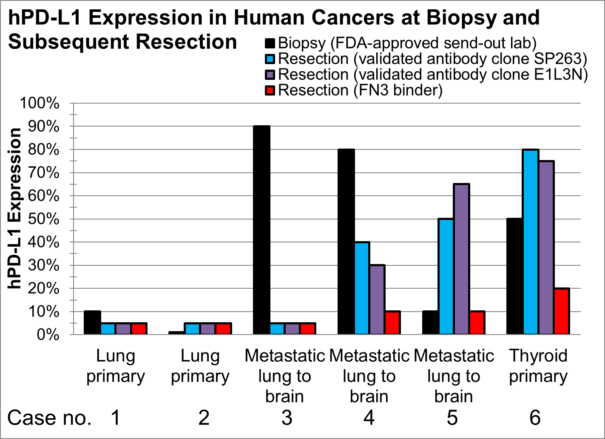
Figure S5

Figure S6
Specimen | H&E (40×, scale bar = 50 µm) | hPD-L1 clone E1L3N | hPD-L1 clone SP263
MDA-MB-231 xenograft (hPD-L1 expressing) | 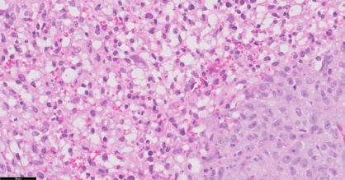 | 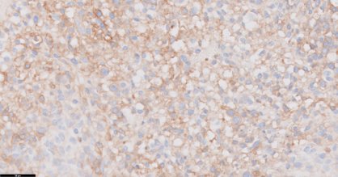 | 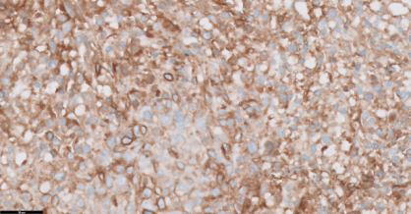
Raji xenograft (hPD-L1 negative) | 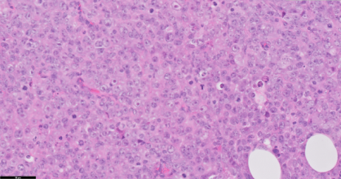 | 