Supplementary Table 1: Number of plasma samples included in the study

Timepoint | Anti-PD-1 monotherapy  (Cohort 1) |  | Anti-CTLA-4 and anti-PD-1 (Cohort 2)
 | Responders | Non-responders | Responders | Non-responders
PRE | 16 | 24 | 47 | 11
EDT | 16 | 22 | 46 | 11
MID | 8 | 14 | 32 | 8
LATE | 11 | 8 | 28 | 7
Abbreviations: PRE, baseline plasma taken 0-29 days before treatment initiation; EDT, early during treatment plasma taken at week 1-6 after therapy initiation; MID, mid timepoint plasma taken at week 7-11 after therapy; LATE, late timepoint plasma taken at week 12-18 after therapy. Patients undergoing complete or partial response were classified as responders, whereas non-responding patients had stable or progressive disease.

Supplementary Table 2: Association of toxicity with treatment response
Cohort 2 | Responders  (RECIST CR or PR) | Non-responders  (RECIST SD or PD) | Fisher’s exact test  Odds ratio, p value
Patients with severe irAEs | 19 | 2 | 0.25, p=0.098
Patients with no-severe irAEs | 21 | 9
Cohort 3 | Responders  (RECIST CR or PR) | Non-responders  (RECIST SD or PD) | Fisher’s exact test  Odds ratio, p value
Patients with severe irAEs | 17 | 5 | 0.97, p>0.999
Patients with no-severe irAEs | 21 | 6
Abbreviations: irAEs, immune-related adverse events; RECIST, response evaluation criteria in solid tumor; CR, complete response; PR, partial response; SD, stable disease; PD, progressive disease

Supplementary Table 3: Differentially expressed cytokines in patients with severe irAEs compared to those with no-severe irAEs at PRE in Cohort 2

Cytokine | T statistic | p value | FDR | Severe irAEs (log₂ mean) | No-severe irAEs (log₂ mean)
Eotaxin-1 | 2.56 | 0.01 | 0.05 | 9.27 | 8.37
FGF-2 | 2.98 | 0 | 0.02 | 6.81 | 5.76
Fractalkine | 2.74 | 0 | 0.02 | 5.73 | 4.86
G-CSF | 2.56 | 0.01 | 0.05 | 6.38 | 5.59
GM-CSF | 2.65 | 0.01 | 0.04 | 6.56 | 5.45
GROpan | 2.79 | 0.01 | 0.05 | 10.62 | 9.17
IFNα2 | 2.88 | 0 | 0.02 | 6.03 | 5.06
IL-12P70 | 2.39 | 0.02 | 0.05 | 6.07 | 5.17
IL-13 | 2.53 | 0.01 | 0.05 | 6.3 | 5.26
IL-1a | 3.17 | 0 | 0.02 | 6.94 | 5.82
IL-1B | 2.5 | 0.01 | 0.05 | 6.17 | 5.32
IL-1RA | 3.16 | 0 | 0.02 | 7.48 | 6.26
IL-2 | 2.65 | 0 | 0.03 | 6.63 | 5.74
IL-3 | 2.47 | 0 | 0.03 | 5.78 | 5.05
IL-9 | 2.13 | 0.02 | 0.05 | 6.12 | 5.28
PDGF-AA | 3.07 | 0.01 | 0.05 | 13.66 | 12.93
TARC | 3.84 | 0 | 0.03 | 11.33 | 10.24
Differentially expressed cytokines were selected using the t-test with an FDR-adjusted p value ≤ 0.05 and log₂ fold change > 0.7 as cut-off criterion.
Abbreviations: irAEs, immune related adverse events; FDR, false discovery rate.

Supplementary Table 4: Differentially expressed cytokines in patients with severe irAEs compared to those with no-severe irAEs at EDT in Cohort 2

Cytokine | T statistic | p value | FDR | Severe irAEs (log₂ mean) | No-severe irAEs (log₂ mean)
EGF | 3.32 | 0 | 0.02 | 7.69 | 5.98
FGF-2 | 2.8 | 0 | 0.03 | 6.75 | 5.77
Fractalkine | 2.85 | 0 | 0.02 | 5.76 | 4.89
G-CSF | 2.35 | 0.01 | 0.04 | 6.45 | 5.71
GM-CSF | 2.48 | 0.01 | 0.03 | 6.5 | 5.45
IFNα2 | 2.56 | 0 | 0.03 | 5.93 | 5.08
IL-12P70 | 2.5 | 0.01 | 0.04 | 6.02 | 5.18
IL-13 | 2.51 | 0.01 | 0.04 | 6.25 | 5.24
IL-1a | 2.52 | 0.01 | 0.04 | 6.68 | 5.94
IL-1B | 2.59 | 0 | 0.02 | 6.12 | 5.26
IL-1RA | 2.42 | 0.01 | 0.05 | 7.41 | 6.46
IL-2 | 2.69 | 0 | 0.02 | 6.51 | 5.72
IL-4 | 2.5 | 0 | 0.02 | 5.9 | 5.19
MIP-1a | 2.77 | 0 | 0.03 | 6.8 | 5.64
MIP-1B | 2.53 | 0.01 | 0.03 | 6.98 | 6.15
VEGF-A | 3.31 | 0 | 0.02 | 6.92 | 5.6
Differentially expressed cytokines were selected using the t-test with an FDR-adjusted p value ≤ 0.05 and log₂ fold change > 0.7 as cut-off criterion.
Abbreviations: irAEs, immune related adverse events; FDR, false discovery rate.

Supplementary Table 5: Univariate analysis of cytokine expression and association with overall survival

Cytokine | Hazard ratio (95% CI) | Log-rank test  P value
Discovery cohort 1 – anti-PD-1 monotherapy
TRAIL | 0.318 (0.141-0.717) | 0.0038
MCP-1 | 2.696 (1.184-6.139) | 0.0141
IL-2 | 0.447 (0.202-0.988) | 0.0410
Discovery cohort 2 - anti-CTLA-4 and anti-PD-1
TNFα | 5.193 (1.119-24.083) | 0.0189
IL-8 | 5.143 (1.109-23.842) | 0.0197
IP-10 | 4.693 (1.013-21.733) | 0.0293
Validation cohort 3 - anti-CTLA-4 and anti-PD-1*
SDF-1 | Undefined | 0.0189
Abbreviations: CI, confidence interval. *Five patients in validation cohort 3 were treated with neoadjuvant combination immunotherapy for clinically detectable, resectable stage III disease and as such were not included in the survival analysis.

Supplementary Table 6: Univariate analysis of cytokine expression and association with RECIST response

Cytokine | Odds ratio (95% CI) | Fisher’s exact test  P value
Discovery cohort 1 – anti-PD-1 monotherapy
IL-2 | 0.175 (0.031-0.815) | 0.0225
IP-10 | 5.708 (1.227-32.73) | 0.0225
MCP-4 | 0.175 (0.031-0.815) | 0.0225
TARC | 0.175 (0.031-0.815) | 0.0225
ENA78 | 0.175 (0.031-0.815) | 0.0225
Abbreviations: CI, confidence interval

Supplementary Figure 1: Distribution of relative fluorescence intensity units of 65 circulating cytokines in plasma collected from 98 melanoma patients (cohorts 1 and 2) prior to therapy initiation. Box plots showing the relative fluorescence intensity units (RFU) of each cytokine. Each box represents the interquartile ranges, the central line indicates median, and the whiskers indicate the minimum and maximum values.

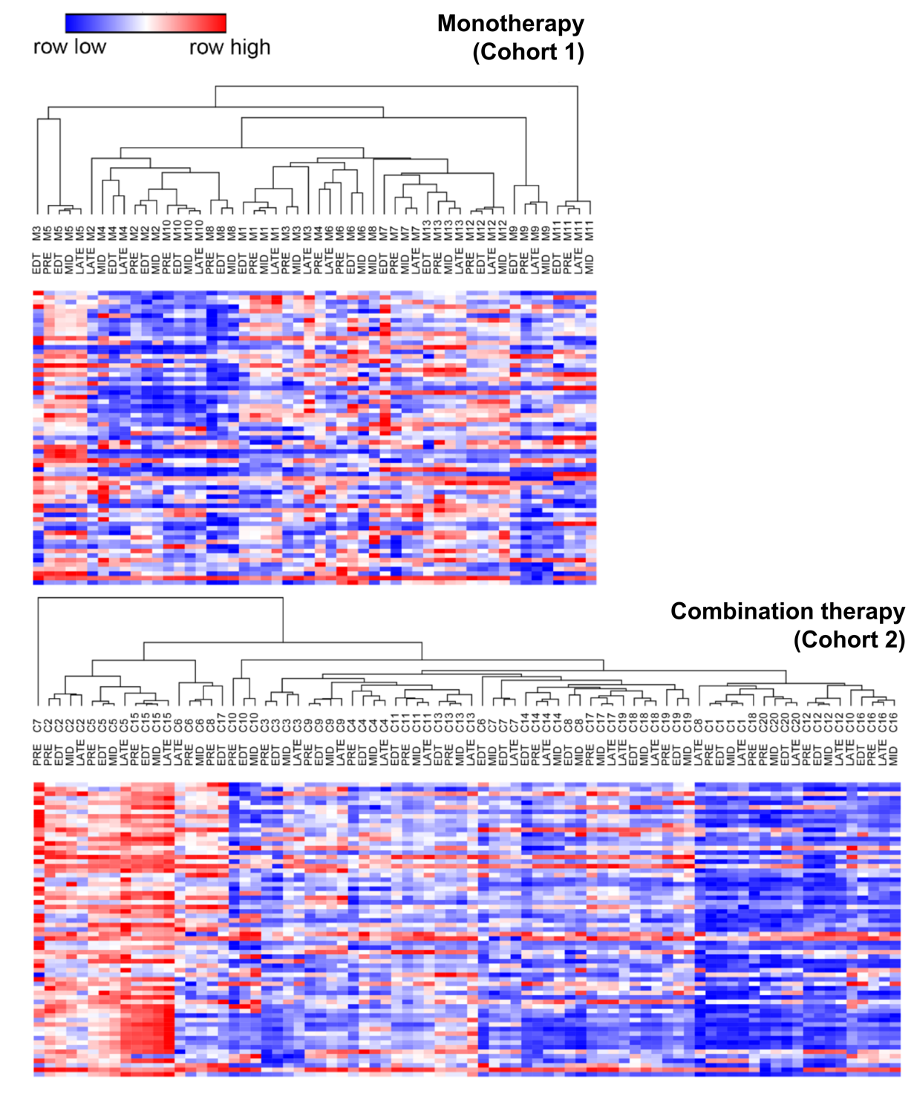
Supplementary Figure 2: Hierarchical clustering of cytokine expression profiles in cohorts 1 and 2. Unsupervised hierarchical clustering of circulating cytokines (Euclidean distance with average linkage of relative fluorescence units) derived from immune therapy treated patients at four timepoints. PRE, baseline plasma taken 0-29 days before treatment initiation; EDT, early during treatment plasma taken at week 1-6 after therapy initiation; MID, mid timepoint plasma taken at week 7-11 after therapy; LATE, late timepoint plasma taken at week 12-18 after therapy. Patients treated with PD-1 monotherapy have the prefix M and those treated with combination therapy are labelled with the prefix C.

