Supplementary data

Tumor microenvironment remodeling by intratumoral oncolytic vaccinia virus enhances the efficacy of immune checkpoint blockade

Hong Jae Chon, Won Suk Lee, Hannah Yang, So Jung Kong, Na Keum Lee, Eun Sang Moon, Jiwon Choi, Eun Chun Han, Joo Hoon Kim, Joong Bae Ahn, Joo Hang Kim, and Chan Kim*

* Corresponding author. e-mail: chan@cha.ac.kr

Supplementary Figures
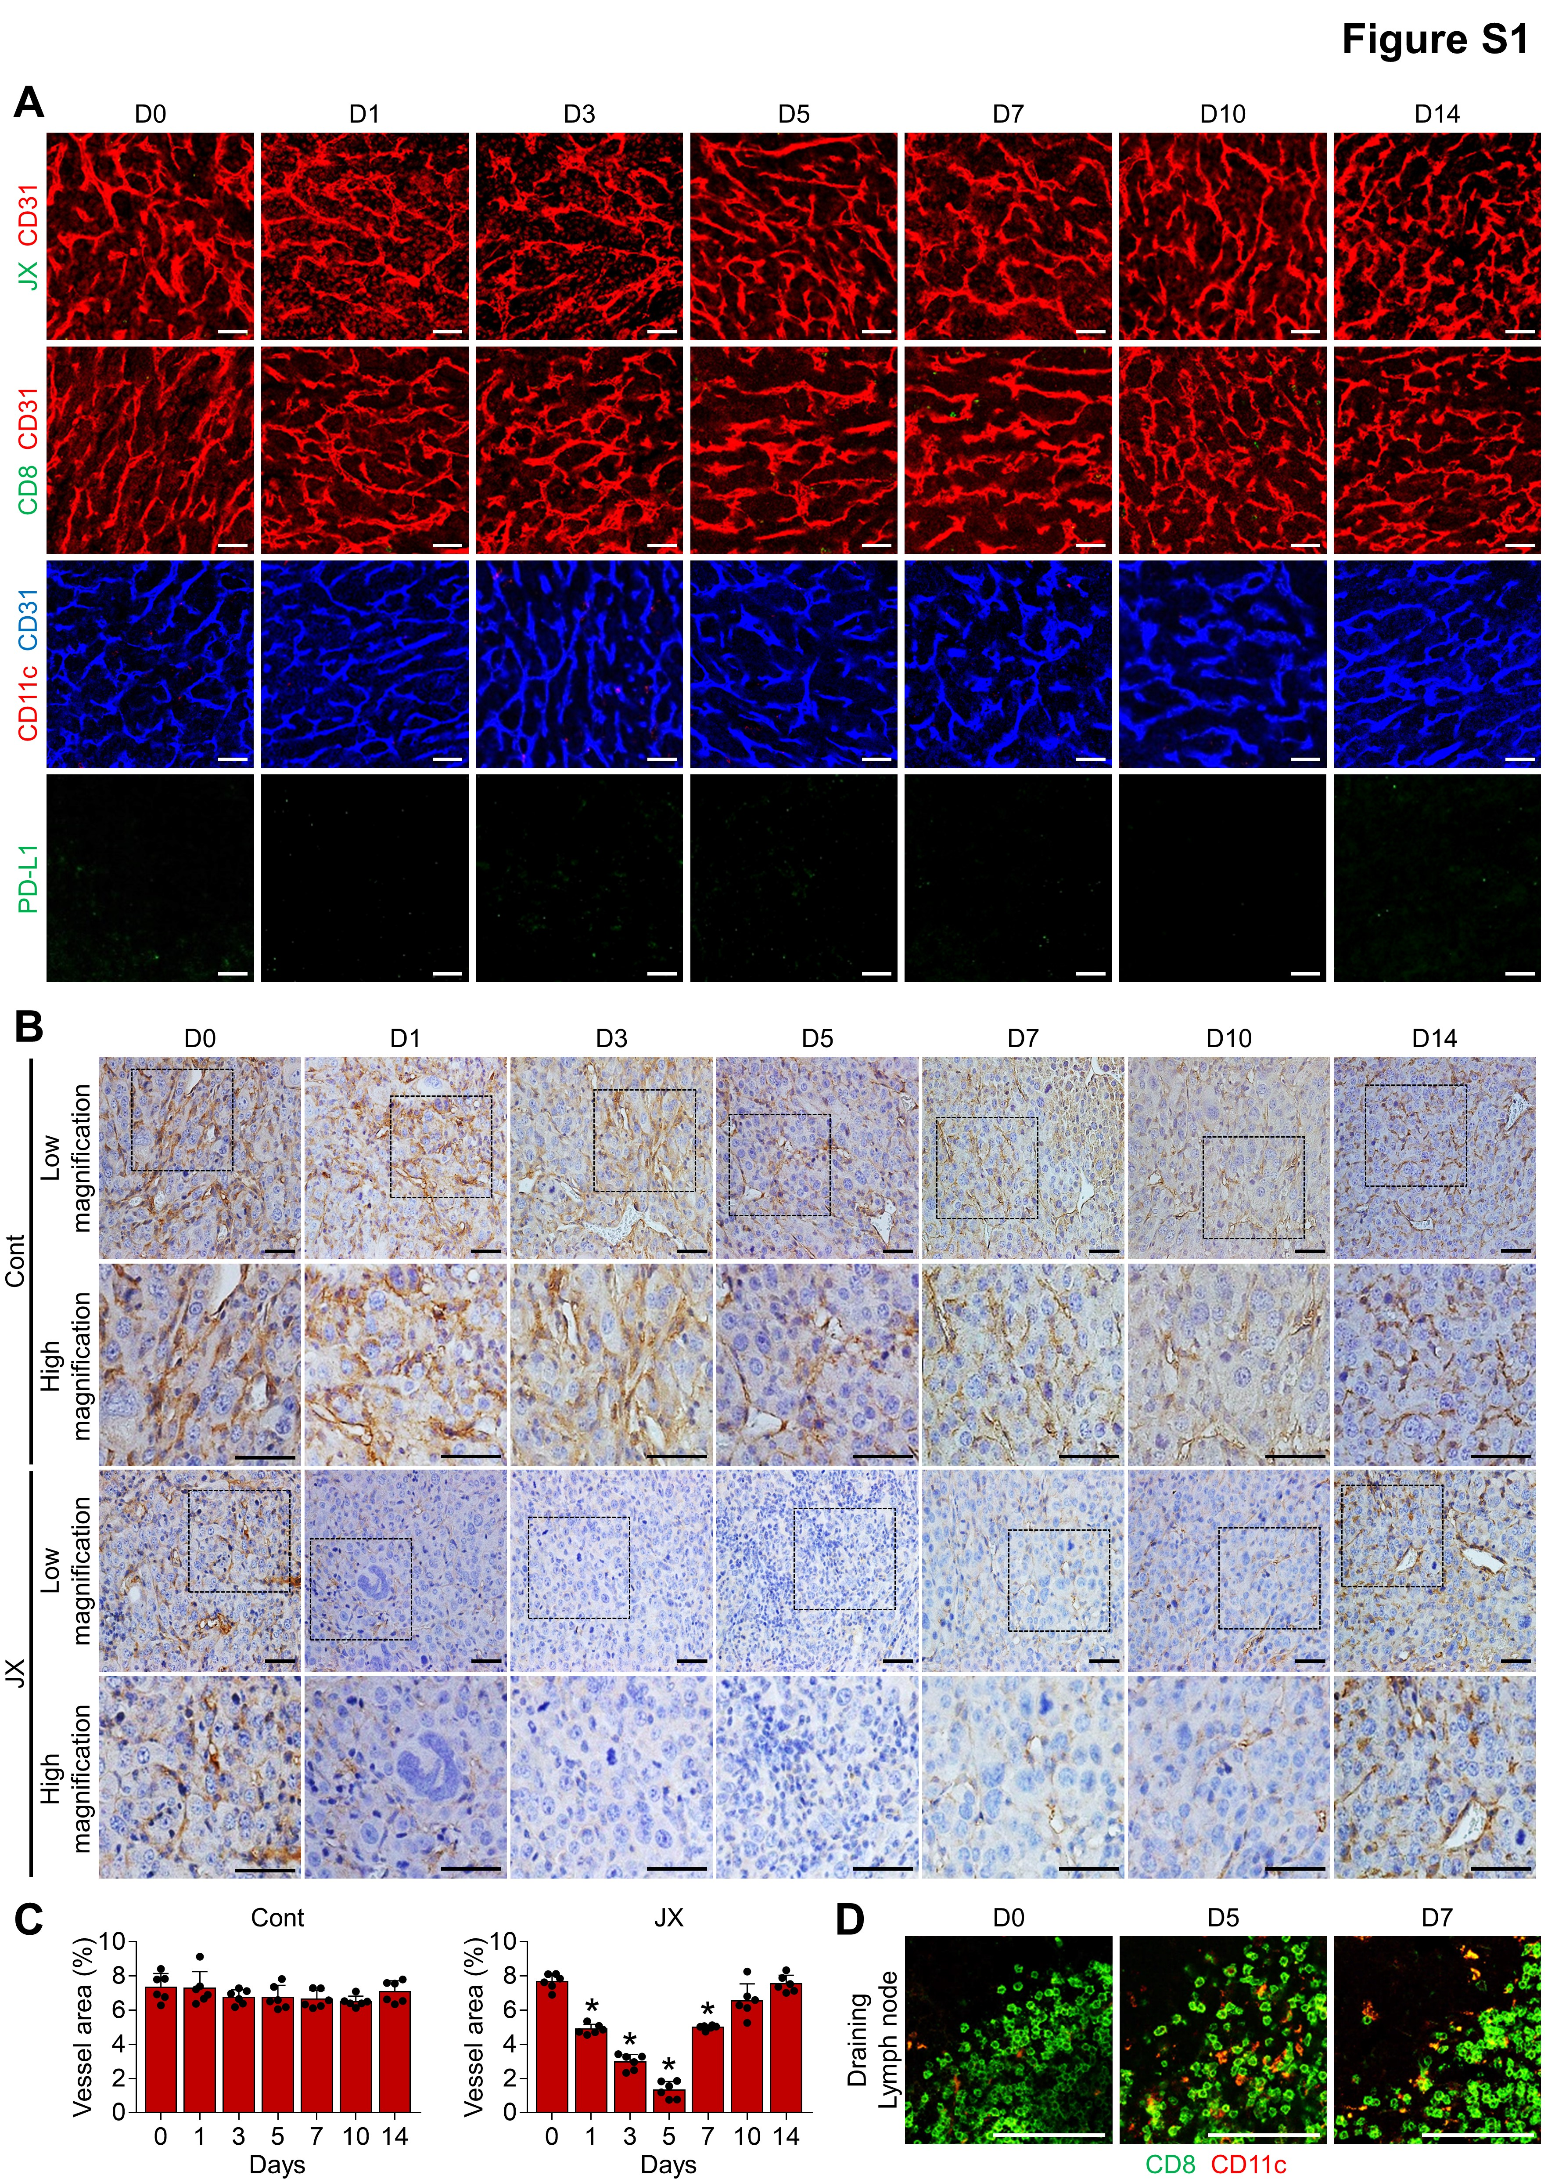
Supplementary Figure 1. Changes in tumor microenvironment after treatment.
Renca tumors were implanted subcutaneously (s.c.) into BALB/c mice and treated with a single intratumoral injection of PBS or mJX-594 (JX).
(A) Representative images of control tumors. Tumors sections were stained for JX, CD31, CD8, CD11c, and PD-L1.
(B and C) Representative images of CD31 immunohistochemical staining in H&E stained sections (B) and their quantifications (C). Scale bars, 500 μm.
(D) Images showing CD11c⁺ dendritic cells (red) in draining lymph node. Note that increased CD11c⁺ dendritic cells interacting with CD8⁺ T cells (green).
Pooled data from three experiments with 5 animals per group. Scale bars, 50 μm.

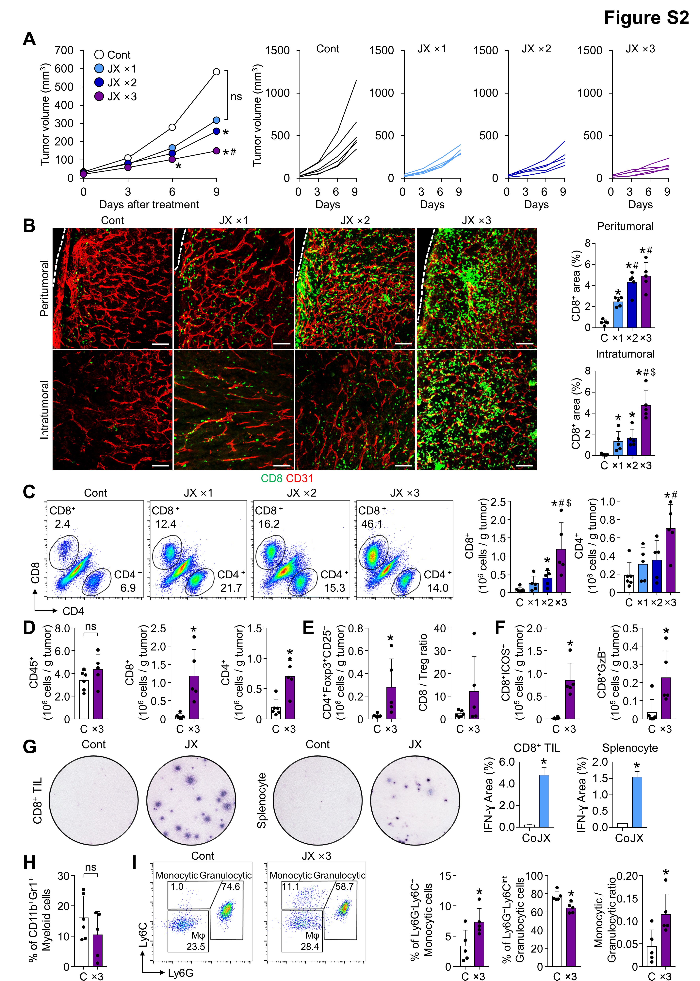
Supplementary Figure 2. JX augments intratumoral infiltration of CD8⁺ T cells and induces myeloid cell repolarization.
Renca tumor–bearing mice were intratumorally treated with PBS or 1 × 10⁷ plaque-forming units (pfu) of JX 1 to 3 times.
(A) Comparisons of tumor growth in mice treated with JX. Mean and individual tumor growth curves over time.
(B) Representative images and comparisons of CD8⁺ T cell in peri- or intratumoral regions of tumors treated with 1 to 3 times of JX.
(C) Representative flow cytometric plot and comparisons of CD8⁺ and CD4⁺ T cell numbers per gram of tumor.
(D) Comparisons of fractions of CD45⁺, CD8⁺, and CD4⁺ cells in tumors treated with the triple administration of JX.
(E) Comparisons of fractions of CD4⁺Foxp3⁺CD25⁺ (Treg) and CD8/Treg ratio in tumor.
(F) Comparisons of fractions of CD8⁺ICOS⁺ and CD8⁺GzB⁺ cells in tumor.
(G) Images and comparisons of IFN-ɣ ELISPOT in CD8⁺ tumor infiltrating lymphocytes (TILs) and splenocytes from control or JX-treated mice. CD8⁺ TILs were isolated from dissociated tumors with anti-CD8 antibody-coated magnetic beads.
(H) Comparison of fractions of CD11b⁺Gr1⁺ myeloid cells in tumor.
(I) Representative flow cytometric plot and comparisons of Ly6G⁻Ly6C⁺ monocytic myeloid cells, Ly6G⁺Ly6C^{int} granulocytic myeloid cells, and monocytic/granulocytic ratio on CD11b⁺ in tumor.
Pooled data from two experiments with 5-6 animals per group. Values are mean ± SEM. *p < 0.05 versus control; #p < 0.05 versus JX ×1; $p < 0.05 versus JX ×2. ns, not significant. Two-tailed Student's t-test was used. Scale bars, 100 μm.

Supplementary Figure 3. JX is not detected in distant tumors.
Although robust JX expression (green) is observable in the right, injected tumors, it was not detected in the left, non-injected tumors. Scale bars, 100 μm.

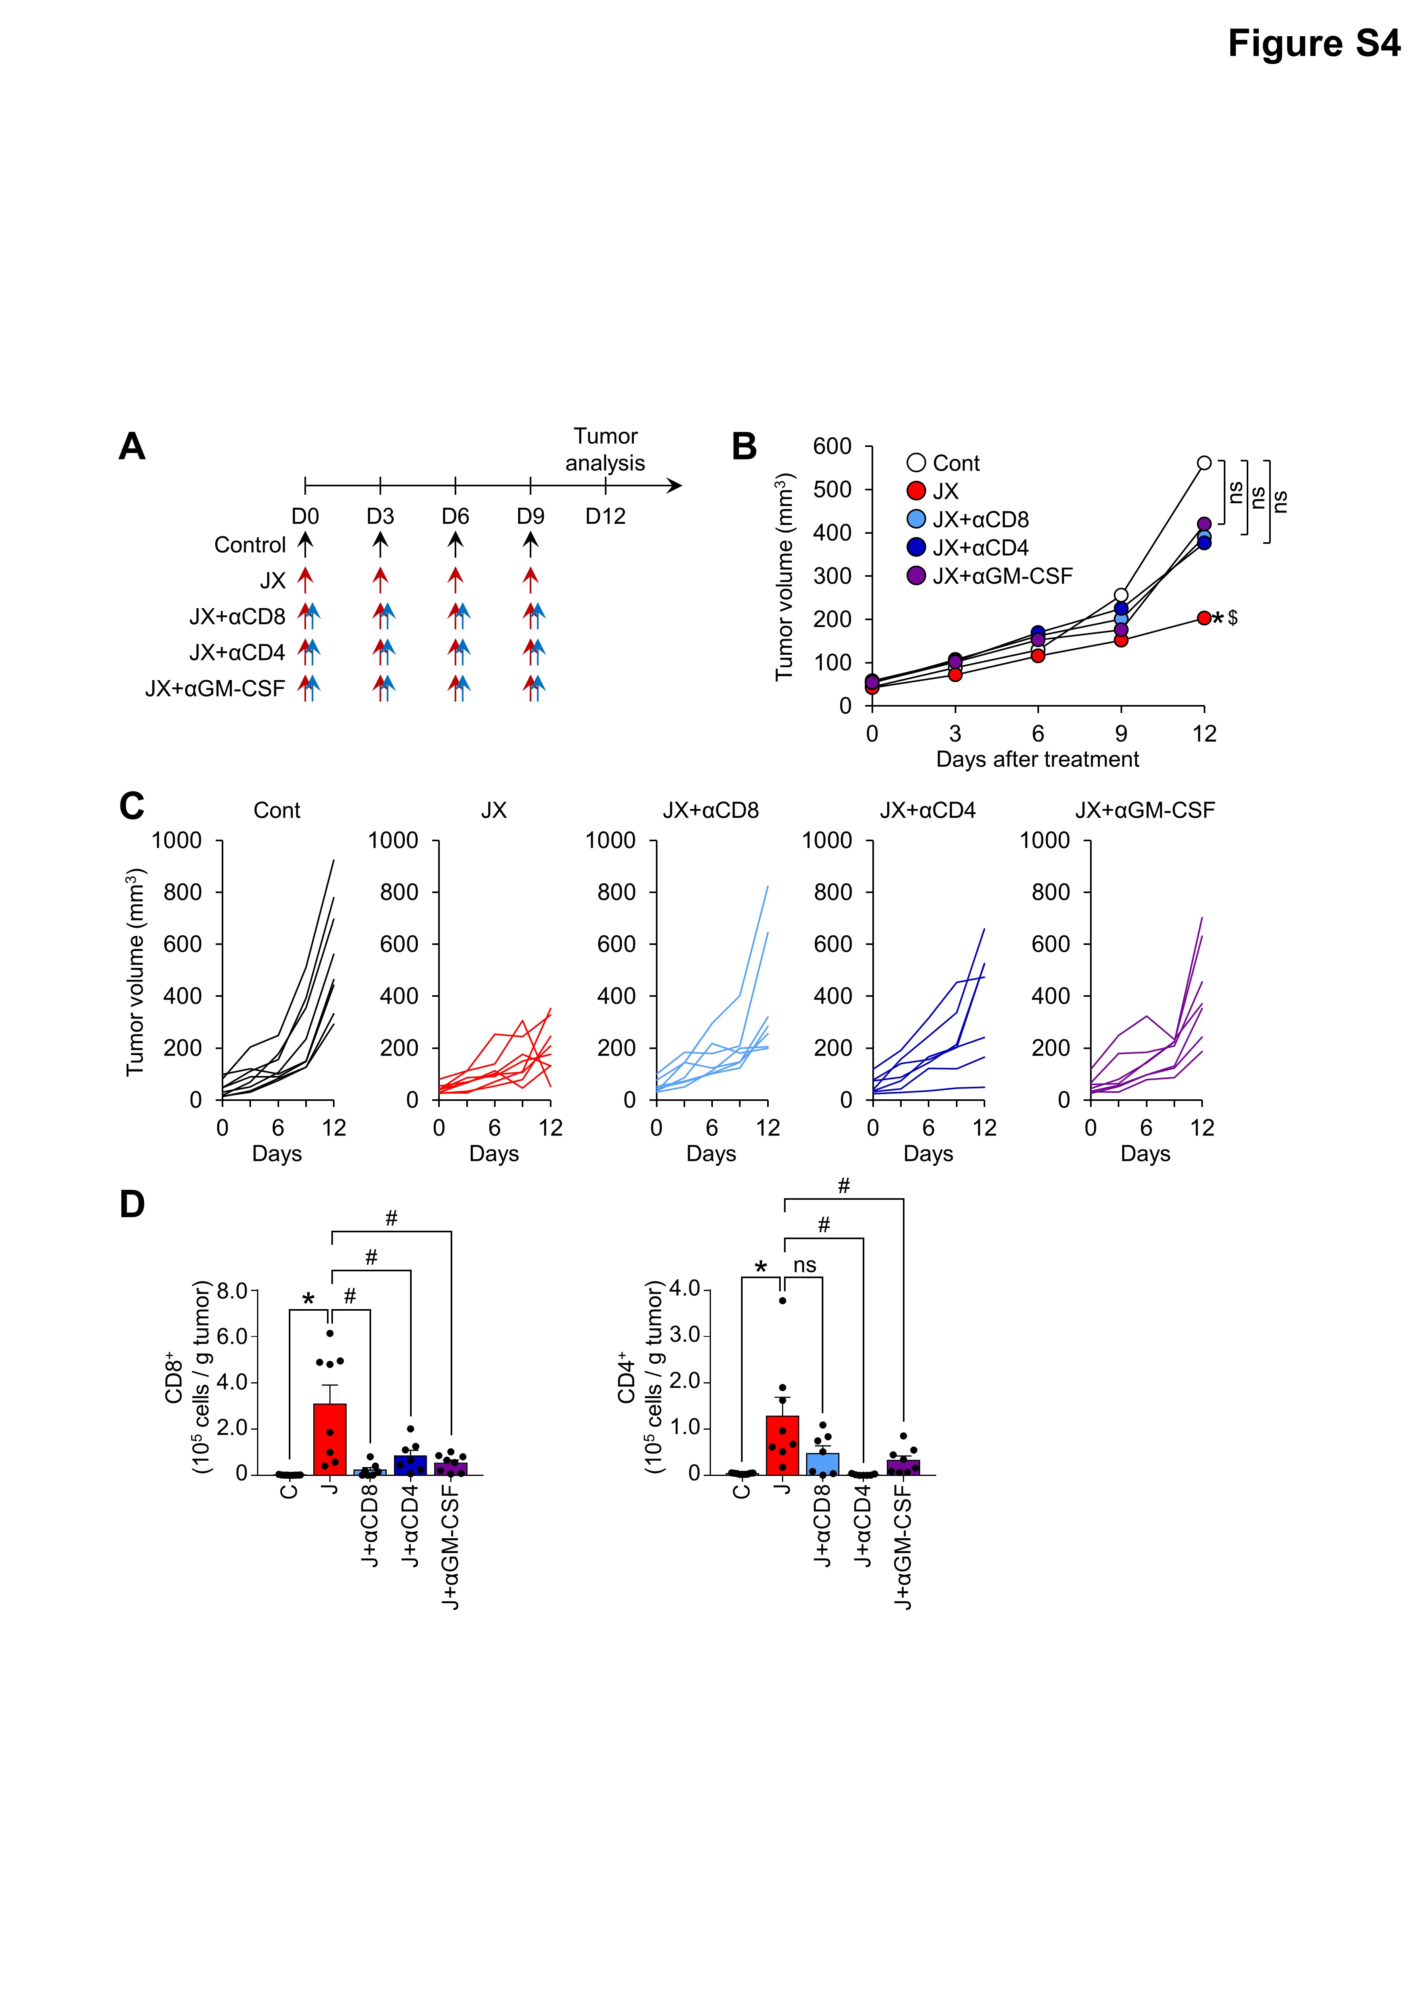
Supplementary Figure 4. Anti-tumor immunity plays an important role in the overall therapeutic efficacy of JX.
Mice were s.c. implanted with Renca and treated with or without JX and depleting antibodies for CD8⁺, CD4⁺ T cells or GM-CSF.
(A) Treatment scheme.
(B and C) Comparisons of tumor growth in mice. Mean (B) and individual (C) tumor growth curves over time.
(D) Absolute numbers of CD8⁺ and CD4⁺ T cells per gram of tumors treated with or without JX and depleting antibodies.
Pooled data from two experiments with 7-8 animals per group. Values are mean ± SEM. *p < 0.05 versus control; #p < 0.05 versus JX; $p < 0.05 versus αGM-CSF. ns, not significant. Two-tailed Student's t-test was used.

Supplementary Figure 5. Combination therapy of JX and αPD-1 improves ant-cancer effect.
Renca tumors were implanted s.c. and treated with or without JX and αPD-1.
(A) Representative images of CD31 immunohistochemical staining in H&E stained sections. Scale bars, 500 μm.
(B) Representative images of activated caspase3 (Casp3)⁺ apoptotic cells and PD-L1⁺ cells in peripheral region of tumor.
(C) Comparisons of tumor growth curve of treated Renca and untreated Renca tumor.
Unless otherwise denoted, n = 5 for each group. *p < 0.05 versus control; #p < 0.05 versus JX; $p < 0.05 versus αPD-1. Two-tailed Student's t-test was used. Scale bars, 100 μm.
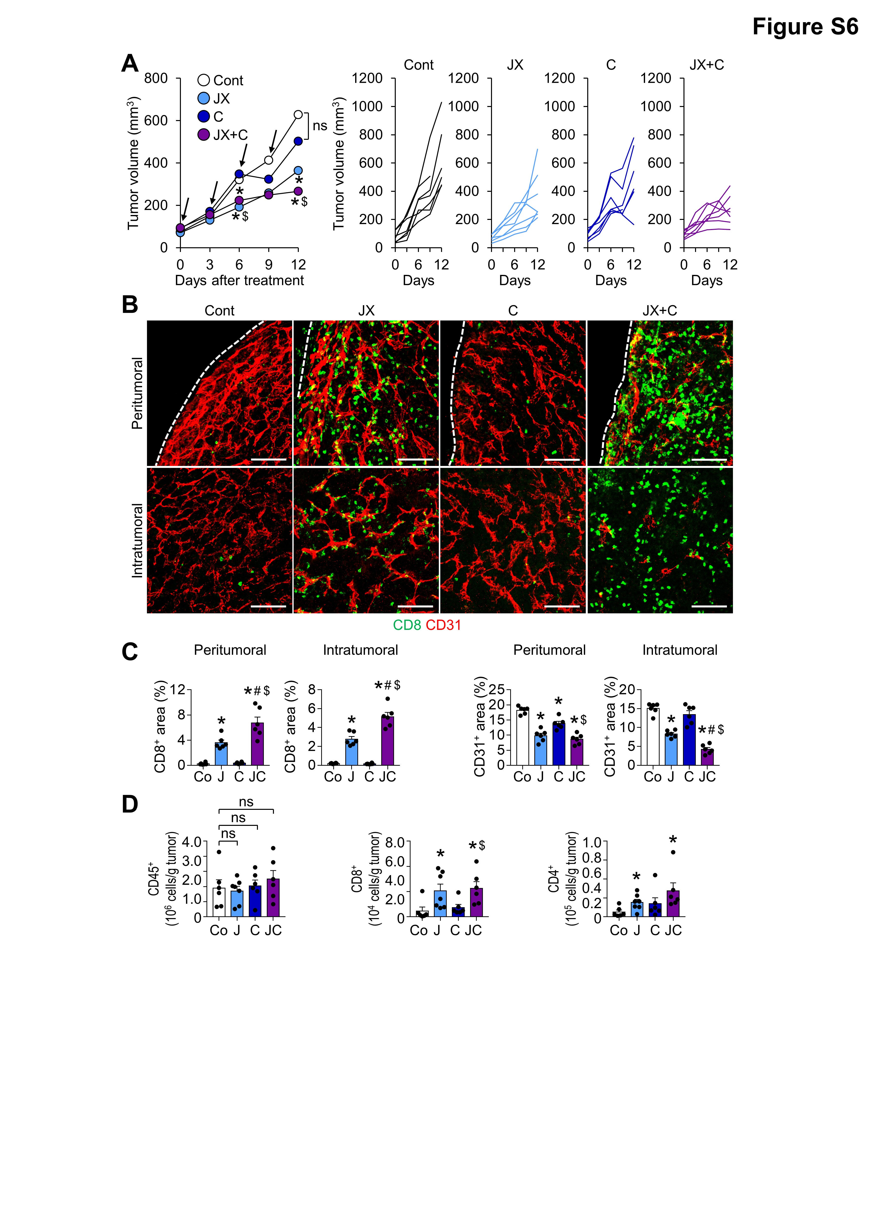
Supplementary Figure 6. Combination therapy of JX and αCTLA-4 further elicits CD8⁺ T cell-mediated anti-tumor immunity.
Mice bearing Renca tumors were treated with either PBS, JX, αCTLA-4, or JX plus αCTLA-4 on indicated days (arrows).
(A) Comparisons of tumor growth in mice. Mean and individual tumor growth curves over time.
(B and C) Representative images (B) and comparisons (C) of CD8⁺ T cells and CD31⁺ blood vessel in tumor.
(D) Absolute numbers of CD45⁺ immune cells, CD8⁺ T cells, and CD4⁺ T cells per gram of tumors.
Pooled data from two experiments with 7 animals per group. Values are mean ± SEM. *p < 0.05 versus control; #p < 0.05 versus JX; $p < 0.05 versus αCTLA-4. ns, not significant. Two-tailed Student's t-test was used. Scale bars, 100 μm.

Supplementary Figure 7. JX potentiates the anti-cancer efficacy and immune response by αCTLA-4 regardless of treatment schedules.
Renca tumor–bearing mice were treated with JX plus immune checkpoint inhibitors (ICIs) on various schedules. Schedule is shown on Figure 4A.
(A) Comparisons of tumor growth in mice treated with JX and αCTLA-4 using different timing schemes. Mean and individual tumor growth curves over time.
(B) Representative flow cytometric plots showing tumor-infiltrating CD8⁺ and CD4⁺ T cell fractions.
(C) Comparisons of absolute numbers of CD8⁺, CD4⁺, CD8⁺ICOS⁺, and CD8⁺GzB⁺ cells per gram of tumors.
Pooled data from two experiments with 7 animals per group. Values are mean ± SEM. *p < 0.05 versus control. ns, not significant. Two-tailed Student's t-test was used.

Supplementary Figure 8. Administration route of JX and the efficacy of concurrent combination therapy.
Renca tumor–bearing mice were treated with either intravenous (IV) or intratumoral (IT) JX with or without concurrent αPD-1.
(A) Representative images of tumoral JX expression (green).
(B) Comparisons of JX⁺ area. *p < 0.05 versus JX monotherapy.
n = 5 for each group. Values are mean ± SD. *p < 0.05 versus JX. ns, not significant. Two-tailed Student's t-test was used. Scale bars, 100 μm

Supplementary Methods

Histologic analysis
For hematoxylin and eosin (H&E) staining, tumors were fixed overnight in 4% paraformaldehyde (PFA). After tissue processing using standard procedures, samples were embedded in paraffin and cut into 3 μm sections followed by H&E staining. Immunofluorescence was performed on frozen tissue sections. Tumors were fixed in 1% PFA at room temperature and were rinsed several times with PBS, infiltrated with 30% sucrose, and frozen in OCT compound. Frozen sections (50 μm thick) were blocked with 5% normal goat serum in PBS-T (0.1% triton X-100 in PBS) and then incubated overnight with the following primary antibodies: anti-vaccinia virus (rabbit, Abcam), anti-CD31 (hamster, clone 2H8, Millipore; rabbit, Abcam), anti-CD8 (rat, clone 53-6.7, BD Pharmingen), anti-CD11c (hamster, clone HL3, BD Pharmingen), anti-PD-L1 (rabbit, clone 28-8, Abcam), anti-Caspase3 (rabbit, R&D Systems), anti-Pan-Cytokeratin (mouse, clone AE1/AE3, DAKO), anti-CD11b (rat, clone M1/70, BD Pharmingen) or anti-CD3e (hamster, clone 145-2C11, BD Pharmingen). After several washes, the samples were incubated for 2 h at room temperature with the following secondary antibodies: FITC-, Cy3-, or Cy5-conjugated anti-rabbit IgG (Jackson ImmunoResearch), FITC-conjugated anti-rat IgG (Jackson ImmunoResearch), FITC- or Cy3-conjugated anti-hamster IgG (Jackson ImmunoResearch), or FITC-conjugated anti-mouse IgG (Jackson ImmunoResearch). Cell nuclei were counterstained with 4’,6-diamidino-2-phenylindole (DAPI, Invitrogen). Finally, samples were mounted with fluorescent mounting medium (DAKO) and images were acquired with a Zeiss LSM 880 microscope (Carl Zeiss).

Immunohistochemistry (IHC)
Tissues were fixed by immersion in a 4% paraformaldehyde (PFA), embedded with paraffin, from which thick tissue sections were cut at 3 μm. For immunohistochemistry (IHC) analysis, slides were performed by initial 55°C incubation, deparaffinization in xylene, and rehydration in decreasing alcohol concentrations. Endogenous peroxidases were quenched by incubating in 3% H₂O₂ for 10 min. And then, the retrieval of antigen was done for 2 min by placing the slides in target retrieval solution (Dako, Carpinteria, CA, USA). Antibody dilutions used were CD31 1:100 (rabbit, clone 2H8, Abcam) in antibody dilution buffer with background reducing components (Dako, Carpinteria, CA, USA). After, the slides were incubated with EnVisionTM detection system (Dako, Carpinteria, CA, USA). Visualization was performed using the 3, 3-diaminobenzidine tetrahydro-chloride (DAB; Dako, Carpinteria, CA, USA). The slides were counterstained with hematoxylin for 7 min, dehydrated which graded alcohols, and then determined under microscopy.

Morphometric analysis
Density measurements of vaccinia virus, blood vessels, T lymphocytes, dendritic cells, apoptotic cells, and PD-L1⁺ cell area, were performed using ImageJ software (http://rsb.info.nih.gov/ij). To determine the level of vaccinia virus infection, VV⁺ area per random 0.49 mm² field was calculated in tumor sections. For blood vessel density, CD31⁺ area per random 0.49 mm² field was calculated in peri- and intratumoral regions. The degree of cytotoxic T lymphocyte infiltration was presented as the percentage CD8⁺ area per random 0.49 mm² field in peri- and intratumoral regions. The density of dendritic cells were measured by calculating the percentage CD11c⁺ area in random 0.49 mm² fields. The extent of apoptosis was shown as the percentage Caspase3⁺ area per random 0.49 mm² fields. To define PD-L1⁺ cells, co-localization of PD-L1⁺ with Pan-CK⁺, CD11b⁺, or CD3⁺ was identified in random 0.01 mm² field. Lung metastasis in MMTV-PyMT mice was quantified by counting tumor colonies >100 μm in diameter. All measurements were performed in at least 5 fields per mouse.

Flow cytometric analysis of tumor-infiltrating immune cells
Tumors from each treatment group were minced prior to shaking incubation for 1 h at 37°C in a mix of collagenase D (20 mg/ml, Roche) and DNase I (2 mg/ml, Roche). Cell suspensions were generated by repeated pipetting, and then filtered through a 70 μm cell strainer and lysed to remove red blood cells. After washing with PBS, resuspended cells were filtered through a nylon mesh. Single cell suspensions from tumor tissues were blocked with an antibody against CD16/32 (clone 2.4G2, BD Pharmingen) and stained with a fixable viability dye (eFlouor450, eBioscience) to distinguish the live cells. For analysis of surface markers, cells were stained in PBS containing 1% FBS, with antibodies targeting CD45 (30-F11, BD Pharmingen), CD4 (RM4-5, BD Pharmingen), CD8 (53-6.7, BD Pharmingen), CD3 (17A2, eBioscience), ICOS (7E.17G9, eBioscience), CD25 (PC61.5, eBioscience), CD11b (M1/70, BD Pharmingen), F4/80 (BM8, eBioscience), MHC II (M5/114.15.2, eBioscience), Ly6C (HK1.4, eBioscience), Ly6G (1A8-Ly6g or RB6-8C5, eBioscience) or CD206 (MR5D3, eBioscience), for 30 min on ice. Cells were further permeabilized using a FoxP3 fixation and permeabilization kit (eBioscience), and stained for FoxP3 (FJK-16s, eBioscience) or Granzyme B (NGZB, eBioscience). Labeled cells were acquired using a CytoFLEX flow cytometer (Beckman Coulter) and analyzed using FlowJo software (Tree Star Inc., Ashland, OR).

IFN-ɣ enzyme-linked immunospot (ELISPOT) assay
For quantification of tumor-specific cytotoxic T cells, splenocytes and TILs from each group were isolated 3 days after the final treatments. Cells were labeled with anti-CD8a microbeads (Miltenyi Biotec, Auburn, CA) according to the manufacturer’s instructions and purified using MACS (Miltenyi Biotec, Auburn, CA). CD8⁺ T cells were enriched to >90% purity for all experiments. Purified CD8⁺ T cells were co-cultured with Renca tumor cells at a 10:1 ratio in 96-well plates precoated with mouse IFN-ɣ (Mabtech, Inc.). After being washed, plates were incubated with 1 μg/ml of the biotinylated anti-mouse IFN-ɣ antibody R4-6A2-biotin for 2 h at room temperature. A streptavidin-ALP solution was then added, followed by incubation for 1 h at room temperature. After the addition of BCIP/NBT-plus substrate solution, spots were analyzed using ImageJ software.

In vivo administration route analysis
BALB/c mice were subcutaneously implanted in the right flank with 2 × 10⁵ Renca cells. Once a palpable tumor developed, a total of 1 × 10⁷ plaque-forming units (pfu) of JX was administered into mice by intratumoral or intravenous injection concurrently with or without anti-PD-1 (10 mg/kg, clone J43, BioXCell) antibody. After 4 days, mice were anesthetized, and tissues were collected for further analyses.

RNA isolation and NanoString gene expression analysis
Total RNA was extracted from whole tumor lysates using TRIzol (Invitrogen) and purified with ethanol; RNA quality was confirmed using a Fragment Analyzer instrument (Advanced Analytical Technologies, IA, USA). Immune profiling was performed with a digital multiplexed NanoString nCounter PanCancer Immune Profiling mouse panel (NanoString Technologies) using 100 ng of total RNA isolated from tumor tissues. Hybridizations were carried out at 65°C for 16-30 h by combining 5 μl of each RNA sample with 8 μl of nCounter Reporter probe in hybridization buffer and 2 μl of nCounter Capture probes for a total reaction volume of 15 μl. Excess probe was removed by two-step magnetic bead-based purification using the nCounter Prep Station (NanoString Technologies). Specific target molecule abundance was quantified with the nCounter Digital Analyzer by counting individual fluorescent barcodes and assessing the corresponding target molecules. For each assay, a high-density scan encompassing 280 fields of view was performed. Data were collected using the nCounter Digital Analyzer after acquiring images of the immobilized fluorescent reporters in the sample cartridge with a CCD camera. Data analysis was performed using nSolver software (NanoString Technologies). The mRNA profiling data was normalized by housekeeping genes and analyzed using R software (www.r-project.org).

