Supplementary Tables and Figures

Supplementary Table 1. Top 30 differentially expressed genes between V600E and V600K mutant melanomas (nanostring).

geneSymbol | logFC | AveExpr | t | P.Value | adj.P.Val | B
DUSP6 | 1.093248 | 11.087046 | 4.392472 | 2.949E-05 | 0.02400718 | 1.937835
ETS1 | -0.75632 | 9.2882729 | -3.79274 | 0.0002639 | 0.10740773 | 0.175064
ETV4 | 1.455176 | 8.4998006 | 3.446136 | 0.0008543 | 0.23179737 | -0.76304
ALDH1B1 | 1.029451 | 7.1760882 | 3.1431 | 0.0022415 | 0.40328281 | -1.52727
Wnt3 | 1.402862 | 4.2011239 | 3.110585 | 0.0024772 | 0.40328281 | -1.60605
GCNT1 | 0.972424 | 5.9155856 | 3.031305 | 0.0031517 | 0.4275831 | -1.79543
PIK3CB | -0.67063 | 8.0043331 | -2.73648 | 0.007431 | 0.68847247 | -2.4647
JUN | -0.61588 | 7.6461292 | -2.71903 | 0.0078037 | 0.68847247 | -2.50258
SFRP1 | 2.389482 | 8.2153922 | 2.690373 | 0.0084571 | 0.68847247 | -2.56466
RET | -0.97839 | 1.0404869 | -2.64456 | 0.0095974 | 0.68847247 | -2.66225
KDM4D | -0.79621 | 4.1646853 | -2.59609 | 0.0109528 | 0.68847247 | -2.7639
FGF1 | 1.521741 | 4.7644421 | 2.59033 | 0.0111261 | 0.68847247 | -2.77594
EPHA2 | 1.013922 | 7.3254063 | 2.579234 | 0.0114647 | 0.68847247 | -2.79896
GPNMB | -0.89339 | 12.786077 | -2.55255 | 0.0123176 | 0.68847247 | -2.85397
DUSP4 | 0.786288 | 10.838461 | 2.541478 | 0.0126868 | 0.68847247 | -2.87661
MRE11A | -0.58244 | 6.532016 | -2.49815 | 0.0142292 | 0.72390825 | -2.96439
Wnt2B | -0.94011 | 2.5805589 | -2.428 | 0.0171005 | 0.81881154 | -3.10425
CD226 | -0.85039 | 4.9180096 | -2.38006 | 0.0193445 | 0.83946273 | -3.19772
ITGAX | -0.59273 | 8.1687041 | -2.37489 | 0.0195943 | 0.83946273 | -3.20752
TYRP1 | -3.38685 | 7.6809201 | -2.33872 | 0.021485 | 0.85427188 | -3.277
PLCB4 | 1.937507 | 5.0876119 | 2.321872 | 0.0224161 | 0.85427188 | -3.30898
DOT1L | 0.352341 | 8.8823709 | 2.281672 | 0.0247752 | 0.85427188 | -3.38429
SPRY2 | 0.739135 | 9.2970567 | 2.280686 | 0.0248435 | 0.85427188 | -3.38627
KIT | -1.61158 | 5.1888555 | -2.25813 | 0.0262686 | 0.85427188 | -3.42809
CSNK1G2 | 0.309151 | 8.2594189 | 2.254061 | 0.0265253 | 0.85427188 | -3.43546
STRA6 | 1.812438 | 4.1268084 | 2.230601 | 0.0281047 | 0.85427188 | -3.47863
CCL28 | -0.86092 | 7.2055077 | -2.20966 | 0.0295754 | 0.85427188 | -3.5167
CDX4 | -0.91493 | 1.366066 | -2.20812 | 0.0296863 | 0.85427188 | -3.51949
HLA-E | -0.50953 | 12.051143 | -2.19108 | 0.0309284 | 0.85427188 | -3.5501
BCL2 | -0.60528 | 7.5775725 | -2.1728 | 0.0323237 | 0.85427188 | -3.58289

Supplementary Table 2. Top 30 genes differentially mutated between V600E and V600K mutant melanomas (NGS).

Gene  Symbol | Total  Counts | Mean  Counts | brafV600E  totalCounts | brafV600K  totalCounts | brafV600E  meanCounts | brafV600K  meanCounts | brafK-brafE  meanCounts | fisher  Pvalue
BRAF | 93 | 1 | 78 | 15 | 1 | 1 | 0 | NA
TP53 | 25 | 0.268817204 | 19 | 6 | 0.243589744 | 0.4 | 0.156410256 | 0.219104191
APC | 25 | 0.268817204 | 20 | 5 | 0.256410256 | 0.333333333 | 0.076923077 | 0.537328667
FBXW7 | 15 | 0.161290323 | 11 | 4 | 0.141025641 | 0.266666667 | 0.125641026 | 0.254065852
EGFR | 13 | 0.139784946 | 9 | 4 | 0.115384615 | 0.266666667 | 0.151282051 | 0.213765762
PIK3CA | 10 | 0.107526882 | 9 | 1 | 0.115384615 | 0.066666667 | -0.048717949 | 1
PTEN | 10 | 0.107526882 | 10 | 0 | 0.128205128 | 0 | -0.128205128 | 0.356712316
PIK3R1 | 8 | 0.086021505 | 5 | 3 | 0.064102564 | 0.2 | 0.135897436 | 0.115833108
NF2 | 7 | 0.075268817 | 5 | 2 | 0.064102564 | 0.133333333 | 0.069230769 | 0.314446392
SMARCA4 | 6 | 0.064516129 | 3 | 3 | 0.038461538 | 0.2 | 0.161538462 | 0.051102847
SMAD4 | 6 | 0.064516129 | 4 | 2 | 0.051282051 | 0.133333333 | 0.082051282 | 0.247594171
GNAQ | 6 | 0.064516129 | 6 | 0 | 0.076923077 | 0 | -0.076923077 | 0.584561199
KIT | 4 | 0.043010753 | 2 | 2 | 0.025641026 | 0.133333333 | 0.107692308 | 0.120617111
HRAS | 4 | 0.043010753 | 3 | 1 | 0.038461538 | 0.066666667 | 0.028205128 | 0.51145395
STK11 | 4 | 0.043010753 | 4 | 0 | 0.051282051 | 0 | -0.051282051 | 1
RB1 | 3 | 0.032258065 | 2 | 1 | 0.025641026 | 0.066666667 | 0.041025641 | 0.413744741
BRCA1 | 3 | 0.032258065 | 3 | 0 | 0.038461538 | 0 | -0.038461538 | 1
NF1 | 3 | 0.032258065 | 3 | 0 | 0.038461538 | 0 | -0.038461538 | 1
RET | 2 | 0.021505376 | 1 | 1 | 0.012820513 | 0.066666667 | 0.053846154 | 0.298036466
CDKN2A | 2 | 0.021505376 | 2 | 0 | 0.025641026 | 0 | -0.025641026 | 1
FGFR3 | 2 | 0.021505376 | 2 | 0 | 0.025641026 | 0 | -0.025641026 | 1
VHL | 2 | 0.021505376 | 2 | 0 | 0.025641026 | 0 | -0.025641026 | 1
KRAS | 2 | 0.021505376 | 2 | 0 | 0.025641026 | 0 | -0.025641026 | 1
CSMD1 | 2 | 0.021505376 | 2 | 0 | 0.025641026 | 0 | -0.025641026 | 1
BRCA2 | 2 | 0.021505376 | 2 | 0 | 0.025641026 | 0 | -0.025641026 | 1
PDGFRA | 1 | 0.010752688 | 1 | 0 | 0.012820513 | 0 | -0.012820513 | 1
CTNNB1 | 1 | 0.010752688 | 1 | 0 | 0.012820513 | 0 | -0.012820513 | 1
AKT2 | 1 | 0.010752688 | 1 | 0 | 0.012820513 | 0 | -0.012820513 | 1
MET | 1 | 0.010752688 | 1 | 0 | 0.012820513 | 0 | -0.012820513 | 1

Supplementary Figure 1

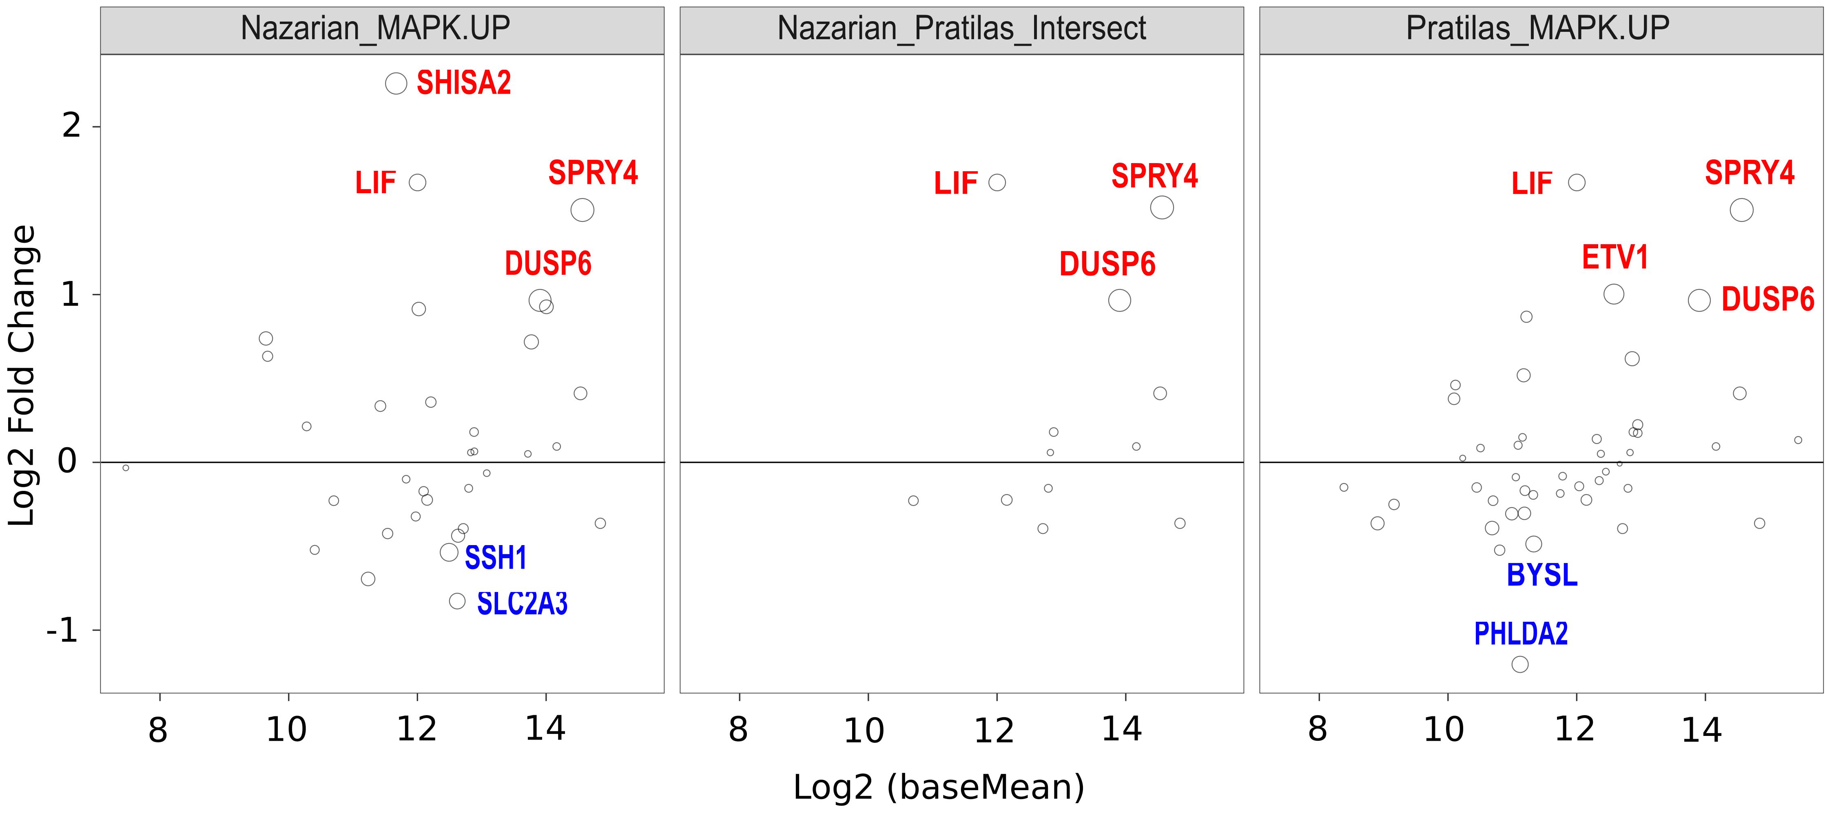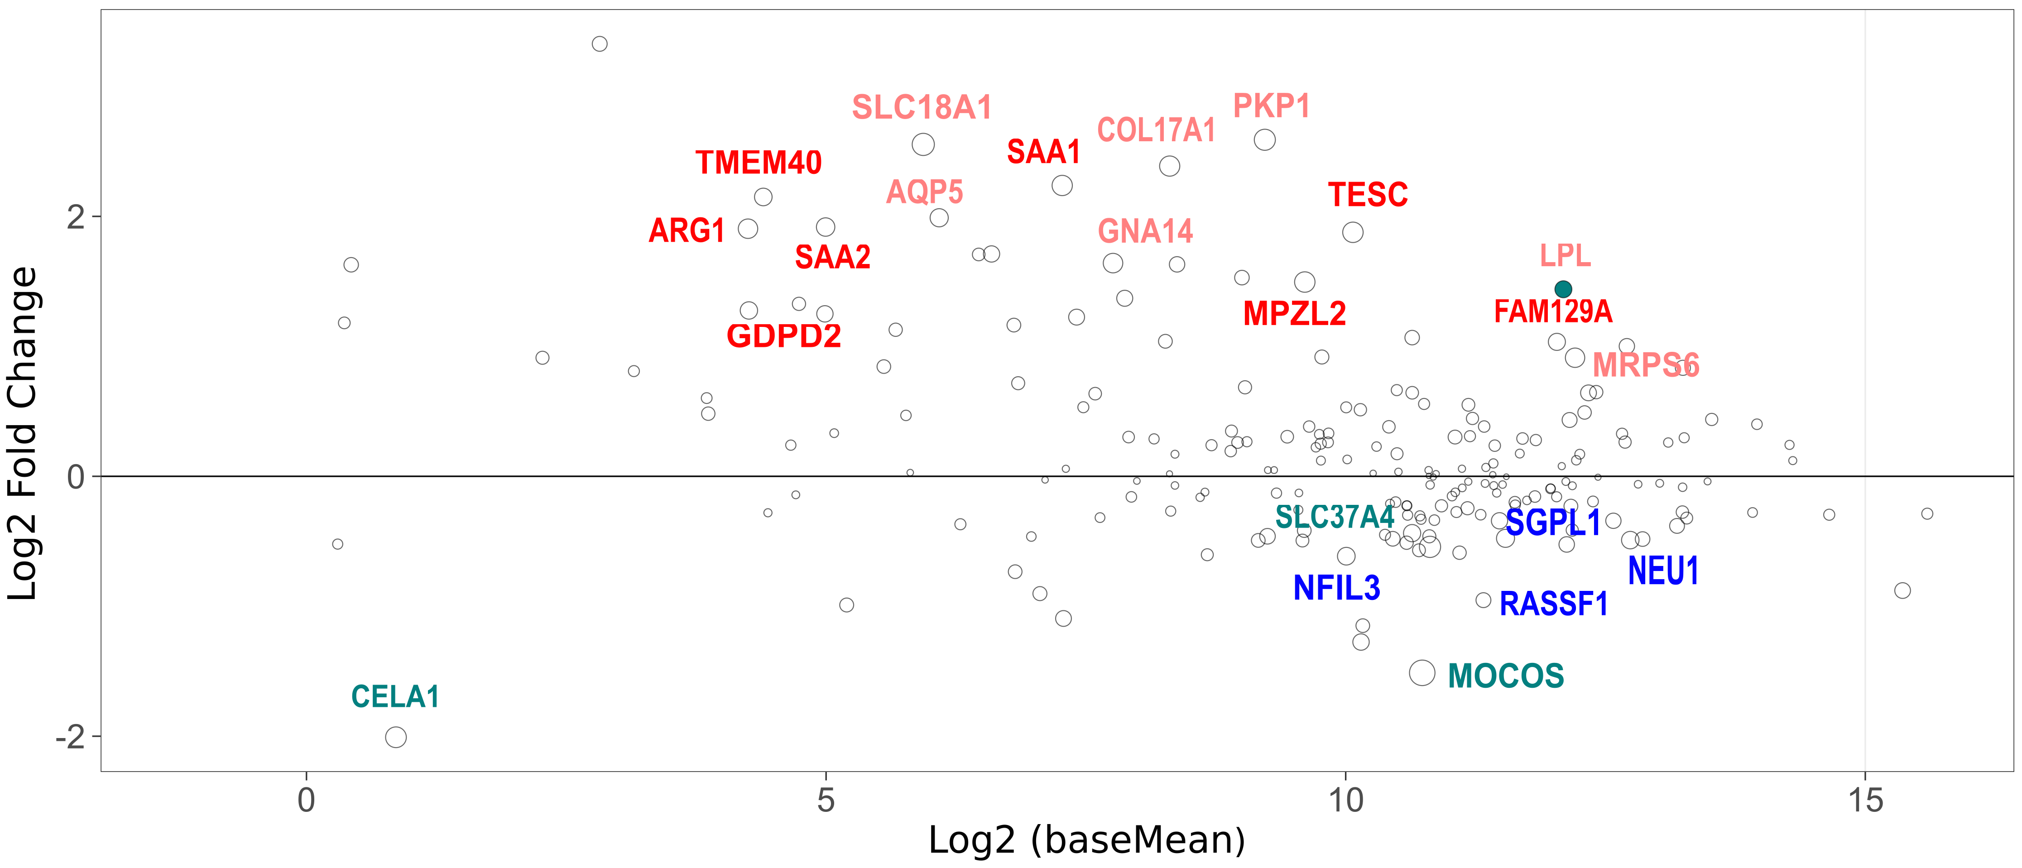

Supplementary Figure 1. RNAseq pathway analysis (TCGA data): Upper panel, Expression of ERK pathway genes in V600E versus V600K melanoma, using Nazarian and Pratilas genesets; and Lower panel, Expression of PI3K-AKT pathway genes in V600E versus V600K melanoma (downSet – light red/blue; upSet – dark red/blue). Hotelling T2 test was used for the comparison of the mean expression for ERK (Upper panel) and PI3K-AKT (Lower panel) genes between V600E and V600K groups. Genes above the line are significantly more expressed in V600E (red) compared to V600K(blue)-mutant melanoma, and that expression increases from the left to the right in the plot.

Supplementary Figure 2

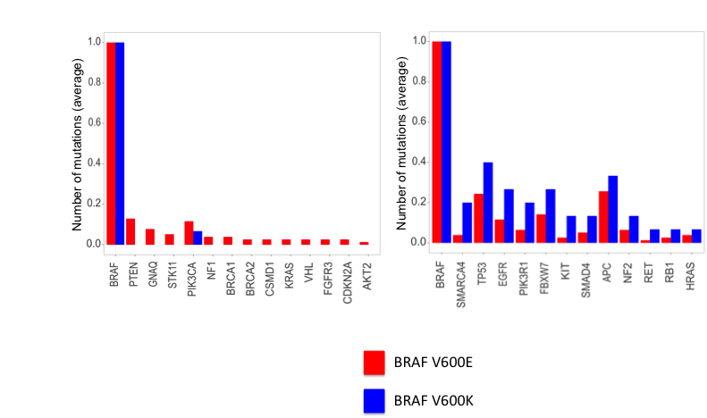

Supplementary Figure 2. Frequency of mutations per gene between V600E (red) and V600K (blue) melanoma (NGS data). Left panel, genes more mutated in V600E; Right panel, genes more mutated in V600K.

Supplementary Figure 3

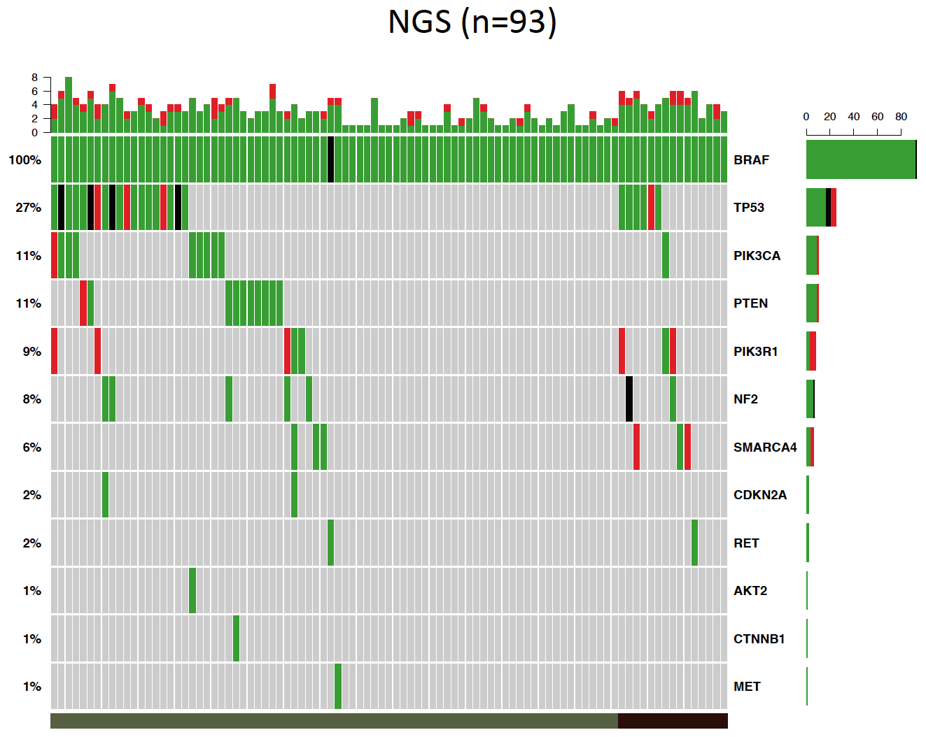

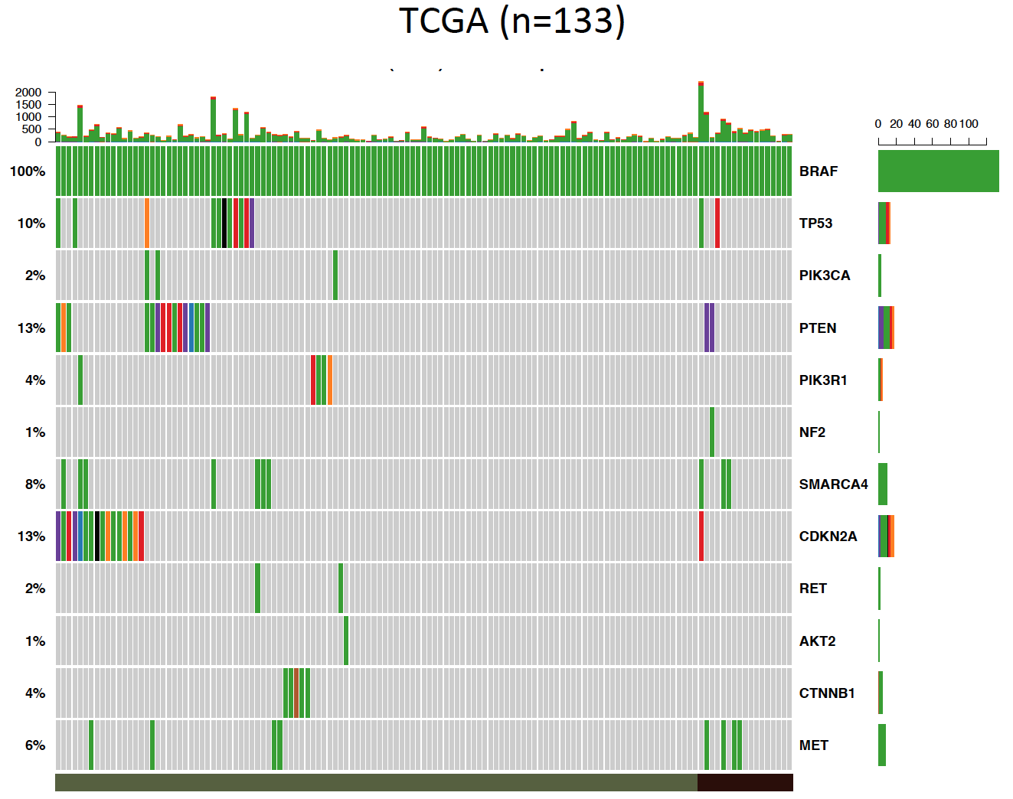

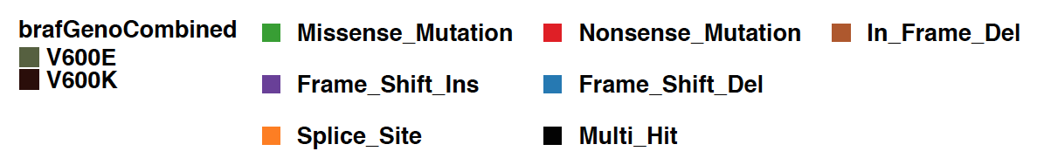

Supplementary Figure 3. Oncoplot of mutations in V600E and V600K melanoma. Frequency of mutations per gene in the NGS (upper panel) and TCGA (lower panel) cohorts.
Supplementary Figure 4

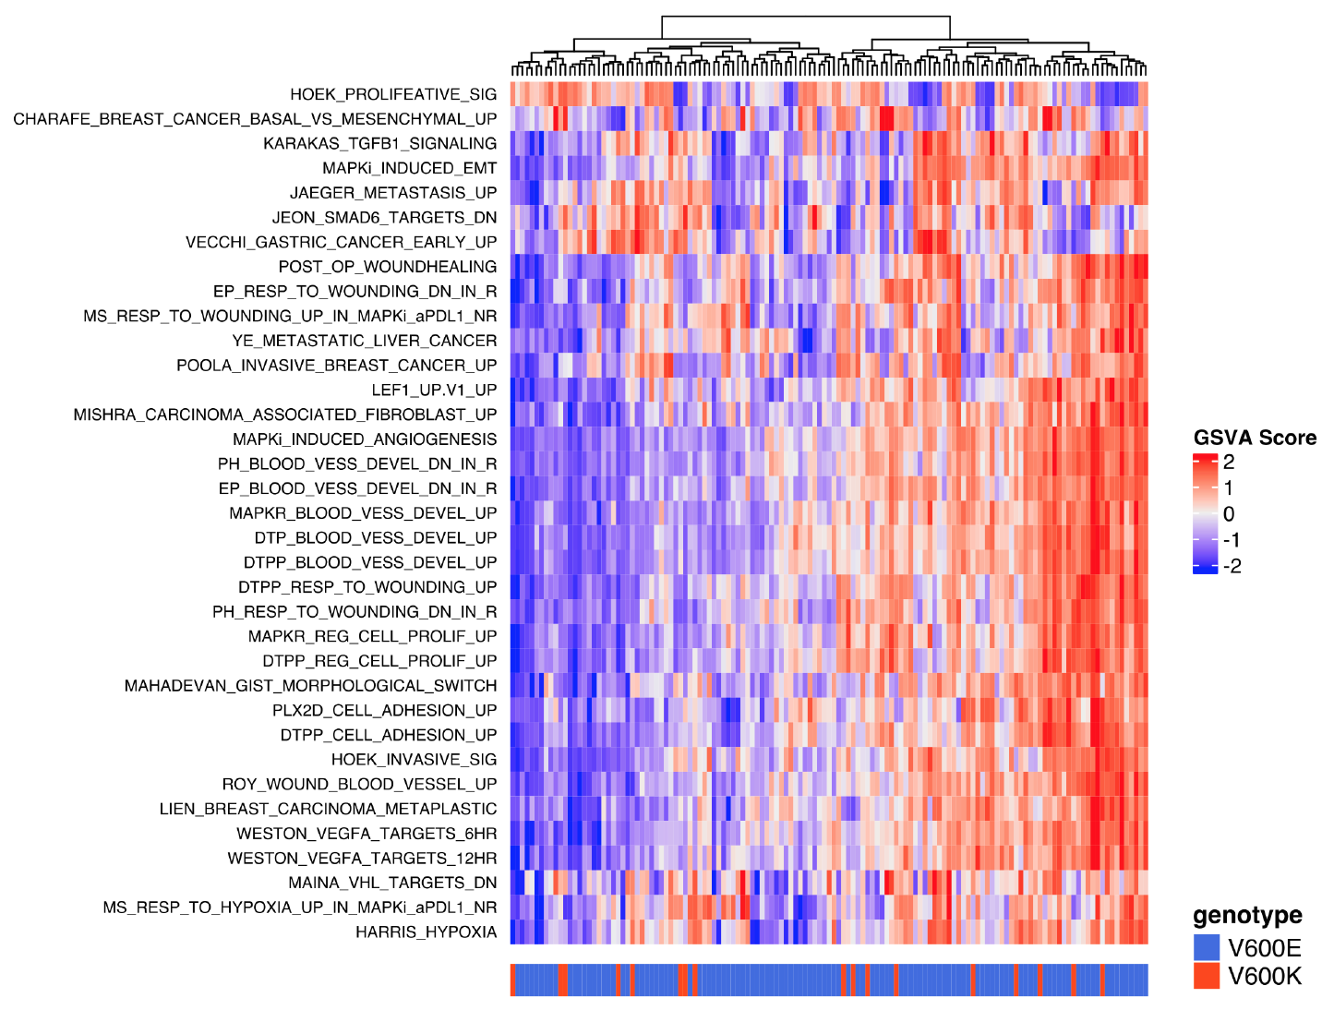

Supplementary Figure 4. Heatmap showing the Gene Set Variance Analysis (GSVA) scores of gene signatures in the V600E versus V600K mutant melanomas (TCGA dataset).

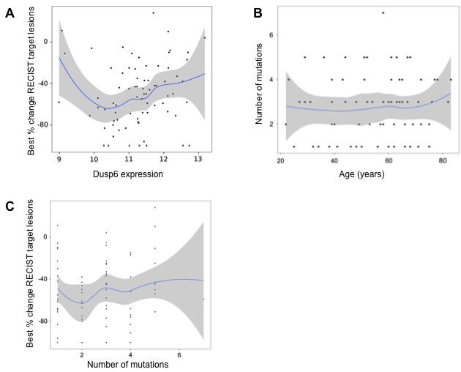

Supplementary Figure 5. Spectrum of BRAF V600E-mutant melanomas. A. Association between DUSP6 expression and response (best % tumor change from baseline); B. Association between mutational burden and age; and C. Association between mutational burden and response (best % tumor change from baseline), in V600E-mutant melanomas

