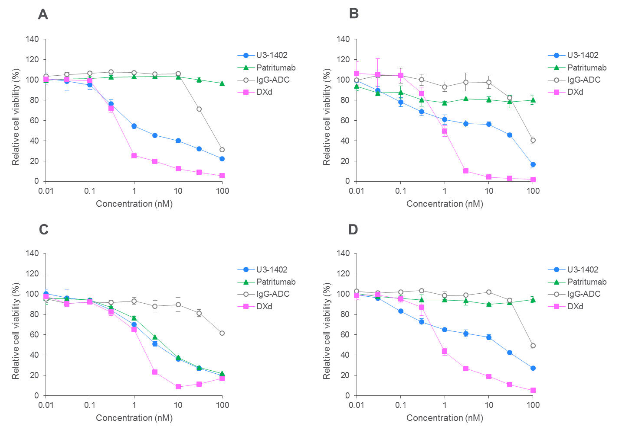

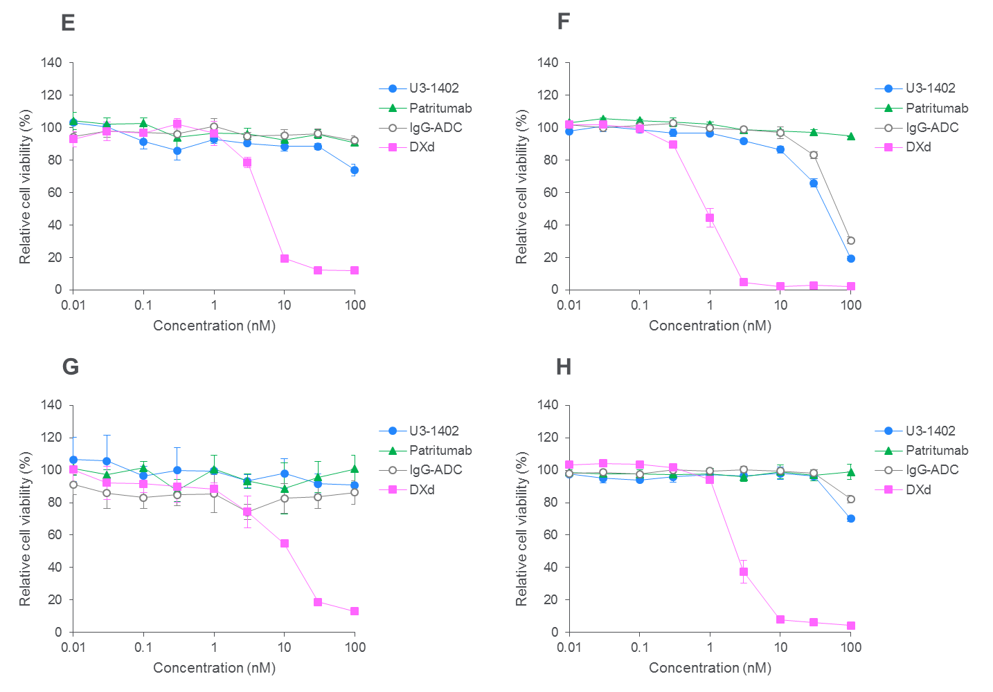

Supplementary Figure 2. Growth inhibition activity in 8 cell lines with different HER3 expression levels. A, HCC1569. B, SK-BR-3. C, MDA-MB-175VII. D, MDA-MB-453. E, MDA-MB-361. F, OVCAR-8. G, JIMT-1. H, MDA-MB-231. The cells were treated with U3-1402, patritumab, IgG-ADC, and DXd for 6 days. Each point represents the mean and SD (N=3).

