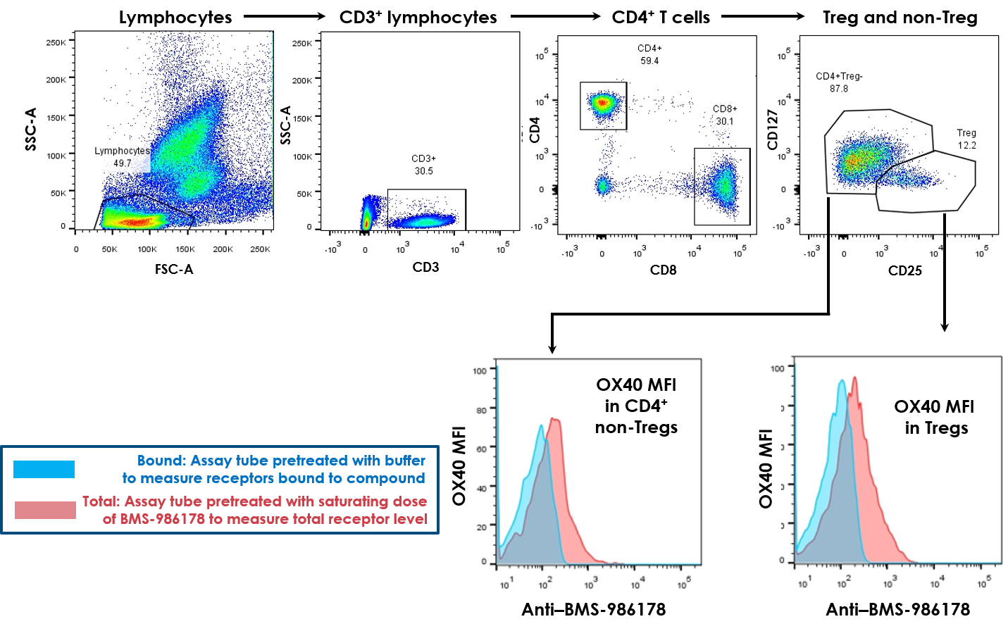

**Supplementary Fig. S1. Gating strategy used in clinical flow cytometric analysis to measure OX40 RO in peripheral T cells and Tregs in patients treated with BMS-986178.** FSC, forward scatter; SSC, side scatter.

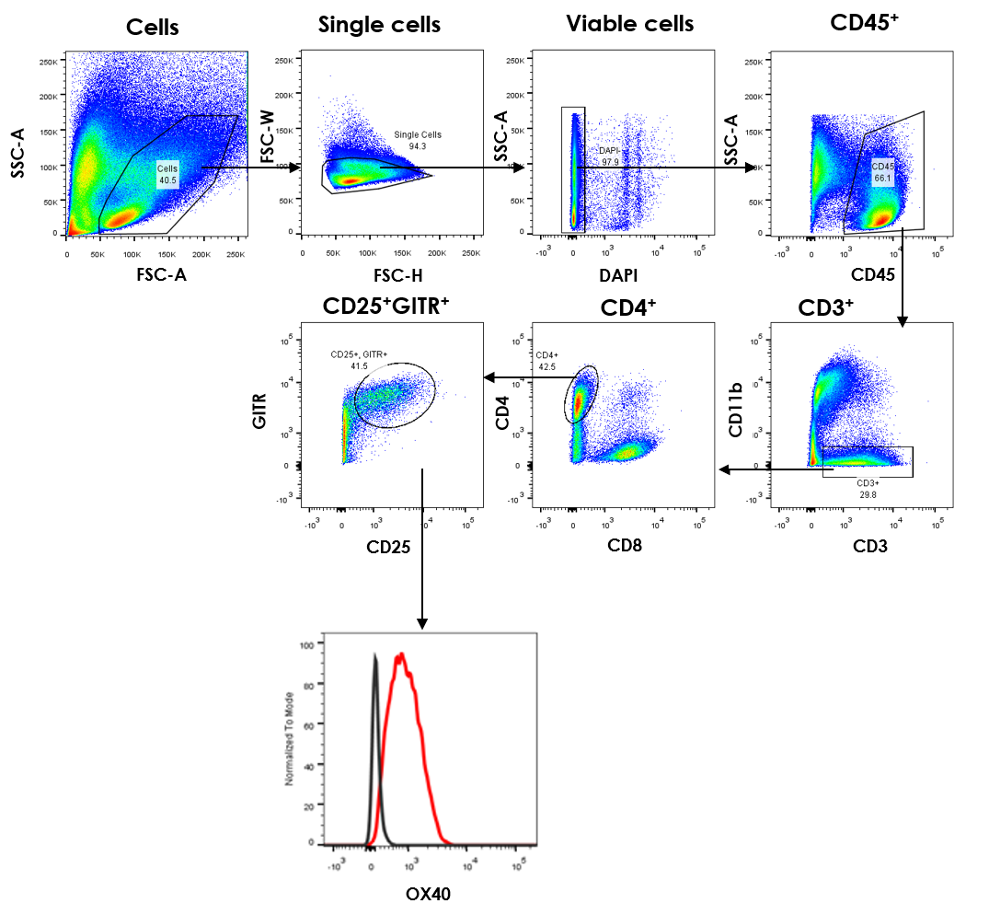

**Supplementary Fig. S2. Gating strategy used in flow cytometric analysis to measure OX40 RO in murine syngeneic model.**

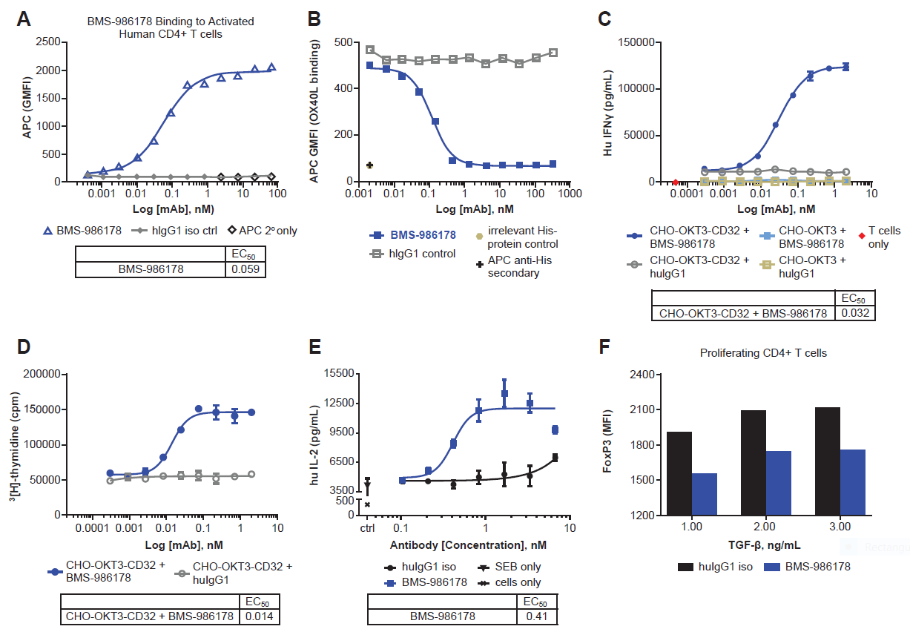

**Supplementary Fig. S3. Characterization of BMS-986178.** **(A)** Human CD4+ T cells were activated by anti-CD3/CD28 and then BMS-986178 binding to T cells was assessed by flow cytometry. **(B)** Soluble human OX40L-his fusion protein was incubated with activated human CD4+ T cells and then blocking of OX40:OX40L interactions by BMS-986178 was assessed by flow cytometry. **(C and D)** Human CD4+ T cells were incubated with CHO cells expressing human anti-CD3 (OKT3) ± CD32a (to allow FcR cross-linking) and indicated doses of BMS-986178. IFN-γ production by T cells was measured by ELISA (C) and T cell proliferation was measured by 3[H]-thymidine incorporation (D). (**E**) Human PBMCs were stimulated by superantigen with either IgG1 isotype or BMS-986178 in the presence of soluble F(ab’)2 cross link antibody IL-2 production was measured by ELISA. (**F**) CFSE-labeled naive CD4+ T cells were stimulated with plate-bound anti-CD3 in the present of isotype control or BMS-986178 with cross like secondary antibody at indicated TGFβ concentrations. TGFβ–mediated induction of FOXP3 expression was measured by flow cytometry.

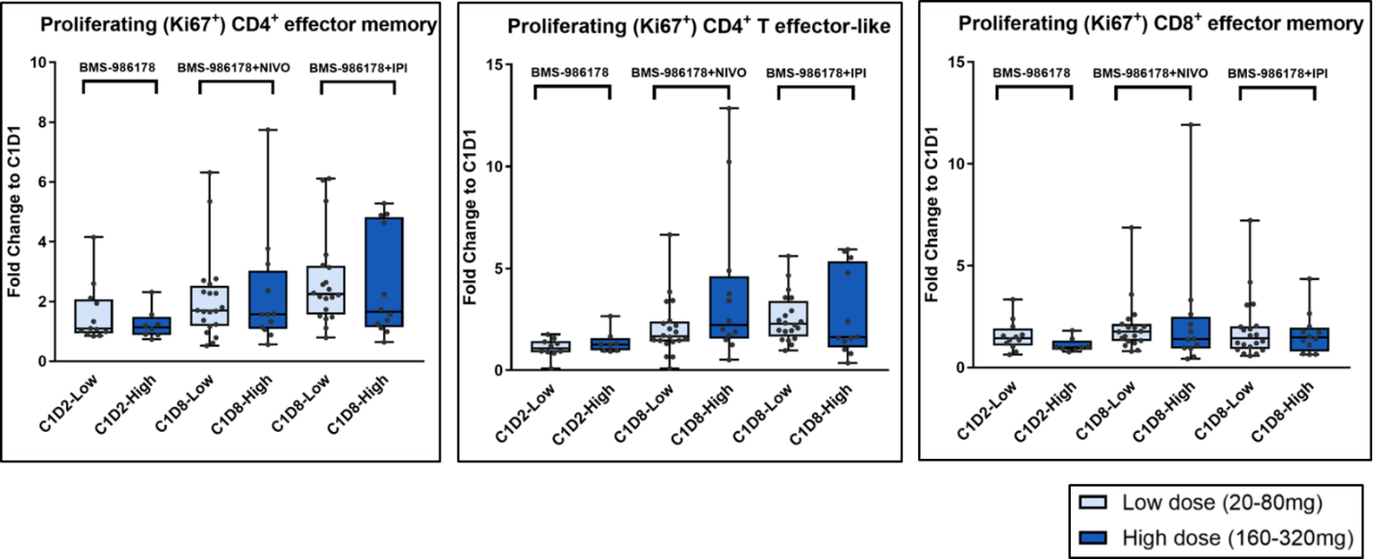

**Supplementary Fig. S4.** **BMS-986178 ± nivolumab or ipilimumab increased levels of proliferating (Ki67+) CD4+ and CD8+ populations in patients with advanced solid tumors.** Graph shows fold increase in (Ki67+) CD4+ and CD8+ T-cell populations (posttreatment compared with baseline). **(A)** Ki67+CD4+ effector memory cells, **(B)** Ki67+CD38+HLA-DR+CD4+ effector cells, and **(C)** Ki67+CD8+ effector memory cells in patient peripheral blood at C1D2 of BMS-986178 monotherapy cohort and C1D8 of NIVO or IPI combination cohorts. See Fig. 1 for modulation at other time points. IPI, ipilimumab; NIVO, nivolumab.

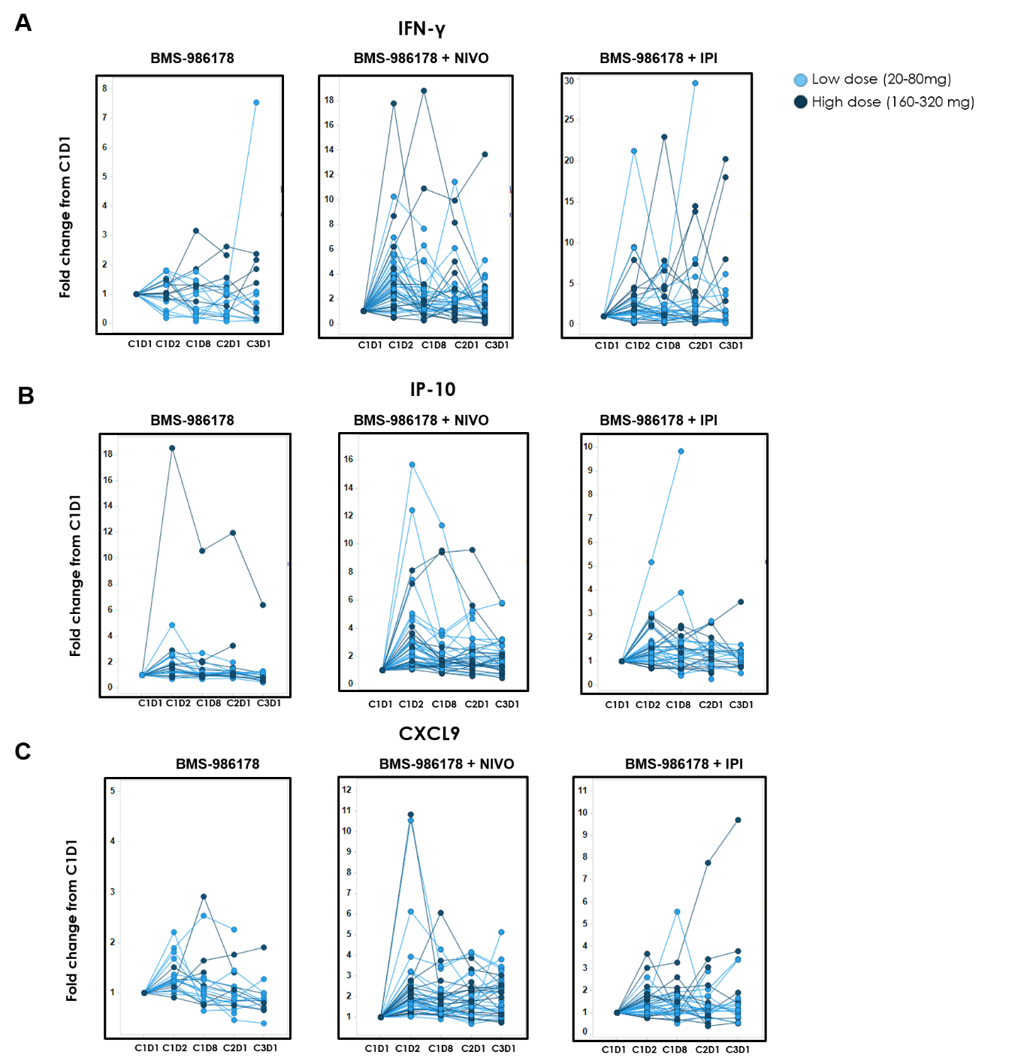

**Supplementary Fig. S5. BMS-986178 ± nivolumab or ipilimumab increased proinflammatory cytokines.** Modulation of patient serum levels of **(A)** IFN-γ, **(B)** IP-10, and **(C)** CXCL9 at pretreatment (C1D1) and various posttreatment time points as measured by Luminex. See Supplementary Table S4 for summary of *P* values.

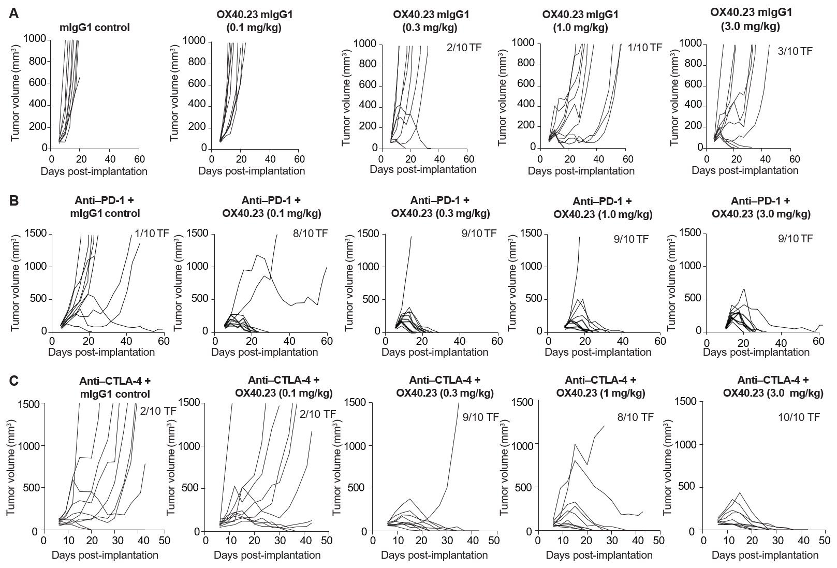

**Supplementary Fig. S6. Anti-OX40 agonist combined with anti–PD-1 or anti–CTLA-4 enhanced antitumor activity in syngeneic CT26 mouse model. (A)** Tumor volumes of mice treated with IgG isotype control or anti-OX40 at indicated doses. **(B)** Tumor volumes of mice treated with anti–PD-1 or anti–PD-1 plus anti-OX40 at indicated doses. **(C)** Tumor volumes of mice treated with anti–CTLA-4 or anti–CTLA-4 plus anti-OX40 at indicated doses. N = 10 mice per group. Doses and dose schedules are described in the Materials and Methods. TF, tumor free.

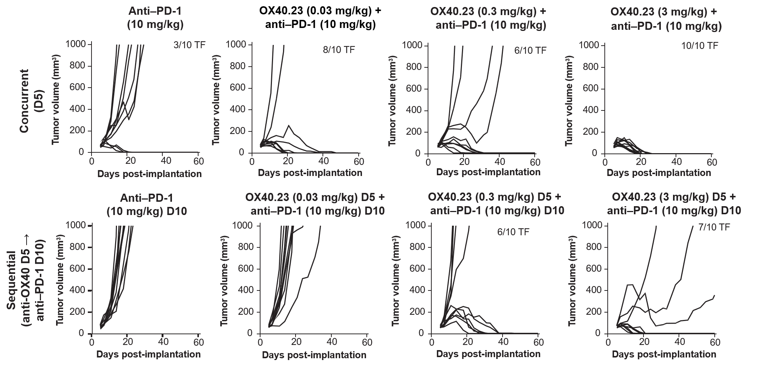

**Supplementary Fig. S7. Concurrent OX40.23-mIgG1 and anti–PD-1 combination treatment was comparable to sequential  
dosing. Top row:** Tumor volumes of mice that received concurrent dosing with OX40.23-mIgG1 at indicated doses and anti–PD-1 10 mg/kg on day 5 post-implantation. Control mice received anti–PD-1 alone. **Bottom row:** Tumor volumes of mice that received OX40.23-mIgG1 at indicated doses on day 5 post-implantation followed by anti–PD-1 10 mg/kg on day 10 post-implantation. Control mice received anti–PD-1 alone on day 10.

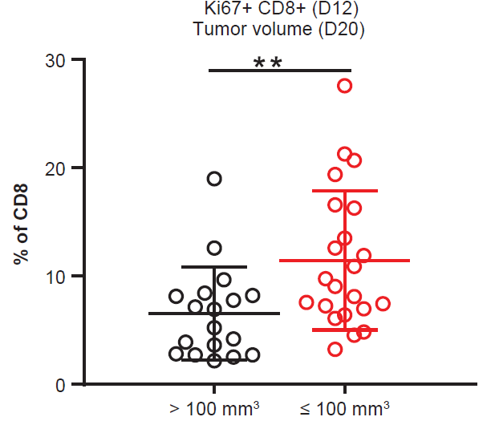

**Supplementary Fig. S8. Correlation between early T cell activation markers and tumor responses to anti-OX40 and anti-PD-1 combination therapy.** Mice treated with combination of anti-OX40 and anti-PD-1 were separated into two groups based on tumor progression statue at Day 20. Tumor volume >100 mm3 was considered as progressive disease, and tumor volume ≤100 mm3 was considered as regression. Percentage of Ki67+ CD8+ at Day 12, when there was no clear separation of tumor volume, were positively correlated to tumor response at later time point (Day 20). **, P<0.05.

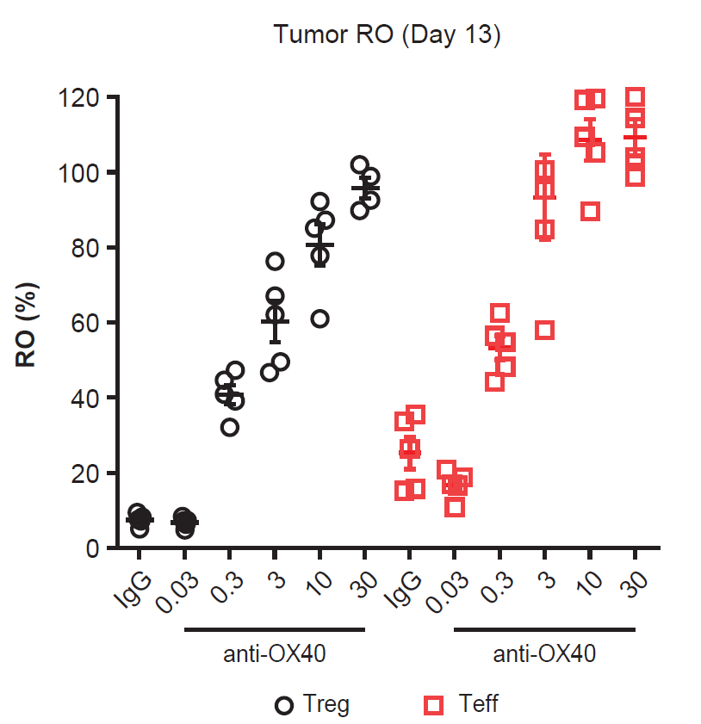

**Supplementary Fig. S9. Anti-mouse OX40 antibody demonstrated high RO in preclinical model**. Anti-mouse OX40 antibody demonstrated similar intratumoral dose-dependent RO changes between Treg (CD4+, CD25+, GITR+, ICOS-high) and Teff (CD4+, GITR-, CD44+, CD45RB-, ICOS-mid) in tumor. Percent RO was evaluated at Day 13 post implantation from mice treated with anti-OX40 single doses.

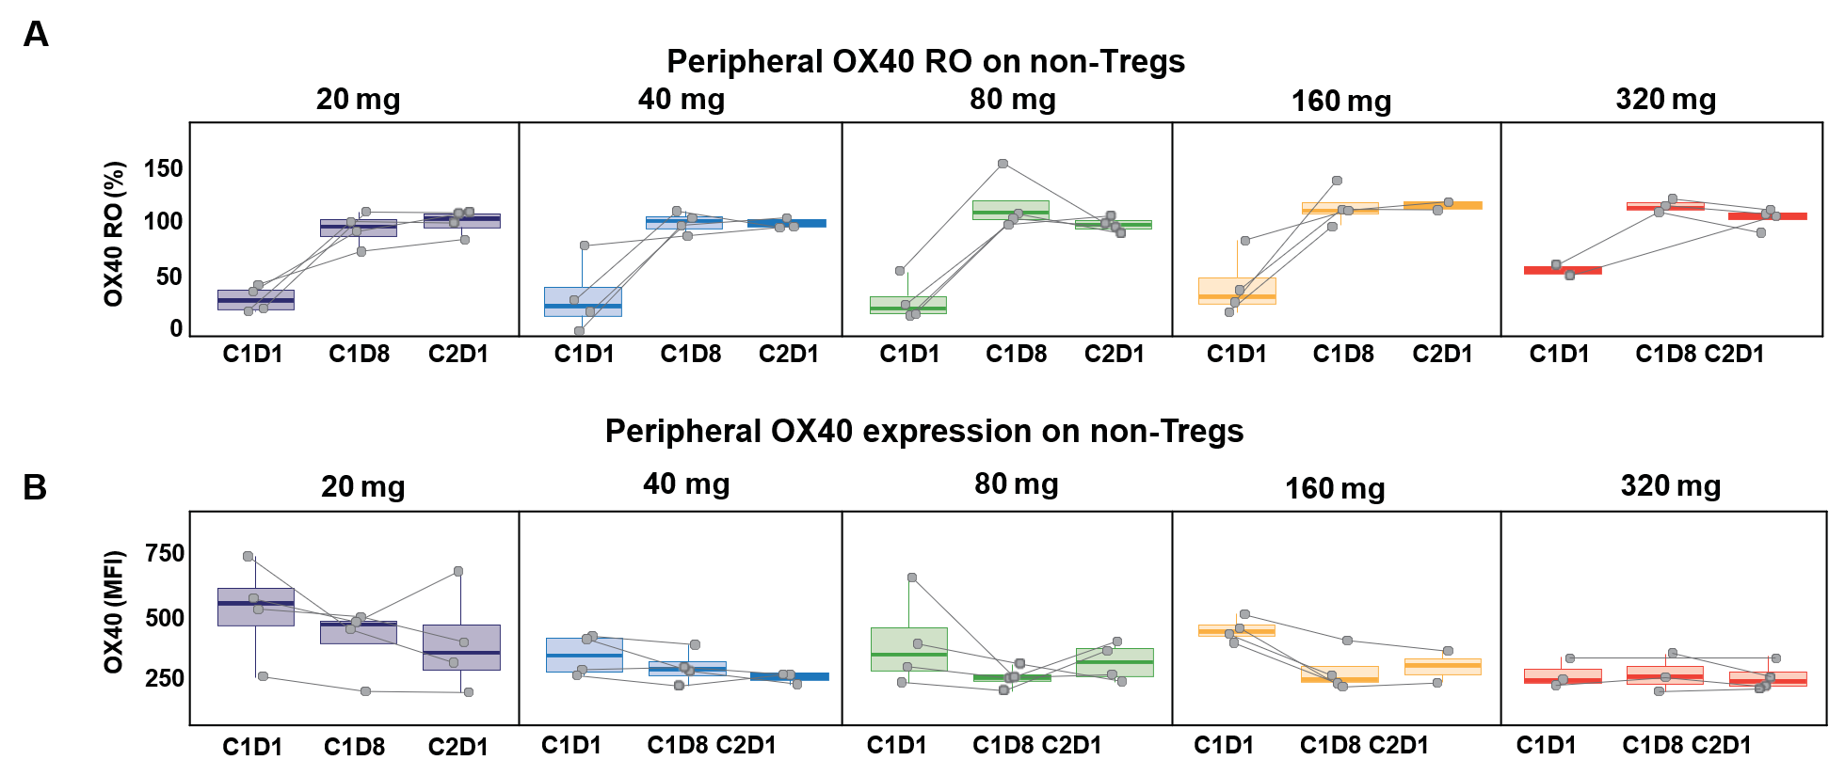

**Supplementary Fig. S10. BMS-986178 demonstrates high RO and surface OX40 receptor downregulation in patients with advanced tumors. (A)** Peripheral OX40 RO on CD4+ non-Tregs of patients treated with BMS-986178 20 to 320 mg. **(B)** Total surface OX40 receptor expression on CD4+ non-Tregs of patients treated with BMS-986178 20 to 320 mg.

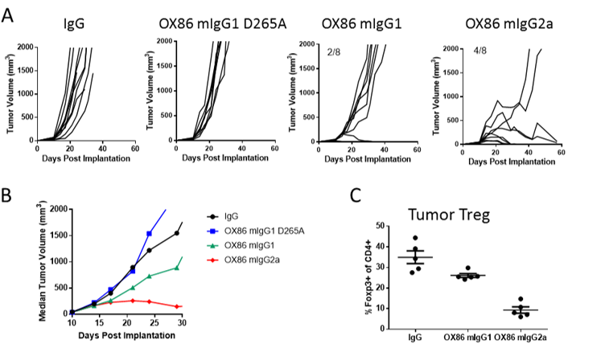

**Supplementary Fig. S11. Fc-FcγR Interactions are Required for Antitumor Activity by Agonist OX86 Antibody.** Mice with established CT26 tumors were treated with indicated isotypes of anti-OX40 agonist (clone OX86) or mIgG1 isotype control. **(A-B)** The Fc domains were selected based on their engagement of mouse FcγRs, with IgG2a binding preferentially to the activation Fc receptors, mouse IgG1 binding preferentially to the inhibitory FcγIIB and a null variant the IgG1 D265A that lacks detectable FcγR binding. OX86 mAb exhibited antitumor activity when administered as IgG1 and IgG2a isotype. **(C)** Depletion of tumor Tregs were only observed in IgG2a subclass of OX86.



**Supplementary Fig. S12. Treatment with BMS-986178 and nivolumab modulates immune infiltration into tumor tissues of patients with advanced solid tumors.** IHC analysis of matched paired tumor biopsies from pre- and post-treatment of BMS-986178 20-320 mg + nivolumab 240 mg demonstrated a trend toward decreasing FoxP3+ Treg cells post-treatment.

**Supplementary Table S1. Clinical study design**: **phase 1/2a study of BMS-986178 ± nivolumab or ipilimumab in advanced solid tumors (NCT02737475)**

|  |  |  |  |  |  |  |  |
| --- | --- | --- | --- | --- | --- | --- | --- |
| **Design phase** | **Treatment** | **Dose** | **Frequency and route of administration** | | | **Patients, n** | |
| Monotherapy dose escalation | BMS-986178 | 20, 40, 80, 160, 320 mg | | Q2W, IV | | | 20 |
| Combination dose escalation | BMS-986178 + nivolumab | Nivolumab: 240 mg  BMS-986178: 20, 40, 80, 160, 320 mg | | | Q2W, IV | 38 | |
| Combination dose escalation | BMS-986178 + ipilimumab | Ipilimumab: 1 mg/kg  BMS-986178: 20, 40, 80, 160, 320 mg | Q3W, IV | | | 32 | |
| August 31, 2017 data cutoff  Primary objectives: safety, tolerability, DLT, MTD, RP2D  Secondary objectives: immunogenicity, PK, PD, preliminary antitumor activity | | | | | | | |

DLT, dose-limiting toxicity; MTD, maximum tolerated dose; RP2D, recommended phase 2 dose.

**Supplementary Table S2. FACS reagents for human blood immunophenotyping**

|  |  |  |  |  |
| --- | --- | --- | --- | --- |
| **Marker** | **Fluorophore** | **Clone** | **Vendor** | **Catalog number** |
| Ki-67 | PerCP5.5 | B56 | BD | 561284 |
| CD45RA | BB515 | HI100 | BD | 564552 |
| CD3 | AF700 | SK7 | Biolegend | 344822 |
| CD4 | BV510 | OKT4 | Biolegend | 300546 |
| CD8a | BV605 | SK1 | BD | 564116 |
| CD38 | PE-Cy7 | HB7 | Biolegend | 356608 |
| HLA-DR | BV650 | G46-6 | BD | 564231 |
| CCR7 | BV421 | GO43H7 | Biolegend | 353208 |
| PD-1 | PE | MIH4 | eBiosciences | 12996942 |

**Supplementary Table S3. FACS reagents and methods used for mouse immunophenotyping**

|  |  |  |  |  |
| --- | --- | --- | --- | --- |
| **Marker** | **Fluorophore** | **Clone** | **Vendor** | **Catalog number** |
| CD11b | BUV395 | M1/70 | BD | 563553 |
| CD45 | PE-Cy7 | 30-F11 | eBiosciences | 25-0451 |
| CD3 | BV421 | 17A2 | Biolegend | 100228 |
| CD4 | BV510 | GK1.5 | Biolegend | 100449 |
| CD8a | BV786 | 53-6.7 | Biolegend | 100750 |
| GITR | FITC | YGITR765 | Biolegend | 120205 |
| CD25 | APC | PC61 | Biolegend | 102012 |
| Ki-67 | PerCP-Cy5.5 | 16A8 | Biolegend | 652424 |

Viable white blood cells from whole blood were recovered by Histopaque-1083 (Sigma‑Aldrich, catalog No. 10831) gradient separation following the manufacturer’s instructions Briefly, 2 mL of Histopaque-1083 was added into a 15-mL conical centrifuge tube, and anticoagulated whole blood was carefully layered onto the top of Histopaque medium. During centrifugation, erythrocytes and neutrophils were aggregated by polysucrose and rapidly sedimented. PBMCs remained at the plasma–Histopaque-1083 interface. Most extraneous platelets were removed by low-speed centrifugation during the washing steps.

**Supplementary Table S4. Summary of PD profiling results**

|  |  |  |  |  |  |  |  |  |  |  |  |  |  |
| --- | --- | --- | --- | --- | --- | --- | --- | --- | --- | --- | --- | --- | --- |
|  |  | **BMS-986178** | | | | **BMS-986178 + nivolumab** | | | | **BMS-986178 + ipilimumab** | | | |
|  |  | **Visit time** | | | | **Visit time** | | | | **Visit time** | | | |
|  | **PD marker** | **C1D2** | **C1D8** | **C2D1** | **C3D1** | **C1D2** | **C1D8** | **C2D1** | **C3D1** | **C1D2** | **C1D8** | **C2D1** | **C3D1** |
| Peripheral blood immunophenotyping | Ki67+CD4+ EM |  | * |  | * |  | *** |  |  |  | *** |  |  |
| Ki67+CD4+ T effector–like |  | * | *** | *** |  | *** |  | * |  | *** |  |  |
| Ki67+CD8+ EM |  |  | * |  |  | *** | * |  |  | ** |  |  |
| Peripheral cytokine/chemokine | IFN-γ |  |  |  |  | *** | ** | *** |  | ** | * | * |  |
| IP-10 | *** |  |  |  | *** | *** | *** | *** | *** | * |  |  |
| CXCL9 | ** |  |  |  | *** | *** | *** | *** | ** | * |  | * |

EM, effector memory.

* *P* < 0.05; ** *P* < 0.01; *** *P* < 0.001; compared with C1D1.

**Supplementary Table S5. Summary of PD profiling results in preclinical murine model**

|  |  |  |  |  |  |  |  |  |  |  |  |  |  |
| --- | --- | --- | --- | --- | --- | --- | --- | --- | --- | --- | --- | --- | --- |
|  |  | **Anti-OX40** | | | | **Anti-OX40 + anti–PD-1** | | | | **Anti-OX40 + anti–CTLA-4** | | | |
|  |  | **Days post-implantation** | | | | **Days post-implantation** | | | | **Days post-implantation** | | | |
| **PD marker** | **Anti-OX40 dose, mg/kg** | **8** | **12** | **15** | **19** | **8** | **12** | **15** | **19** | **8** | **12** | **15** | **20** |
| Ki67+CD4+ | 0.1 |  |  | ** |  |  | *** | *** |  |  |  |  | * |
| 0.3 |  |  |  | ** |  | *** | *** |  |  | *** |  | ** |
| 1 |  |  |  | ** |  | *** | *** | * |  | *** | *** | * |
| 3 |  |  | ** | *** |  | *** | *** | *** |  | *** | *** |  |
| Ki67+CD8+ | 0.1 |  | ** | *** | *** |  | *** | *** |  | * |  |  | *** |
| 0.3 |  |  |  | * |  | *** | *** |  |  |  |  | *** |
| 1 |  |  | ** | *** |  | *** | *** |  | * | ** | * |  |
| 3 |  |  | *** | * |  | *** | *** | *** |  |  | * | * |

* *P* < 0.05; ** *P* < 0.01; *** *P* < 0.001.