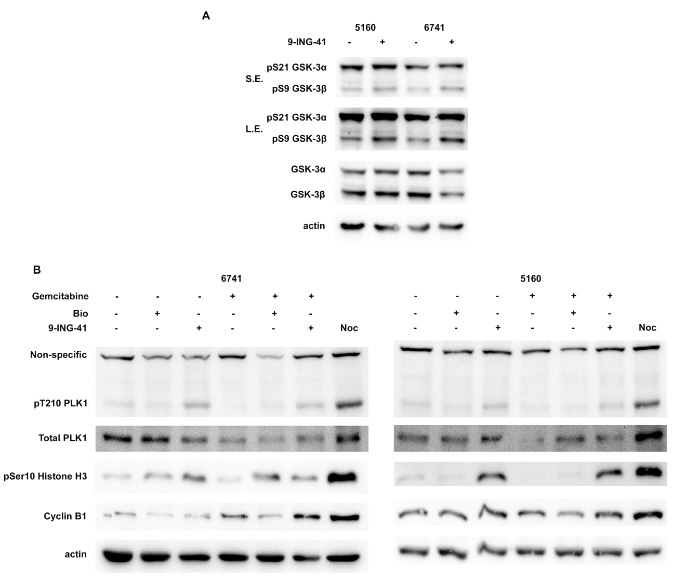

Supplemental Figure S4
9-ING-41 reduces the activity of GSK-3β and maintains the phosphorylation of Plk1 with the combination of gemcitabine. (A) 5160 and 6741 cells were treated with DMSO or 9-ING-41 (5 µM) for 24 hours and lysates were collected and immunoblotted with the indicated antibodies. S.E.: short exposure. L.E.: long exposure. (B) 5160, 6741 cells were treated as indicated in Figure 3B and lysates were prepared and immunoblotted with the indicated antibodies. Lysates from M phase arrested 5160 and 6741 cells induced by thymidine and nocodazole block were used as a positive control. Noc: nocodazole.

