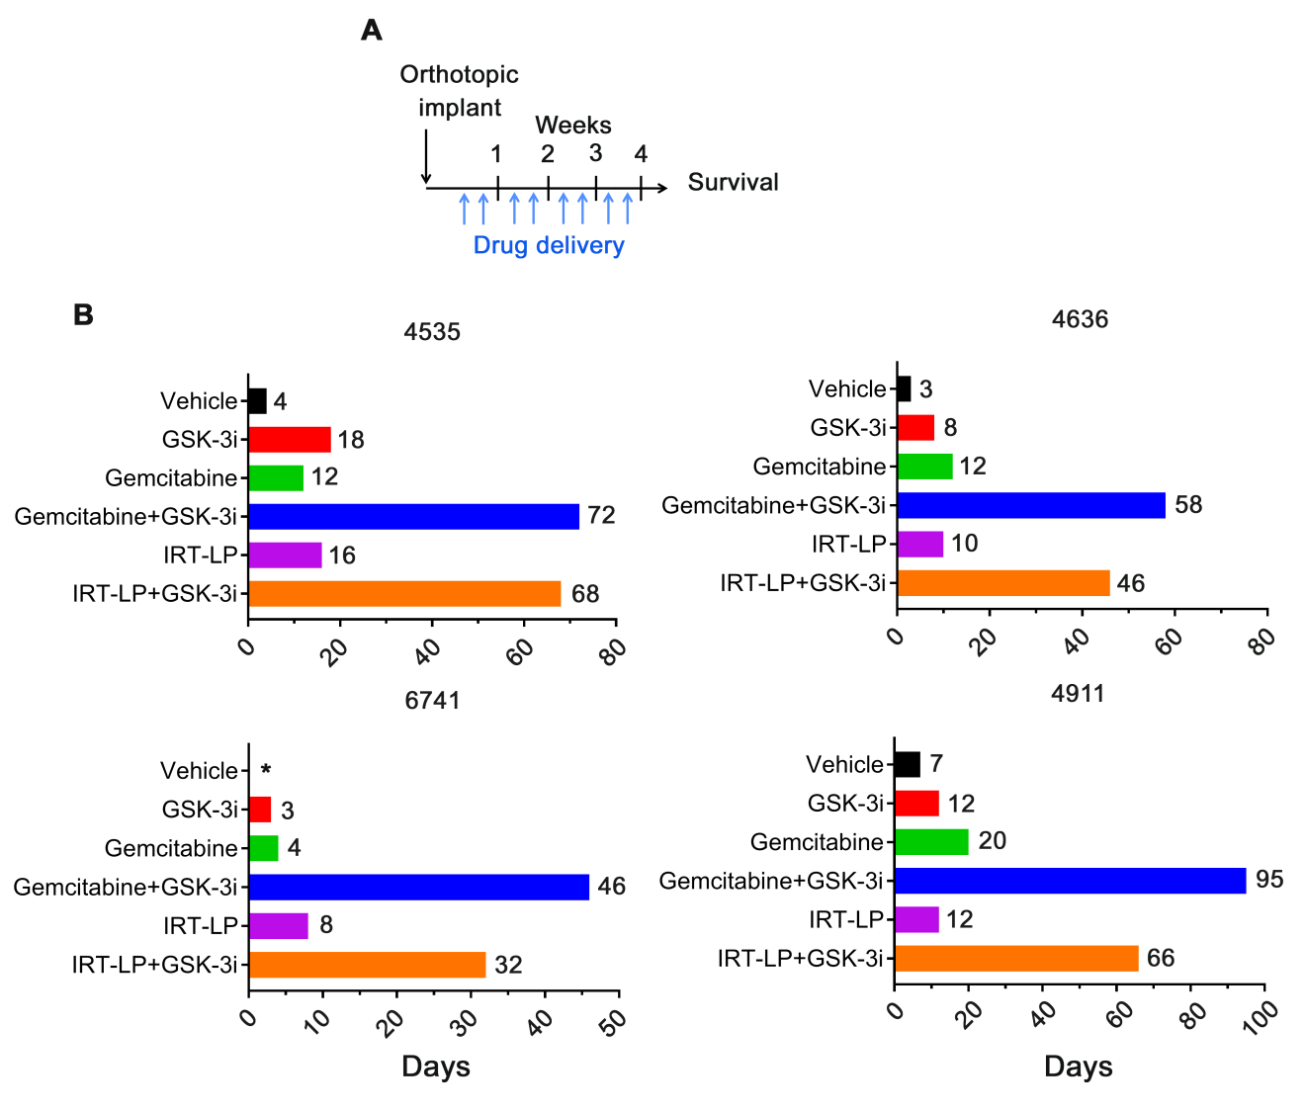

Supplemental Figure S3
9-ING-41 in combination with either gemcitabine or liposomal-formulated irinotecan (IRT-LP) enhances survival of orthotopically implanted PDAC tumors. (A) Schematic representation of experimental design. Once tumors were palpable, mice were randomly divided into 4 groups with one mouse in each group. Mice were then treated 2 times a week for four weeks by i.p. injection with either vehicle, gemcitabine (10 mg/kg), IRT-LP (15 mg/kg), 9-ING-41 (40 mg/kg), both gemcitabine (10 mg/kg) and 9-ING-41 (40 mg/kg), or IRT-LP (15 mg/kg) and 9-ING-41 (40 mg/kg). Following the last treatment, animals were monitored for survival and euthanized when IACUC endpoints were met. (B) Swimmer plots depicting days of survival following final treatment. (*) Denotes that vehicle-treated 6741 met IACUC endpoint criteria and had to be euthanized following the last day of treatment.

