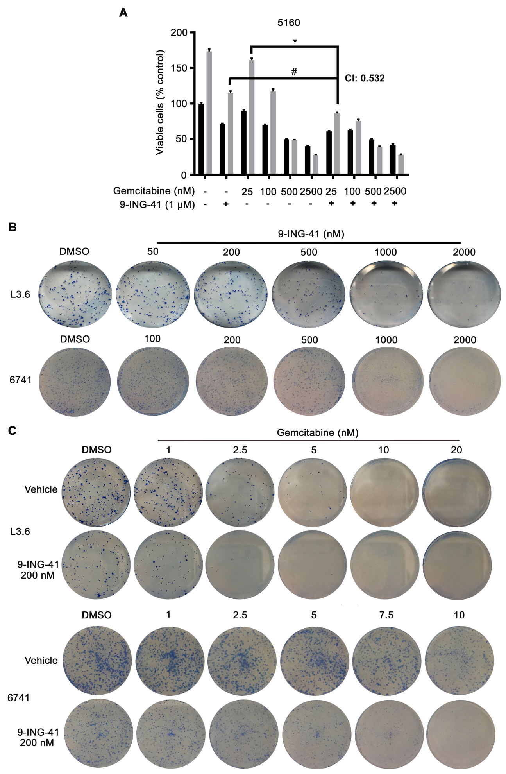
Supplemental Figure S1
9-ING-41 treatment synergizes with gemcitabine to inhibit PDAC proliferation and colony formation. (A) The 5160 PDAC cell line was plated and treated with 1 μM 9-ING-41 alone or with increasing concentration of gemcitabine (nM) for 48 and 72 hours. Cell proliferation was determined by MTS assay. Data was quantified as percentage of control and expressed as mean ± SEM. n=6. *P<0.05 gemcitabine and 9-ING-41 versus gemcitabine alone. #P<0.05 gemcitabine and 9-ING-41 versus 9-ING-41 alone. n=6. CI: combination index. (B) L3.6 and 6741 PDAC cells were seeded in a 6-well plate and treated with DMSO or increasing concentration of 9-ING-41 (nM) for 48 hours. Supernatant was then removed and remaining cells were allowed to form colonies, which were enumerated and displayed graphically in Figure 1C. Shown is representative crystal violet staining from each treatment condition. (C) Clonogenic assays were carried out as described in (B) but 200 nM 9-ING-41 was added together with increasing concentration of gemcitabine. Colonies that formed were counted and displayed graphically in Figure 1D. Shown is representative crystal violet staining from each treatment condition.

