Supplementary Table S1
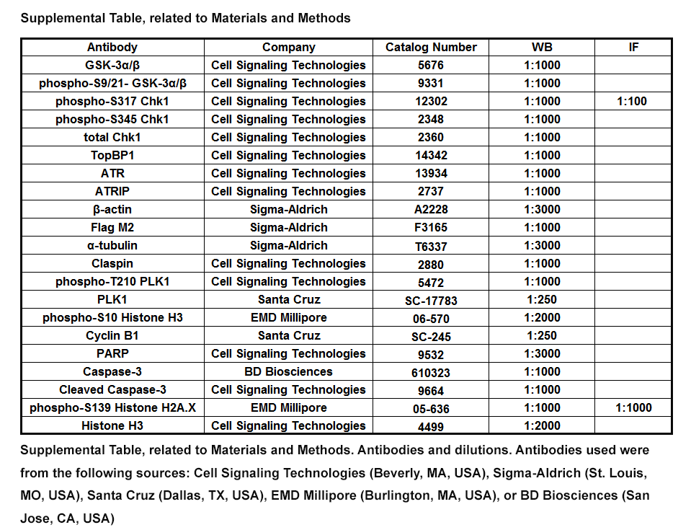

Supplemental Figure S1
9-ING-41 treatment synergizes with gemcitabine to inhibit PDAC proliferation and colony formation. (A) The 5160 PDAC cell line was plated and treated with 1 μM 9-ING-41 alone or with increasing concentration of gemcitabine (nM) for 48 and 72 hours. Cell proliferation was determined by MTS assay. Data was quantified as percentage of control and expressed as mean ± SEM. n=6. *P<0.05 gemcitabine and 9-ING-41 versus gemcitabine alone. #P<0.05 gemcitabine and 9-ING-41 versus 9-ING-41 alone. n=6. CI: combination index. (B) L3.6 and 6741 PDAC cells were seeded in a 6-well plate and treated with DMSO or increasing concentration of 9-ING-41 (nM) for 48 hours. Supernatant was then removed and remaining cells were allowed to form colonies, which were enumerated and displayed graphically in Figure 1C. Shown is representative crystal violet staining from each treatment condition. (C) Clonogenic assays were carried out as described in (B) but 200 nM 9-ING-41 was added together with increasing concentration of gemcitabine. Colonies that formed were counted and displayed graphically in Figure 1D. Shown is representative crystal violet staining from each treatment condition.

Supplemental Figure S2
GSK-3 inhibition leads to cell death and sensitizes PDAC cells to gemcitabine in vitro. (A) 5160, 6741 cells were treated with DMSO, 9-ING-41 (5 µM), gemcitabine (1 µM), both 9-ING-41 (5 µM) and gemcitabine (1 µM) for 24 or 48 hours. The treated cells were collected and stained with annexin V-APC and PI to evaluate cell death. Shown are representative Flowjo analyses from each treatment condition. (B) Percentage of live cells (duel negative), early apoptotic cells (Annexin V positive/PI negative), necrotic cells (Annexin V negative/PI positive) and late apoptotic cells (duel positive) from 5160 and 6741 cells were quantified and expressed as mean ± SEM. n=3. (C) 5160 and 6741 cells were treated as indicated in supplement Figure S3A and lysates were prepared and immunoblotted with the indicated antibodies.

Supplemental Figure S3
9-ING-41 in combination with either gemcitabine or liposomal-formulated irinotecan (IRT-LP) enhances survival of orthotopically implanted PDAC tumors. (A) Schematic representation of experimental design. Once tumors were palpable, mice were randomly divided into 4 groups with one mouse in each group. Mice were then treated 2 times a week for four weeks by i.p. injection with either vehicle, gemcitabine (10 mg/kg), IRT-LP (15 mg/kg), 9-ING-41 (40 mg/kg), both gemcitabine (10 mg/kg) and 9-ING-41 (40 mg/kg), or IRT-LP (15 mg/kg) and 9-ING-41 (40 mg/kg). Following the last treatment, animals were monitored for survival and euthanized when IACUC endpoints were met. (B) Swimmer plots depicting days of survival following final treatment. (*) Denotes that vehicle-treated 6741 met IACUC endpoint criteria and had to be euthanized following the last day of treatment.

Supplemental Figure S4
9-ING-41 reduces the activity of GSK-3β and maintains the phosphorylation of Plk1 with the combination of gemcitabine. (A) 5160 and 6741 cells were treated with DMSO or 9-ING-41 (5 µM) for 24 hours and lysates were collected and immunoblotted with the indicated antibodies. S.E.: short exposure. L.E.: long exposure. (B) 5160, 6741 cells were treated as indicated in Figure 3B and lysates were prepared and immunoblotted with the indicated antibodies. Lysates from M phase arrested 5160 and 6741 cells induced by thymidine and nocodazole block were used as a positive control. Noc: nocodazole.

Supplemental Figure S5
GSK-3 inhibition abrogates gemcitabine-induced cell cycle arrest. (A) 5160, 6741 and L3.6 cells were treated as indicated in Figure 3B and then stained with propidium iodide (PI). DNA content was measured by flow cytometry and analyzed with Modfit software. Data presented in A is representative of three independent experiments. (B) The percentage of G0/G1, S phase and G2/M phase cells from different treatments was expressed as mean ± SEM. n=3. (C) L3.6 cells were treated as indicated in Figure 3B and then provided EdU for 1 hour prior to harvesting. EdU incorporation was detected using the EdU detection kit followed by flow cytometry. (D) EdU positive cells were gated and the normalized MFI of the EdU peak is graphically displayed as are the percentage of EdU+ cells are expressed as mean ± SEM. *P<0.05 gemcitabine versus DMSO. #P<0.05 gemcitabine and GSK-3 inhibitor versus gemcitabine alone. Data presented in C and D is representative of three independent experiments.

Supplement Figure 6
GSK-3 inhibition maintains prolonged DNA damage signaling. (A) 5160 and 6741 cells were treated as indicated in Figure 5A and lysates were prepared and immunoblotted with the indicated antibodies. (B) 5160 and 6741 cells were grown on coverslips, treated with DMSO or gemcitabine (500 nM) for 2 hours, cells were washed with PBS and supplied with or without 9-ING-41 (5 µM) containing medium for 48 hours (gemcitabine withdrawal) prior to fixation. Fixed cells were subsequently stained with anti-gamma H2Ax antibodies and detected with an Alexa 488 conjugated donkey-anti-mouse rabbit secondary (green). DNA was visualized following Hoechst staining (blue). (C) The normalized MFI of nuclear gamma H2Ax was evaluated by ImageJ and expressed as mean ± SEM. *P<0.05 gemcitabine or 9-ING-41 versus DMSO. #P<0.05 gemcitabine and 9-ING-41 versus gemcitabine alone. n=500 cells per treatment group.

