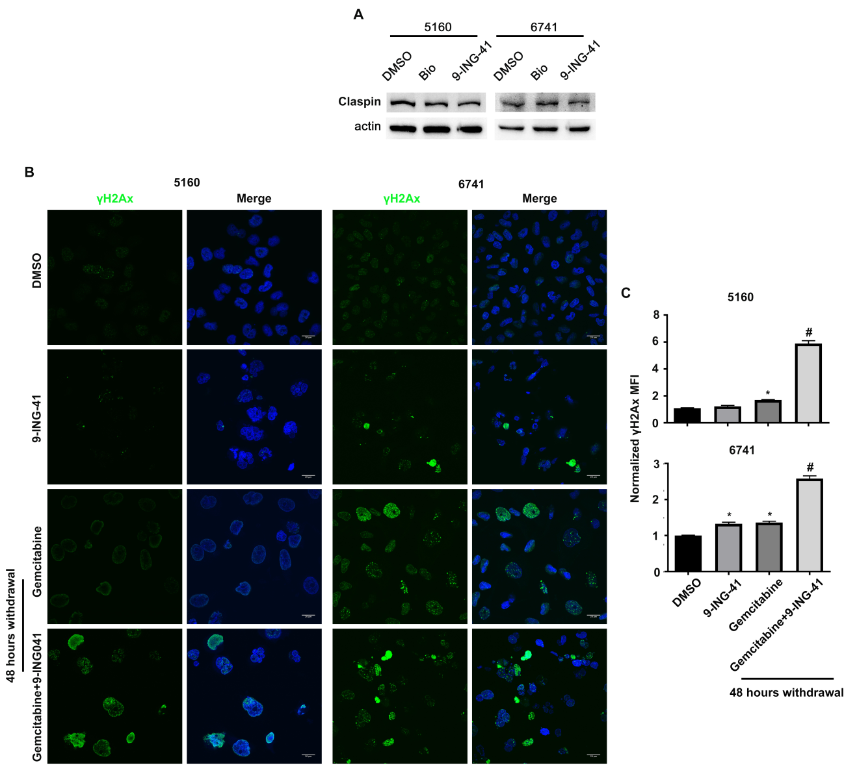

Supplement Figure 6
GSK-3 inhibition maintains prolonged DNA damage signaling. (A) 5160 and 6741 cells were treated as indicated in Figure 5A and lysates were prepared and immunoblotted with the indicated antibodies. (B) 5160 and 6741 cells were grown on coverslips, treated with DMSO or gemcitabine (500 nM) for 2 hours, cells were washed with PBS and supplied with or without 9-ING-41 (5 µM) containing medium for 48 hours (gemcitabine withdrawal) prior to fixation. Fixed cells were subsequently stained with anti-gamma H2Ax antibodies and detected with an Alexa 488 conjugated donkey-anti-mouse rabbit secondary (green). DNA was visualized following Hoechst staining (blue). (C) The normalized MFI of nuclear gamma H2Ax was evaluated by ImageJ and expressed as mean ± SEM. *P<0.05 gemcitabine or 9-ING-41 versus DMSO. #P<0.05 gemcitabine and 9-ING-41 versus gemcitabine alone. n=500 cells per treatment group.

