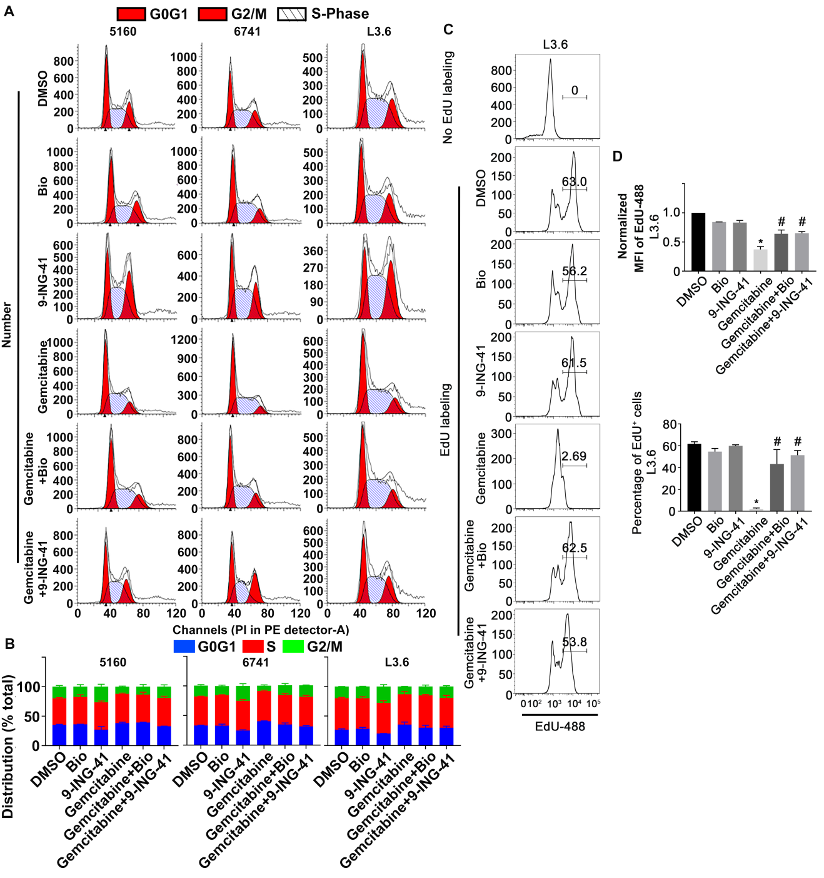

Supplemental Figure S5
GSK-3 inhibition abrogates gemcitabine-induced cell cycle arrest. (A) 5160, 6741 and L3.6 cells were treated as indicated in Figure 3B and then stained with propidium iodide (PI). DNA content was measured by flow cytometry and analyzed with Modfit software. Data presented in A is representative of three independent experiments. (B) The percentage of G0/G1, S phase and G2/M phase cells from different treatments was expressed as mean ± SEM. n=3. (C) L3.6 cells were treated as indicated in Figure 3B and then provided EdU for 1 hour prior to harvesting. EdU incorporation was detected using the EdU detection kit followed by flow cytometry. (D) EdU positive cells were gated and the normalized MFI of the EdU peak is graphically displayed as are the percentage of EdU+ cells are expressed as mean ± SEM. *P<0.05 gemcitabine versus DMSO. #P<0.05 gemcitabine and GSK-3 inhibitor versus gemcitabine alone. Data presented in C and D is representative of three independent experiments.

