**Supplementary Data**

**Title: Theranostic Convergence Bioradiopharmaceutical for Immuno-PET based Radioimmunotherapy of L1CAM in Cholangiocarcinoma Model**

**Authors and Affiliations:** In Ho Song1,2, Mun Sik Jeong3, Hyo Jeong Hong3,4, Jong Il Shin1, Yong Serk Park2, Sang-Keun Woo1, Byung Seok Moon4, Kwang Il Kim1, Yong Jin Lee1, Joo Hyun Kang1, and Tae Sup Lee1*

1Division of RI Application, Korea Institute of Radiological and Medical Sciences, Seoul, South Korea; 2Department of Biomedical Laboratory Science, Yonsei University, Wonju, South Korea;

3Department of Systems Immunology, Kangwon National University, Chuncheon, South Korea;

4Scripps Korea Antibody Institute, Chuncheon, South Korea;

5Department of Nuclear Medicine, Ewha Womans University Seoul Hospital, Ewha Womans University School of Medicine, Seoul, South Korea

**Supplemental Materials and Methods**

**MALDI-TOF mass spectrometry**

Matrix-assisted laser desorption ionization/time of flight (MALDI/TOF) mass spectra were obtained on an Ultraflextreme (Bruker Daltonics, Germany) mass spectrometer using sinapinic acid as a matrix (Bruker Daltonics) in Korea Basic Science Institute (Ohchang, South Korea).

**Size-exclusion HPLC**

The radiochemical purity of radioimmunoconjugate was analyzed by size exclusion HPLC using a MAbPac SEC-1 column (Thermo Scientific). The mobile phase consisted of 0.3 M NaCl in 50 mM sodium phosphate buffer, pH 6.8, eluted at a flow rate of 0.2 mL/min. The retention time of radioimmunoconjugate was determined from UV absorbance (Younglin Instrument Co., LTD) and radioactivity (GABI RI detector, Raytest) detectors.

***In vitro* serum stability assay**

*In vitro* stabilities of 64Cu-NOTA-cA10-A3 and 177Lu-NOTA-cA10-A3 were evaluated for 24 h and 7 days, respectively. Each radioimmunoconjugate was added to the same volume of human serum and incubated at 37℃. Samples were analyzed by instant thin layer chromatography-silica gel (ITLC-sg) at different incubation times.

**Immunoreactivity test**

The immunoreactivity of radiolabeled cA10-A3 in SCK-L1 cells was determined according to the Lindmo method (1). 64Cu-/177Lu-NOTA-cA10-A3 (100 ng) were incubated with increasing cell concentration (1.25, 2.5, 5, 12.5 and 25 × 106 cells/mL, *n* = 3) of SCK-L1 cells. Nonspecific binding was evaluated with the 100-fold excess cold cA10-A3 antibody. After 1 h incubation, the samples were triple washed in cold PBS containing 1% BSA. Each sample was counted in a gamma counter (WIZARD 1480). The data were plotted as a double inverse plot of the applied radiolabeled antibody over the specific binding, as a function of the inverse cell concentration. Immunoreactivity was calculated as the inverse intercept value at the ordinate.

**Pharmacokinetic analysis**

Pharmacokinetic data were based on the biodistribution study of SCK-L1 xenograft model. The percentage injected dose per gram (%ID/g) of blood was calculated for each of the samples, and the clearance was determined by biphasic nonlinear regression analysis using Prism 5 (GraphPad). Pharmacokinetic parameters, blood clearance of distribution, elimination phase, and mean residence time was calculated.

**Radiation dosimetry**

Estimated human dosimetry was calculated from the biodistribution results on SCK-L1 xenograft model injected with 64Cu-NOTA-cA10-A3 and 177Lu-NOTA-cA10-A3, respectively. Time-activity curves were generated from the mean values obtained in mice for each tissue of interest. Source organ residence times for the human model by integrating a mono-exponential fit to the experimental biodistribution data for major organs and the whole body were calculated. The mouse normal organ cumulated activities were converted to human normal organ cumulated activities by adjustment for the differences in total-body and organ masses between mouse and humans (assuming 70 kg standard human). The human normal organ cumulated activities calculated were entered into the Organ Level INternal Dose Assessment (OLINDA) dosimetry computer program v1.1 to calculate, using the formalism of the Medical Internal Dosimetry Committee of the Society of Nuclear Medicine (2), the standard human organ absorbed doses. Extrapolated radiation dosimetry for humans was made by assuming that the metabolism rates and pharmacokinetics of 64Cu-NOTA-cA10-A3 and 177Lu-NOTA-cA10-A3, respectively, in man and mouse, are equivalent.

**Digital whole-body autoradiography**

After PET or SPECT/CT scan of SCK-L1 tumor model, digital whole-body autoradiography (DWBA) was performed by previously described methods (3). After PET or SPECT/CT imaging, mice were sacrificed and immediately frozen at -70°C deep freezer. Mice were embedded in a mold on a microtome stage by adding an ice-cold aqueous solution of 3% carboxymethyl cellulose sodium salt (Wako Pure Chemical Industries). Coronal whole-body frozen sections (30 μm thick) were obtained by whole-body autocryotome (Nakagawa Seisakusho). The frozen sections were exposed to an image plate for 24 h, and the plates were scanned with BAS-5000 scanner (Fujiﬁlm).

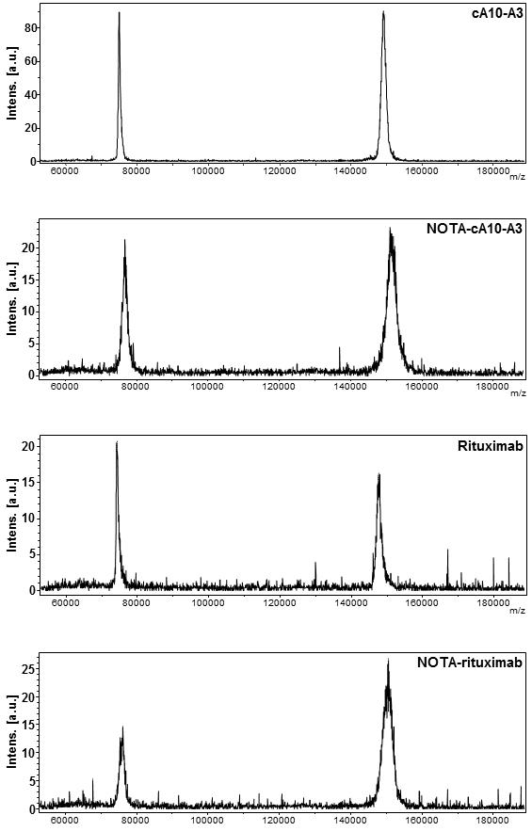

**Figure S1.** MALDI-TOF/TOF mass spectra of cA10-A3, NOTA-cA10-A3, rituximab (isotype control) and NOTA-rituximab. The difference of mass between the molecular peaks gives a degree of conjugation of 4.1 ± 0.1 macrocycles per cA10-A3 antibody and 5.1 ± 0.004 macrocycles per rituximab antibody. a.u., arbitrary unit.

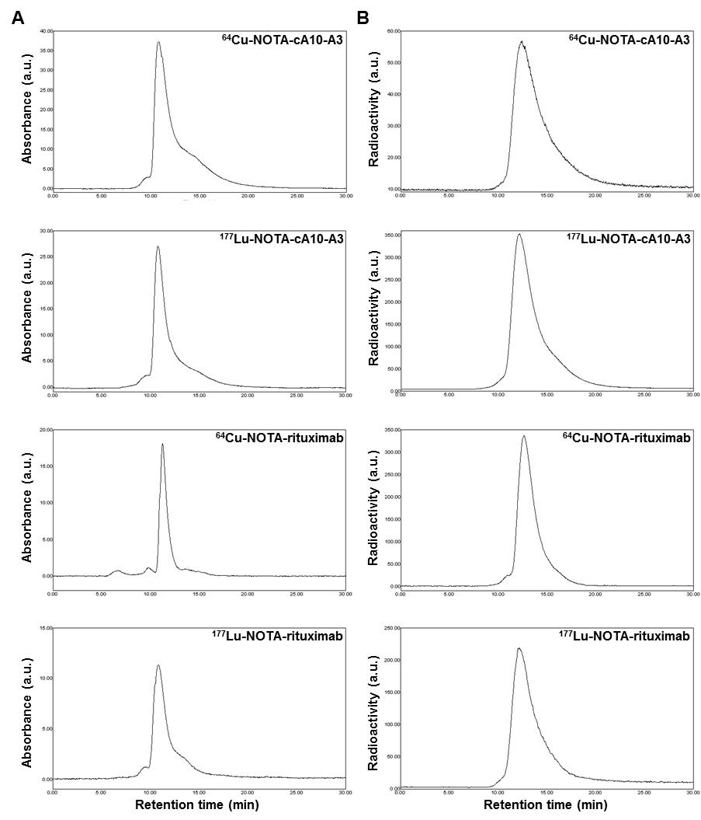

**Figure S2.** Size exclusion-HPLC chromatograms of 64Cu-/177Lu-NOTA-cA10-A3 and 64Cu-/177Lu-NOTA-rituximab. HPLC chromatograms measured by absorbance (A) at 280 nm and radioactivity (B) of radioimmunoconjugates. The shift in retention time between UV absorbance and radioactivity peaks is due to the physical interval between absorbance and radioactivity detectors. a.u., arbitrary unit.

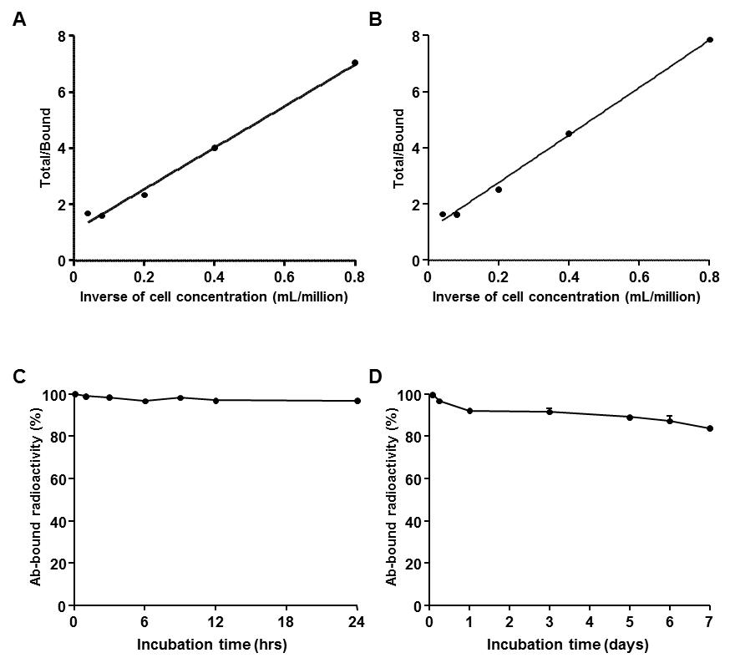

**Figure S3.** Characteristics of 64Cu-/177Lu-NOTA-cA10-A3. Immunoreactivity of 64Cu-NOTA-cA10-A3 (A) and 177Lu-NOTA-cA10-A3 (B). The immunoreactive fraction of 64Cu-/177Lu-NOTA-cA10-A3 was 0.94 and 0.93, respectively, calculated by the Lindmo method. *In vitro* serum stabilities of 64Cu-NOTA-cA10-A3 (C) and 177Lu-NOTA-cA10-A3 (D). 64Cu-/177Lu-NOTA-cA10-A3 showed favorable stability with above 97% and 84% at 24 h and 7 day, respectively.



**Figure S4.** Blood clearance and pharmacokinetic variables of 177Lu-NOTA-cA10-A3 in SCK-L1 xenografted model. Blood clearance of 177Lu-NOTA-cA10-A3 was measured. Inset, a summary of pharmacokinetic variables of 177Lu-NOTA-cA10-A3.

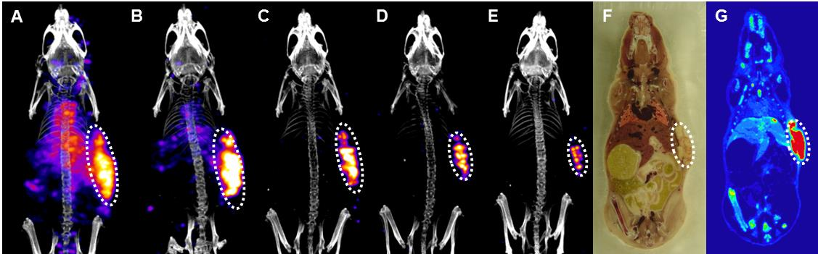

**Figure S5.** Micro-SPECT/CT images of 177Lu-NOTA-cA10-A3 in SCK-L1 xenografted model. SPECT/CT images were obtained at 1 (A), 3 (B), 7 (C), 10 (D) and 14 days (E) post-injection. Frozen section photo image (F) and digital whole-body autoradiographic image (G).

**Table S1.** Biodistribution data of 177Lu-cA10-A3 in SCK-L1 xenografted model

|  |  |  |  |  |  |  |  |  |  |  |  |  |  |  |  |  |  |  |  |  |  |
| --- | --- | --- | --- | --- | --- | --- | --- | --- | --- | --- | --- | --- | --- | --- | --- | --- | --- | --- | --- | --- | --- |
|  | 2 h | | | 1 d | | | 3 d | | | 5 d | | | 7 d | | | 10 d | | | 14 d | | |
| Blood | 26.0 | ± | 3.3 | 14.0 | ± | 2.2 | 7.6 | ± | 1.8 | 6.1 | ± | 1.6 | 1.8 | ± | 0.8 | 0.7 | ± | 0.1 | 0.3 | ± | 0.2 |
| Muscle | 1.1 | ± | 0.1 | 2.2 | ± | 0.3 | 1.4 | ± | 0.3 | 1.1 | ± | 0.3 | 0.5 | ± | 0.2 | 0.3 | ± | 0.2 | 0.1 | ± | 0.1 |
| Liver | 12.1 | ± | 2.8 | 7.9 | ± | 1.0 | 6.7 | ± | 1.1 | 5.8 | ± | 0.2 | 4.3 | ± | 0.8 | 2.9 | ± | 0.8 | 3.0 | ± | 0.7 |
| SCK-L1 | 15.5 | ± | 2.4 | 25.7 | ± | 3.1 | 34.7 | ± | 4.6 | 44.6 | ± | 3.2 | 26.7 | ± | 4.2 | 19.9 | ± | 1.7 | 10.5 | ± | 1.6 |
| T/B | 0.6 | ± | 0.1 | 1.9 | ± | 0.2 | 4.7 | ± | 1.4 | 7.6 | ± | 2.5 | 16.7 | ± | 5.1 | 28.5 | ± | 6.5 | 40.9 | ± | 17.5 |
| T/M | 14.2 | ± | 1.0 | 11.9 | ± | 1.1 | 24.9 | ± | 4.4 | 43.0 | ± | 14.1 | 56.3 | ± | 18.0 | 78.4 | ± | 35.1 | 85.0 | ± | 30.1 |
| T/L | 1.3 | ± | 0.1 | 3.3 | ± | 0.5 | 5.3 | ± | 1.1 | 7.7 | ± | 0.8 | 6.3 | ± | 0.9 | 7.2 | ± | 1.8 | 3.7 | ± | 1.5 |

Data (%ID/g) were presented as mean ± S.D. (*n* = 3 or 4).

T/B, Tumor-to-blood ratio; T/M, Tumor-to-muscle ratio; T/L, Tumor-to-liver ratios.

**Table S2.** Extrapolated radiation dosimetry to an adult human after intravenous injection of 64Cu-NOTA-cA10-A3 based on the biodistribution data obtained from SCK-L1 xenografted model

|  |  |  |
| --- | --- | --- |
|  | mSv/MBq | rad/mCi |
| Adrenals | 3.0E-05 ± 3.0E-06 | 1.1E-04 ± 1.1E-05 |
| Brain | 6.3E-06 ± 4.0E-07 | 2.3E-05 ± 1.5E-06 |
| Breasts | 2.0E-04 ± 2.5E-05 | 7.3E-04 ± 9.2E-05 |
| LLI* | 6.5E-03 ± 5.7E-04 | 2.4E-02 ± 2.1E-03 |
| Small Intestine | 1.1E-04 ± 8.5E-06 | 4.0E-04 ± 3.1E-05 |
| Stomach Wall | 3.4E-03 ± 1.0E-03 | 1.2E-02 ± 3.8E-03 |
| ULI* | 1.7E-05 ± 1.4E-06 | 6.2E-05 ± 5.3E-06 |
| Kidneys | 8.7E-04 ± 1.5E-04 | 3.2E-03 ± 5.4E-04 |
| Liver | 3.9E-03 ± 1.1E-04 | 1.4E-02 ± 4.1E-04 |
| Lungs | 1.1E-02 ± 2.1E-03 | 4.2E-02 ± 7.8E-03 |
| Muscle | 8.1E-06 ± 7.0E-07 | 3.0E-05 ± 2.6E-06 |
| Ovaries | 8.9E-04 ± 6.6E-05 | 3.3E-03 ± 2.4E-04 |
| Pancreas | 3.0E-05 ± 2.8E-06 | 1.1E-04 ± 1.0E-05 |
| Red Marrow | 2.0E-03 ± 2.2E-04 | 7.4E-03 ± 8.2E-04 |
| Osteogenic Cells | 9.2E-05 ± 1.0E-05 | 3.4E-04 ± 3.7E-05 |
| Skin | 1.5E-05 ± 1.4E-06 | 5.6E-05 ± 5.0E-06 |
| Spleen | 4.0E-03 ± 4.2E-04 | 1.5E-02 ± 1.5E-03 |
| Thymus | 1.7E-05 ± 3.9E-06 | 6.1E-05 ± 1.4E-05 |
| Thyroid | 5.9E-05 ± 5.8E-06 | 2.2E-04 ± 2.1E-05 |
| Urinary Bladder Wall | 7.3E-05 ± 5.4E-06 | 2.7E-04 ± 2.0E-05 |
| Uterus | 8.2E-06 ± 6.5E-07 | 3.0E-05 ± 2.4E-06 |
| Effective dose | 3.4E-02 ± 4.0E-03 | 1.2E-01 ± 1.5E-02 |

Data were presented as mean ± S.D. (*n* = 4).

* LLI, lower large intestine; **ULI, upper large intestine.

**Table S3.** Extrapolated radiation dosimetry to an adult human after intravenous injection of 177Lu-NOTA-cA10-A3 based on the biodistribution data obtained from SCK-L1 xenografted model

|  |  |  |
| --- | --- | --- |
|  | mSv/MBq | Rad/mCi |
| Adrenals | 4.2.E-05 ± 1.2.E-05 | 1.6E-04 ± 4.5E-05 |
| Brain | 4.1.E-05 ± 6.8.E-06 | 1.5E-04 ± 2.5E-05 |
| Breasts | 1.6.E-04 ± 5.7.E-05 | 6.1E-04 ± 2.1E-04 |
| LLI* | 7.1.E-02 ± 2.8.E-02 | 2.6E-01 ± 1.1E-01 |
| Small Intestine | 5.1.E-04 ± 5.7.E-05 | 1.9E-03 ± 2.1E-04 |
| Stomach Wall | 2.9.E-02 ± 5.1.E-03 | 1.1E-01 ± 1.9E-02 |
| ULI* | 2.1.E-05 ± 4.3.E-06 | 7.6E-05 ± 1.6E-05 |
| Kidneys | 4.3.E-03 ± 1.1.E-03 | 1.6E-02 ± 3.9E-03 |
| Liver | 2.3.E-02 ± 5.3.E-03 | 8.4E-02 ± 2.0E-02 |
| Lungs | 5.3.E-02 ± 1.5.E-02 | 2.0E-01 ± 5.7E-02 |
| Muscle | 2.2.E-05 ± 6.3.E-06 | 8.2E-05 ± 2.3E-05 |
| Ovaries | 1.2.E-03 ± 3.1.E-04 | 4.3E-03 ± 1.1E-03 |
| Pancreas | 6.7.E-05 ± 2.0.E-05 | 2.5E-04 ± 7.5E-05 |
| Red Marrow | 5.7.E-04 ± 1.6.E-04 | 2.1E-03 ± 6.0E-04 |
| Osteogenic Cells | 5.5.E-05 ± 1.6.E-05 | 2.0E-04 ± 6.0E-05 |
| Skin | 1.6.E-05 ± 4.7.E-06 | 6.0E-05 ± 1.7E-05 |
| Spleen | 1.5.E-01 ± 5.0.E-02 | 5.6E-01 ± 1.9E-01 |
| Thymus | 1.2.E-05 ± 5.4.E-06 | 4.5E-05 ± 2.0E-05 |
| Thyroid | 4.9.E-05 ± 1.6.E-05 | 1.8E-04 ± 5.8E-05 |
| Urinary Bladder Wall | 9.9.E-05 ± 2.9.E-05 | 3.7E-04 ± 1.1E-04 |
| Uterus | 9.9.E-06 ± 2.2.E-06 | 3.7E-05 ± 8.2E-06 |
| Effective dose | 3.3.E-01 ± 1.1.E-01 | 1.2E+00 ± 3.9E-01 |

Data were presented as mean ± S.D. (*n* = 4).

* LLI, lower large intestine; **ULI, upper large intestine.

**References**

1. Lindmo T, Boven E, Cuttitta F, Fedorko J, Bunn PA, Jr. Determination of the immunoreactive fraction of radiolabeled monoclonal antibodies by linear extrapolation to binding at infinite antigen excess. *J Immunol Methods* 1984;72:77-89.

2. Sgouros G. Dosimetry of internal emitters. *J Nucl Med* 2005;46 Suppl 1:18S-27S.

3. Park JJ, Lee TS, Son JJ, Chun KS, Song IH, Park YS, et al. Comparison of cell-labeling methods with 124I-FIAU and 64Cu-PTSM for cell tracking using chronic myelogenous leukemia cells expressing HSV1-tk and firefly luciferase. *Cancer Biother Radiopharm* 2012;27:719-28.