Supplementary Figure 1: Overall Survival Subpopulation Analysis for Patients with Newly-Diagnosed AML*

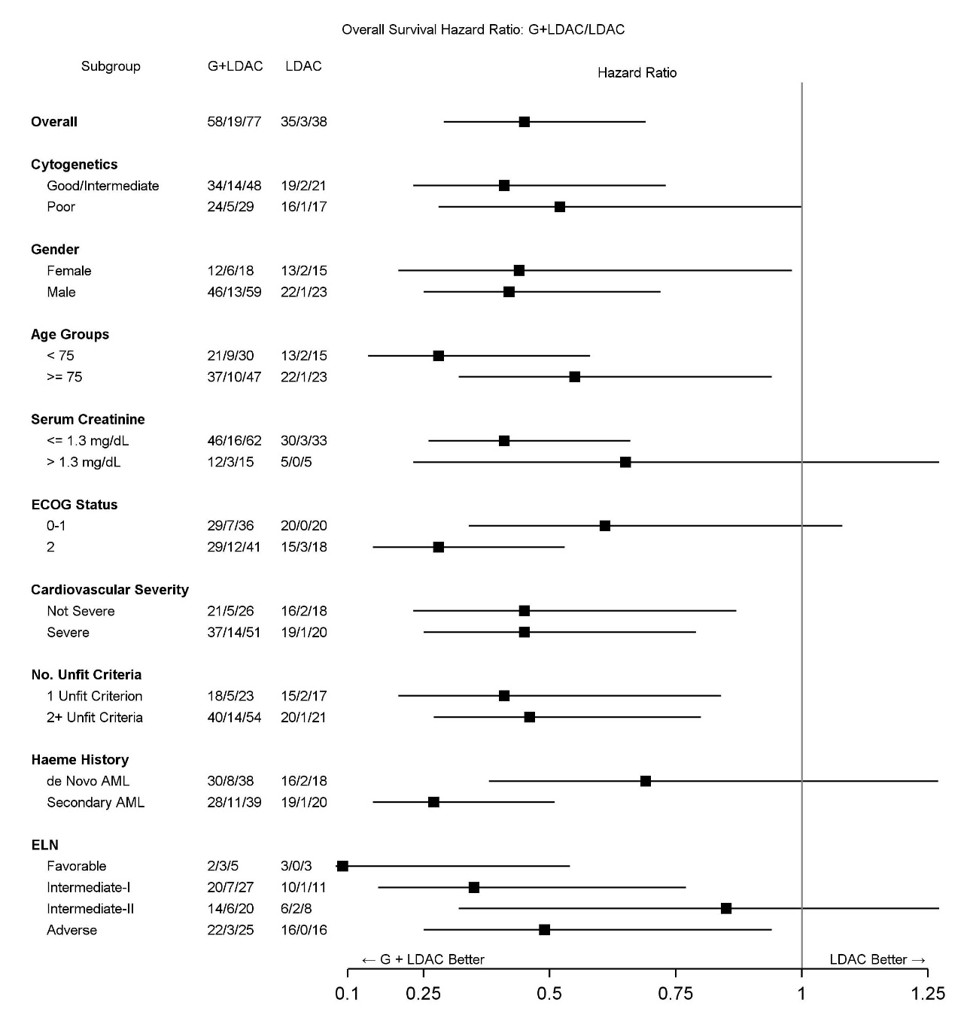
*Hazard ratios for survival by demographic and disease-based subgroups in Study BRIGHT AML 1003. Note that values in the
treatment columns have the format A/B/C, where A = number of events, B = number censored, and C = total number of
patients.

Abbreviations: ECOG, Eastern Cooperative Oncology Group; ELN, European LeukemiaNet risk classification; G, glasdegib; LDAC, low-dose cytarabine

