SUPPLEMENTAL INFORMATION
Eµ-TCL1xMyc mice as a therapeutic model of accelerated B-cell malignancy
Fabienne Lucas, MD, PhD¹*, Kerry A. Rogers, MD¹*, Bonnie K. Harrington, DVM, PhD^{1,2}*, Alexander Pan, BS³, Lianbo Yu, PhD⁴, Justin Breitbach, DVM², Ralf Bundschuh, PhD^{1,5}, Virginia M. Goettl, DVM, PhD¹, Zachary A. Hing, BS, PhD^{1,6}, Parviz Kanga¹, Rose Mantel¹, Deepa Sampath, PhD¹, Lisa L. Smith, MS¹, Ronni Wasmuth, MS¹, Danielle K. White, BS¹, Pearlly Yan, PhD¹, John C. Byrd, MD¹, Rosa Lapalombella, PhD¹⁺, Jennifer A. Woyach, MD¹⁺

¹Division of Hematology, The Ohio State University, Columbus, OH
²Department of Veterinary Biosciences, The Ohio State University, Columbus, OH
³Comprehensive Cancer Center, The Ohio State University, Columbus, OH
⁴Center for Biostatistics, Department of Bioinformatics, The Ohio State University, Columbus, OH
⁵Department of Physics, Department of Chemistry&Biochemistry, The Ohio State University, Columbus, OH
⁶Medical Scientist Training Program, The Ohio State University, Columbus, OH
*These first authors contributed equally to this work. +These senior authors contributed equally to this work.
Running Title: Eµ-TCL1xMyc Mice as B-cell Malignancy Therapeutic Platform
Keywords: CLL, lymphoma, mouse model, targeted therapy, ibrutinib, XPO1
Abstract: 239
Article text: 4998
Figures/ Tables: 6/0
References: 50
Suppl. figures/ tables: 8/6

Corresponding Author: Jennifer A. Woyach, MD 455D Wiseman Hall 410 W 12th Ave Columbus, OH 43210, Phone: (614) 685-5667, Fax: (614) 293-4812, e-mail: jennifer.woyach@osumc.edu

Supplemental Figure 1: Commonly used murine cell surface markers of B-cell development: Murine markers of B-cell development commonly used in published data and technical resource publications¹⁻³. #early B-cell stages include pre-pro-B, pro-B, pre-B cells, which were not further differentiated based on CD43 expression in our studies. Abbreviations: PB – peripheral blood; BC – B cell; HSC – hematopoietic stem cells.

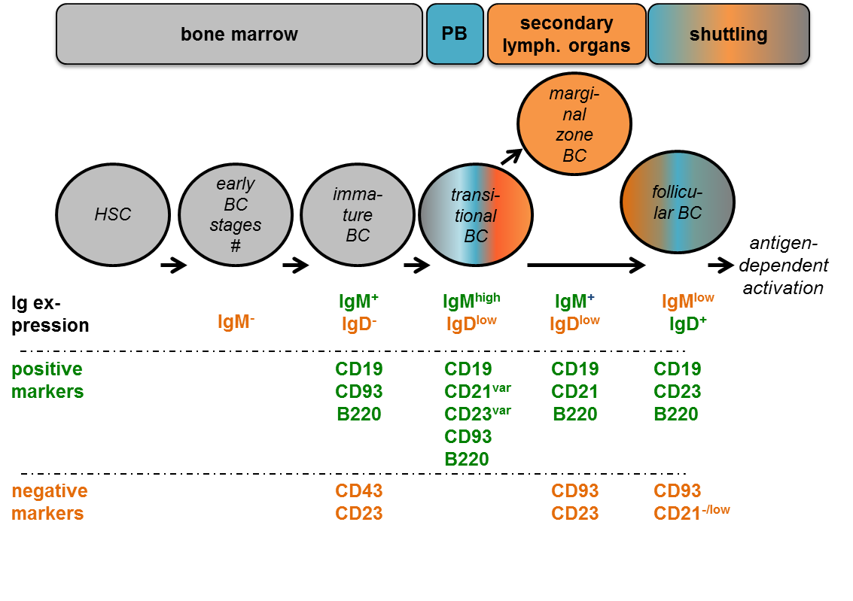

Supplemental Figure 2: Multicolor flow cytometry gating strategy and representative flow plots from a WT spleen sample: Gating strategies followed published data and technical resource publications¹⁻³ and were adapted to allow exclusion and interrogation of CD19⁺CD5⁺ CLL-like populations. Fluorescence-minus-one (FMO) controls were used for each marker and gate position. Cells were gated on viable single mononuclear cells (MNC, 1-3). After excluding CD3⁺ T and CD11b⁺ myeloid cells (4), cells were either gated on B220⁺CD5⁻ cells (5) to exclude cells with a CLL phenotype, followed by interrogation of IgM and IgG, or plotted using B220 and CD93 expression (6). Representative FMO controls for CD93 and B220 are depicted. After exclusion of CD5⁺ cells via a histogram and FMO CD5 control (representative plots not shown), B220⁺CD93⁺ cells were identified as transitional B cells (a), and IgM, IgD and CD23 expression were used to further evaluate different transitional cell stages. B220^{low}CD93⁻ cells (b) were then plotted using CD19 and CD5 expression, to identify CD19⁺CD5⁻ immature B cells and CD19⁺CD5⁺ CLL cells with downregulated B220 expression. B220^{high}CD93⁻ cells (c) were also plotted using CD19 and CD5 expression, to identify CD19⁺CD5⁻ mature non-CLL B cells and CD19⁺CD5⁺ CLL cells. Mature B cells were further dissected according to CD21 and IgM expression to identify CD21⁺IgM⁺ marginal zone/ marginal zone progenitor (MZ/MZP) B cells, CD21^{int}IgM^{dim} follicular B cells, CD21⁻IgM⁻ and CD21⁻IgM⁺ atypical B cells. Representative flow plots and gating controls for a-c are depicted alongside the numerical quantification and comparisons of the respective cell subsets in figures 2 and 3.

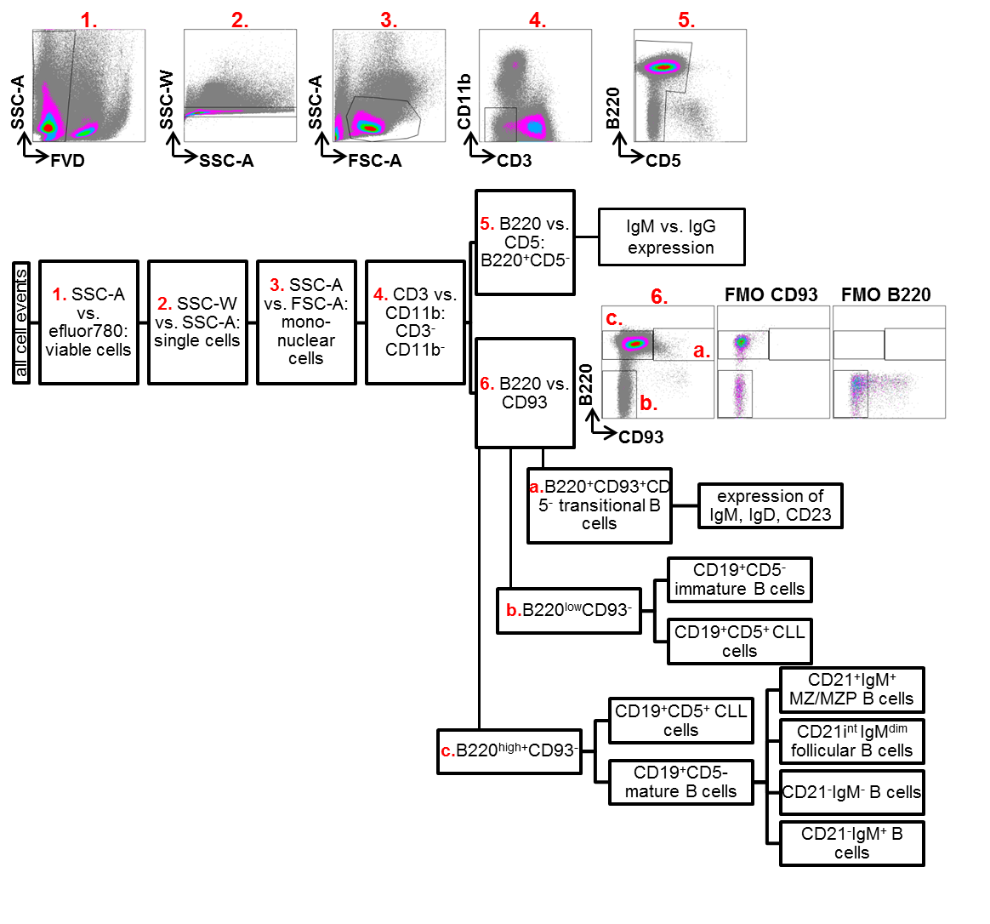

Supplemental Figure 3: Histopathological assessment of bone marrow aspirates: Bone marrow aspirates were obtained from WT and diseased dTG mice (n=3 each) to confirm tissue infiltration patterns. 500 cells were counted. Photographs were taken with an Olympus SC30 camera with an Olympus BX53 microscope. (A) 50X (500x total magnification) and 100X (1000x total magnification) objectives: Infiltration with large lymphoid blastoid cells in aspirates from diseased Eµ-TCL1xMyc, characterized by the presence of distinct cellular borders with a small amount of deeply basophilic cytoplasm, a small perinuclear colorless zone, and nuclei with coarsely stippled chromatin with one to two, large, round to oval, nucleoli. Red arrow head: immature lymphocyte/ lymphoid blastoid cells, black arrow head: mature lymphocyte. (B) Comparison of relative frequencies of cells within myeloid, erythroid and lymphoid linages in Eµ-TCL1xMyc and WT mice using a non-parametric Wilcoxon-Mann-Whitney test. Enumeration and maturation stages of (C) myeloid and (D) lymphoid lineage cells.
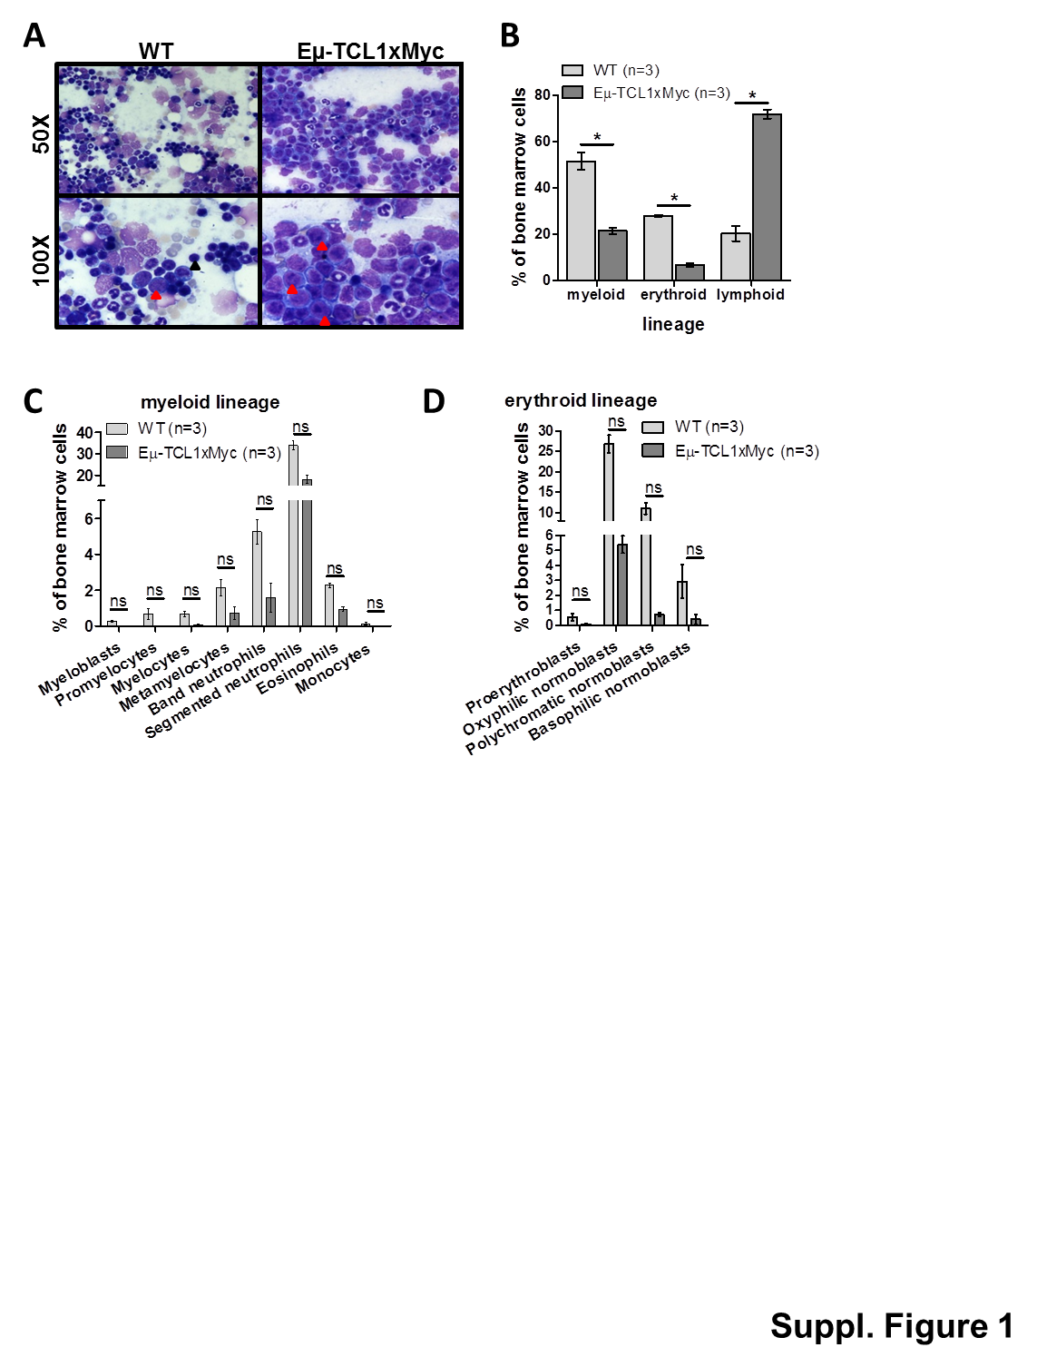

Supplemental Figure 4: Relative changes of mature B-cell subsets in marrow and blood: Among non-CLL maturing B (B220⁺CD19⁺CD5⁻) cells, the frequencies of follicular (Foll BC) and marginal zone/marginal zone progenitor (MZ/MZP) cells were compared in WT (n=5) and diseased Eµ-TCL1 (n=8), Eµ-Myc (n=6), and Eµ-TCL1xMyc (n=9) mice (all transgenic mice with disease requiring euthanasia) using 1-way ANOVA with Dunn’s multiple comparison and non-parametric tests.. All graphs show mean±SEM.
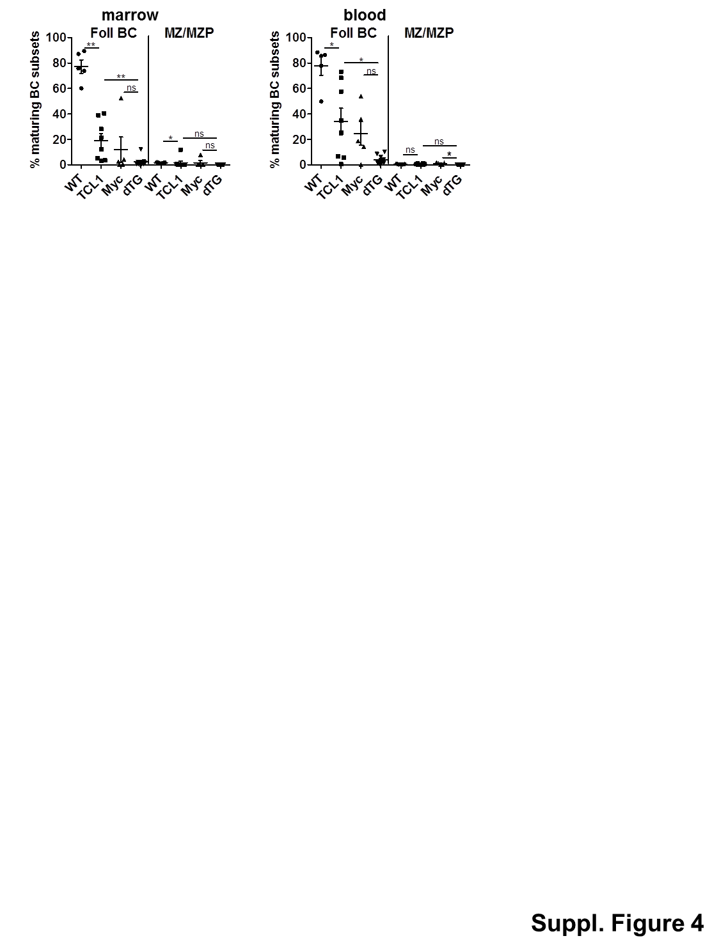

Supplemental Figure 5: Myc and TCL1 expression in CD21⁻IgM⁻, CD21⁻IgM⁺ and CD19⁺CD5⁺ populations: (A) Spleens from 8 additional diseased dTG Eµ-TCL1xMyc mice were stained with intracellular c-Myc and TCL1-A or respective isotypes after B-cell surface staining, and corrected median fluorescence intensities (MFIs, MFI TCL1/ Myc MINUS MFI isotype PE/ AF488) were compared to those in WT spleen B cells (n=2). Graphs show mean±SEM. (B) CD19⁺CD5⁺ CLL-like, CD21⁻IgM⁻ and CD21⁻IgM⁺ cells were flow-sorted from spleen suspensions from representative diseased dTg mice (n=3) meeting euthanasia criteria, and low-input RNAseq was performed. Transcript counts for the human TCL1A transgene were quantified by aligning preprocessed reads to a TCL1A reference and counting the number of aligned reads. The mean DESeq2 normalized expression for TCL1A and Myc with SEM error bars. Benjamini-Hochberg corrected DESeq2 p-values (q-values) were used to calculate significance. * : q < 0.05; ** : q < 0.01.
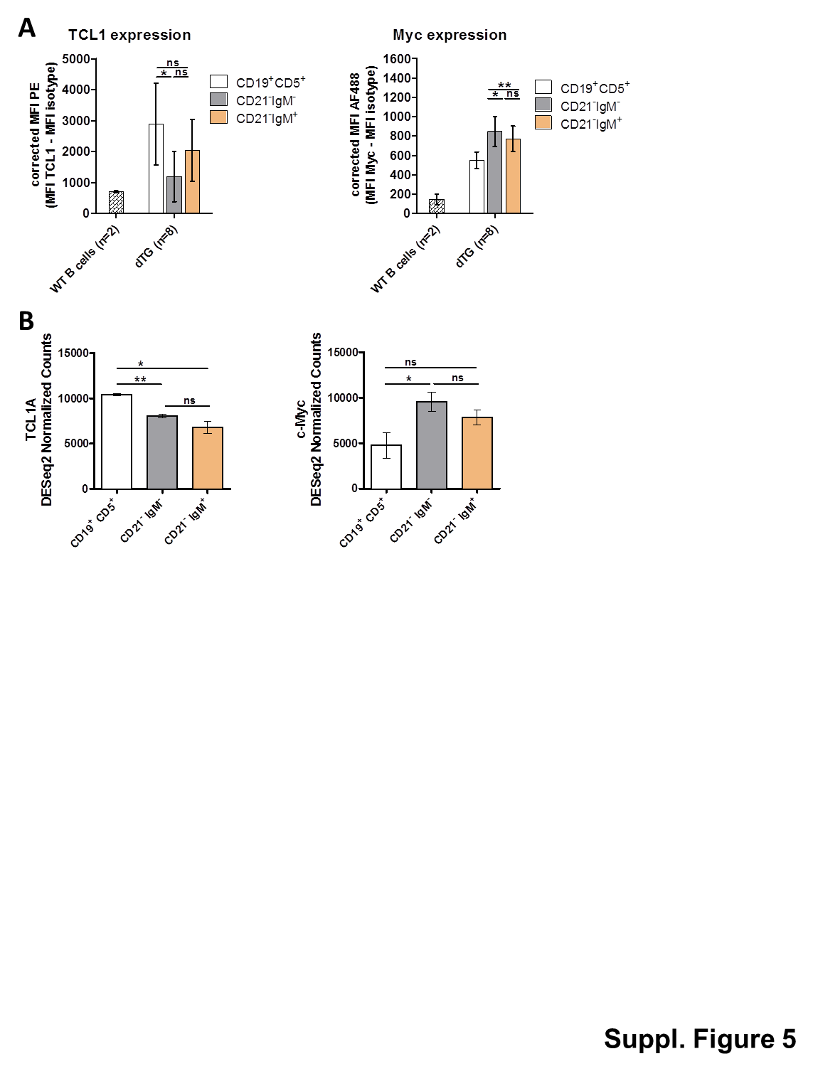

Supplemental Figure 6: Characterization of BCR and V gene usage: (A) CDR3 sequence abundances presented as pie-charts. The top 20 most abundant CDR3 sequences are shown by replicate; shared sequences have the same color across all replicates and samples. Cross hatch: Light-chain CDR3 sequence; Solid color: Heavy-chain CDR3 sequence. Sequences not in the top 20 are grouped as “Others” (forest green sector). (B) BCR reads were binned by lambda-light chain V gene names. Each V gene was normalized by the total number of lambda -chain reads. Shared V genes have the same color across all replicates and samples. (C) BCR reads were binned by heavy-chain V gene names. Each V gene was normalized by the total number of heavy -chain reads. The top 10 most abundant genes are shown by replicate with shared V genes having the same color across all replicates and samples. Genes not in the top 10 are grouped as “Others” (bottom-most segment in each stacked-bar). Actual CDR3 sequences for the top 20 CDR3 sequences and gene names for the top 10 V genes, in the order of their abundance, are presented in Suppl. Table 4.

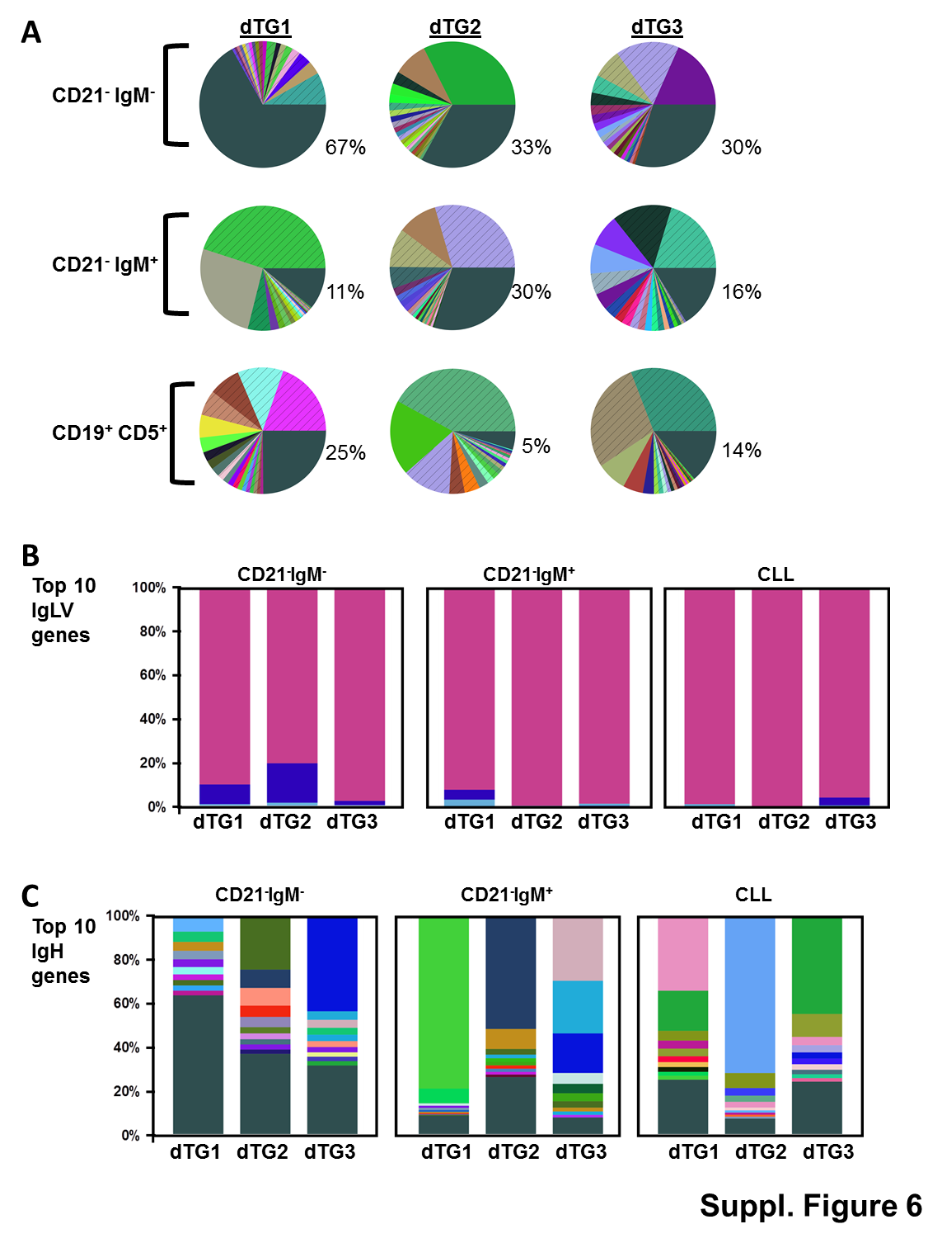

Supplemental Figure 7: B220^{low/+}CD19⁺CD5⁺ CLL-like population in recipients of flow-sorted dTG malignancy components: Flow plots at time of euthanasia from all organs in recipients of CD19⁺CD5⁺ cells (top panel), CD21⁻IgM⁻ cells (middle panel) and CD21⁻IgM⁺ cells (lower panel). The B220^{low/+}CD19⁺CD5⁺ CLL like population was gated on viable single CD3⁻CD11b⁻CD93⁻ MNCs. C1457 did not show any signs or symptoms of disease and is therefore considered a failed engrafter. Note: Our previous experiments had demonstrated very similar patterns for FMO controls using spleen, marrow and blood cells. For endpoint phenotyping in most mice, FMO controls for CD5 were therefore prepared from spleen cells only and by mixing spleen cell suspension from several mice. The FMO depicting control plots (grey) are therefore derived from the same FCS file for CD5 in C1459 and C1439; C1436 and C1464; C1438 and C1465. Separate CD5 FMO controls were generally prepared for blood that had been analyzed the day before euthanasia.
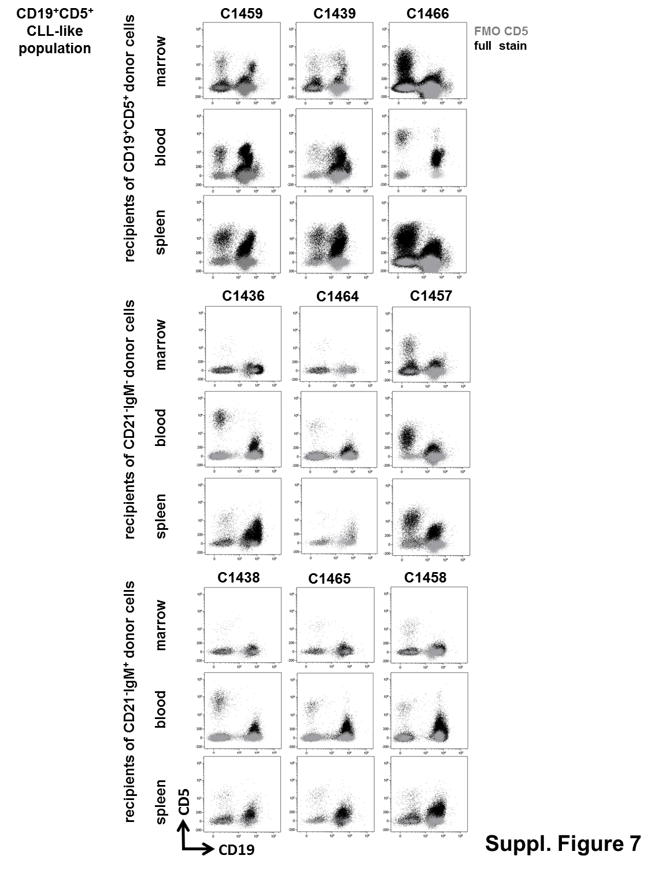

Supplemental Figure 8: Immunophenotype of B220⁺ non-CLL cells in recipients of flow-sorted dTG malignancy components: Flow plots at time of euthanasia from all organs in recipients of CD19⁺CD5⁺ cells (top panel), CD21⁻IgM⁻ cells (middle panel) and CD21⁻IgM⁺ cells (lower panel). B220⁺ non-CLL cells were gated on viable single CD3⁻CD11b⁻CD93⁻CD19⁺CD5⁻ MNCs. C1457 did not show any signs or symptoms of disease and is therefore considered a failed engrafter. Note: Our previous experiments had demonstrated very similar patterns for FMO controls using spleen, marrow and blood cells. For endpoint phenotyping in most mice, FMO organ controls for IgM were therefore prepared from spleen cells only and by mixing spleen cell suspension from several mice. The FMO depicting control plots (grey) are therefore derived from the same FCS file for IgM in C1459 and C1439; C1436 and C1464; C1438 and C1465. Separate IgM FMO controls were generally prepared for blood that had been analyzed the day before euthanasia.

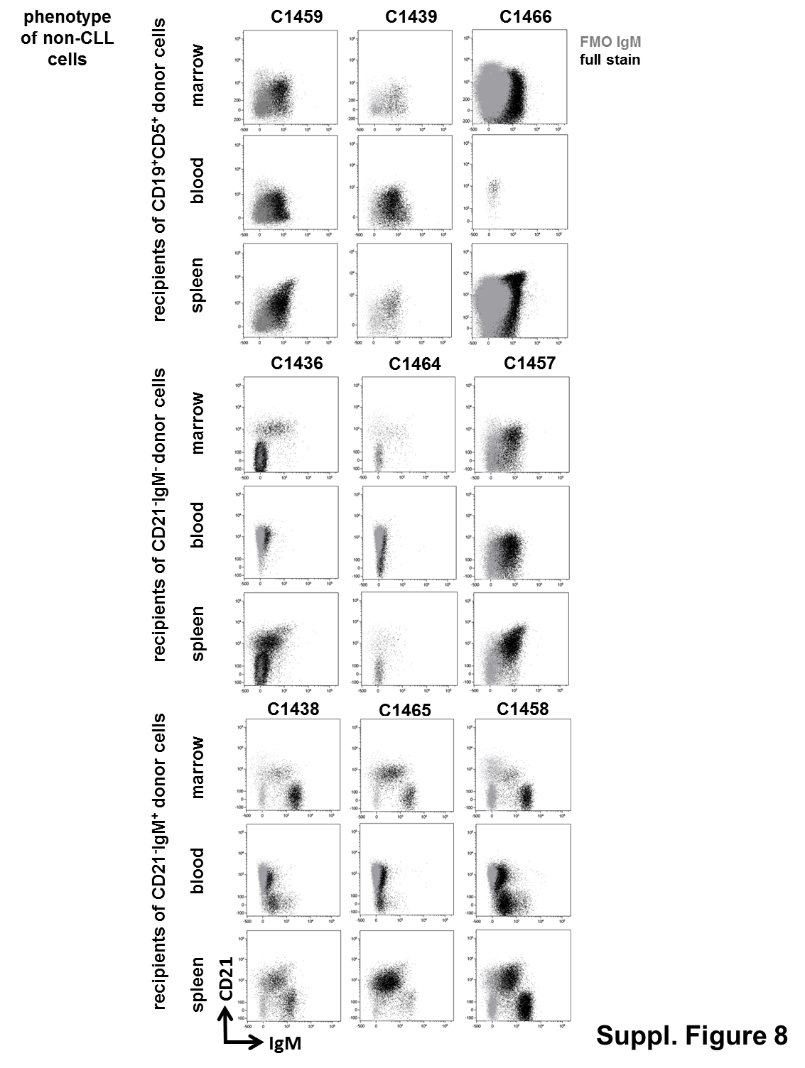

SUPPLEMENTAL MATERIALS: SUPPLEMENTAL METHODS AND MATERIALS

Mouse Genotyping by PCR
Mouse tail biopsies were digested overnight at 56°C using proteinase K (0.5mg/µL final concentration). Standard PCR technique was used to verify the TCL1 and/or c-Myc transgenes using the following primers and programs: TCL1 (Fwd: GCC GAG TGC CCG ACA CTC and Rev: CAT CTG GCA GCA GCT CGA) 95°C 5min, 30-35 cycles of 95° 30 sec 59°C 30 sec and 72°C 2 min followed by 72°C 10 min. Myc (Fwd: GAA TGG TAT CAA AGG ACA GTG C and Rev: CTC GGC TGA ACT GTG TTC TTG) 94°C 3 min, 35 cycles of 94°C 30 sec 62°C30 sec and 72°C 1 min followed by 72°C 2 min.

Immunoblotting
Freshly isolated CD19⁺ cells from mouse spleens were selected using the Pan-B-cell selection kit (STEMCELL Technologies Inc., Vancouver, Canada) following the manufacture’s protocol. Proteins extracted from whole-cell lysates (30μg/lane) were separated on a 14% polyacrylamide gel, transferred on nitrocellulose membrane and probed using anti-TCL1 (1:5000, MBL-international Corporation), cMYC (1:1000, Cell Signaling Technology) and GAPDH (EMD Millipore).

Histopathology
Tissues were fixed in 10% neutral buffered formalin (NBF). Bones were decalcified in formic acid (Surgipath). All tissues were then embedded in paraffin and sectioned at 4μM onto glass slides. Stained sections were assessed by a mouse anatomic histopathologist (BH). Bone marrow aspirates were assessed by a mouse clinical histopathologist (JB), and results were reported as numbers and percentages of cells at different myeloid, erythroid and lymphoid maturation stages. 500 cells were counted, with a focus on morphology of immature cells.

Preparation of single cell suspensions from mouse organs
Organs were harvested and processed immediately following standard procedures. Briefly, spleens were prepared into single cell suspension using an AUTOMACS tissue dissociator (Miltenyi) as per manufacturer’s recommendation. Red blood cells (RBCs) in EDTA-collected blood were lysed twice in 10-times volume of an ammonium-chloride based hypotonic solution. Bones were flushed, filtered through a 70µm strainer (BD) and RBCs lysed. All steps were performed on ice/ at 4°C, with the exception of RBC lysis (room temperature). Cell viability was assessed on an automated hemocytometer, and only samples with >70% viability (determined by trypan-blue exclusion) were used for downstream applications.

Flow cytometry
All flow cytometry panels assessing B-cell phenotype were optimized on cells from healthy WT and leukemic TCL1 mice (biological positive and negative controls), and isotype or fluorescence-minus-one (FMO) controls were prepared for every organ during each experiment. Antibodies were titrated for optimal performance. The effect of formaldehyde fixation and cryopreservation on antigen stability was compared in pilot experiments. Cells were stained using antibody cocktails to ensure uniform staining of samples. 1x10⁷ cells were stained for sample tubes, and 5x10⁶ cells for control tubes. Cells were resuspended in 100µl fixable viability dye (eBioscience, 1:1000) or nearIR (LifeTechnologies, 0.3µl) diluted in PBS:Brilliant Buffer (BD) 1:1, antibody cocktail was added, and cells were stained at 4°C for 30min. Cells were then washed, fixed with 1.7% formaldehyde in PBS/1% BSA for 15min at room temperature, washed again, and acquired on a BD Fortessa after overnight storage. For intracellular staining protocols, 1x10⁷ cells were stained with nearIR viability dye, washed, and resuspended in 100µl PBS:Brilliant Buffer buffer containing Fc blocking solution, Surface stain cocktail was added for 30min as above. After washing, cells were fixed and permeabilized using Fixation/Permeabilization solution from BD as per manufacturers’ protocol. C-Myc and TCL1A or respective isotype cocktails were added and cells were incubated at 4°C for 30 minutes in the dark. After washing with 1× BD Perm/Wash™ buffer, cells were resuspend in PBS and acquired on a BD Fortessa. WT spleen B cells were prepared under identical conditions as negative controls for Myc and TCL1A expression. Compensation matrixes were created using single-stained compensation particles (LifeTechnologies and BD) and DIVA automated compensation algorithms⁴.

Low-input RNA-seq
For RNA extraction using a chloroform/ alcohol extraction method, samples were brought to room temperature (RT). Volumes were adjusted to 1ml Trizol. After 1h at RT, 200µl chloroform and 1µl glycogen were added. Tubes were shaken vigorously by hand for 15 seconds, incubated at RT for 3 minutes at RT, and centrifuges at 12000g for 15 minutes at 4°C. The aqueous phase was transferred to a fresh 1.7ml tube, and 500µl 100% isopropanol were added. Tubes were vortexed, incubated at RT for 10 minutes, and centrifuged at 12000g for 15 minutes at 4°C. The pellet was washed with 500µl 75% ethanol, vortexed, and centrifuged at 750g for 5 minutes at 4°C. Supernatant was discarded completely, and the pellet was allowed to air dry for 5-10 minutes before resuspending in 20µl RNase/DNase free water.
Sequencing reads were adapter- and quality trimmed followed by alignment to the mouse GRCm39p4 reference. Post alignment quality was assessed using QuaCRS⁵. Transcripts from each replicate were assessed by CLEAR for expression robustness and transcript counts quantified by featureCounts (v1.5.1).
For characterization of CDR3 information from reads aligned to B-cell receptors, the percentage of reads with heavy, kappa, and lambda chains compared to the number of total sequencing reads were quantified for each replicate. Welch-corrected t-tests using GraphPad Prism (v7.0e) were used to determine significant differences in the percentage of BCR reads (% of total sequencing reads) between CD21⁻IgM⁻, CD21⁻IgM⁺, and CD19⁺CD5⁺ CLL-like groups. The relative CDR3 sequence abundances were plotted as pie-charts. We provided the top 20 most abundant sequences with shared CDR3 sequences having the same color across all samples. The remaining CDR3 sequences are jointly denoted as “Others”. This feature serves to highlight CDR3 population complexity. To examine the differences in V gene usage, BCR reads were binned by specific heavy- (H) and light chain- (L and K) V genes. Each V gene was normalized by the total number of reads corresponding to that chain. The top 10 most abundant genes were visualized using a stacked-bar chart with shared V genes having the same color across all samples. The remaining genes are jointly denoted as “Others”. For differentially expressed gene (DEG) analysis, Benjamini-Hochberg corrected p-values (q-values) were calculated; genes with q-values < 0.05 were considered significant. A heatmap was generated for the selected genes. The values plotted were obtained from the DESeq2 size-normalized and log transformed CLEAR counts table. Each row (gene) was normalized to a range of (-1, 1) using the R function rescale().

SUPPLEMENTAL MATERIALS: SUPPLEMENTAL TABLES

Supplemental Table 1: Fluorophores, concentrations and suppliers of antibodies used to stain murine cells
fluorophore | antigen | clone | µl per 100µl cell suspension | supplier
BB515 | CD19 | 1D3 | 0.5 | BD Biosciences
PerCP-Cy5.5 | CD21 | 7E9 | 0.5 | Biolegend
APC | CD93 | AA4.1 | 1 | Biolegend
efluor780 and nearIR | fixable viability dye |  | NA | eBioscience and LifeTechnologies
BV510 | CD3 | 145-2C11 | 0.66 | BD Biosciences
BV605 | IgD | 11-26c.2a | 1 | BD Biosciences
BV650 | CD11b | M1/70 | 0.5 | BD Biosciences
BV711 | CD23 | B3B4 | 0.5 | BD Biosciences
BV786 | IgM | R6-60.2 | 1 | BD Biosciences
BUV 395 | B220 | RRA3-6B2 | 0.5 | BD Biosciences
BUV 737 | CD5 | 53-7.3 | 0.66 | BD Biosciences
AF700 | Igkappa | RMK-45 | 1 per 1x10⁶ cells | Biolegend
PE | Iglambda | RML_42 | 5 per 1x10⁶ cells | Biolegend
Alexa Fluor® 488 | c-Myc | D84C12 | 5 | CellSignalling
PE | TCL1 | 1-21 | 5 | BioLegend

Supplemental Table 2: Low-input RNA-seq post-alignment quality control metrics
Sample | Total PF Clusters | Uniquely Mapped Read Ratio | Dupli-cation Rate | Intra-genic Rate | Exonic Rate | Intronic Rate | Inter-genic Rate | Expressed Transcripts
dTG1  CD21⁻IgM⁻ | 10,472,074 | 84.6% | 15.4% | 96.6% | 87.0% | 9.6% | 3.4% | 60,357
dTG2  CD21⁻IgM⁻ | 12,449,594 | 83.5% | 16.5% | 97.5% | 88.1% | 9.3% | 2.5% | 61,569
dTG3  CD21⁻IgM⁻ | 12,291,185 | 84.5% | 15.5% | 97.5% | 89.5% | 8.0% | 2.4% | 61,386
dTG1  CD21⁻IgM⁺ | 12,415,179 | 85.0% | 15.0% | 95.7% | 86.0% | 9.8% | 4.2% | 62,094
dTG2  CD21⁻IgM⁺ | 12,801,182 | 85.8% | 14.2% | 91.7% | 75.6% | 16.0% | 8.3% | 66,288
dTG3  CD21⁻IgM⁺ | 10,705,051 | 85.8% | 14.2% | 96.9% | 88.4% | 8.5% | 3.0% | 60,951
dTG1 CD19⁺CD5⁺CLL | 10,656,243 | 84.5% | 15.5% | 96.3% | 82.3% | 14.0% | 3.6% | 62,282
dTG2 CD19⁺CD5⁺CLL | 11,157,411 | 85.0% | 15.0% | 96.5% | 77.3% | 19.1% | 3.4% | 62,357
dTG3 CD19⁺CD5⁺CLL | 12,118,661 | 84.1% | 15.9% | 96.8% | 87.2% | 9.6% | 3.1% | 63,484

Supplemental Table 3: Alignment statistics of heavy- and light chain- (lambda and kappa) B-cell receptor (BCR) reads
Sample | Total Sequencing Reads | BCR Reads | IgH Reads | Ig Kappa Reads | Ig Lambda Reads
dTG1 CD21⁻IgM⁻ | 9,962,550 | 7,166  (0.07%) | 2,165  (30.2%) | 3,946  (55.1%) | 1,055  (14.7%)
dTG2 CD21⁻IgM⁻ | 11,993,721 | 7,718  (0.06%) | 2,592  (33.6%) | 3,478  (45.1%) | 1,648  (21.4%)
dTG3 CD21⁻IgM⁻ | 11,897,655 | 7,394  (0.06%) | 2,356  (31.9%) | 3,578  (48.4%) | 1,460  (19.7%)
dTG1 CD21⁻IgM⁺ | 12,037,186 | 49,343  (0.41%) | 13,648 (27.7%) | 34,787 (70.5%) | 908  (1.8%)
dTG2 CD21⁻IgM⁺ | 12,440,325 | 46,350  (0.37%) | 8,142  (17.6%) | 18,234 (39.3%) | 19,974 (43.1%)
dTG3 CD21⁻IgM⁺ | 10,357,621 | 31,204  (0.3%) | 7,948  (25.5%) | 21,154 (67.8%) | 2,102  (6.7%)
dTG1 CD19⁺CD5⁺CLL | 10,150,131 | 83,399  (0.82%) | 18,801 (22.5%) | 50,359 (60.4%) | 14,239 (17.1%)
dTG2 CD19⁺CD5⁺CLL | 10,681,241 | 103,652 (0.97%) | 20,763  (20%) | 22,039 (21.3%) | 60,850 (58.7%)
dTG3 CD19⁺CD5⁺CLL | 11,650,861 | 53,542  (0.46%) | 11,478 (21.4%) | 36,572 (68.3%) | 5,492  (10.3%)

Supplemental Table 4: Abundance information of top 20 CDR3 sequences and top 10 heavy chains and top 10 light chains (see supplemental Excel file)

Supplemental Table 5: DESeq2 normalized counts, log2-fold change, and p-values and adjusted p-values for selected oncogenes, Myc and TCL1A (see supplemental Excel file)

Supplemental Table 6: Characteristics of recipient mice and engrafted diseases after injection of flow-sorted CLL, CD21⁻IgM⁻ and CD21⁻IgM⁺ cells obtained from pooled diseased dTG donor mice (n=3)
injected with | recipient ID | sex | cells per mouse | days survival after AT | age (mo) at death | reason for death | necropsy observations
CLL | C1439 | M | 3.33E+05 | 136 | 8.9 | end of experiment | modest splenomegaly
 | C1466 | M | 3.33E+05 | 94 | 6.9 | ↓ body condition, respiratory distress upon handling | large cystic neck mass  modest splenomegaly and lymphadenopathy
 | C1459 | F | 3.33E+05 | 136 | 7.0 | end of experiment | modest splenomegaly
CD21⁻IgM⁻ | C1436 | M | 1.00E+06 | 58 | 6.3 | respiratory distress after handling,  ↓ grip strength | splenomegaly and lymphadenopathy
 | C1464 | M | 1.00E+06 | 58 | 5.8 | respiratory distress after handling,  ↓ grip strength | splenomegaly, lymphadenopathy, hepatomegaly
 | C1457 | F | 1.00E+06 | 136 | 7.0 | end of experiment | NAD
CD21⁻IgM⁺ | C1438 | M | 1.00E+06 | 58 | 6.3 | ↓ grip strength | splenomegaly and lymphadenopathy
 | C1465 | M | 1.00E+06 | 58 | 5.8 | ↓ grip strength | splenomegaly and lymphadenopathy
 | C1458 | F | 1.00E+06 | 69 | 4.8 | ↓ body condition | hemorrhagic ascites, multiple small sites of mesenteric and gastrointestinal infiltration

REFERENCES
1. Becton, Dickinson, company. B-Cell Research. Flow cytometry tools for the study of B-cell biology. 2014.
2. Pieper K, Grimbacher B, Eibel H. B-cell biology and development. The Journal of allergy and clinical immunology. 2013;131(4):959-971.
3. Allman D, Pillai S. Peripheral B cell subsets. Curr Opin Immunol. 2008;20(2):149-157.
4. Tung JW, Parks DR, Moore WA, Herzenberg LA, Herzenberg LA. New approaches to fluorescence compensation and visualization of FACS data. Clinical immunology (Orlando, Fla). 2004;110(3):277-283.
5. Kroll KW, Mokaram NE, Pelletier AR, et al. Quality Control for RNA-Seq (QuaCRS): An Integrated Quality Control Pipeline. Cancer Inform 2014;13(Suppl 3):7-14.

