Supporting Information for

**Leveraging bioorthogonal click chemistry to improve 225Ac-radioimmunotherapy of pancreatic ductal adenocarcinoma**

Sophie Poty1, Lukas M. Carter1, Komal Mandleywala1,Rosemery Membreno2,3, Dalya Abdel-Atti1, Ashwin Ragupathi1, Wolfgang W. Scholz4, Brian M. Zeglis1,2,3,6,*, Jason S. Lewis1,5,6,7,*

1 Department of Radiology, Memorial Sloan Kettering Cancer Center, New York, NY, USA

2 Department of Chemistry, Hunter College of the City University of New York, New York, NY, USA

3 Ph.D. Program in Chemistry, Graduate Center of the City University of New York, NY, USA

4 MabVax Therapeutics, San Diego, California, USA

5 Molecular Pharmacology Program, Memorial Sloan Kettering Cancer Center, New York, NY, USA

6 Department of Radiology and Pharmacology, Weill Cornell Medical College, New York, NY, USA

7 Radiochemistry and Molecular Imaging Probes Core, Memorial Sloan Kettering Cancer Center, New York, NY, USA

**Figures:**

**Figure S1: Pretargeting RIT versus conventional RIT** 6

**Figure S2: Pretargeting RIT versus conventional RIT with DO3A chelator and huA33 antibody** 8

**Figure S3: Spleen uptake as immunosuppression predictor** 9

**Figure S4: Cerenkov Luminescence Imaging and evaluation of 225Ac daughters’ redistribution** 10

**Figure S5: The growth of 225Ac daughters activity (Bq) in a pure parent fraction as a function of time. 225Ac secular equilibrium state is reach 20 hours post-disruption of an equilibrium state.** 11

**Figure S6. Percentage survival as a function of time in the longitudinal therapy study using a subcutaneous BxPC3 PDAC mouse model** 17

**Figure S7. Haematological parameters 10 days and 45 days after the administration of the radiopharmaceuticals** 20

**Figure S8. Percentage survival as a function of time in the longitudinal therapy study using an orthotopic BxPC3-Luc PDAC mouse model. Blood Urea Nitrogen (BUN), creatine (CREA), and BUN/CREA levels in mice bearing orthotopic BxPC3 xenografts treated with either conventional of pretargeted RIT (37 kBq) that showed normal or cortical tubular degeneration of the kidneys upon pathological evaluation.** 21

**Tables:**

**Table S1: Adjusted P values** 5

**Table S2: Tumor-to-tissue ratios extracted from the biodistribution data of 225Ac-DOTA-PEG7-5B1** 5

**Table S3: Tumor-to-tissue ratios extracted from the biodistribution data of 5B1-TCO + 225Ac-DOTA-PEG7-Tz** 5

**Table S4:** **Mouse dosimetry of conventional RIT and pretargeted RIT** 10

**Table S5:** **Normal organs absorbed doses and relative contribution of alpha, beta and photon radiation with pretargeted RIT following hypothesis 1** 11

**Table S6:** **Normal organs absorbed doses and relative contribution of alpha, beta and photon radiation with pretargeted RIT following hypothesis 2** 12

**Table S7: Extrapolation of pretargeted RIT dosimetry to humans** 13

**Table S8:** **Extrapolation of conventional RIT dosimetry to humans** 14

**Table S9. Logrank Mantel-Cox test comparing survival of pretargeted RIT and conventional RIT in mice bearing subcutaneous BxPC3 xenografts** 17

**Table S10.** **Logrank Mantel-Cox test comparing survival of pretargeted RIT and conventional RIT in orthotopic BxPC3-Luc xenografted mice** 20

**Table S11. Summary of the pathological evaluation of the kidneys of mice bearing BxPC3 orthotopic xenografts treated with conventional of pretargeted RIT (37 kBq)** 21

**Methods**…………………………………………………………………………………………………… 21

**References**…………………………………………………………………………………………………..25

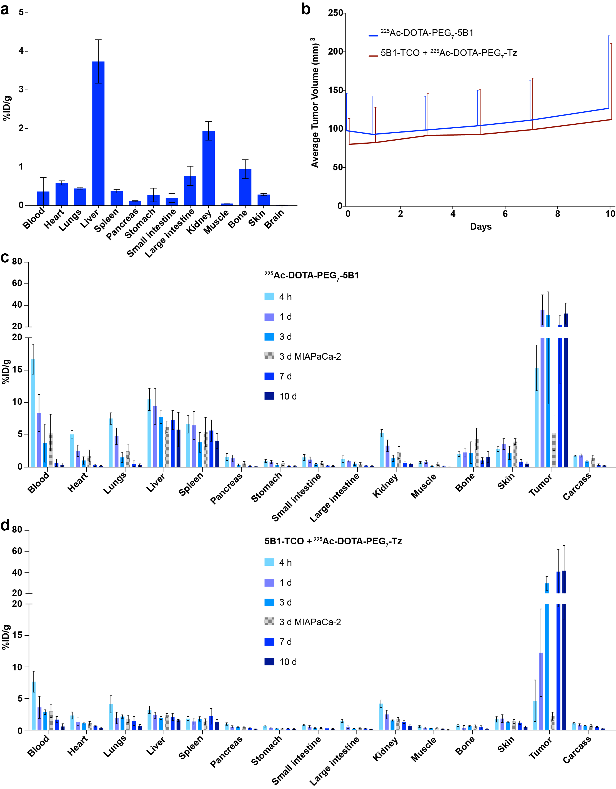

**Figure S1: Pretargeting RIT versus conventional RIT. a.** *In vivo* biodistribution in healthy athymic nude mice of 225Ac-DOTA-PEG7-Tz (18.5 kBq, 300 ng, 0.3 nmol), 4 h post-injection. Error bars represent the SD (n = 5). **b.** Plot of the average tumor volume of the 10 days biodistribution BxPC3 (CA19.9-positive) tumor bearing athymic nude mice cohort. **c.** Full *in vivo* biodistribution of 225Ac-DOTA-PEG7-5B1 (18.5 kBq, 8.6 μg, 0.06 nmol) in athymic nude mice bearing BxPC3 (CA19.9 positive) and MIAPaCa-2 (CA19.9 negative) tumors up to 10 days post injection. Error bars represent the SD (n = 5). **d.** Full *in vivo* biodistribution of 5B1-TCO + 225Ac-DOTA-PEG7-Tz (200 μg, 1.32 nmol + 18.5 kBq, 0.5 μg, 0.4 nmol) in athymic nude mice bearing BxPC3 (CA19.9 positive) and MIAPaCa-2 (CA19.9 negative) tumors up to 10 days post injection. Error bars represent the SD (n = 5).

|  |  |  |  |  |  |
| --- | --- | --- | --- | --- | --- |
|  | 225Ac-DOTA-PEG7-5B1 versus 5B1-TCO + 225Ac-DOTA-PEG7-Tz | | | | |
|  | 4 hours | 1 day | 3 days | 7 days | 10 days |
|  | BxPC3 | BxPC3 | BxPC3 | BxPC3 | BxPC3 |
| Blood | *** | n.s. | n.s. | n.s. | n.s. |
| Liver | *** | ** | *** | *** | * |
| Spleen | *** | ** | n.s. | * | ** |
| Kidney | n.s. | n.s. | n.s. | * | n.s. |
| Bone | *** | ** | n.s. | n.s. | * |
| Tumor | ** | * | n.s. | n.s. | n.s. |

**Table S1: Adjusted P values** were calculated from multiple t-tests using a Bonferroni correction and allows the comparison of the biodistribution data of 225Ac-DOTA-PEG7-5B1 (18.5 kBq, 8.6 μg, 0.06 nmol) and 5B1-TCO + 225Ac-DOTA-PEG7-Tz (200 μg, 1.32 nmol + 18.5 kBq, 0.5 μg, 0.4 nmol). * adjusted P ≤ 0.05, ** adjusted P ≤ 0.01, *** adjusted P ≤ 0.001, n.s. = non significant.

|  |  |  |  |  |  |
| --- | --- | --- | --- | --- | --- |
|  | 225Ac-DOTA-PEG7-5B1 | | | | |
|  | 4 hours | 1 day | 3 days | 3 days | 7 days |
|  | BxPC3 | BxPC3 | BxPC3 | MIAPaCa-2 | BxPC3 |
| Tumor:Blood | 0.92 ± 0.25 | 4.29 ± 2.21 | 8.37 ± 8.74 | 32.72 ± 30.8 | 87.8 ± 73.74 |
| Tumor:Heart | 3.03 ± 0.83 | 14.15 ± 7.34 | 30.15 ± 26.54 | 78.35 ± 57.99 | 212.6 ± 156.8 |
| Tumor: Lungs | 2.04 ± 0.53 | 7.5 ± 3.52 | 20.69 ± 17.99 | 42.81 ± 41.06 | 100.57 ± 68.53 |
| Tumor: Liver | 1.47 ± 0.38 | 3.82 ± 1.85 | 4.00 ± 2.79 | 3.01 ± 1.37 | 5.59 ± 3.06 |
| Tumor: Spleen | 2.31 ± 0.67 | 5.56 ± 2.83 | 8.08 ± 6.42 | 3.88 ± 1.95 | 8.04 ± 3.35 |
| Tumor: Pancreas | 9.62 ± 4.91 | 26.2 ± 14.4 | 91.01 ± 75.54 | 132.03 ± 69.38 | 295.6 ± 163.76 |
| Tumor: Stomach | 15.98 ± 8.58 | 45.05 ± 22.03 | 80.79 ± 71.68 | 114.59 ± 76.29 | 257.84 ± 207.84 |
| Tumor: Small Intestine | 10.21 ± 5.11 | 30.82 ± 15.99 | 74.01 ± 58.06 | 88.47 ± 44.66 | 166.5 ± 87.98 |
| Tumor: Large Intestine | 12.23 ± 7.45 | 37.16 ± 15.68 | 57.75 ± 49.69 | 96.05 ± 47.15 | 160.73 ± 56.59 |
| Tumor: Kidney | 2.93 ± 0.79 | 10.81 ± 5.08 | 22.65 ± 17.46 | 35.00 ± 22.28 | 63.62 ± 26.21 |
| Tumor: Muscle | 21.15 ± 13.31 | 43.52 ± 21.28 | 139.21 ± 110 | 257.32 ± 273.26 | 850.08 ± 503.48 |
| Tumor: Bone | 7.43 ± 2.86 | 15.74 ± 7.68 | 13.94 ± 14.22 | 21.47 ± 12.68 | 20.53 ± 12.39 |

**Table S2: Tumor-to-tissue ratios extracted from the biodistribution data of 225Ac-DOTA-PEG7-5B1** (18.5 kBq, 8.6 μg, 0.06 nmol) up to 10 days post injection in mice bearing BxPC3 (CA19.9 positive) tumors (n = 5).

|  |  |  |  |  |  |
| --- | --- | --- | --- | --- | --- |
|  | 5B1-TCO + 225Ac-DOTA-PEG7-Tz | | | | |
|  | 4 hours | 1 day | 3 days | 3 days | 7 days |
|  | BxPC3 | BxPC3 | BxPC3 | MIAPaCa-2 | BxPC3 |
| Tumor:Blood | 0.6 ± 0.45 | 3.4 ± 2.54 | 10.37 ± 2.7 | 24.58 ± 14.72 | 73.72 ± 71.64 |
| Tumor:Heart | 2.01 ± 1.57 | 9.2 ± 6.58 | 28.22 ± 6.8 | 69.71 ± 38.32 | 139.66 ± 111.66 |
| Tumor: Lungs | 1.14 ± 0.87 | 6.38 ± 4.7 | 13.79 ± 3.55 | 28.45 ± 20.76 | 69.07 ± 50.4 |
| Tumor: Liver | 1.44 ± 1.08 | 5.21 ± 3.14 | 15.36 ± 3.96 | 19.56 ± 11.52 | 27.04 ± 15.81 |
| Tumor: Spleen | 2.54 ± 1.97 | 9.04 ± 6.26 | 16.77 ± 5.12 | 18.71 ± 14.44 | 31.91 ± 20.28 |
| Tumor: Pancreas | 4.81 ± 4.07 | 23.99 ± 15.79 | 65.71 ± 18.04 | 151 ± 94.12 | 345.86 ± 286.74 |
| Tumor: Stomach | 7.34 ± 6.95 | 37.3 ± 27.12 | 122.75 ± 44.57 | 179.69 ± 101.94 | 244.85 ± 164.1 |
| Tumor: Small Intestine | 5.7 ± 4.7 | 24.15 ± 16.79 | 93.7 ± 26.11 | 162.95 ± 99.69 | 235.79 ± 160.67 |
| Tumor: Large Intestine | 3.2 ± 2.53 | 27.74 ± 20.62 | 134.21 ± 36.81 | 171.21 ± 96.23 | 349.67 ± 231.98 |
| Tumor: Kidney | 1.11 ± 0.81 | 4.97 ± 3.13 | 19.35 ± 4.52 | 32.17 ± 17.68 | 63.75 ± 40.44 |
| Tumor: Muscle | 8.25 ± 7.98 | 35.89 ± 25.16 | 106.44 ± 24.76 | 263.3 ± 171.15 | 913.57 ± 928.71 |
| Tumor: Bone | 6.48 ± 5.56 | 26.23 ± 22.35 | 48.69 ± 13.2 | 93.87 ± 74.42 | 341.71 ± 322.21 |

**Table S3: Tumor-to-tissue ratios extracted from the biodistribution data of 5B1-TCO + 225Ac-DOTA-PEG7-Tz** (200 μg, 1.32 nmol + 18.5 kBq, 0.5 μg, 0.4 nmol) up to 10 days post injection in mice bearing BxPC3 (CA19.9 positive) tumors (n = 5).

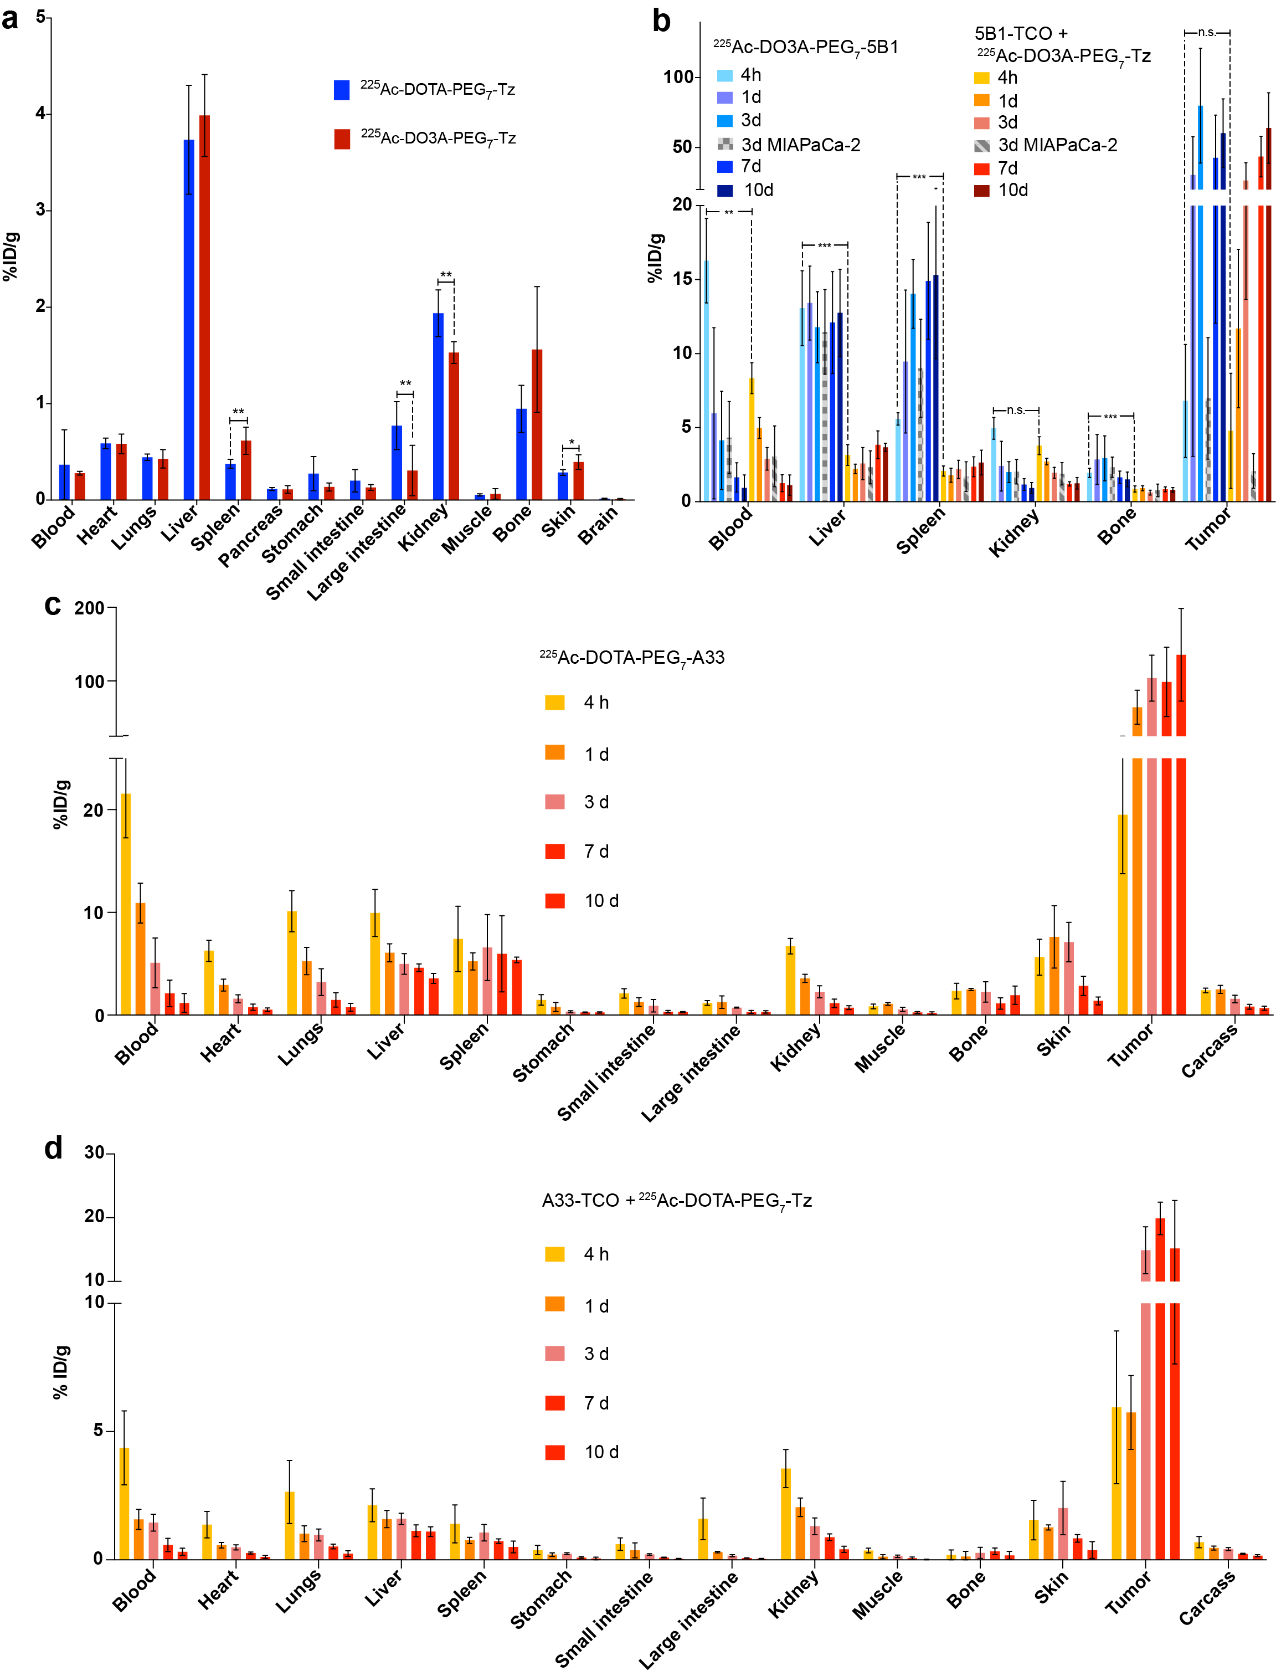

**Figure S2: Pretargeting RIT versus conventional RIT with DO3A chelator and huA33 antibody. a.** Comparisonof *in vivo* biodistribution of 225Ac-DOTA-PEG7-Tz (18.5 kBq, 300 ng, 0.3 nmol) and 25Ac-DO3A-PEG7-Tz (18.5 kBq, 815 ng, 0.7 nmol) in healthy athymic nude mice at 4 h post injection. Error bars represent the SD (n = 5). Unpaired, two-tailed t-tests were performed for each organ individually. Differences at the 95% confidence level (P < 0.05) were considered to be statistically significant. * P ≤ 0.05, ** P ≤ 0.01. **b.** Comparison of the *in vivo* biodistribution of 225Ac-DO3A-PEG7-5B1 (18.5 kBq, 8.6 μg, 0.06 nmol) and 5B1-TCO + 225Ac-DO3A-PEG7-Tz (200 μg, 1.32 nmol + 18.5 kBq, 0.5 μg, 0.4 nmol) in athymic nude mice bearing BxPC3 (CA19.9 positive) and MIAPaCa-2 (CA19.9 negative) tumors up to 10 days post injection. Only major organs are represented. Error bars represent the SD (n = 5). Multiple t-tests were performed and a Bonferroni correction was applied for the calculation of adjusted P values. ** adjusted P ≤ 0.01, *** adjusted P ≤ 0.001, n.s. = non significant. **c.** Full*in vivo* biodistribution of 225Ac-DOTA-PEG7-A33 (18.5 kBq, 13.2 μg 0.09 nmol) and **d.** A33-TCO + 225Ac-DOTA-PEG7-Tz (100 μg, 0.7 nmol A33-TCO + 18.5 kBq, 0.5 μg, 0.4 nmol) in athymic nude mice bearing SW1222 xenografts up to 10 days post injection. Error bars represent the SD (n = 5).

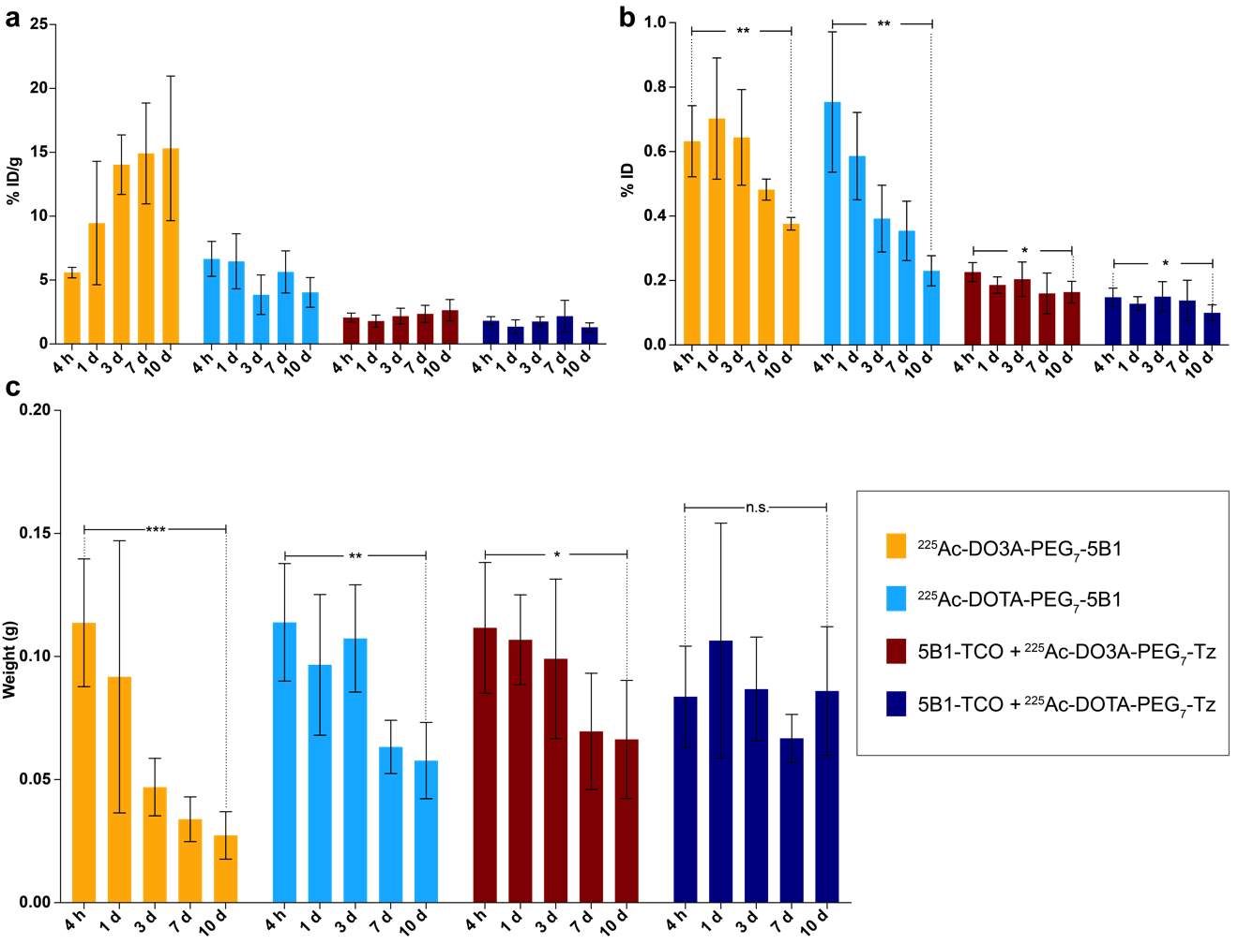

**Figure S3: Spleen uptake as immunosuppression predictor.** Comparison of the**a.** *In vivo* spleen uptake, **b.** *In vivo* spleen percentage of injected dose and **c.** Spleen weight in athymic nude mice bearing BxPC3 (CA19.9 positive) tumors up to 10 days after the administration of 225Ac-DO3A-PEG7-5B1, 225Ac-DOTA-PEG7-5B1, 225Ac-DO3A-PEG7-Tz (72 h following 5B1-TCO), and 225Ac-DOTA-PEG7-Tz (72 h following 5B1-TCO). Error bars represent the SD (n = 5). P values were determined using unpaired t-tests with Welch’s correction. * P ≤ 0.05, ** P ≤ 0.01, *** P ≤ 0.001, n.s. = non-significant.

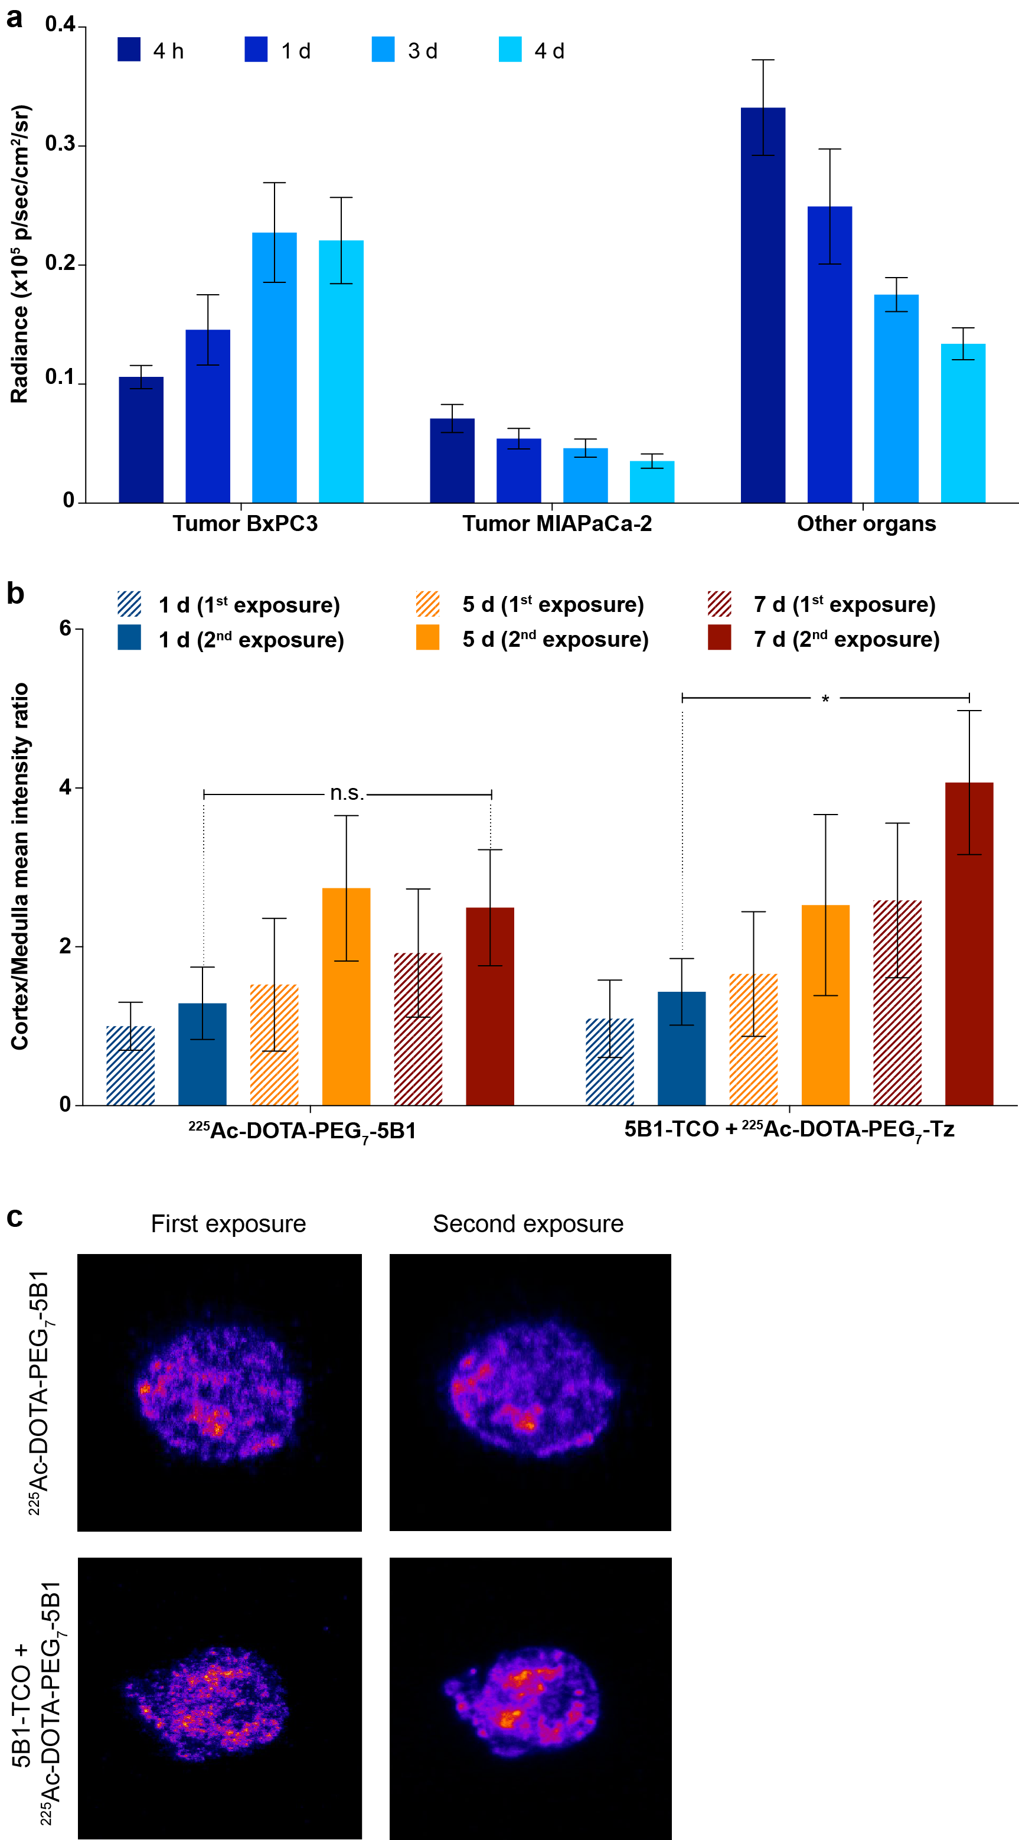

**Figure S4: Cerenkov Luminescence Imaging and evaluation of 225Ac daughters’ redistribution. a.** *In vivo* average radiance based upon ROI analysis in athymic nude mice bearing bilateral BxPC3 (CA19.9 positive) and MIAPaCa-2 (CA19.9 negative) tumors injected with 5B1-TCO + 225Ac-DOTA-PEG7-Tz (200 μg, 1.32 nmol + 1.85 MBq, 20.8 μg, 26.0 nmol). Error bars represent the SD (n = 4). **b.** Quantitative analysis of uptake in the cortex and medulla according to autoradiography mean intensity ratios. Error bars represent the SD (n = 3). P values were determined using unpaired two-tailed t-tests without assuming a consistent population standard deviation. * P ≤ 0.05, n.s. = non-significant. **c.** Autoradiography of the same tumor section performed at two time points: after the animal sacrifice (first exposure) and once secular equilibrium was reached (second exposure).

**Figure S5: The growth of 225Ac daughters activity (Bq) in a pure parent fraction as a function of time. 225Ac secular equilibrium state is reach 20 hours post-disruption of an equilibrium state.**



|  |  |  |  |  |
| --- | --- | --- | --- | --- |
| **225Ac-DOTA-PEG7-5B1** | | | | |
|  | Hypothesis 1 | | Hypothesis 2 | |
| Target organ | Gy/MBq | Therapeutic index | Gy/MBq | Therapeutic index |
| Tumor | 1377 | -- | 935.8 | -- |
| Blood | 120.3 | 11.4 | 81.81 | 11.4 |
| Heart | 36.57 | 37.6 | 24.86 | 37.6 |
| Lungs | 60.40 | 22.8 | 41.06 | 22.8 |
| Liver | 322.3 | 4.27 | 219.1 | 4.27 |
| Spleen | 227.6 | 6.05 | 154.7 | 6.05 |
| Pancreas | 15.80 | 87.1 | 10.74 | 87.1 |
| Stomach | 12.60 | 109 | 8.566 | 109 |
| Small Intestine | 16.44 | 83.8 | 11.17 | 83.8 |
| Large Intestine | 16.03 | 85.9 | 10.90 | 85.9 |
| Kidney | 50.37 | 27.3 | 1101 | 0.850 |
| Muscle | 9.086 | 152 | 6.177 | 152 |
| Bone | 68.70 | 20.0 | 46.70 | 20.0 |
| Carcass | 27.68 | 49.7 | 18.82 | 49.7 |
| **5B1-TCO + 225Ac-DOTA-PEG7-Tz** | | | | |
|  | Hypothesis 1 | | Hypothesis 2 | |
| Target organ | Gy/MBq | Therapeutic index | Gy/MBq | Therapeutic index |
| Tumor | 1994 | -- | 1355 | -- |
| Blood | 82.65 | 24.1 | 56.19 | 24.1 |
| Heart | 30.51 | 65.4 | 20.74 | 65.4 |
| Lungs | 58.91 | 33.8 | 40.04 | 33.8 |
| Liver | 87.89 | 22.7 | 59.75 | 22.7 |
| Spleen | 94.23 | 21.2 | 64.06 | 21.2 |
| Pancreas | 13.20 | 151 | 8.971 | 151 |
| Stomach | 10.41 | 192 | 7.077 | 192 |
| Small Intestine | 12.79 | 156 | 8.695 | 156 |
| Large Intestine | 9.983 | 200 | 6.787 | 200 |
| Kidney | 56.25 | 35.4 | 706 | 1.92 |
| Muscle | 8.773 | 227 | 5.964 | 227 |
| Bone | 14.19 | 140 | 9.648 | 140 |
| Carcass | 20.06 | 99.4 | 13.64 | 99.4 |

**Table S4:** **Mouse dosimetry of conventional RIT and pretargeted RIT.** Absorbed doses and therapeutic indexes are calculated using the biodistribution data of 225Ac-DOTA-PEG7-5B1 and 5B1-TCO + 225Ac-DOTA-PEG7-Tz in athymic nude mice bearing BxPC3 xenografts.

|  |  |  |  |  |  |
| --- | --- | --- | --- | --- | --- |
| *Target Organ* | **Alpha** (cGy/MBq) | **Beta** (cGy/MBq) | **Gamma** (cGy/MBq) | **Total** (cGy/MBq) | **Total** (mSvRBE5/MBq) |
| Adrenals | 1.1772 | 0.0309 | 0.0058 | 1.2130 | 59.2279 |
| Brain | 1.1772 | 0.0291 | 0.0032 | 1.2092 | 59.1836 |
| Esophagus | 1.1772 | 0.0291 | 0.0047 | 1.2104 | 59.1990 |
| Eyes | 1.1772 | 0.0291 | 0.0032 | 1.2092 | 59.1836 |
| Gallbladder Wall | 1.1772 | 0.0300 | 0.0066 | 1.2128 | 59.2270 |
| Left colon | 1.1772 | 0.0331 | 0.0049 | 1.2146 | 59.2418 |
| Small Intestine | 1.1772 | 0.0343 | 0.0050 | 1.2157 | 59.2550 |
| Stomach Wall | 1.1772 | 0.0335 | 0.0047 | 1.2148 | 59.2437 |
| Right colon | 1.1772 | 0.0331 | 0.0051 | 1.2147 | 59.2436 |
| Rectum | 1.1772 | 0.0291 | 0.0050 | 1.2107 | 59.2022 |
| Heart Wall | 2.4188 | 0.0597 | 0.0059 | 2.4840 | 121.5964 |
| Kidneys | 1.8934 | 0.0460 | 0.0053 | 1.9451 | 95.1837 |
| Liver | 2.9592 | 0.0723 | 0.0068 | 3.0381 | 148.7516 |
| Lungs | 1.9838 | 0.0476 | 0.0046 | 2.0355 | 99.7125 |
| Pancreas | 0.4445 | 0.0107 | 0.0049 | 0.4603 | 22.3799 |
| Prostate | 1.1772 | 0.0291 | 0.0050 | 1.2107 | 59.2025 |
| Salivary Glands | 1.1772 | 0.0291 | 0.0041 | 1.2100 | 59.1935 |
| Red Marrow | 1.9148 | 0.0298 | 0.0038 | 1.9488 | 96.0761 |
| Osteogenic Cells | 6.3846 | 0.0422 | 0.0050 | 6.4326 | 319.7023 |
| Spleen | 3.1731 | 0.0764 | 0.0057 | 3.2551 | 159.4769 |
| Testes | 1.1772 | 0.0291 | 0.0038 | 1.2098 | 59.1902 |
| Thymus | 1.1772 | 0.0292 | 0.0047 | 1.2105 | 59.1999 |
| Thyroid | 1.1772 | 0.0291 | 0.0043 | 1.2102 | 59.1951 |
| Urinary Bladder Wall | 1.1772 | 0.0291 | 0.0050 | 1.2107 | 59.2024 |

**Table S5:** **Normal organs absorbed doses and relative contribution of alpha, beta and photon radiation with pretargeted RIT following hypothesis 1.**

|  |  |  |  |  |  |
| --- | --- | --- | --- | --- | --- |
| *Target Organ* | **Alpha** (cGy/MBq) | **Beta** (cGy/MBq) | **Gamma** (cGy/MBq) | **Total** (cGy/MBq) | **Total** (mSvRBE5/MBq) |
| Adrenals | 0.8210 | 0.1461 | 0.0689 | 1.0353 | 43.1994 |
| Brain | 0.8210 | 0.0014 | 0.0009 | 0.8231 | 41.0727 |
| Esophagus | 0.8210 | 0.0014 | 0.0045 | 0.8264 | 41.1089 |
| Eyes | 0.8210 | 0.0014 | 0.0009 | 0.8231 | 41.0727 |
| Gallbladder Wall | 0.8210 | 0.0015 | 0.0101 | 0.8316 | 41.1652 |
| Left colon | 0.8210 | 0.0017 | 0.0127 | 0.8346 | 41.1940 |
| Small Intestine | 0.8210 | 0.0017 | 0.0079 | 0.8298 | 41.1461 |
| Stomach Wall | 0.8210 | 0.0017 | 0.0069 | 0.8289 | 41.1355 |
| Right colon | 0.8210 | 0.0017 | 0.0089 | 0.8308 | 41.1558 |
| Rectum | 0.8210 | 0.0014 | 0.0037 | 0.8255 | 41.1010 |
| Heart Wall | 1.6860 | 0.0029 | 0.0038 | 1.6924 | 84.3671 |
| Kidneys | 98.9500 | 7.4093 | 0.1569 | 106.5280 | 5023.1617 |
| Liver | 2.0630 | 0.0051 | 0.0127 | 2.0805 | 103.3275 |
| Lungs | 1.3830 | 0.0024 | 0.0032 | 1.3881 | 69.2057 |
| Pancreas | 0.3095 | 0.0006 | 0.0096 | 0.3199 | 15.5772 |
| Prostate | 0.8210 | 0.0014 | 0.0046 | 0.8264 | 41.1102 |
| Salivary Glands | 0.8210 | 0.0014 | 0.0011 | 0.8232 | 41.0757 |
| Red Marrow | 1.3690 | 0.0019 | 0.0046 | 1.3758 | 68.5144 |
| Osteogenic Cells | 5.4990 | 0.0083 | 0.0047 | 5.5132 | 275.0797 |
| Spleen | 2.2120 | 0.0132 | 0.0241 | 2.2491 | 110.9727 |
| Testes | 0.8210 | 0.0014 | 0.0012 | 0.8233 | 41.0762 |
| Thymus | 0.8210 | 0.0014 | 0.0021 | 0.8240 | 41.0855 |
| Thyroid | 0.8210 | 0.0014 | 0.0016 | 0.8235 | 41.0797 |
| Urinary Bladder Wall | 0.8210 | 0.0014 | 0.0026 | 0.8244 | 41.0902 |

**Table S6:** Normal organs absorbed doses and relative contribution of alpha, beta and photon radiation with pretargeted RIT following hypothesis 2.

|  |  |  |  |  |  |  |
| --- | --- | --- | --- | --- | --- | --- |
|  | *Hypothesis 1* | | | *Hypothesis 2* | | |
|  | **Absorbed dose** | **Equivalent dose** | **Equivalent dose (**SvRBE5**)** | **Absorbed dose** | **Equivalent dose** | **Equivalent dose (**SvRBE5**)** |
|  | cGy/MBq | mSvRBE5/MBq | 10.4 MBq | cGy/MBq | mSvRBE5/MBq | 5.3 MBq |
| Adrenals | 1.21 | 59.2 | 0.62 | 1.04 | 43.2 | 0.23 |
| Brain | 1.21 | 59.2 | 0.62 | 0.82 | 41.1 | 0.22 |
| Esophagus | 1.21 | 59.2 | 0.62 | 0.83 | 41.1 | 0.22 |
| Eyes | 1.21 | 59.2 | 0.62 | 0.82 | 41.1 | 0.22 |
| Gallbladder Wall | 1.21 | 59.2 | 0.62 | 0.83 | 41.2 | 0.22 |
| Left colon | 1.21 | 59.2 | 0.62 | 0.83 | 41.2 | 0.22 |
| Small Intestine | 1.22 | 59.3 | 0.62 | 0.83 | 41.1 | 0.22 |
| Stomach Wall | 1.21 | 59.2 | 0.62 | 0.83 | 41.1 | 0.22 |
| Right colon | 1.21 | 59.2 | 0.62 | 0.83 | 41.2 | 0.22 |
| Rectum | 1.21 | 59.2 | 0.62 | 0.83 | 41.1 | 0.22 |
| Heart Wall | 2.48 | 121.6 | 1.26 | 1.69 | 84.4 | 0.45 |
| Kidneys | 1.95 | 95.2 | 0.99 | 106.53 | 5023.2 | 26.62 |
| Liver | 3.04 | 148.8 | 1.55 | 2.08 | 103.3 | 0.55 |
| Lungs | 2.04 | 99.7 | 1.04 | 1.39 | 69.2 | 0.37 |
| Pancreas | 0.46 | 22.4 | 0.23 | 0.32 | 15.6 | 0.08 |
| Prostate | 1.21 | 59.2 | 0.62 | 0.83 | 41.1 | 0.22 |
| Salivary Glands | 1.21 | 59.2 | 0.62 | 0.82 | 41.1 | 0.22 |
| Red Marrow | 1.95 | 96.1 | 1.00 | 1.38 | 68.5 | 0.36 |
| Osteogenic Cells | 6.43 | 319.7 | 3.32 | 5.51 | 275.1 | 1.46 |
| Spleen | 3.26 | 159.5 | 1.66 | 2.25 | 111.0 | 0.59 |
| Testes | 1.21 | 59.2 | 0.62 | 0.82 | 41.1 | 0.22 |
| Thymus | 1.21 | 59.2 | 0.62 | 0.82 | 41.1 | 0.22 |
| Thyroid | 1.21 | 59.2 | 0.62 | 0.82 | 41.1 | 0.22 |
| Urinary Bladder Wall | 1.21 | 59.2 | 0.62 | 0.82 | 41.1 | 0.22 |

a Projected dose-limiting organ for the pretargeting method according to the first hypothesis taking into account a maximum tolerated dose of 1 SvRBE5 for the bone marrow.

b Projected dose-limiting organ for the pretargeting method according to the second hypothesis taking into account a maximum tolerated dose of 27 SvRBE5 for the kidneys.

**Table S7: Extrapolation of pretargeted RIT dosimetry to humans.** Absorbed dose estimations for the ICRP 89 adult man model calculated from the biodistribution data of 5B1-TCO + 225Ac-DOTA-PEG7-Tz in BxPC3 xenografted mice.

|  |  |  |  |  |  |
| --- | --- | --- | --- | --- | --- |
|  | *Hypothesis 1* | | *Hypothesis 2* | | |
|  | **Absorbed dose** | **Equivalent dose** | | **Absorbed dose** | **Equivalent dose** |
|  | cGy/MBq | mSv/MBq | | cGy/MBq | mSv/MBq |
| Adrenals | 1.26 | 61.07 | | 1.13 | 45.06 |
| Brain | 1.25 | 60.96 | | 0.85 | 42.27 |
| Esophagus | 1.25 | 60.99 | | 0.85 | 42.33 |
| Eyes | 1.25 | 60.96 | | 0.85 | 42.27 |
| Gallbladder Wall | 1.26 | 61.09 | | 0.86 | 42.41 |
| Left colon | 1.26 | 61.05 | | 0.86 | 42.43 |
| Small Intestine | 1.26 | 61.05 | | 0.86 | 42.37 |
| Stomach Wall | 1.25 | 61.04 | | 0.86 | 42.36 |
| Right colon | 1.26 | 61.06 | | 0.86 | 42.39 |
| Rectum | 1.25 | 60.98 | | 0.85 | 42.31 |
| Heart Wall | 3.35 | 163.77 | | 2.28 | 113.64 |
| Kidneys | 1.74 | 85.27 | | 138.94 | 6551.45 |
| Liver | 11.14 | 545.25 | | 7.61 | 378.34 |
| Lungs | 2.09 | 102.21 | | 1.42 | 70.92 |
| Pancreas | 0.55 | 26.82 | | 0.38 | 18.69 |
| Prostate | 1.25 | 60.97 | | 0.85 | 42.32 |
| Salivary Glands | 1.25 | 60.97 | | 0.85 | 42.28 |
| Red Marrow | 4.48 | 221.40 | | 3.26 | 162.65 |
| Osteogenic Cells | 21.69 | 1078.23 | | 19.67 | 982.43 |
| Spleen | 7.86 | 385.15 | | 5.39 | 267.54 |
| Testes | 1.25 | 60.96 | | 0.85 | 42.28 |
| Thymus | 1.25 | 60.98 | | 0.85 | 42.29 |
| Thyroid | 1.25 | 60.97 | | 0.85 | 42.28 |
| Urinary Bladder Wall | 1.25 | 60.97 | | 0.85 | 42.30 |

**Table S8:** **Extrapolation of conventional RIT dosimetry to humans.** Absorbed dose estimations for the ICRP 89 adult man model calculated from the biodistribution data of 225Ac-DOTA-PEG7-5B1 in BxPC3 xenografted mice.

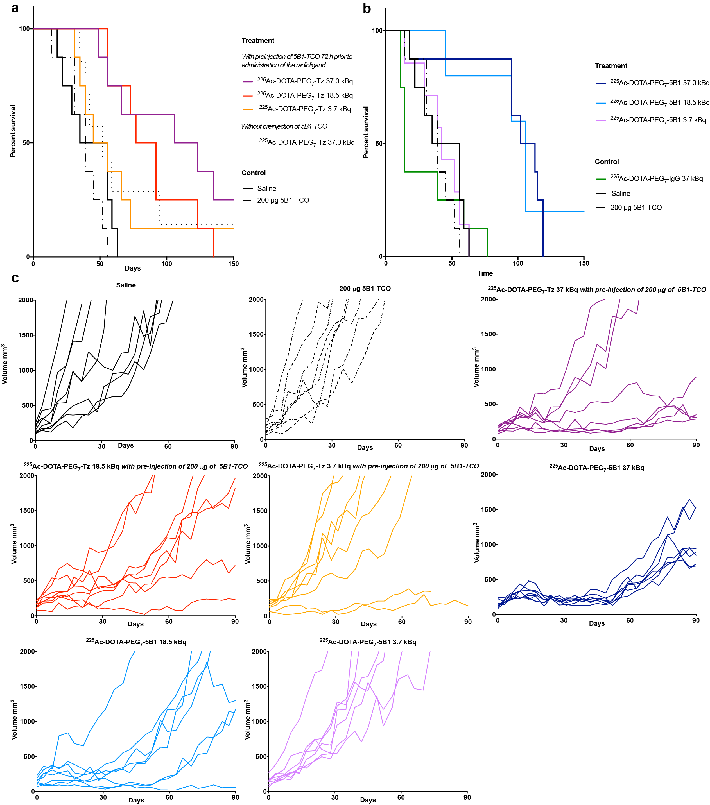

**Figure S6. Percentage survival as a function of time in the longitudinal therapy study using a subcutaneous BxPC3 PDAC mouse model. a.** Kaplan-Meier survival curves after pretargeted RIT (n = 8/cohort). Day zero represents the day of the radioactive injection. **b.** Kaplan-Meier survival curves after conventional RIT (n = 8/cohort). Day zero represents the day that the radiopharmaceutical is administered. **c.** The therapeutic response of individual mice in the longitudinal therapy study.

|  |  |  |  |  |  |  |  |  |  |  |  |  |
| --- | --- | --- | --- | --- | --- | --- | --- | --- | --- | --- | --- | --- |
|  | Median Survival | 5B1-TCO +225Ac-DOTA-PEG7-Tz 37 kBq | 5B1-TCO +225Ac-DOTA-PEG7-Tz 18.5 kBq | 5B1-TCO +225Ac-DOTA-PEG7-Tz 3.7 kBq | 225Ac-DOTA-PEG7-5B1 37 kBq | 225Ac-DOTA-PEG7-5B1 18.5 kBq | 225Ac-DOTA-PEG7-5B1 3.7 kBq | **Control** | 225Ac-DOTA-PEG7-Tz 37 kBq | 225Ac-DOTA-PEG7-IgG 37 kBq | 200 μg 5B1-TCO | Saline |
| Median Survival | - | 114.5 | 84.5 | 50.5 | 107.5 | 106.0 | 42.0 |  | 52.0 | 14.0 | 39.0 | 45.5 |
| 5B1-TCO +225Ac-DOTA-PEG7-Tz 37 kBq | 114.5 | - | n.s. | n.s. | n.s. |  |  |  | n.s. |  | *** | ** |
| 5B1-TCO +225Ac-DOTA-PEG7-Tz 18.5 kBq | 84.5 | n.s. | - | n.s. |  |  |  |  | n.s. |  | *** | ** |
| 5B1-TCO +225Ac-DOTA-PEG7-Tz 3.7 kBq | 50.5 | n.s. | n.s. | - |  |  |  |  | n.s. |  | n.s. | n.s. |
| 225Ac-DOTA-PEG7-5B1 37 kBq | 107.5 | n.s. |  |  | - | n.s. | ** |  |  | *** | *** | *** |
| 225Ac-DOTA-PEG7-5B1 18.5 kBq | 106.0 |  |  |  | n.s. | - | ** |  |  | ** | ** | ** |
| 225Ac-DOTA-PEG7-5B1 3.7 kBq | 42.0 |  |  |  | ** | ** | - |  |  | n.s. | n.s. | n.s. |
| **Control** |  |  |  |  |  |  |  |  |  |  |  |  |
| 225Ac-DOTA-PEG7-Tz 37 kBq | 52.0 | n.s. | n.s. | n.s. |  |  |  |  | - |  |  |  |
| 225Ac-DOTA-PEG7-IgG 37 kBq | 14.0 |  |  |  | *** | ** | n.s. |  |  | - |  |  |
| 200 μg 5B1-TCO | 39.0 | *** | *** | n.s. | *** | ** | n.s. |  |  |  | - |  |
| Saline | 45.5 | ** | ** | n.s. | *** | ** | n.s. |  |  |  |  | - |

**Table S9. Logrank Mantel-Cox test comparing survival of pretargeted RIT and conventional RIT in mice bearing subcutaneous BxPC3 xenografts.** * P ≤ 0.05, ** P ≤ 0.01, *** P ≤ 0.001, n.s. = non significant.



**Figure S7. Haematological parameters 10 days and 45 days after the administration of the radiopharmaceuticals.** Values are represented as means, and error bars represent standard deviations (n = 3-5). Unpaired t-tests were performed between the saline control group and the treatment groups to determine P-values. ** P ≤ 0.01, * P ≤ 0.05, n.s. = non-significant.

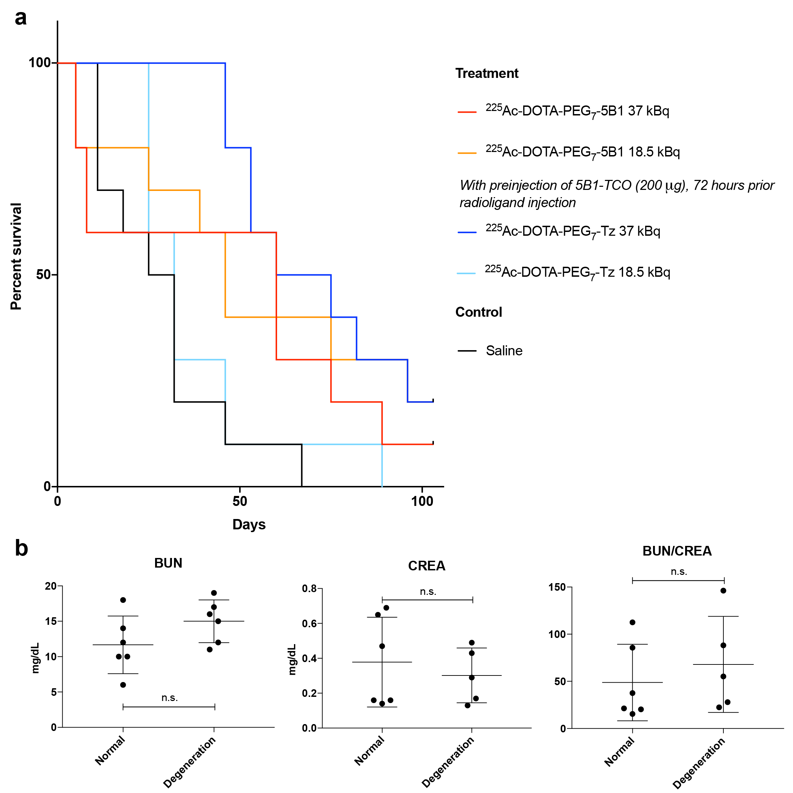

**Figure S8. a. Percentage survival as a function of time in the longitudinal therapy study using an orthotopic BxPC3-Luc PDAC mouse model.** Kaplan-Meier survival curves after pretargeted and conventional RIT (n = 10/cohort). Day zero represents the day that the radiopharmaceutical is administered. **b.** **Blood Urea Nitrogen (BUN), creatine (CREA), and BUN/CREA levels in mice bearing orthotopic BxPC3 xenografts treated with either conventional of pretargeted RIT (37 kBq) that showed normal or cortical tubular degeneration of the kidneys upon pathological evaluation.** Blood chemistry was performed when the mice reached the set endpoint. Unpaired t-test indicates a non-significance difference (P>0.05) between the values for the normal kidneys and those of the kidneys showing minimal to mild cortical tubular degeneration.

|  |  |  |  |  |  |  |  |
| --- | --- | --- | --- | --- | --- | --- | --- |
|  | Median Survival | 5B1-TCO +225Ac-DOTA-PEG7-Tz 37 kBq | 5B1-TCO +225Ac-DOTA-PEG7-Tz 18.5 kBq | 225Ac-DOTA-PEG7-5B1 37 kBq | 225Ac-DOTA-PEG7-5B1 18.5 kBq | **Control** | Saline |
| Median Survival | - | 67.5 | 32.0 | 60.0 | 46.0 |  | 28.5 |
| 5B1-TCO +225Ac-DOTA-PEG7-Tz 37 kBq | 67.5 | - | ** | n.s. |  |  | *** |
| 5B1-TCO +225Ac-DOTA-PEG7-Tz 18.5 kBq | 32.0 | ** | - |  |  |  | n.s. |
| 225Ac-DOTA-PEG7-5B1 37 kBq | 60.0 | n.s. |  | - | n.s. |  | n.s. |
| 225Ac-DOTA-PEG7-5B1 18.5 kBq | 46.0 |  |  | n.s. | - |  | * |
| **Control** |  |  |  |  |  |  |  |
| Saline | 28.5 | *** | n.s. | n.s. | * |  | - |

**Table S10.** **Logrank Mantel-Cox test comparing survival of pretargeted RIT and conventional RIT in orthotopic BxPC3-Luc xenografted mice.** * P ≤ 0.05, ** P ≤ 0.01, *** P ≤ 0.001, n.s. = non significant.

|  |  |
| --- | --- |
| 225Ac-DOTA-PEG7-5B1 37 kBq | Normal |
| Cortical tubular degeneration and necrosis, F, UL, 1. |
| Normal |
| Cortical tubular basophilia, MF, BL, 1. |
| Normal |
| Cortical tubular basophilia, MF, BL, 1. |
| 5B1-TCO +225Ac-DOTA-PEG7-Tz 37 kBq | Normal |
| Cortical tubular degeneration, MF, BL, 2. |
| Normal |
| Cortical tubular degeneration, with intracytoplasmic pigment (most consistent with hemosiderin), F, UL, 2. |
| Normal |
| Cortical tubular degeneration, F, UL, 1. |

**Table S11. Summary of the pathological evaluation of the kidneys of mice bearing BxPC3 orthotopic xenografts treated with conventional of pretargeted RIT (37 kBq).** F: focal, MF: multifocal, UL: unilateral, BL: bilateral, 1: minimal, 2: mild.

**Methods**

***Antibody functionalization and radiolabeling***

The conjugation of TCO-NHS to 5B1, huA33 and human IgG was performed according to previously published methods (1, 2). The average number of TCO moieties per antibody was estimated by incubating the antibody-TCO conjugate (100 μg, PBS) with >150-fold excess of a Tz-functionalized AlexaFluor680 for 180 minutes at room temperature. After purification on PD-10 gel filtration column and concentration via centrifugal filtration, the degree of labelling (DOL) was determined by UV-Vis analysis.

DOL (5B1-TCO) = 1.8 ± 0.4 (n = 3); DOL (IgG-TCO) = 1.3 ± 0.2 (n=3).

DOTA-PEG7-Tz and DO3A-PEG7-Tz were synthesized according to the previously reported methods (3, 4). 225Ac was supplied by the United States Department of Energy Office of Science by the Isotope Program in the Office of Nuclear Physics. Radiolabelings were performed according to protocol previously published by our group (4). The immunoreactivity of the 225Ac-labeled radioimmunoconjugates were determined using a protocol adapted from the Lindmo binding assay (5) and performed before *in vivo* experimentation. Samples for injections to animals were prepared and injected at least 4 h after the purification of the radiotracers to allow actinium to reach a pseudo-equilibrium state and have an accurate reading of the activity injected.

Based on previously published results from our groups and unpublished results obtained with 177Lu, a ratio of 0.2:1 Tz-to-TCO was chosen for further injection into animals (3, 6). The influence of the Tetrazine-radioligand molar activity on the total biodistribution was not investigated as similar experiments were performed with 177Lu and no deviation of the biodistribution was observed (3).

***Cell lines and xenograft models***

CA19.9-positive BxPC3 and BxPC3-Luc (BxPC3 with the luciferin-luciferase reporter gene) cells were grown in RPMI medium modified to contain 4.5 g/L sodium bicarbonate and supplemented with 10 % (vol/vol) heat-inactivated FCS, 100 IU penicillin, 100 μg/mL streptomycin, 10 mM HEPES, and 10 cc/L nonessential amino acids. MIAPaCa-2 (CA19.9 negative) cells were grown in Dulbecco’s modified essential medium (DMEM) modified to contain 4.5 g/L glucose and 1.5 g/L sodium bicarbonate and supplemented with 10 % (vol/vol) heat-inactivated FCS, 100 IU penicillin, and 100 μg/mL streptomycin. SW1222 (A33 antigen positive) cells were grown in Iscove’s Modified Dulbecco’s Medium (IMDM) supplemented with 10% (vol/vol) heat-inactivated FCS, 2 mM glutamine, 100 IU penicillin, and 100 μg/mL streptomycin. All media were purchased from the Media Preparation Facility at Memorial Sloan Kettering Cancer Center.

BxPC3 and MIAPaCa-2 cells where acquired from ATCC in September 2014 and September 2015, respectively. The most recent authentication was performed by STR in May 2018 and revealed 100% match to the submitted cell line. The most recent mycoplasma testing was performed in June 2018, no mycoplasma was detected in any of the cell line.

All animals were treated according to the guidelines approved by the Research Animal Resource Center and Institutional Animal Care and Use Committee at Memorial Sloan Kettering Cancer Center. Female athymic homozygous nude mice ⎯ strain Crl:NU(NCr)-Foxn1nu (Charles River Laboratories, Wilmington, MA), age 6-8 weeks ⎯ were xenografted subcutaneously with 5×106 BxPC3 and/or MIAPaCa-2 cells or 5×106 SW1222 cells (passage <25) , suspended in 150 μL of a 1:1 Matrigel (Becton Dickson, Bedford, MA) and cell culture medium mixture. BxPC3-Luc cells (3×105) in 30 μL of 1:1 Matrigel (Becton Dickson, Bedford, MA) and cell culture medium mixture were orthotopically transplanted in the pancreas via surgery in female athymic homozygous nude mice.

**Biodistribution**

Acute biodistribution studies were performed using healthy athymic nude mice bearing subcutaneous SW1222 xenografts (right flank, ~ 100 mm3). For the pretargeting strategy, 225Ac-DOTA-PEG7-Tz (18.5 kBq; 0.4 nmol; in 150 μL of 0.9 % NaCl + 1.0 % BSA) was injected 24 h following the administration of A33-TCO (100 μg; 0.66 nmol; in 150 μL saline). At the appropriate time post-injection, mice (n = 5) were euthanized via CO2 asphyxiation and tissues of interest were collected. Each sample was counted for up to 10 min (24 h after collection when secular equilibrium was reached) using a Wizard2 automatic gamma counter set up to a 150 to 600 keV energy window.

The percentage of injected (% ID) was determined by counting standards prepared from the formulated radiotracer together with the tissue samples. The same standards were used to convert the injected weight of the formulated solution into counts. The counts from each sample were decay corrected and background corrected, and the count in each sample was converted to % ID/g.

**Cerenkov Lumininescence Imaging**

Images were analysed using the Living Image 2.6 software. The average radiance (p/sec/cm2/sr) is used for the quantification of region of interests. Background correction is performed using a region of interest in the same experimental image but in a remote area relative to the actual area of interest.

***Ex vivo* analysis**

Phosphorimaging plates were read at a pixel size of 25 μm with a Typhoon 7000 IP plate reader (GE Healthcare). Autoradiographic images were analysed using Fiji. Hematoxylin and eosin staining were registered using Panorama Viewer. Region of interest mean intensity was determined by colocalizing the autoradiography and H&E staining. The ratio of the mean intensities of the cortex and medulla of the kidneys was later calculated.

**Dosimetry**

225Ac %ID/g organ uptake values were re-expressed as Standardized Uptake Values (SUV). The fraction of injected dose projected in human organ *I*, *FIDI*, was obtained from the following equation, which assumes that SUV is independent of body mass and species:

where *SUVi* is the standardized uptake value for mouse organ *i*, *mI* is the mass of human organ *I*, and *mTB*is the human total body mass. In the case of both the pretargeted and standard approaches, the uptake and clearance for most organs was characterized by a rapid clearance phase followed by a slow clearance phase. Thus, the last four time points (the slow clearance phase) of the FID vs. time curve were fit with a monophasic exponential decay function to obtain the effective composite clearance constant, *λeff*. This constant was used to estimate the contribution of decays occurring after the final experimental time point (taken as *FIDi,f*/*λeff*, where *FIDi,f*is the fit value of the fraction of injected dose in organ *i* at the final time point). In the case of 225Ac-DOTA-PEG7-Tz, a markedly increased uptake over the initial time points was observed in the tumor with no evident biological clearance; therefore, for this tissue, *λeff* was assumed to be equal to the radioactive decay constant of 225Ac.

Finally, the residence times were entered into OLINDA-EXM 2.0 to calculate the mean organ absorbed doses and the total body effective dose in the ICRP 89 adult man model for 225Ac and each daughter radionuclide. Following the re-normalization of the doses to account for differences in branching ratios, the dose contribution for 225Ac and each daughter were summed to give the total dose to each target organ. Taking into account the US Department of Energy recommendations and the average LET of the alpha particles emitted in during the decay of 225Ac, an RBE of 5 was applied for effective dose calculations.

A similar methodology was applied to the mouse dosimetry. However, in lieu of a phantom-based model as in OLINDA-EXM, the dose was computed under the assumption that the absorbed dose *Di* for each mouse organ *i* is dominated by contributions from non-penetrating radiation:

where *Ãi* is the residence time in each mouse organ *i*, *mi* is the organ mass, and *ΔNP* is the equilibrium absorbed dose constant for non-penetrating radiation (225Ac: 12.5 g*Rad/uCi*h; 221Fr: 13.6 g*Rad/uCi*h; 217At: 15.3 g*Rad/uCi*h; 213Bi: 1.2 g*Rad/uCi*h; 213Po: 18.2 g*Rad/uCi*h; 209Tl: 1.5 g*Rad/uCi*h; 209Pb: 0.4 g*Rad/uCi*h).

**References**

1. Zeglis BM, Sevak KK, Reiner T, Mohindra P, Carlin SD, Zanzonico P, et al. A pretargeted PET imaging strategy based on bioorthogonal Diels-Alder click chemistry. J Nucl Med. 2013;54:1389-96.

2. Houghton JL, Zeglis BM, Abdel-Atti D, Sawada R, Scholz WW, Lewis JS. Pretargeted Immuno-PET of Pancreatic Cancer: Overcoming Circulating Antigen and Internalized Antibody to Reduce Radiation Doses. J Nucl Med. 2016;57:453-9.

3. Houghton JL, Membreno R, Abdel-Atti D, Cunanan KM, Carlin S, Scholz WW, et al. Establishment of the In Vivo Efficacy of Pretargeted Radioimmunotherapy Utilizing Inverse Electron Demand Diels-Alder Click Chemistry. Mol Cancer Ther. 2017;16:124-33.

4. Poty S, Membreno R, Glaser JM, Ragupathi A, Scholz WW, Zeglis BM, et al. The inverse electron-demand Diels-Alder reaction as a new methodology for the synthesis of (225)Ac-labelled radioimmunoconjugates. Chem Commun (Camb). 2018;54:2599-602.

5. Lindmo T, Boven E, Cuttitta F, Fedorko J, Bunn PA, Jr. Determination of the immunoreactive fraction of radiolabeled monoclonal antibodies by linear extrapolation to binding at infinite antigen excess. J Immunol Methods. 1984;72:77-89.

6. Meyer JP, Houghton JL, Kozlowski P, Abdel-Atti D, Reiner T, Pillarsetty NV, et al. (18)F-Based Pretargeted PET Imaging Based on Bioorthogonal Diels-Alder Click Chemistry. Bioconjug Chem. 2016;27:298-301.