Supplementary Figure 1. Relative abundance of glycochenodeoxycholate (GCDC) in human breast tumors and adjacent non-cancerous tissues. Shown are relative abundance measurements by Metabolon. Eight-teen tumors and 17 adjacent non-cancerous tissues contained elevated GCDC levels above the detection limit. Significance testing with paired t-test for 65 tumor-adjacent non-cancerous tissue pairs. Horizontal line shows median.

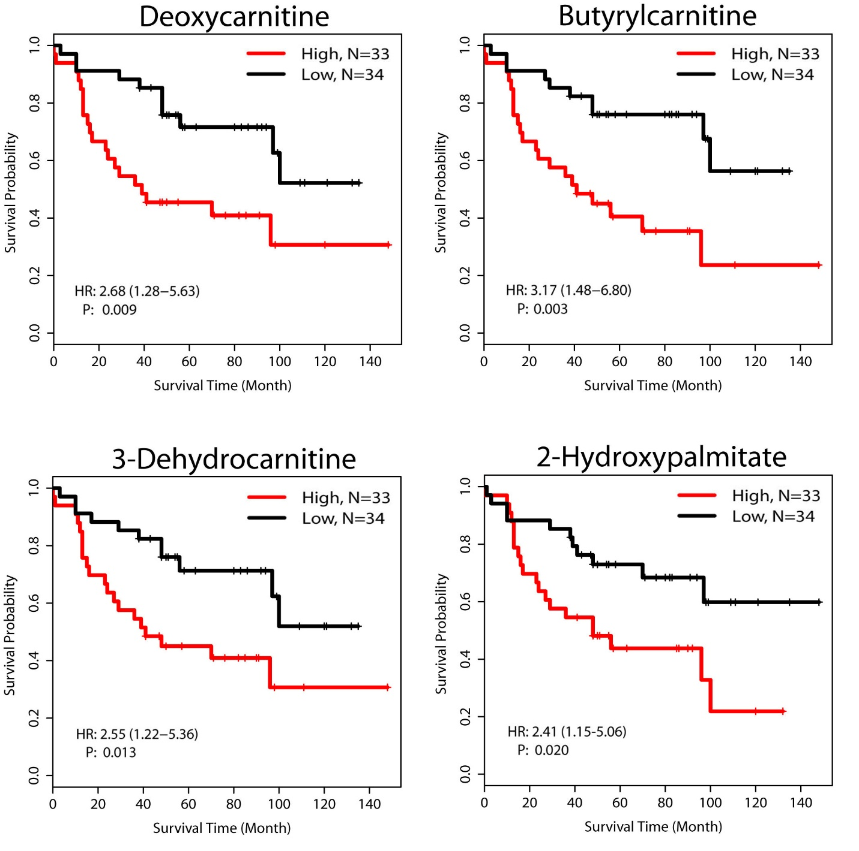
Supplementary Figure 2. Association of fatty acid metabolism-related metabolites with breast cancer survival. Shown are Kaplan-Meier survival plots for four metabolites that were selected as predictors of patient survival by LASSO. Metabolites abundance profiles in breast tumors were median split into high and low and examined for their association with survival. A Cox proportional hazards model was used to estimate the hazard ratio (HR) and a Wald test was applied for further significance testing.

Supplementary Figure 3. Correlation matrix for bile acids in the Tang et al. breast cancer dataset (“Duke cohort”) and association of glycochenodeoxycholate (GCDC) with tumor subtype and proliferation. Bile acid measurements were obtained from 25 breast tumors (Tang et al., Breast Cancer Res 2014; 16:415). A. Correlation matrix showing Pearson’s correlation coefficients for five bile acids in the 25 tumors. A high correlation was observed between GCDC, glycocholate and glycolithocholate sulfate (all r > 0.6). Deoxycholate (DC) showed a high correlation with cholate (r = 0.77) and glycocholate (r = 0.6). B. GCDC abundance levels are elevated in luminal A breast tumors (n = 10). C. Tumor proliferation score is higher in GCDC-low than GCDC-high tumors. A Wilcoxon rank test was applied for significance testing to compare proliferation scores between GCDC-high (n = 19) and low tumors (n = 6). GCDC-low: GCDC is at/below detection limit. GCDC-high: elevated above detection limit. Horizontal line inside the box shows median.

Supplementary Figure 4. Inverse association between bile acid levels and the tumor proliferation score. Correlations are shown for 20 breast tumors in which deoxycholate (DC), chenodeoxycholate (CDC), glycodeoxycholate (GDC), and glycochenodeoxycholate (GCDC) were measured using absolute quantification. Tumor proliferation score was calculated with the inclusion of 11 cell cycle gene, as described in methods, and the Pearson’s correlation coefficient was calculated for the correlation analysis. Regression lines are plotted as blue dash lines.

Supplementary Figure 5. Tissue glycochenodeoxycholate (GCDC) levels in tumor-adjacent non-cancerous tissue (n = 65) do not associate with the tissue proliferation score. There is no significant difference between GCDC-high (n = 17) and GCDC-low (n = 48) tissues. Significance testing with Wilcoxon rank sum test. Horizontal line inside the box shows median.

Supplementary Figure 6. Proteomics identifies the Complement & Coagulation pathway as being activated in breast tumors with high glycochenodeoxycholate (GCDC). Breast tumors (n = 58) with available proteome profiling data were divided according to high (n = 15) and low GCDC levels (n = 43) and compared. A. Gene set enrichment analysis (GSEA) based on proteomics-annotated genes identifies the Complement & Coagulation Cascade gene set as one of the top up-regulated and the fatty acid metabolism and G2/M checkpoint gene sets as the top down-regulated Hallmark gene sets in GCDC-high tumors. B-C. GSEA using KEGG pathways as the reference also identifies the Complement & Coagulation Cascade as one of the top up-regulated KEGG pathways (Enrichment score = 0.82 and FDR < 0.05).

Supplementary Figure 7. Up-regulated proteins of the Complement & Coagulation Cascade in glycochenodeoxycholate (GCDC)-high tumors. Graph shows proteins (annotated by gene symbol) that were up-regulated in GCDC-high breast tumors. Proteomics-annotated genes were mapped to the Complement & Coagulation Cascade and labeled as red and green when up- or down-regulated in GCDC-high tumors, respectively.

Supplementary Figure 8. TGR5 and OATP1B1/3 antagonists attenuate the anti-proliferative effect of deoxycholate (DC) in T47D cells. Proliferation was measured by BrdU incorporation and normalized to untreated cells (bar on the right side). Shown are relative ratios (BrdU incorporation of untreated = 1) with mean ± S.E.M (n = 8). Cells were pretreated with 10 µM of NF449, a TGR5 antagonist, or 10 µM of rifampicin, an OATP1B1/3 antagonist, before 20 µM deoxycholate was added to the cell culture for an additional 48 hours. * P < 0.05, ** < 0.01, *** < 0.001, for significantly altered BrdU incorporation. Significance testing was performed with ANOVA and a posthoc t-test.

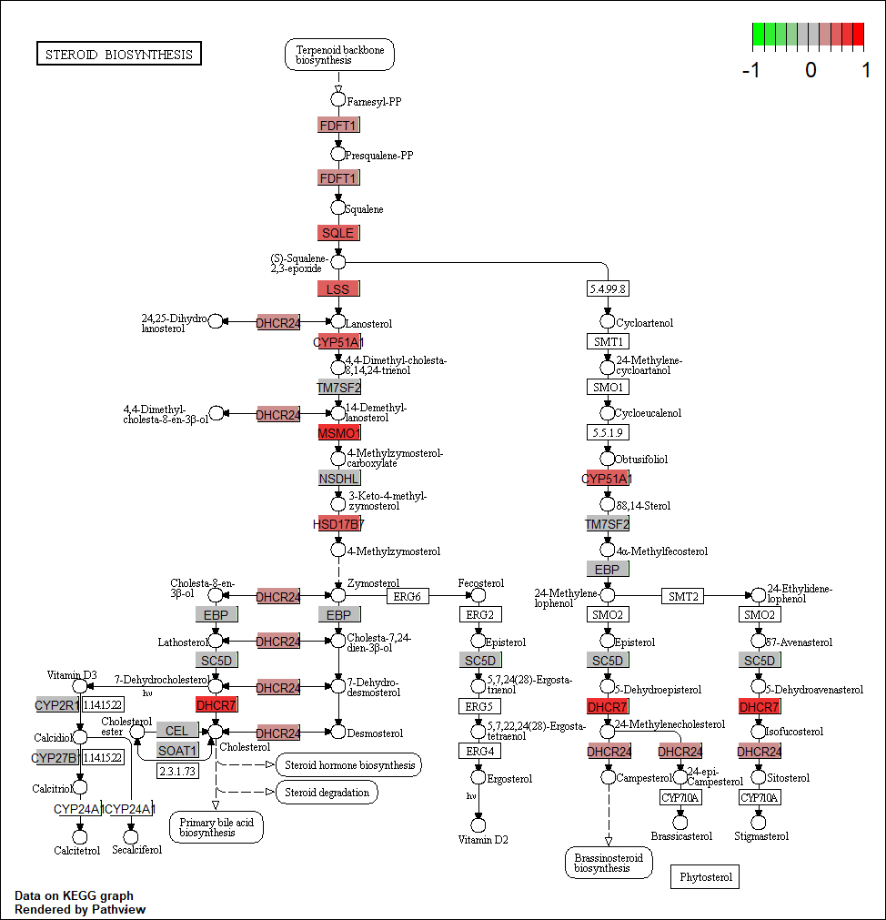

Supplementary Figure 9. Up-regulated genes in the Steroid Biosynthesis pathway in deoxycholate-treated T47D cells. Graph shows genes whose expression was altered by deoxycholate and labeled as red and green when up- or down-regulated, respectively. Visualization of KEGG pathway annotations from the GSEA results.

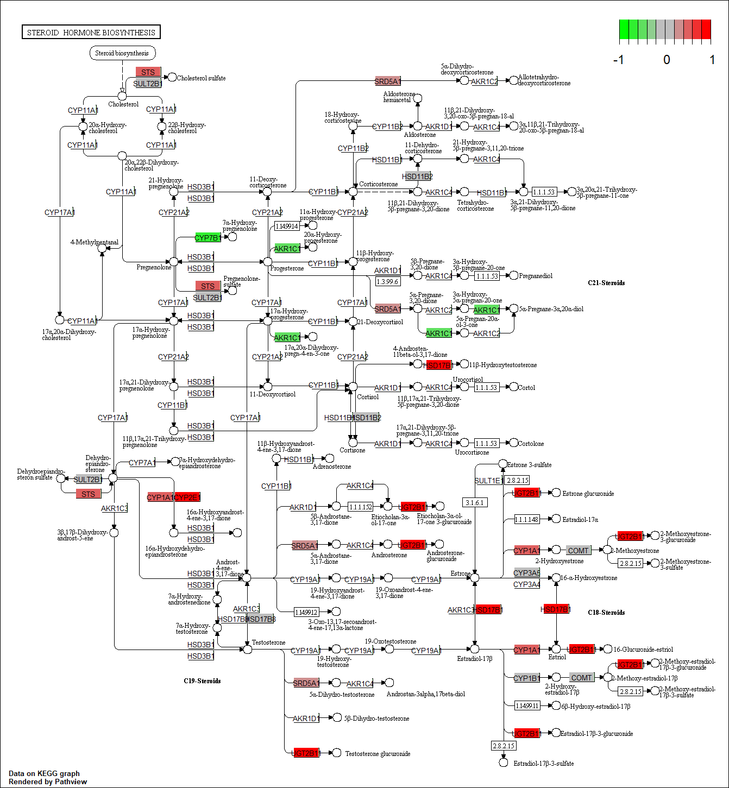
Supplementary Figure 10. Differentially expressed genes in the Steroid Hormone Biosynthesis pathway in deoxycholate-treated T47D cells. Graph shows genes whose expression was altered by deoxycholate and labeled as red and green when up- or down-regulated, respectively. Visualization of KEGG pathway annotations from the GSEA results.

