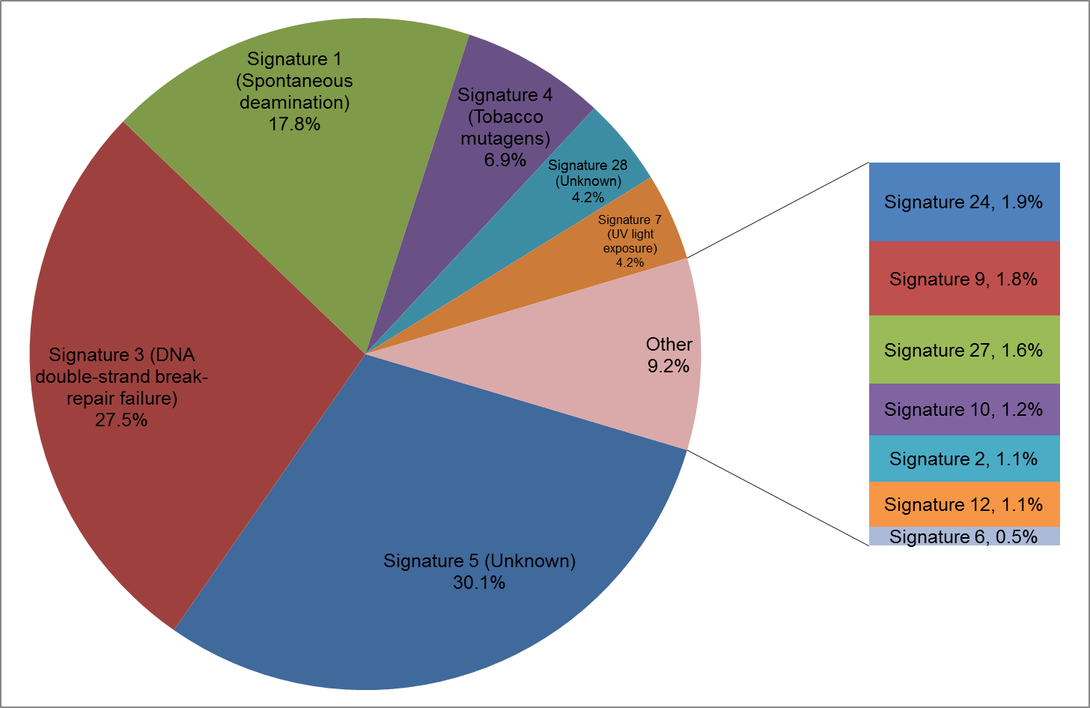
Supplementary Figure 4. Percentage fit of collective mutations in the TMB-low group.
All COSMIC defined signatures with greater than 4% fit are included in the main pie with the remaining signatures with >0% fit included in the second plot. Any signature not included here had a 0% fit.

