Supplementary data
Supplementary materials and methods

Study design:
Clinical criteria used:
Inclusion:
- Clinical diagnosis of NMIBC based on cystoscopic appearance
- Age > 18 years
- Able to read, understand and provide written informed consent to participate in the study
- Performance Status (PS): Eastern Cooperative Oncology Group (ECOG) Performance Status of 0-2
- No intravesical therapy within 6 weeks of study entry
- No prior radiation to the pelvis
- Adequate hematologic function, defined as:
  - Absolute neutrophil count (ANC) > 1,500/mm³
  - Haemoglobin >9.0 g/dl
  - Platelet count > 100,000/mm³
- Adequate renal function, defined as:
  - Serum creatinine ≤ 1.5 mg/dL
- Adequate hepatic function, defined as:
  - Total bilirubin within normal limits
  - Aspartate transaminase (AST) ≤ 2.5 x upper limits of normal (ULN)
  - Alanine transaminase (ALT) ≤ 2.5 x ULN
  - Alkaline phosphatase ≤ 2.5 x ULN, unless bone metastasis was present in the absence of liver metastasis

Exclusion:
- Prior local or systemic treatments for NMIBC
- Concurrent treatment with any chemotherapeutic agent
- Subjects not deemed acceptable to receive general anaesthesia
- Women who were pregnant or lactating
- History of vesicoureteric reflux or an indwelling urinary stent
- Participation in any other research protocol involving administration of an investigational agent within 3 months prior to study entry
- Active cardiac disease
- Known infection with HIV, hepatitis B or hepatitis C
- Active uncontrolled infection
Mitomycin C preparation
Mitomycin C prepared in the aseptic department, and made up from a lyophilised stock into 30 mls of 0.9% saline . It was administered at 10 mg in 30 mL 0.9% saline by intravesical instillation on Day 1 via in/out urinary catheter and retained for one hour, then voided by draining the bladder. Four hours after instillation of mitomycin C, CVA21 was administered.
CVA21 was prepared in a Pharmacy Department laminar flow hood according to biohazard Level 2 handling guidelines. CVA21 is supplied as a sterile frozen liquid in a 3mL aluminum crimp-sealed vial containing 2 mL of CVA21. To prepare the 1x10E8 TCID50 dose, 1.33 mL of CVA21 was diluted to 30 mL in 0.9% saline and transferred to a 30 mL syringe. The 3x10E8 TCID50 dose was prepared in a similar manner but using 4.0 mL of CVA21. The infusion syringe was placed in a transport box with ice packs to maintain the dose at 2-8C and administered within 12 hours of preparation. The 30 mL dose was administered to the subject via an in/out urinary catheter and retained for 2 hours, with the subject changing position every 15-20 minutes so the entire bladder wall was exposure to the virus.
A Dose Limiting Toxicity (DLT) was defined as:
- any Grade 3 or greater non-hematological toxicity judged to be clinically significant lasting greater than 3 days, with the exception of self-limiting or medically controllable toxicities (e.g. chills, muscle aches, flu-like symptoms, nausea, vomiting fatigue);
- febrile neutropenia not related to underlying disease (defined as Grade 4 neutropenia with fever greater than 38.5C, both of which are sustained over a 24-hour period);
- prolonged Grade 4 neutropenia (lasting 7 days or more, or with sepsis), except for CVA21-related viraemia;
- neutropenic infection (Grade 3 or greater neutropenia with Grade 3 or greater infection);
- thrombocytopenia of Grade 3 or greater with bleeding, and finally
- thrombocytopenia of Grade 4 lasting 7 days or more.

Adverse Events
All subjects in this study experienced at least one treatment-emergent adverse event. Most treatment-emergent adverse events were renal and urinary disorders that were considered unrelated to study treatment. All but 2 events were Grade 1 or Grade 2 in severity, no subjects were withdrawn early following start of treatment and no subjects died during the study.
One subject with a prior history of hypertension developed Grade 2 hypertension during the study, but this was considered unrelated to study therapy. Five (5) subjects developed urinary tract infections, that might be related to the catherization process. The protocol was amended to provide prophylactic antibiotic therapy prior to catheter introduction and no further urinary tract infections were noted. Three adverse events, all Grade 1, were considered related to CVA21 treatment: tight feeling on the left side of the abdomen, shivers/feeling cold, and nausea. No clinically significant changes were noted from the daily clinical laboratory assessments.
No differences were noted between Cohorts that received one versus two intravesical doses, or between Cohorts that received CVA21 alone versus the combination with low dose mitomycin C, but conclusions are limited by the small subject numbers. The maximum intravesical CVA21 dose administered in this study on 2 consecutive days with 10 mg of mitomycin C prior to the CVA21 dose on day 1, was well tolerated.

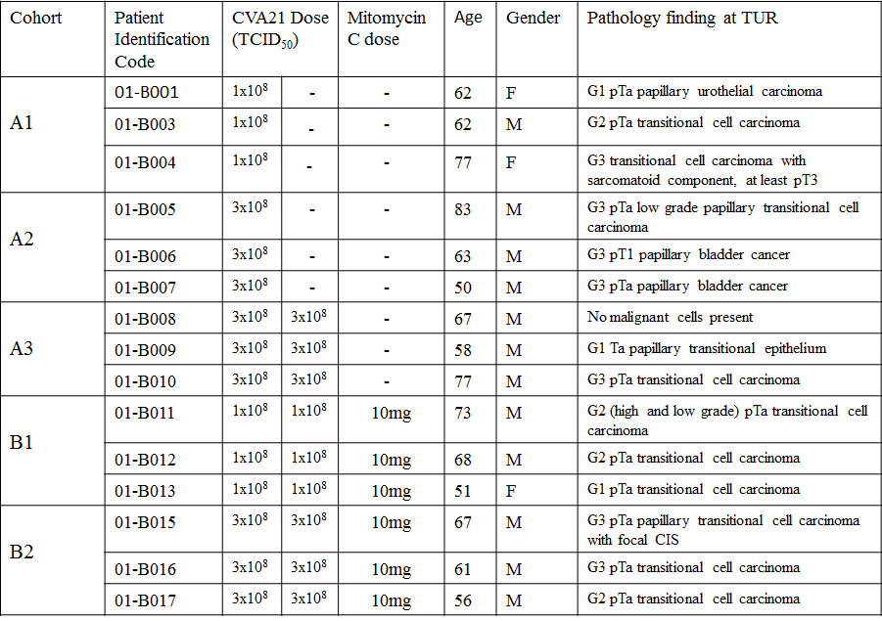
Sup Table 1: Patients and treatment characteristics

Sup Table 2. Summary of Treatment-Emergent Adverse Events in CANON Study
TEAE = Treatment-emergent adverse event. NCI-CTCAE = National Cancer Institute Common Terminology Criteria for Adverse Events. MedDRA used for coding. Subjects were counted only once for each system organ class and preferred term. A subject with multiple severity grades for a given adverse event was counted only once under the maximum severity.

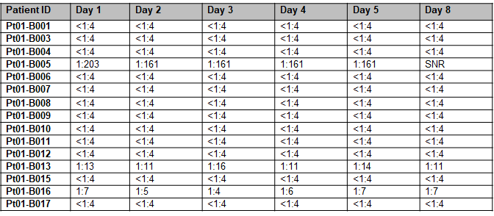
Sup Table 3. Neutralising anti-coxsackievirus antibody titres
Test serum was serially diluted in the range 1:4 to 1:32768 and 100ul of each dilution mixed with 100μl of media containing 100 TCID₅₀ CVA21 and incubated at 37°C for 1 hour. Following incubation, the sera were added to SK-MEL-28 cells and incubated for 72 hours with cytopathic effect scored visually at the endpoint and 50% neutralising titre calculated. A score of <1:4 represents no neutralising antibody response could be detected. SNR= sample not received.

Fig S1. Urine cytology slide from complete responder patient B008
Urine cytology examination prior to TURBT resection shows cells with increased nuclear to cytoplasmic ratio, irregular nuclear outlines and variation in nuclear size consistent with malignancy

Fig S2. Homogeneous DAF expression in NMIBC tissues

Immunohistochemistry was performed with an anti‐CD55 monoclonal antibody and DAB detection (brown colour). CD55 (Decay-accelerating factor, DAF) was detected in all CAVATAK-treated bladder cancer tissues (9 representative cases shown). Placenta tissue was used as a positive control for DAF expression. (Magnification x20).

Fig S3. Quantitation of intratumoral immune cell and PD-L1+ cell densities
4µm thick sections of normal bladder, superficial bladder cancer and CAVATAK-treated bladder cancer with or without mitomycin C treatment were prepared and stained using PerkinElmer Opal kit. Slides were scanned using the PerkinElmer Vectra and images were analyzed using the inForm software (PerkinElmer, Hopkinton, MA). For cells marked by CD8 or PD-L1, the cell density was evaluated as total cell density of extratumoral cells (within the stroma) and intratumoral cells (within the tumour epithelial regions). The density of the cells was recorded as the number of positive cells per mm² surface area using the inform software.

Fig S4. Opal seven-colour multiplex analysis of biopsy from Patient B008 identifies significant immune infiltration
Representative images from three different TMA cores after spectral unmixing (composite images) showing each of the individual markers (PD-L1: red, CD3: magenta, CD8: yellow, FoxP3: green, CD163: orange and cytokeratin: turquoise together with the DAPI nuclear marker (blue).

A
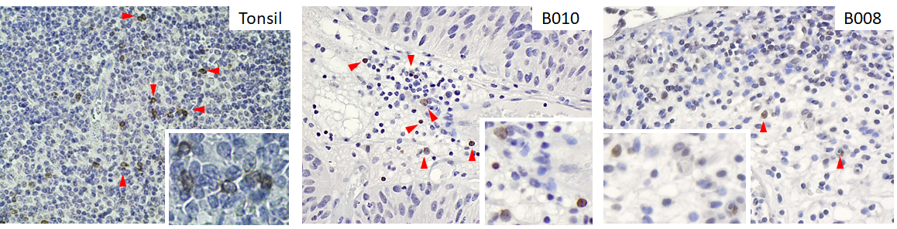
B
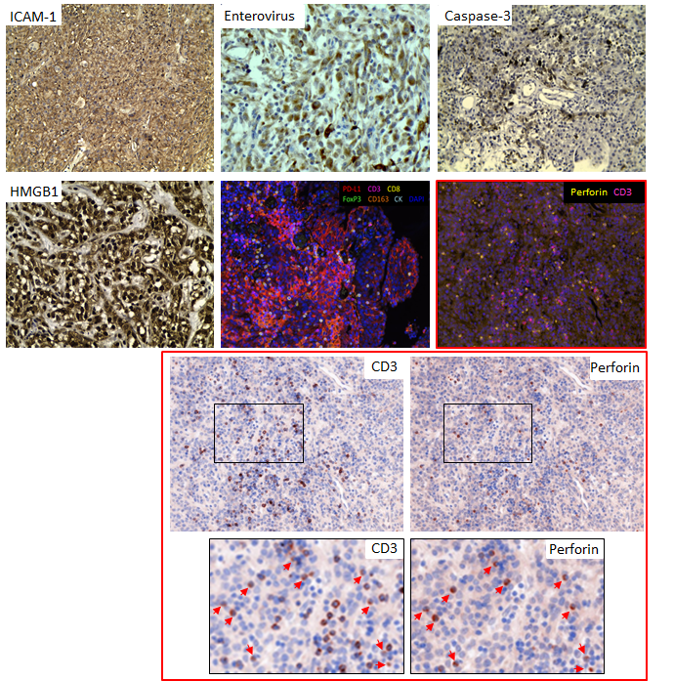

Fig S5 A. Perforin positive cells detected in CAVATAK-treated bladder cancer Perforin expression (brown staining indicated by red arrowheads) detected in CAVATAK-treated bladder cancer (2 representative cases shown, B010 and B008) and tonsil tissue (positive control) by immunohistochemistry. (Magnification x20, inset images x40).
Fig S5 B ICAM-1 positive tumour from patient B004 shows productive CAVATAK infection
Immunohistochemical images from patient B004 CAVATAK-treated bladder tumour showing homogeneous ICAM-1 positivity, enterovirus protein (VP-1), cleaved caspase 3 and cytoplasmic HMGB1 (positive staining shown in brown). Fluorescent multiplexed IHC images stained with PD-L1 (red), CD3 (magenta), CD8 (yellow), FoxP3 (green), CD163 (orange), cytokeratin (white), and DAPI (blue) and CD3 (magenta), perforin (yellow), and DAPI (blue). The dual fluorescent multiplexed image is also displayed as simulated single CD3 and perforin DAB and haematoxylin images using the Pathology ViewsTM feature of the inForm image analysis software. The zoomed images are shown to more clearly validate the colocalisation of CD3 and perforin.

