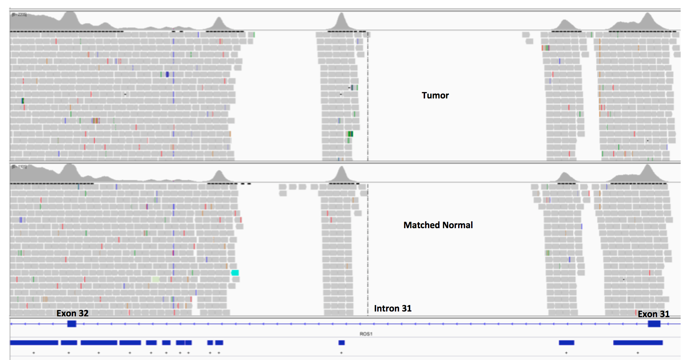

Supplementary Figure1. ROS1 Intron 31 coverage by DNASeq. Horizontal gray bars indicate sequencing coverage as illustrated on Integrated Genomics Viewer (IGV). Horizontal bottom blue bars indicate MSK-IMPACT discontinuous probe tiling in intron 31 due to known repetitive elements (purple bars). Intronic regions without tiling probes lack sequencing coverage (as indicated by blank areas).

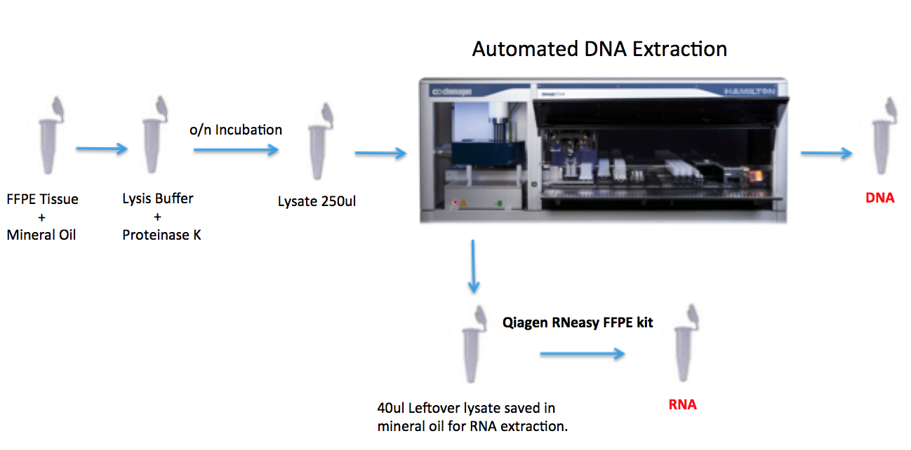
Supplementary Figure 2. Access to adequate material for RNA extraction. Simplified schematic description of the DNA extraction workflow from FFPE specimen submitted for MSK-IMPACT. Leftover lysate material from DNA extraction is saved at room temperature and used for RNA extraction whenever needed.

