**Supplementary Figure S1**

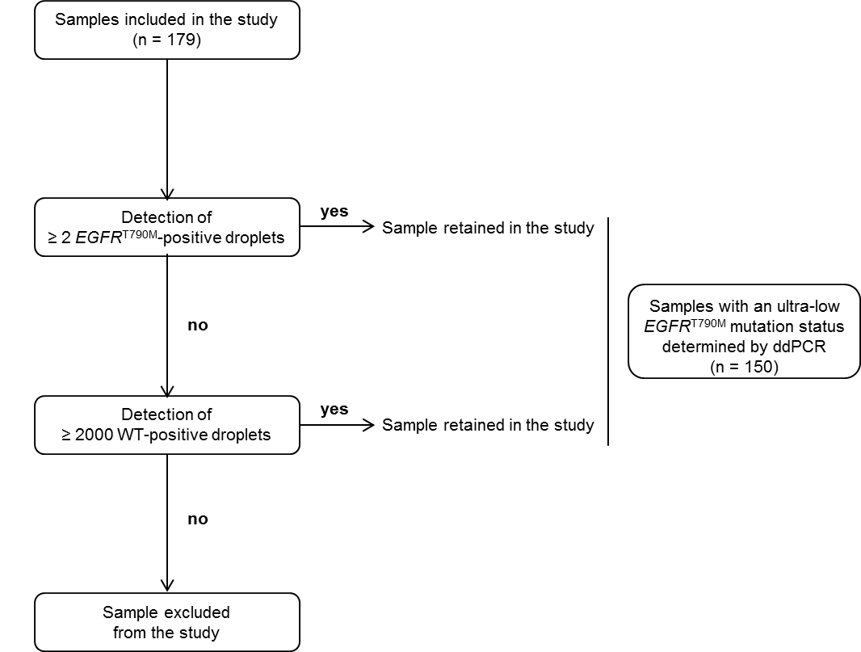

**Supplementary Figure S1.** Flowchart of sample selection criteria. Samples with at least 2 *EGFR*T790M-positive droplets or greater than 2000 WT-positive droplets detected by ddPCR were retained. These criteria allow a minimum limit of detection of 0.1%.

**Supplementary Figure S2**

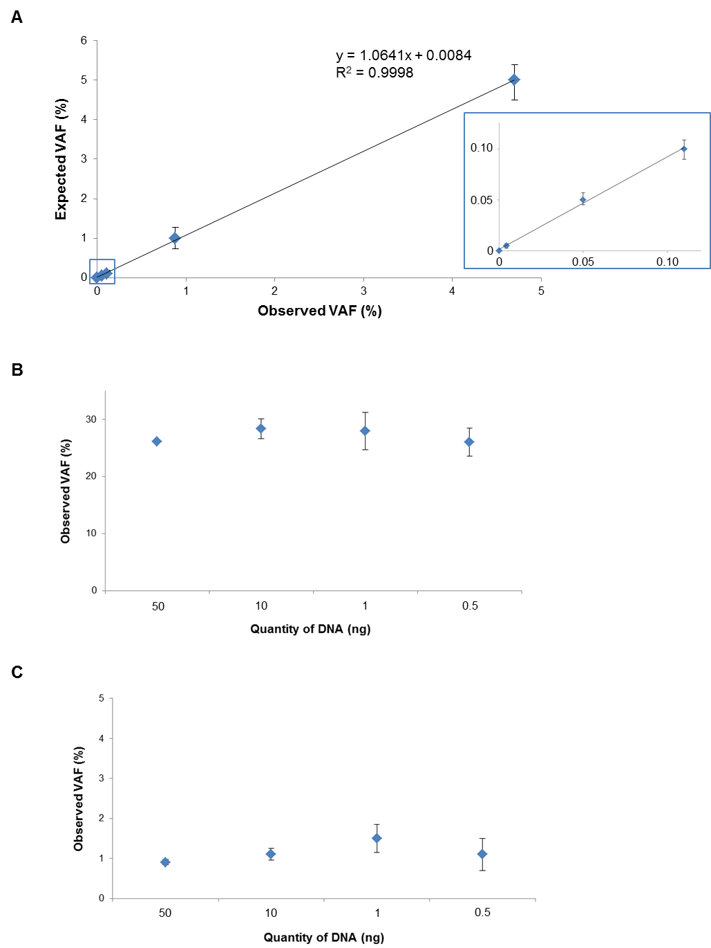

**Supplementary Figure S2.** Sensitivity and reproducibility of our ddPCR assay for ultra-low *EGFR*T790M mutation detection. (A) Correlation between the expected and observed variant allele frequency (VAF, %) for gDNA reference standard control samples. Observed values are the means of 3 independent experiments. The inset highlights samples with an expected VAF < 0.1%. (B) Reproducibility of detection according to the DNA amount for a FFPE sample with a VAF of 26%. (C) Same as (B) for a FFPE sample with a VAF of 1%. Observed values are the means of 3 independent experiments.

**Supplementary Figure S3**

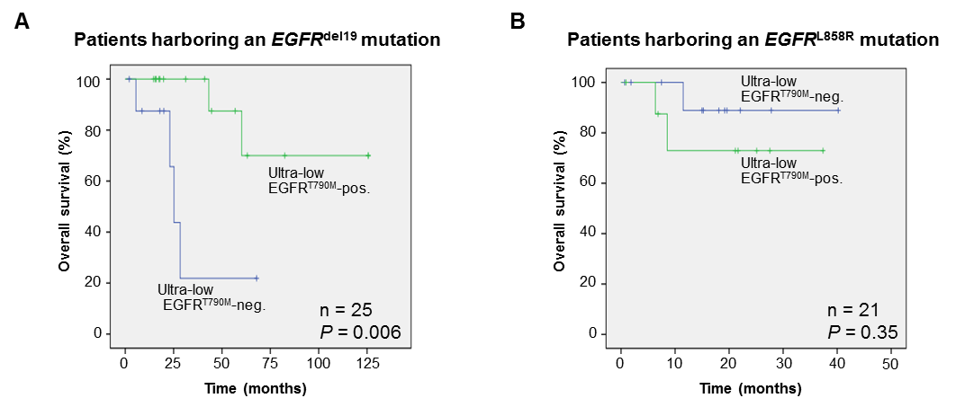

**Supplementary Figure S3.** Kaplan-Meier analyses for OS for ultra-low *EGFR*T790M mutation status in patients treated with first-generation TKIs harboring an *EGFR*del19 mutation (A) or the *EGFR*L858R mutation (B).

**Supplementary Table S1.** Additional patient and specimen characteristics



**Supplementary Table S1 (suite)**



**Supplementary Table S1 (suite)**



**Supplementary Table S1 (suite)**



**Supplementary Table S1 (suite)**



M, Male; F, Female; HS, Have smoked; S, Smoker; NS, Non-smoker; WT, wild-type.

a NGS experiments have been performed as previously described (Vendrell et al. 2017) (Supplementary Table S4).

**Supplementary Table S2.** Determination of the limit of detection of ultra-low *EGFR*T790M mutation using FFPE tissue samples



WT, wild-type; NA, not applicable

**Supplementary Table S3.** Characteristics of patients and specimens with an *EGFR*activating mutation according to their ultra-low *EGFR*T790M mutation status (n = 82)

|  |  |  |  |  |  |  |  |  |
| --- | --- | --- | --- | --- | --- | --- | --- | --- |
|  |  | Ultra-low *EGFR*T790M negative (n = 49) | |  | Ultra-low *EGFR*T790M positive (n = 33) | |  |  |
| Characteristics | | n | % |  | n | % |  | *P* |
| Sex | |  |  |  |  |  |  |  |
|  | Male | 20 | 40.8 |  | 9 | 27.3 |  | NS (0.21) |
|  | Female | 29 | 59.2 |  | 24 | 72.7 |  |  |
| Age | |  |  |  |  |  |  |  |
|  | <60 | 18 | 36.7 |  | 7 | 21.2 |  | NS (0.13) |
|  | ≥60 | 31 | 63.3 |  | 26 | 78.8 |  |  |
| Smoking status | |  |  |  |  |  |  |  |
|  | Have smoked | 21 | 42.9 |  | 10 | 30.3 |  | NS (0.36) |
|  | Smoker | 5 | 10.2 |  | 2 | 6.1 |  |  |
|  | Non-smoker | 22 | 44.9 |  | 20 | 60.6 |  |  |
|  | Unknown | 1 | 2.0 |  | 1 | 3.0 |  |  |
| Stage | |  |  |  |  |  |  |  |
|  | I | 24 | 49.0 |  | 9 | 27.3 |  | NS (0.11) |
|  | II | 3 | 6.1 |  | 3 | 9.1 |  |  |
|  | III | 4 | 8.2 |  | 1 | 3.0 |  |  |
|  | IV | 17 | 34.7 |  | 19 | 57.6 |  |  |
|  | Unknown | 1 | 2.0 |  | 1 | 3.0 |  |  |
| Tumor cell contenta | |  |  |  |  |  |  |  |
| *<50%* | | 17 | 21.8 |  | 11 | 14.1 |  | NS (0.81) |
| ≥50% | | 29 | 37.2 |  | 21 | 26.9 |  |  |
| *EGFR*activating mutation status | |  |  |  |  |  |  |  |
|  | *EGFR*del19 | 24 | 49.0 |  | 21 | 63.6 |  | NS (0.14) |
|  | *EGFR*L858R | 25 | 51.0 |  | 12 | 36.4 |  |  |

The χ2 or Fisher exact test was applied according to the number of samples per group. Significance was considered at *P* < 0.05.

NS, not significant.

a Information available for 78 samples.

**Supplementary Table S4.** Description of the region targeted by the amplicon-based panel used in our NGS experiments (Vendrell et al. 2017).

|  |  |  |
| --- | --- | --- |
| Gene | Transcript of reference | Exon |
| *AKT1* | NM_001014431 | 3 |
| *ALK* | NM_004304 | 20+21+22+23+24+25 |
| *BRAF* | NM_004333 | 11+15 |
| *CDKN2A* | NM_000077 | 1+2+3 |
| *CTNNB1* | NM_001904 | 3 |
| *DDR2* | NM_006182 | 17 |
| *EGFR* | NM_005228 | 18+19+20+21 |
| *ERBB2* | NM_004448 | 20 |
| *ERBB4* | NM_005235 | 10+12 |
| *FGFR1* | NM_023110 | 12+14 |
| *FGFR2* | NM_000141 | 7+12+14 |
| *FGFR3* | NM_000142 | 7+9+14 |
| *GNA11* | NM_002067 | 4+5 |
| *GNAQ* | NM_002072 | 5 |
| *GNAS* | NM_000516 | 8+9 |
| *H3F3A* | NM_002107 | 2 |
| *H3F3B* | NM_005324 | 2 |
| *HIST1H3B* | NM_003537 | 1 |
| *HRAS* | NM_005343 | 2+3+4 |
| *IDH1* | NM_005896 | 4 |
| *IDH2* | NM_002168 | 4 |
| *JAK2* | NM_004972 | 12+13+14 |
| *KIT* | NM_000222 | 8+9+11+13+17+18 |
| *KRAS* | NM_033360 | 2+3+4 |
| *MAP2K1* | NM_002755 | 2 |
| *MET* | NM_001127500 | 2+intron13+14+intron14+15+16+17+18+19+20 |
| *NRAS* | NM_002524 | 2+3+4 |
| *PDGFRA* | NM_006206 | 12+14+18 |
| *PIK3Ca* | NM_006218 | 10+21 |
| *POLE* | NM_006231 | 9+10+11+12+13+14 |
| *PTEN* | NM_000314 | 1+2+3+4+5+6+7+8+9 |
| *RAC1* | NM_018890 | 2 |
| *SMAD4* | NM_005359 | 2+3+9+10+11+12 |
| *STK11* | NM_000455 | 1+2+3+4+5+6+7+8+9 |
| *TERT* |  | Promoter |

**Reference**

Vendrell, J.A., Grand, D., Rouquette, I., Costes, V., Icher, S., Selves, J., et al. (2017). High-throughput detection of clinically targetable alterations using next-generation sequencing. *Oncotarget*. 8, 40345-40358.