**Supplementary Figure 3.** **Immune modulatory effects of isatuximab on T-lymphocytes.** Relative percentage of T-lymphocytes **(A)** and Tregs **(B)** among total bone marrow cells from primary patient samples (n=13), before and after treatment with isatuximab (10 µg/mL) for 24-hour **(C)** Relative percentage of different of CD4+ and CD8+ T lymphocytes subset before and after treatment with isatuximab (10 µg/mL) for 24-hour: Naive, central memory (CM), effector (E) and effector memory (EM) T cell subsets. **(D)** Percentage of expression of different activation markers in CD4+ and CD8+ T cells before and after treatment with isatuximab. Relative percentage of neutrophils **(E)** and monocytes/macrophages **(F)** among bone marrow total cells from primary patient samples, before and after treatment with isatuximab (10 µg/mL) for 24-hour. **(D)** The absolute number of CD34+ progenitor cells per microliter was determined before and after treatment with isatuximab.

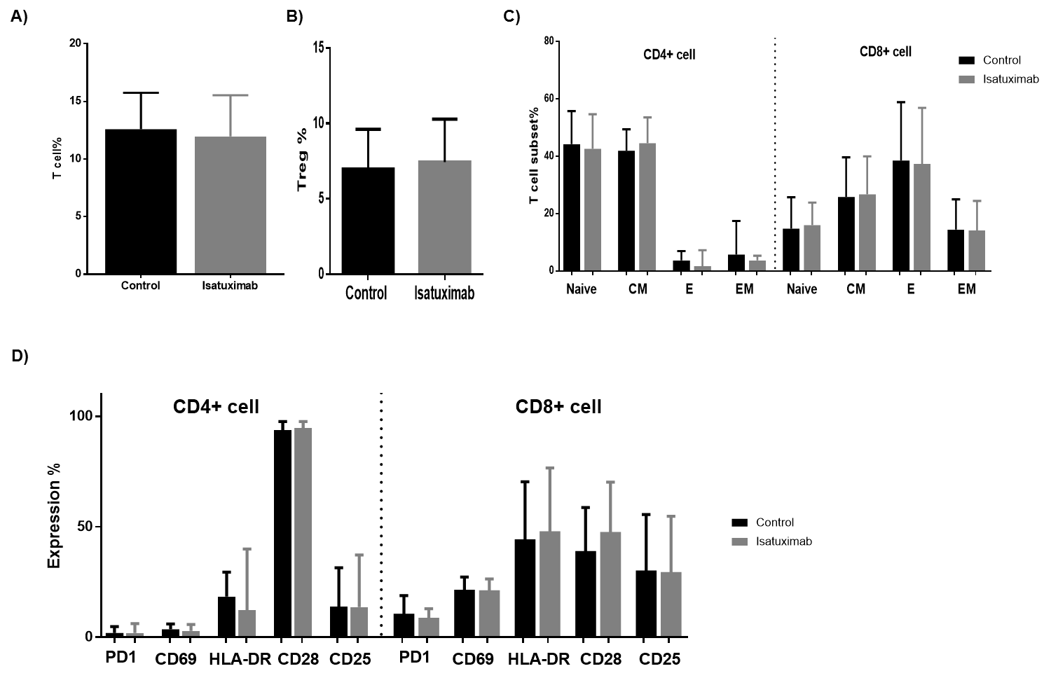



**P=0,0625**

**G)**

**CD34 + cells per microliter**

**F)**



**E)**