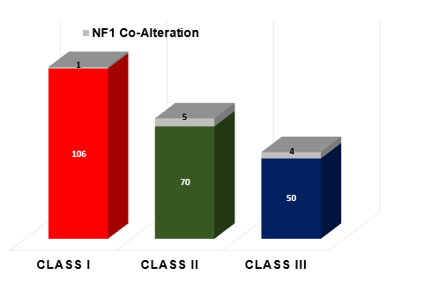
Supplementary Figure 1. Overlap between BRAF and NF1 Genetic Alterations. The stacked bar graphs depict the frequency of NF1 co-alterations in each functional class. The number of tumors with and without NF1 mutation in each functional class is indicated by the numbers on the bar graphs. Grey=NF1 co-alteration, Red= class I, Green= class II, Blue= class III.

