Supplemental Material
Supplementary Methods
Cell lines
Ba/F3 murine pro-B-cell line was a kind gift from Nikolas von Bubnoff and were cultured with 10% Wehi-3b-conditioned media in the parental state (+IL-3) or without (-IL-3) after successful transduction with KIF5B- or STARD3NL-MET. NIH-3T3 murine fibroblast cell line was purchased from DSMZ in 8/2014 and instantly expanded and frozen at passage 1 for further experiments (p.2 – p.15). All cell lines were grown in a humidified incubator at 37°C and 5% CO₂ in the corresponding recommended media supplemented with antibiotics and fetal calf serum. STR analysis was performed on regular basis. and cell lines were tested regularly against mycoplasma contamination (MycoAlert, Lonza).
Molecular cloning and viral transduction
Cloning of constructs was performed via Gibson assembly using 2x NEBuilder HiFi DNA assembly mix (NEB, Catalog No. #E5520). Inserts were introduced into a modified pLenti6-EF1a-IRES-blasticidine backbone (LifeTechnologies) and were amplified using phusion polymerase (NEB, Catalog No. #M0530 or Q5 polymerase (NEB, Catalog No. #M0491 using the following primer. KIF5B-MET (KIF5B template cDNA: H2081): forward: tcaagcttcgaattctgcagtcgacatggcggacctggccgag, reverse: cgttctgagatgaattaggaaactgatcaatctgtgcagaatgccctct (MET template: pBabe-puro-MET) forward:agagggcattctgcacagattgatcagtttcctaattcatctcagaacg, reverse: agggagaggggcggatccgcggccgctatgatgtctcccagaag. STARD3NL-MET (STARD3NL template cDNA Calu3): forward: tcaagcttcgaattctgcagtcgacatgaaccacctgccagaagac, reverse: cgttctgagatgaattaggaaactgattgttttcttcttctgcttcttgaggt (MET template: pBabe-puro-MET) forward: acctcaagaagcagaagaagaaaacaatcagtttcctaattcatctcagaacg, reverse: ctgacacacattccacagggtcgactatgatgtctcccagaag. MET-KDD was cloned using a pBabe-puro-MET plasmid as template using the following primers: forward1: tcaagcttcgaattctgcagtcgacatgaaggcccccgctgtg, reverse1: atcctgtaacttctaaagataatggagctgatgacaacagagaaggata, forward2: ctccattatctttagaagttacaggatatcagtttcctaattcatctcagaac, reverse2: agggagaggggcggatccgcggccgctatgatgtctcccagaag. All inserts were fully sequenced via dideoxy sequencing. pLenti vectors were co-transfected with corresponding helper plasmids with TransIT-LT1 (Mirus) using standard procedures in HEK-293T cells. Blasticidine (Life Technologies) was used at a concentration of 5 µg/ml for selection.
Viability and Colony formation assays
7,000 cells were used for viability assays in 96-well plates. Cells were seeded in white-bottom 96-well plates and treated with the inhibitors for 72 hours. Viability was assessed using CellTiter-Glo using the standard manufacturers protocol. Fitted curves were determined using GraphPad Prism 6.0h.
For the colony formation assay 10,000 NIH-3T3 cells/well in 24-well plates were embedded in 0.6% top-agar (1:1 low melting agarose and 2x DMEM + CS) on a layer of 1% bottom agar. The next day equal volumes of media supplemented with inhibitor were layered on the agar. After 10 days pictures were taken with a Zeiss Axiovert 40 CFL microscope at 100x magnification.
Immunoblotting
Immunoblotting was performed using standard protocols. PVDF membranes were blocked in 4% skim milk/TBST for 1 h. Immunoblots were analyzed on a LI-COR Odyssey CLx system. Antibodies were obtained from Cell Signaling: AKT (Catalog No. #2920), phospho-AKT Ser473 (Catalog No. #4060), ERK 1/2 (Catalog No. #4696), phospho-ERK1/2 Thr202/Tyr204 (Catalog No. #4370), MET (Catalog No. #3148), phospho-MET (Catalog No. #3077), HSP90 (Catalog No. #4877) and phospho-ALK (Catalog No. #3341). Total ALK antibody was purchased from LifeTechnologies (Catalog No. #35-4306). The antibody directed against actin was purchased from Santa Cruz Biotechnology (Catalog No. #sc47778).
Secondary antibodies for 800 nm channel were purchased from Cell Signaling (anti-mouse: Catalog No. #5257, anti-rabbit (Catalog No.#5151). Secondaray antibodies for the 680 nm channel were purchased from LI-COR (anti-mouse: Catalog No.#926-68022), anti-rabbit: Catalog No.#926-68023).
Pan-TCGA copy number analysis
Pan-TCGA SNP array data were used to plot copy number alterations (CNA) of EGFR or MET. As requirement only the cases were plotted that show a CNA in the marked regions ± 10 kb (mainly kinase domain) of a segment length >50%. The following hg19 coordinates for chromosome 7 were used: EGFR start 55086725, EGFR end 55275031, EGFR exon 17 end: 55240817, EGFR exon 25 end: 55269048. MET start 116312459, MET end 116438440, MET exon 14 end 116412043, MET exon 21 end 116438440.

Supplementary Figures
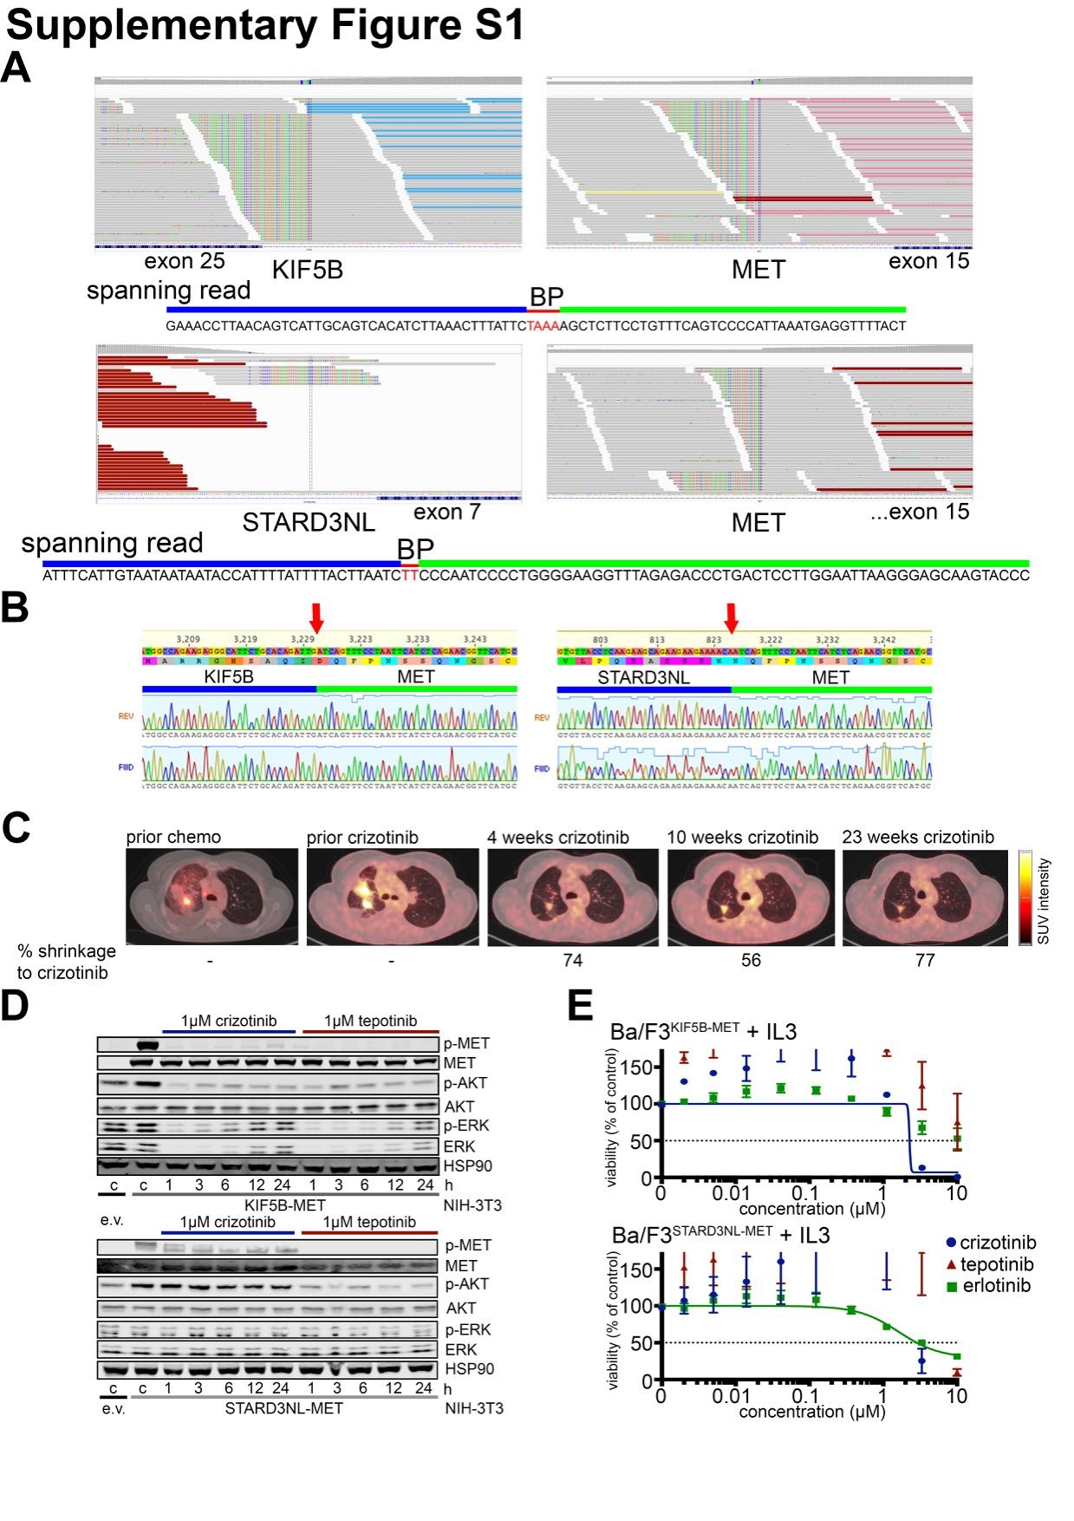Supplementary Figure S1. Characterization of KIF5B- and STARD3NL-MET rearrangements. A) IGV screenshots of next-generation sequencing reads from breakpoint regions of KIF5B- and STARD3NL-MET positive patient tissue. Due to homology in both regions the breakpoint region is marked with a red bar. The spanning read indicates the genomic sequence of the rearrangement. B) Dideoxy sequencing of exonic breakpoint regions of patient cDNA extracted from FFPE cuts for KIF5B- and STARD3NL-MET. C) PET/CT scans of KIF5B-MET patient. Numbers below indicate reduction of SUV_{max} under crizotinib therapy. D) Immunoblots of NIH-3T3 cells transduced with KIF5B-MET (upper panel) and STARD3NL-MET (lower panel) treated with 1 µM crizotinib or tepotinib over time. HSP90 serves as loading control. A representative blot from n=3 independent experiments is shown. E) Dose-response curves (72 h) of Ba/F3 cells stably transduced with KIF5B-MET or STARD3NL-MET supplemented with IL-3 (10% conditioned Wehi-3b media) and treated with crizotinib, tepotinib and erlotinib (as control compound). (n=3)

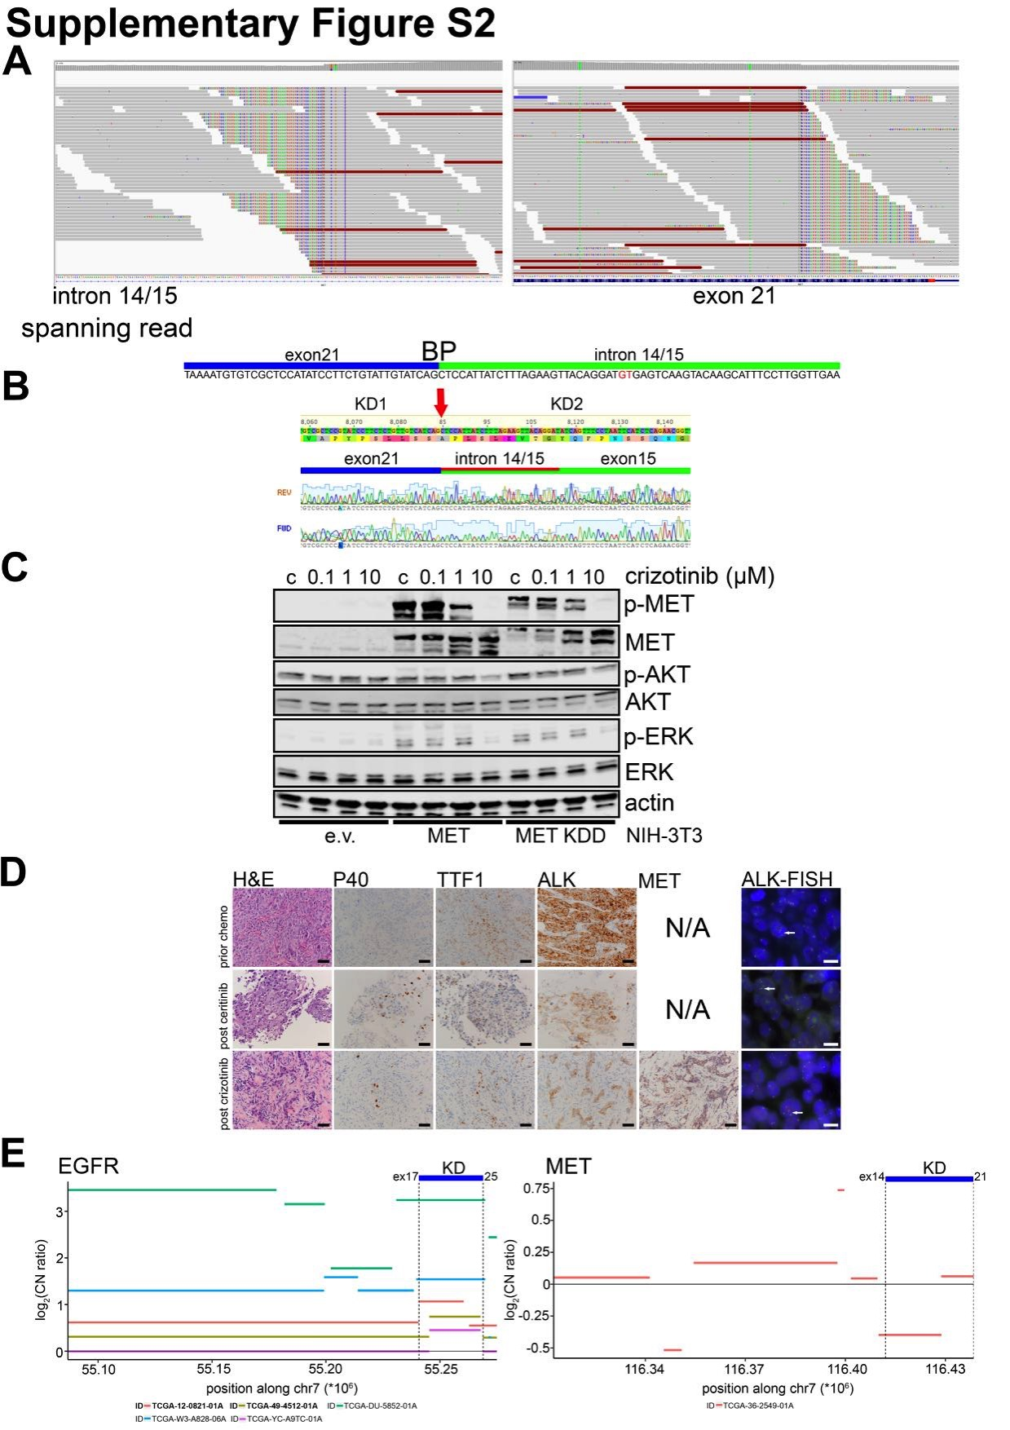
Supplementary Figure S2. Characterization of MET KDD rearrangement. A) IGV pictures of MET KDD patient for intronic region between exon 14 and 15 and exon 21. Spanning read indicates the genomic sequence of the breakpoint surrounding both kinase domains. Splice donor site is marked in red. B) Dideoxy sequencing of breakpoint region of MET KDD from exon 21 to exon 15 from patient cDNA extracted from FFPE. Red arrow marks the breakpoint. C) Immunoblot of transiently transfected (48 h) NIH-3T3 cells with e.v., MET or MET KDD. Cells were treated with crizotinib for 4 h. Actin serves as loading control. A representative blot from n=3 independent experiments is shown. D) Immunohistochemistry and FISH marker analysis of patient tissue under different treatment regimens. E) Pan-TCGA analysis (n>11,000) of SNP array copy number data for EGFR and MET, displaying patients with copy number alterations in the corresponding kinase domains (+/- 10 kb), covering at least 50% of the KD. The published cases for EGFR are detected (red and beige; bold). No case with specifically increased copy number in the kinase domain was found for MET.

