Supplemental Figures
Supplemental Figure 1.
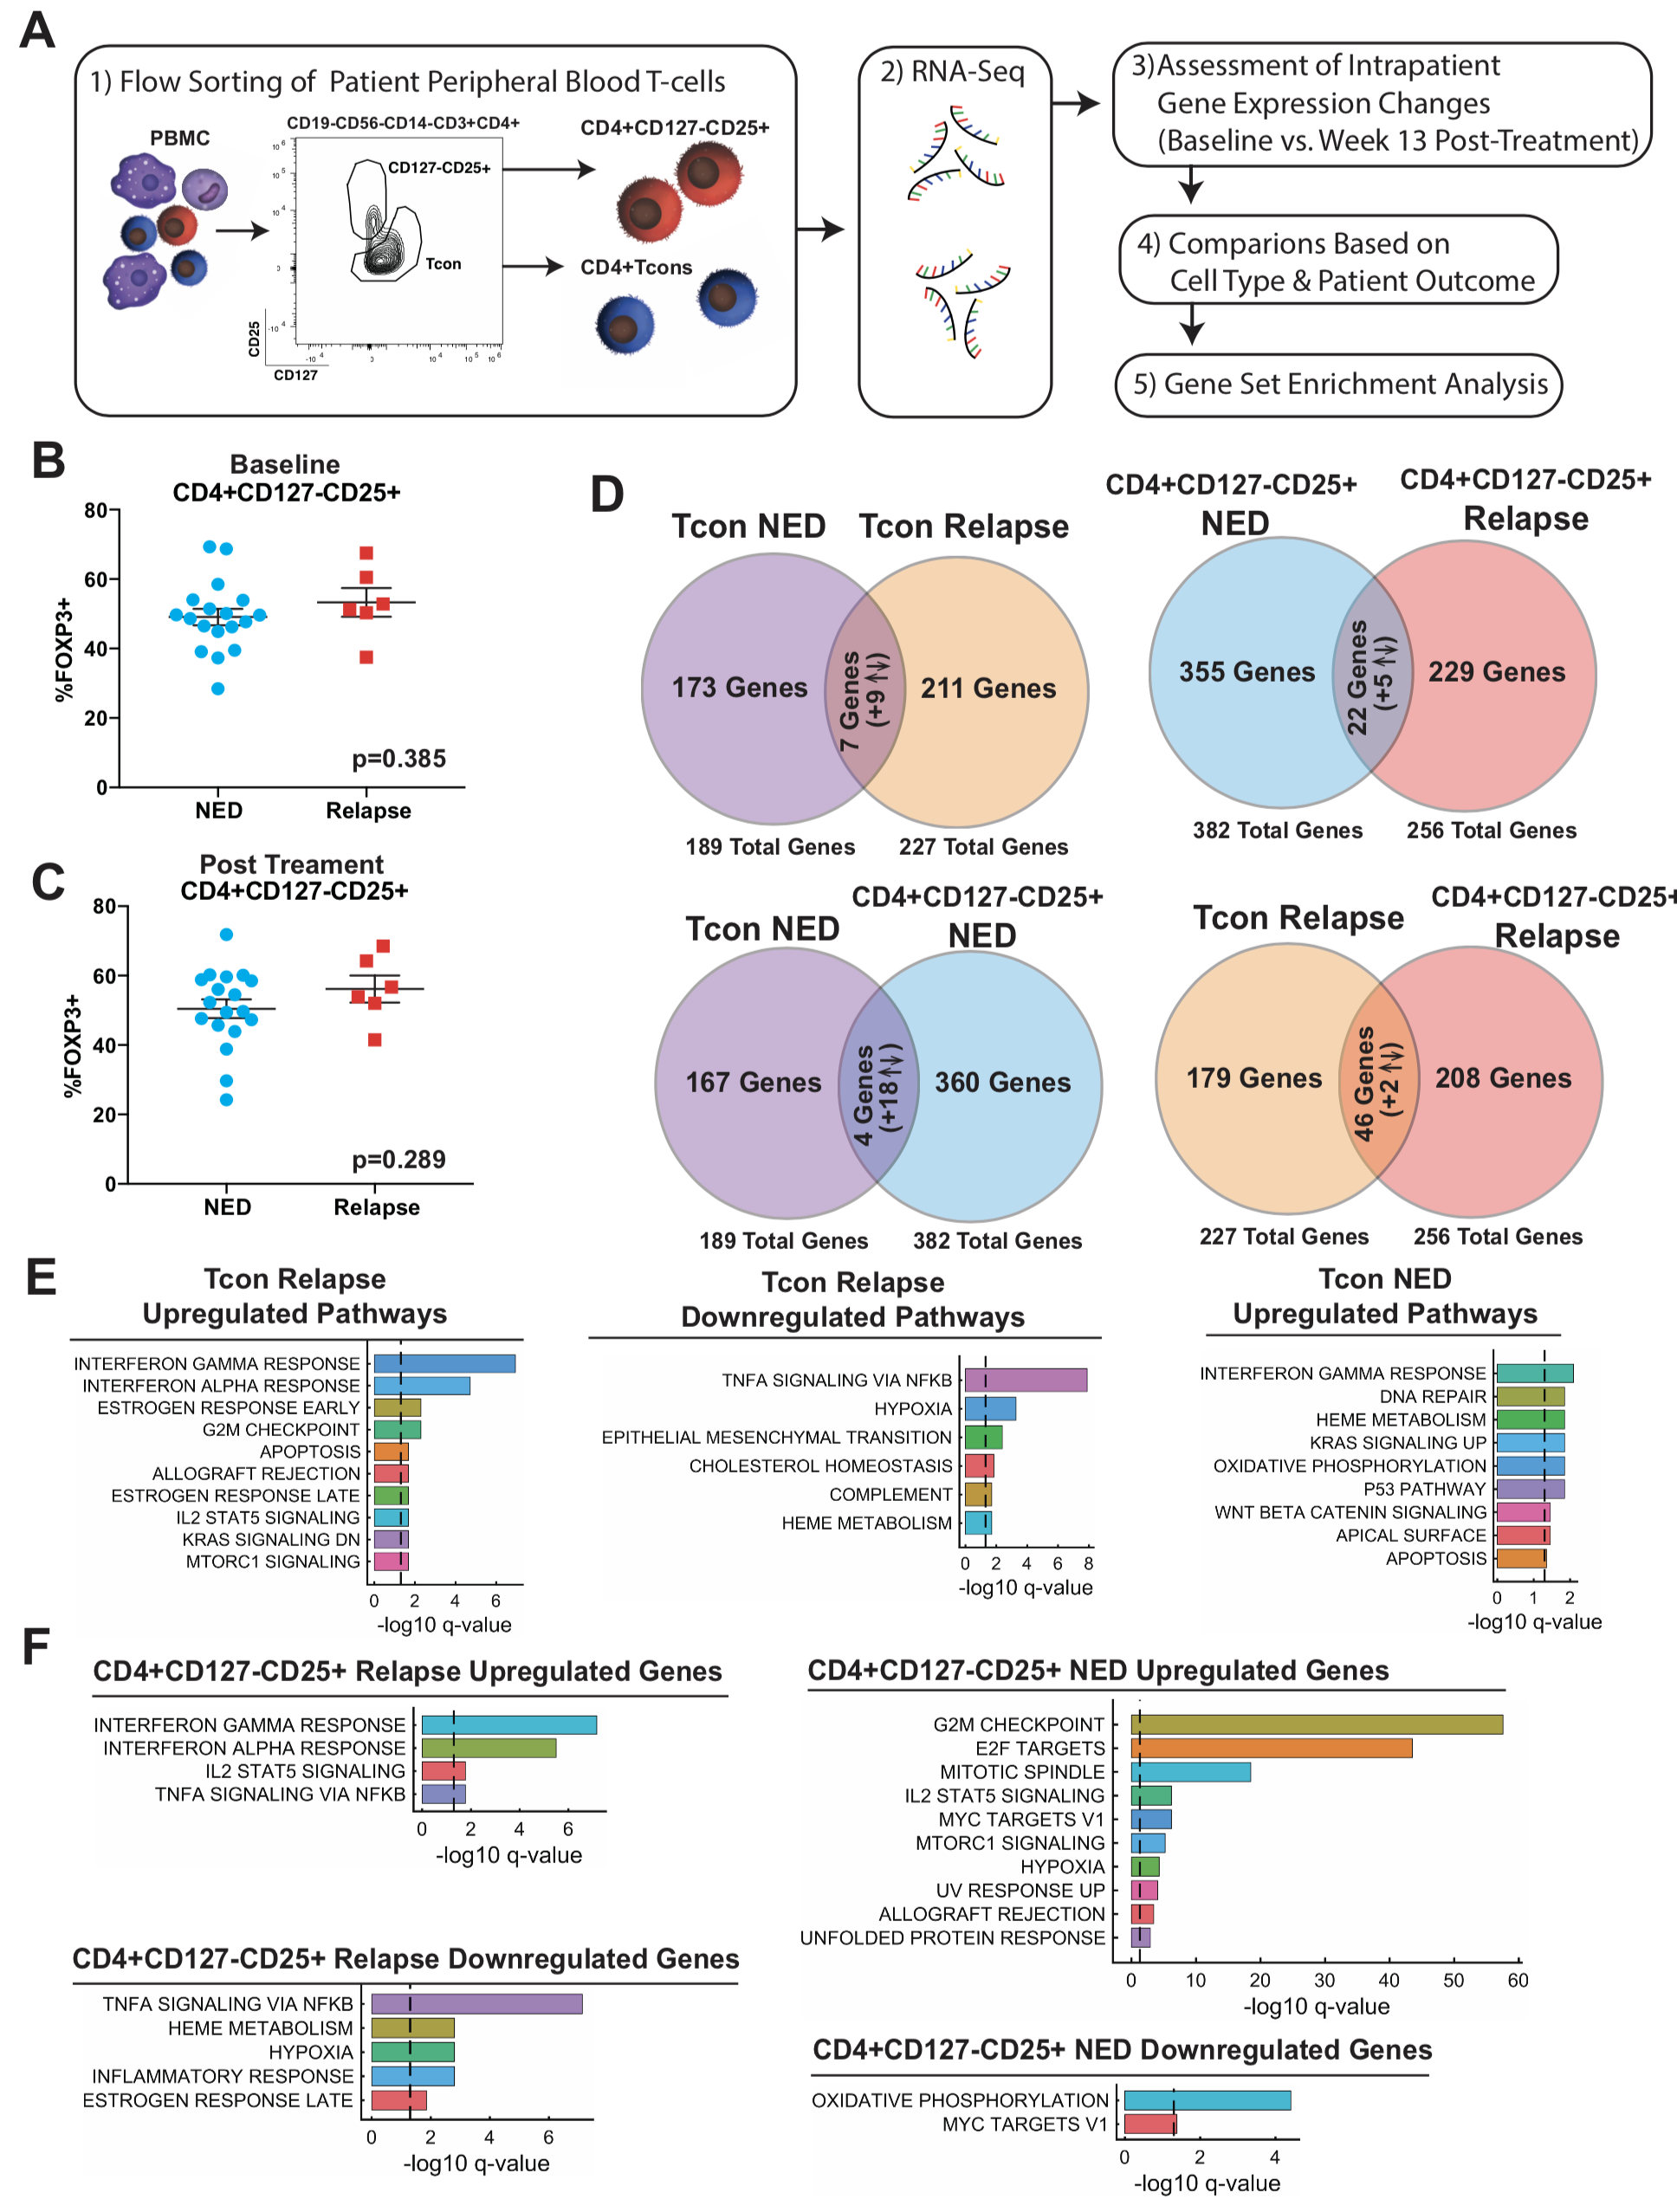
Supplemental Figure 1. Changes in Gene Expression After Nivolumab Therapy Differ Based on Patient Outcome and T-cell Subset. (A) Paired (baseline and week 13 after initiation of nivolumab treatment) patient PBMC were flow sorted for DAPI-CD19-CD56-CD14-CD3+CD4+CD127^{-/low}CD25+ T-cells and the remainder of the CD4+ population (Tcons). Cells were assessed by RNA-Seq. (B) Pre-treatment and (C) post-treatment patient CD4+CD127^{-/low}CD25+ peripheral blood T-cells were evaluated by intracellular flow cytometry for FOXP3 expression. (D) Venn diagrams with overlaps in significantly changed genes (q>0.05, comparing pre- vs. post samples), in NED Tcons (purple), relapse Tcons (orange), NED CD4+CD127^{-/low}CD25+ (blue) and relapse CD4+CD127^{-/low}CD25+ (red) are shown. (E) Tcon patient genes with significant changes (increased or decreased levels post-nivolumab) were assessed using GSEA and compared against hallmark gene sets. GSEA hallmark analysis did not return any results for downregulated NED Tcon genes and is consequently not graphed. (F) CD4+CD127^{-/low}CD25+ hallmark gene sets were likewise assessed.

Supplemental Figure 2.
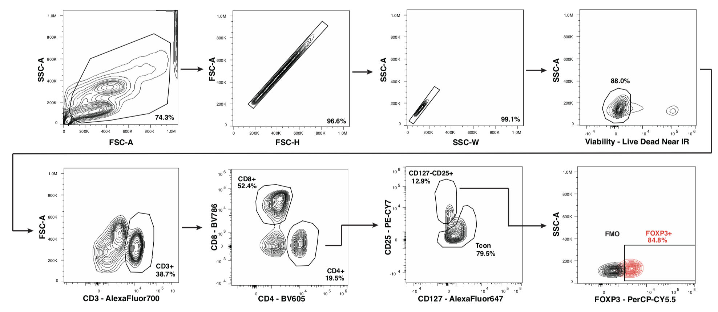

Supplemental Figure 2. Flow Cytometry Gating Strategy. The general gating strategy for flow cytometry and flow sorting experiments is shown. Initial FSC vs. SSC gate was used to gate on cells. FSC-H vs. FSC-A and SSC-W vs. SSC-A graphs were used to gate out doublets. In some experiments SSC-H vs. SSC-A gating was used in lieu of SSC-W vs. SSC-A. Viable cells were next gated using an amine reactive viability stain (e.g. LiveDead Near IR) or the DNA intercalating dye DAPI. CD3+ T-cells were next gated (in experiments using CD3 negative isolation, CD3 was not stained for). CD4+ vs. CD8+ T-cells were next gated. CD4+ were further divided into two populations: CD127^{-/low}CD25+ (Tregs) and the remainder of the CD4+ population (Tcons). For flow sorting, CD19, CD56 and CD8 dump channeled was used to exclude unwanted lineages. In indicated experiments, Tregs were further gated using FOXP3 expression.

Supplemental Figure 3.

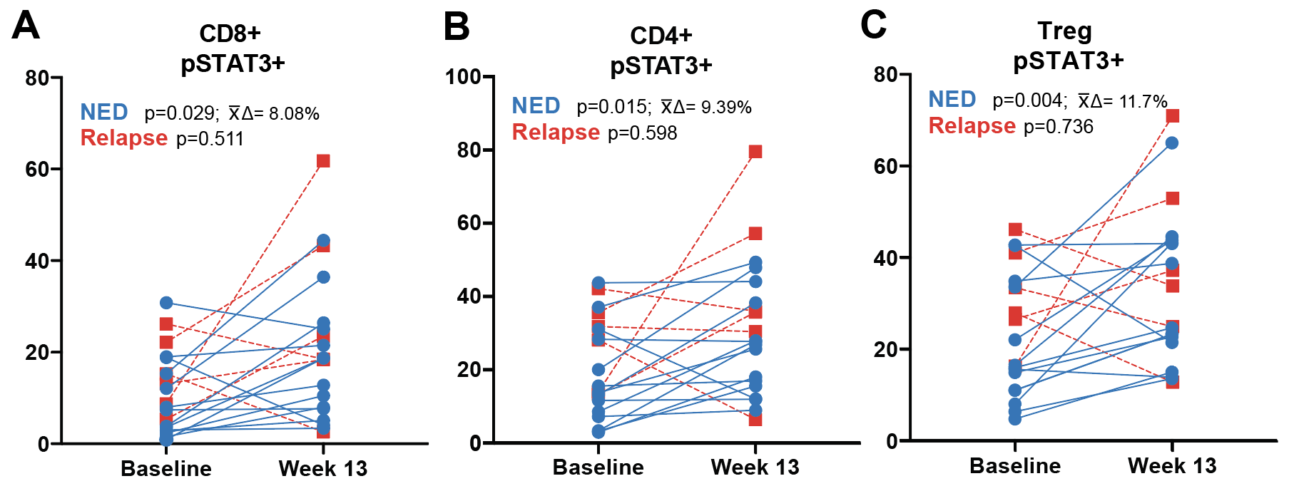

Supplemental Figure 3. Changes in the Percentages of Patient T-cell Populations Expressing Phosphorylated STAT3. Paired PBMC samples (baseline and week 13 after initiation of nivolumab treatment) from resected patients treated with adjuvant nivolumab were assessed by flow cytometry and percentages of (A) CD8+T-cells, (B) CD4+ Tcons and (C) Tregs expressing pSTAT3 were assessed. Blue lines connect paired NED patient samples and red, dotted lines connect relapsing patient samples. P-values are reported in the graphs along with average change in means (∆x̄) for NED patients.

Supplemental Figure 4.

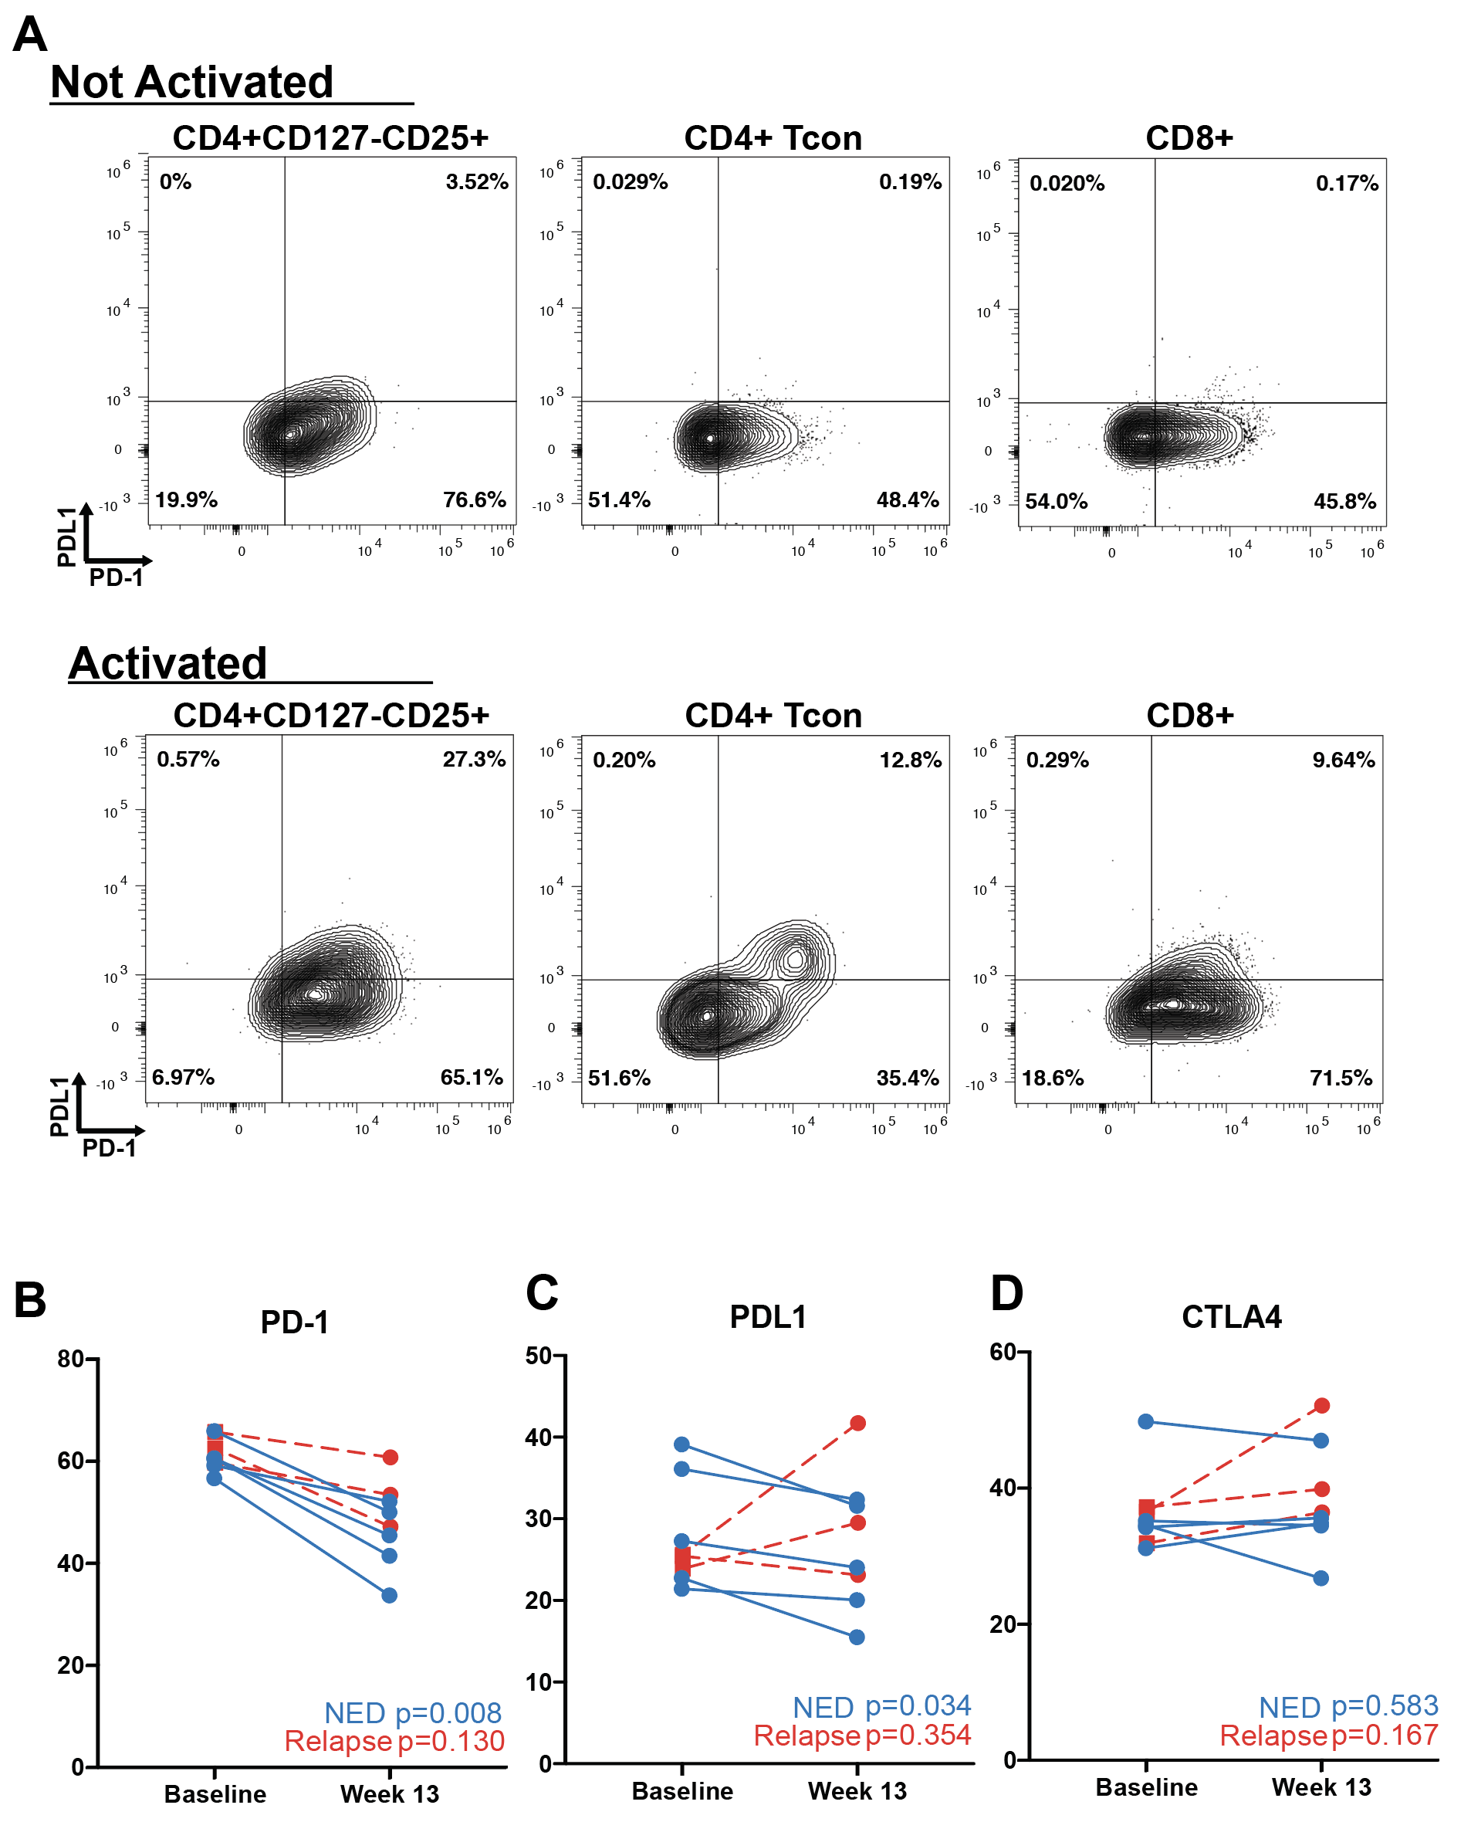
Supplemental Figure 4. T-cells express PDL1. (A) T-cell populations were evaluated by flow cytometry for expression of PD-1 and PDL1 without (top graphs) or with the addition of CD3/CD28 Dynabead activation (bottom graphs). (B-D) Patient CD4+CD127-CD25+ T-cells were evaluated for expression of indicated co-inhibitory markers. Blue lines connect paired NED patient samples and red, dotted lines connect relapsing patient samples. P-values from ratio paired T-tests are reported in the graphs.

Supplemental Figure 5.
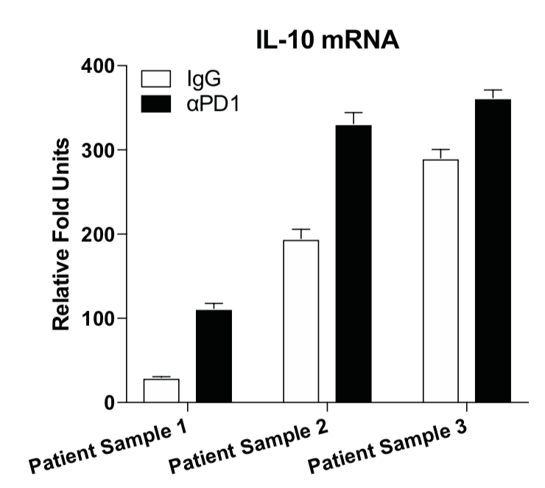
Supplemental Figure 5. PD-1 Blockade Increases IL-10 Expression in Vitro. CD3+ T-cells isolated from three baseline patient PBMC samples were cultured overnight with IgG (white bars) or αPD-1 (5ug/mL) (black bars) then activated for six hours using CD3/CD28 Dynabeads. IL-10 gene expression was measured by qRT-PCR. Fold units were calculated relative to 18S rRNA using ∆CT and normalized to IgG non-activated controls (∆∆CT). Error bars are SEM of technical triplicates.

Supplemental Figure 6.
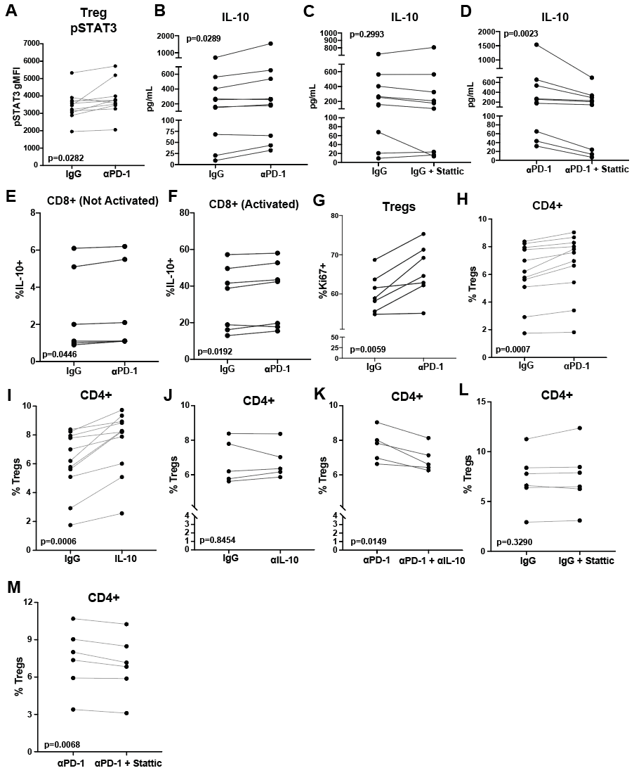

Supplemental Figure 6. Paired Analyses of In Vitro Experiments. (A) Isolated baseline patient CD3+ T-cells were cultured with the addition of αPD-1 (5ug/mL) for 48 hours. Tregs were evaluated by flow cytometry for pSTAT3 expression levels. Paired analyses of samples assessed over seven independent experiments are shown. (B-D) Isolated baseline patient CD3+ T-cells were cultured with the addition of indicated treatments for two hours and subsequently activated by CD3/CD28 Dynabeads. After 48 or 72 hours, culture supernatants were assessed for IL-10. Paired analyses of samples assessed over five independent experiments are shown. (E-F) Isolated baseline patient CD3+ T-cells were cultured with IgG or αPD-1 (5ug/mL) (E) without or (F) with CD3/CD28 Dynabead activation. After 72 hours, cells were assessed by intracellular flow cytometry for CD8+ IL-10 production. Paired samples were assessed over two independent experiments. (G) Isolated baseline patient CD3+ T-cells were cultured with the addition of indicated treatments overnight and subsequently activated by CD3/CD28 Dynabeads. After 48 hours, CD4+CD127-CD25+FOXP3+ cells were assessed for Ki67 expression. Paired analyses were assessed over two independent experiments. (H-M) Isolated baseline patient CD3+ T-cells were cultured with the indicated treatments for 48 hours and assessed by flow cytometry for Tregs as a percentage of the CD4+ population. For all plots, pairs are based on pre- and post- in vitro treatment of the same patient sample. Paired samples were assessed in three to seven independent experiments. Accompanying p-values, determined by paired t-tests, are shown in each graph.

