Supplemental methods and results
This section provides detailed information about the patient cohort, imaging protocol, histopathology and image correlations.

Patient cohorts
This study served as a prospective training cohort in the scope of an ongoing prospective diagnostic trial (clinicaltrials.gov NCT02659527) applying PSMA-PET/MRI in patients suspicious of having prostate cancer due to elevated PSA levels (validation cohort). The inclusion and exclusion criteria of the training cohort were:
Inclusion Criteria
- biopsy proven carcinoma of the prostate
- scheduled radical prostatectomy
Exclusion Criteria
- antiandrogen therapy
- patient not eligible for 3 Tesla MRI
- prostate needle biopsy <21 days before PET/MRI
- known active secondary cancer
- endorectal coil not applicable (e.g. anus praetor with short rectal stump)
- known anaphylaxis against gadolinium-DOTA
- patient's written informed consent not given
- prostatectomy compound not available for detailed histology (in case of radical prostatectomy)

Imaging protocol
Local and staging PET-MRI
All PET-MRI examinations were performed using a hybrid PET-MRI system (Biograph mMR, Siemens, Germany) capable of simultaneous data acquisition. The system consists of an MRI-compatible state-of the art PET detector integrated in a 3.0-T whole-body MRI scanner. In short, the PET detector technology relies on lutetium oxyorthosilicate scintillation crystals in combination with MRI-compatible avalanche photodiodes instead of photomultiplier tubes. The PET component uses a 3-dimensional (3D) acquisition technique and offers an axial FOV of approximately 23 cm and a transversal FOV of 45 cm. The gradient system of the MRI scanner operates with a maximum gradient strength of 45 mT/m and a slew rate of 200 T/m/s in all 3 axes.

PET studies
Patients received PET/MRI scans, starting with a 45 minutes local list mode scan immediately after the injection of 2 MBq/kg body weight [⁶⁸Ga]Ga-PSMA-11 (PSMA) intravenously while acquiring the prostate MRI sequences. Patients were hydrated with 500 ml sodium chloride 30 minutes before. 20mg furosemide was injected intravenously before the PSMA application for forced diuresis. Patients received a bladder catheter before the PET/MRI examinations to ensure stable assessment of the prostatic region. The final whole body scan was performed with 4 bed positions, 4 minutes sinogram mode each. Reconstruction parameters for PET were: 3 iterations/ 21 subsets for static images; 1 frame/2 minutes with 3 iterations/21 subsets for listmode PSMA data as well as the summation of the last 10 minutes PSMA acquisition for visual analysis. Nuclear medicine assessment was performed using 35-45 minutes summed frames of the local PSMA-PET fused with T2w HR sequences as well as whole body PET fused with axial T1 VIBE CE fs and coronal T2 HASTE. Hermes Hybrid 3D (Hermes Medical Solutions, Sweden) was used for analyses.

MRI studies
Morphological and functional MRI (T2-weighted, DCE-MRI, DWI) was performed according to the European Society of Urogenital Radiology (ESUR) guidelines including Pi-RADS criteria. The biograph mMR integrates a 3 Tesla MRI with a gradient strength of 45 mT/m @200 T/m/s). An endorectal coil was applied for improved signal to noise ratio..
Data for T2w sequences were: Pelvis: Matrix size: 235x512, in-plane resolution: 1.1x0.8x5mm; FoV: 262x400mm; TR: 5650ms; TE: 105ms. Prostate: Matrix size: 346x384, in-plane resolution: 0.6x0.5x3mm; FoV: 200x200mm; TR: 4000ms; TE: 104ms. Additional T2w 3D SPACE for MPR-reconstructions: Matrix size: 289x320, in-plane resolution: 0.9x0.9x0.9mm; FoV: 268x300mm; TR: 1800ms; TE: 128ms. WB (incl. T1-images): T2w HASTE: Matrix size: 256x256, in-plane resolution: 1.56x1.5x6mm; FoV: 380x380mm; TR: 1400ms; TE: 121ms. T1 VIBE fs post CE: Matrix size: 195x320, in-plane resolution: 1.6x1.2x3mm; FoV: 309x380mm; TR: 4.56ms; TE: 2.03ms.
DCE-MRI images were processed using a quantitative model (parameters Ktrans and iAUC). The results were translated in color-coded schemes. biograph mMR Data for DCE-VIBE sequences were: Matrix: 138x192; in-plane resolution: 1.9x1.4x3.6; FoV: 260x260mm; 2ml/kg body weight Gd-DOTA (Dotarem®, Guerbet, France), administered intravenously as a bolus followed by a 20ml saline flush using a power injector (Spectris Solaris EP®, Medrad, Pittsburgh, USA); injection flow: 3ml/sec; 35 images (6:34min) without gap; TR: 5.98; TE: 1.78; T1-mapping: 2, 15, 29 degree flip angle.
DWI B-values acquired were 0, 800, 1400. biograph mMR Data for DWI sequences were: Matrix size: 102x160, in-plane resolution: 2.2x1.6x3.6mm; FoV: 260x221mm; TR: 5400ms; TE: 93ms.
MRSI was renounced due to the length of the protocol and patient handling.
The whole body MRI from skull base to upper thigh was simultaneously performed with the whole body PET at the end of the investigation with the following parameters: T2w HASTE coronal: Matrix size: 256x256, in-plane resolution: 1.56x1.5x6mm; FoV: 380x380mm; TR: 1400ms; TE: 121ms. T1 VIBE axial: Matrix size: 195x320, in-plane resolution: 1.6x1.2x3mm; FoV: 309x380mm; TR: 4.56ms; TE: 2.03ms.
MRI data was transferred to a dedicated RAID system. Data analysis was performed with Agfa IMPAXX and OsiriX.

Histolopathological analysis and image correlation
Histology
After radical prostatovesiculectomy and formaldehyde fixation, the organ was rendered with different colors for each side. The axial slicing was done using a 3mm stable whole mount slicing box with a perpendicular orientation to the Denonvillier fascia. The first apex slice and the last base slice were additionally cut vertically for assessment of the apical or basal pT3a stage and the invasion of seminal vesicles. After embedding and staining with hematoxylin-eosin, the prostate, seminal vesicles, and lymph nodes were assessed in consensus by three experienced pathologists (MS, 35 years of experience; PM, 26 years, SH, 10 years). Tumor edges were dot-marked and whole mount sections were digitalized using a dedicated electronic microscope system (Leica Microsystems GmbH, Wetzlar, Germany).

Tumor alignment for detection rate: PET/MRI-Histology
Histology and PET/MRI were merged in a side-by-side analysis using a portable software fusion system (Hermes Medical Solutions, Stockholm, Sweden) next to the sorted, reoriented and dot-marked whole-mount sections (MH, PB and SH in consensus). Identical angulation of the histological step sections and the MRI slices was assured by initial perpendicular orientation of the axial MRI sequences to the Denonvillier fascia. Significant angulation errors were not detected in the presented cohort. A matching tumor lesion had to be in the same three-dimensional organ region in both imaging (PET, MRI, PET/MRI) and histology. In addition, the lesion shape as visualized on imaging had to fit the histological one >50%.

Table S1. Clinicopathologic features of 80 patients staged with [⁶⁸Ga]Ga-PSMA-11 PET/MRI before definitive treatment with radical prostatectomy
Age (years), median (IQR) | 64 (59-71)
PSA (ng/ml), median (IQR) | 7.63 (5.5-13.4)
Primary Gleason pattern at Biopsy, n (%)
3 | 52 (65.0)
4 | 27 (33.8)
5 | 1 (1.2)
Secondary Gleason pattern at Biopsy, n (%)
3 | 29 (36.2)
4 | 42 (52.5)
5 | 9 (11.2)
Total Gleason Score at Biopsy, n (%)
6 | 19 (23.8)
7 | 39 (48.8)
≥8 | 22 (27.5)
Number of positive cores, median (IQR) | 5.00 (3-8)
Number of negative cores, median (IQR) | 7.00 (4-10.25)
Clinical T staging in PSMA-PET/MRI, n (%)
2 | 41 (51.2)
3a | 19 (23.8)
3b | 20 (25)
Positive lymph nodes in PSMA-PET/MRI, n (%) | 11 (13.8)
Site of positive lymph nodes in PSMA-PET/MRI, n (%)
Bilateral external iliac | 4 (5.0)
Left external iliac | 1 (1.2)
Left obturator | 1 (1.2)
Left pelvis | 2 (2.5)
Presacral | 1 (1.2)
Right external iliac | 1 (1.2)
Right internal iliac | 1 (1.2)
IQR = Interquartile range, PSA = prostate specific antigen, PSMA = [⁶⁸Ga]Ga-PSMA^{HBED-CC} conjugate 11 ligand, PET = positron emission tomography, MRI = magnetic resonance imaging

Table S2. Clinicopathologic features of 41 patients staged with [⁶⁸Ga]Ga-PSMA-11 PET/MRI in whom the therapeutic management changed after imaging
Age (years), median (IQR) | 65 (60-72)
PSA (ng/ml), median (IQR) | 13.2 (6.6-32)
Primary Gleason pattern at Biopsy, n (%)
3 | 23 (56.1)
4 | 15 (36.6)
5 | 3 (7.3)
Secondary Gleason pattern at Biopsy, n (%)
3 | 20 (48.8)
4 | 11 (26.8)
5 | 10 (24.4)
Total Gleason Score at Biopsy, n (%)
6 | 15 (36.6)
7 | 13 (31.7)
≥8 | 13 (31.7)
Number of positive cores, median (IQR) | 6.00 (3-12.5)
Number of negative cores, median (IQR) | 5.50 (3.25-7.75)
Clinical T staging in PSMA-PET/MRI, n (%)
0 | 3 (7.3)
2 | 17 (41.5)
3a | 2 (4.9)
3b | 9 (21.9)
4 | 10 (24.4)
Positive pelvic lymph nodes in PSMA-PET/MRI, n (%) | 15 (36.6)
Distant metastases in PSMA-PET/MRI, n (%) | 14 (34.1)
IQR = Interquartile range, PSA = prostate specific antigen, PSMA = [⁶⁸Ga]Ga-PSMA^{HBED-CC} conjugate 11 ligand, PET = positron emission tomography, MRI = magnetic resonance imaging

Supplemental Figure 1:
⁶⁸Ga-PSMA 11 SUVmax taken out of the main tumor region in 80 patients after radical prostatectomy demonstrating significantly higher SUVmax in high risk patients (as classified after radical prostatectomy according to the d‘Amico criteria).
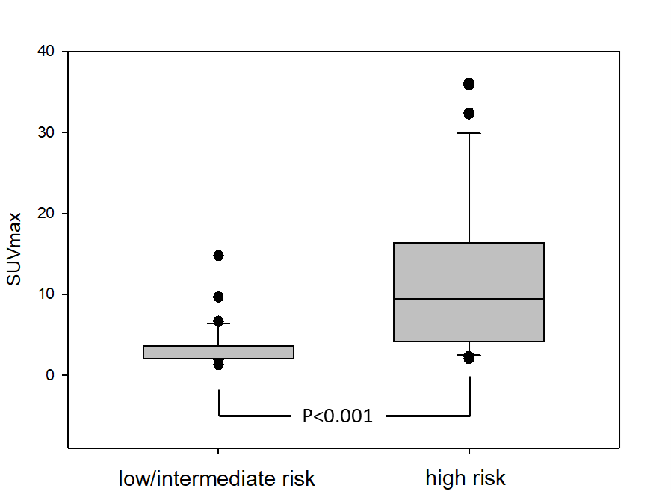

Supplemental Figure 2:
ADCmean (10⁻⁶ mm²/s) taken out of the main tumor region in 80 patients after radical prostatectomy demonstrating significantly lower ADC values in high risk patients (as classified after radical prostatectomy according to the d‘Amico criteria), but at a lower level of sgnificance as compared to ⁶⁸Ga-PSMA 11 SUVmax (suppl. figure 1)
