Supplemental Table1. Cell line source information.
Cell Line | Source
A549 | American Type Culture Collection, Manassas, VA
H1299
H226
H2009
PC9 | Immuno-Biological Laboratories Co, Japan
COLO699 | German Collection of Microorganisms and Cell Culture, Germany
H157 | Drs. John Minna and Adi Gazdar, University of Texas Southwestern Medical Center, Dallas, TX
H3122
H358

Supplemental Table2. Reagent information.
Reagents | Company | Catalog#
Recombinant human EGF | R&D Systems | 236-EG-200
Free base CO-1686 | MedChem Express | HY-15729
CO-1686 hydrobromide | Utanpharma, China
osimertinib
erlotinib | LC Laboratories | E-4007
EGFR siRNA | ThermoFisher Scientific | EGFRHSS103114
MERTK siRNA | ThermoFisher Scientific | MERTKHSS116030
Control siRNA | Santa Cruz | sc-37007

Supplemental Table 3. Antibody information.
Antibody | Catalog # | Company | Application
pAKT | 9271 | Cell signaling | Immunoblot
AKT | 9272
pAURKA/pAURKB/pAURKC | 2914
AURKA | 3092
AURKB | 3094
pEGFR-Y1068 | 2234
EGFR | 2232
pERBB2/ERBB2 and pERBB3/ERBB3 | 8339
pERK | 9106
ERK | 9102
GAPDH | 2118
tubulin | 2125
pEGFR-Y1101 | ab76195 | Abcam
MERTK | ab52968
pMERTK | N/A | Phosphosolutions [1]
Goat-anti-mouse | 1706516 | BioRad
Goat-anti-rabbit | 1721019
MERTK | MAB8912 | R&D Systems | Immunoprecipitation
EGFR | MAB1095

Supplemental Videos (Download them separately): SupVideo1: H1299 + vehicle; SupVideo2: H1299 + 1µM CO-1686; SupVideo3: H1299 + 100nM MRX-2843; SupVideo4: H1299 + combined.

Supplemental Table4. Ten EGFR TKIs that are most effective in combination with MRX-2843 for treatment of wtEGFR NSCLC.
Name | Targets | Reversible/Irreversible | Z score |  | Citations
 |  |  | Combined | Single
CO-1686 | L858R, del19, T790M | Irreversible | -1.53 | -0.52 | [2]
Pelitinib | L858R, del19, T790M | Irreversible | -1.10 | -0.87 | [3, 4]
WZ3146 | L858R, del19, T790M | Irreversible | -1.04 | -1.08 | [5]
CNX-2006 | L858R, del19, T790M | Irreversible | -0.93 | -0.43 | [6]
WZ8040 | L858R, del19, T790M | Irreversible | -0.90 | -0.01 | [5]
osimertinib | L858R, del19, T790M | Irreversible | -0.77 | -0.40 | [7]
AST-1306 | L858R, del19, T790M | Irreversible | -0.69 | -0.21 | [8, 9]
PD168393 | L858R, del19, T790M | Irreversible | -0.66 | 0.53 | [10, 11]
AZD8931 | L858R and del19 | Reversible | -0.58 | 0.49 | [12, 13]
OSI-420 | L858R and del19 | Reversible | -0.33 | 0.01 | [14]

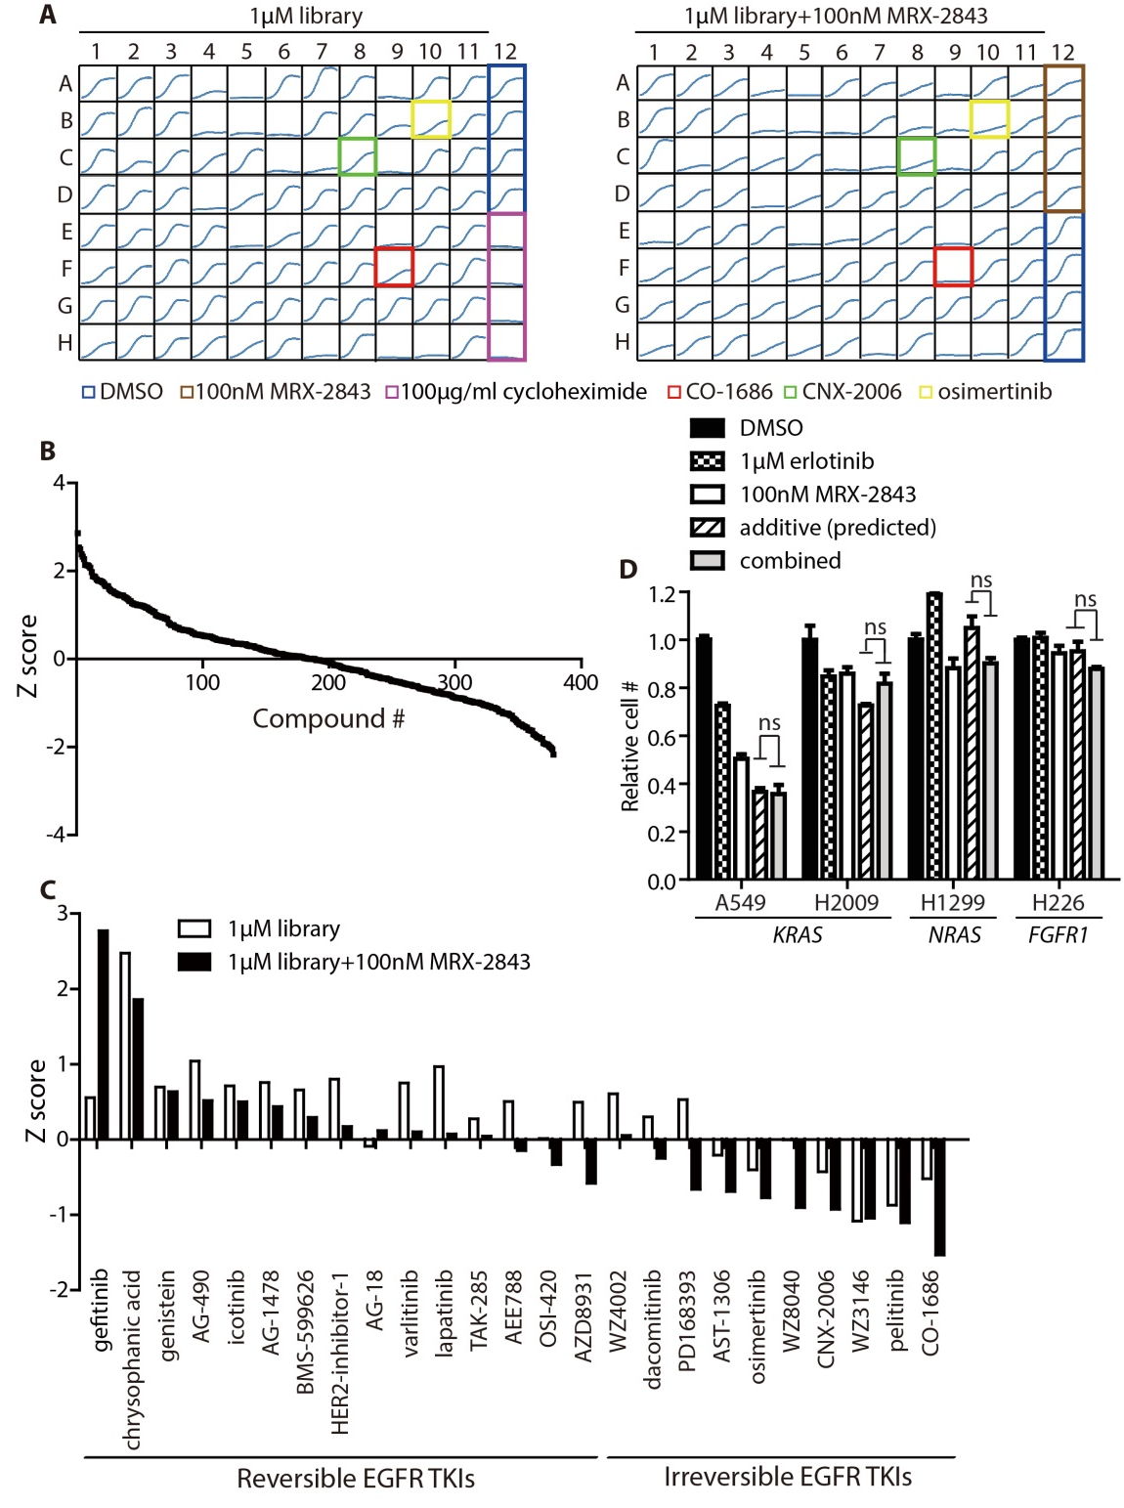
Sup1. Assay miniaturization and validation and independent evaluation of erlotinib. NuclightTMRed A549 cells were cultured in 96-well format and treated with vehicle (DMSO), 1µM library compound alone (left panel), or 1µM library compound in combination with 100nM MRX -2843 (right panel) for 4d. Cell numbers were determined at 2h intervals using the Incucyte™ZOOM live cell imaging system. Cycloheximide (100µg/ml) was used as a positive control. (A) Representative plate layout for the library screen. Control samples (DMSO, MRX-2843 alone, and cycloheximide) are indicated and cell expansion curves for three irreversible EGFR inhibitors CO-1686, CNX-2006, and AZD9291 are highlighted. (B) Z scores for the 378 compounds in the kinase inhibitor library in combination with 100nM MRX-2843.(C) Z scores for wtEGFR A549 NSCLC cells treated with 25 EGFR inhibitors with/without concurrent MRX-2843. NuclightTMRed A549 cells were cultured in 96-well plates and treated with 1μM library alone and in combination with 100nM MRX-2843 for 70h. Cell numbers were determined using the IncucyteTMZOOM live cell imaging system and Z scores were calculated as an indicator of relative anti-tumor activity, with a lower Z score indicating a smaller number of cells remaining post-treatment. Irreversible EGFR inhibitors exhibited smaller Z scores compared to reversible EGFR TKIs, indicating greater therapeutic efficacy, both alone and in combination with MRX-2843. (D) MRX-2843 does not sensitize wtEGFR NSCLC cell lines to the first-generation EGFR TKI erlotinib. Cell numbers were determined after 100h of treatment. The expected number of remaining cells assuming an additive interaction was calculated using the fractional product method (additive/predicted) and compared to the actual number of remaining cells observed after treatment with the combination therapy (combined).

Sup2. Optimization of drug concentrations for combination studies. (A) NuclightTMRed A549 cells were treated with the indicated concentrations of MRX-2843 and/or CO-1686, alone or combined, for 90h and cell numbers were determined using the IncucyteTMZOOM live cell imaging system. Mean values and standard errors derived from four independent experiments are shown. (B) A549 cells were treated with CO-1686 and/or MRX-2843 or with vehicle only for 3.5d. Alternatively, after treatment for the indicated times (4, 16, or 24h), the medium containing the combination therapy was removed and replaced with fresh medium without treatment. Mean values and standard errors derived from three independent experiments are shown.
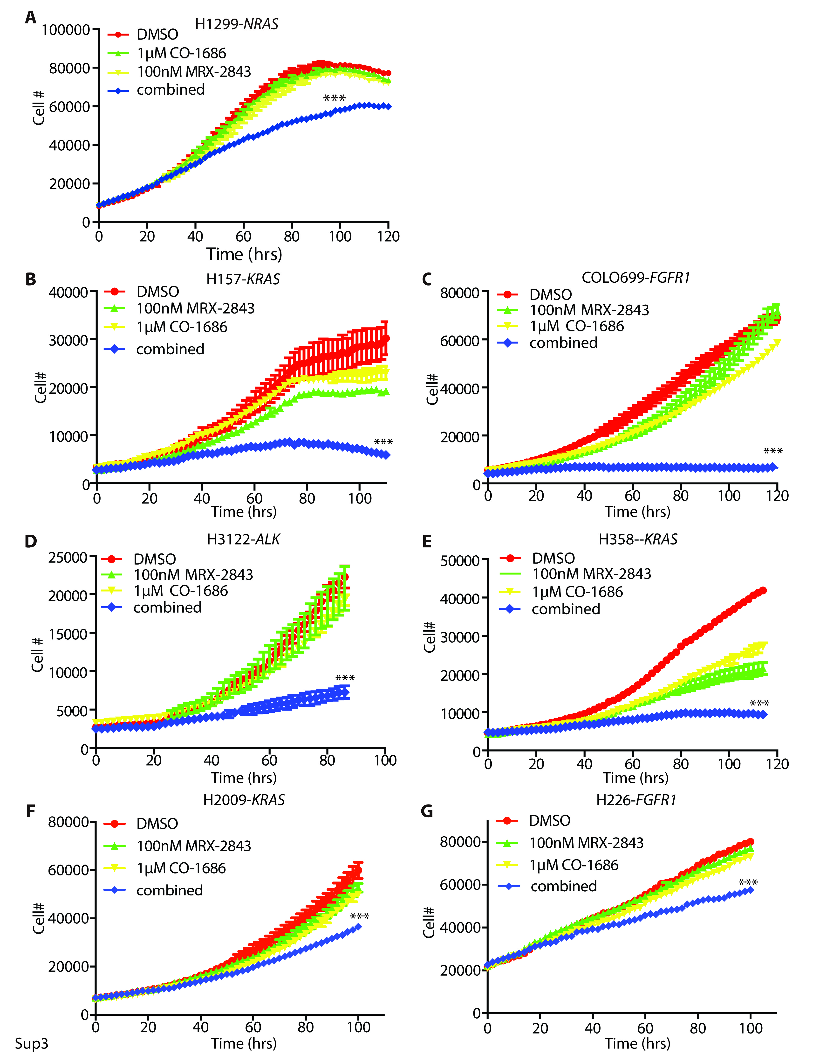
Sup3. Combined treatment with CO-1686 and MRX-2843 is effective in a panel of wtEGFR NSCLC cell lines with different driver oncogenes. Growth curves derived from cultures of the indicated NSCLC cell lines treated with MRX-2843, CO-1686, MRX-2843 and CO-1686 combined or vehicle only. Data shown are representative of at least 3 independent experiments.
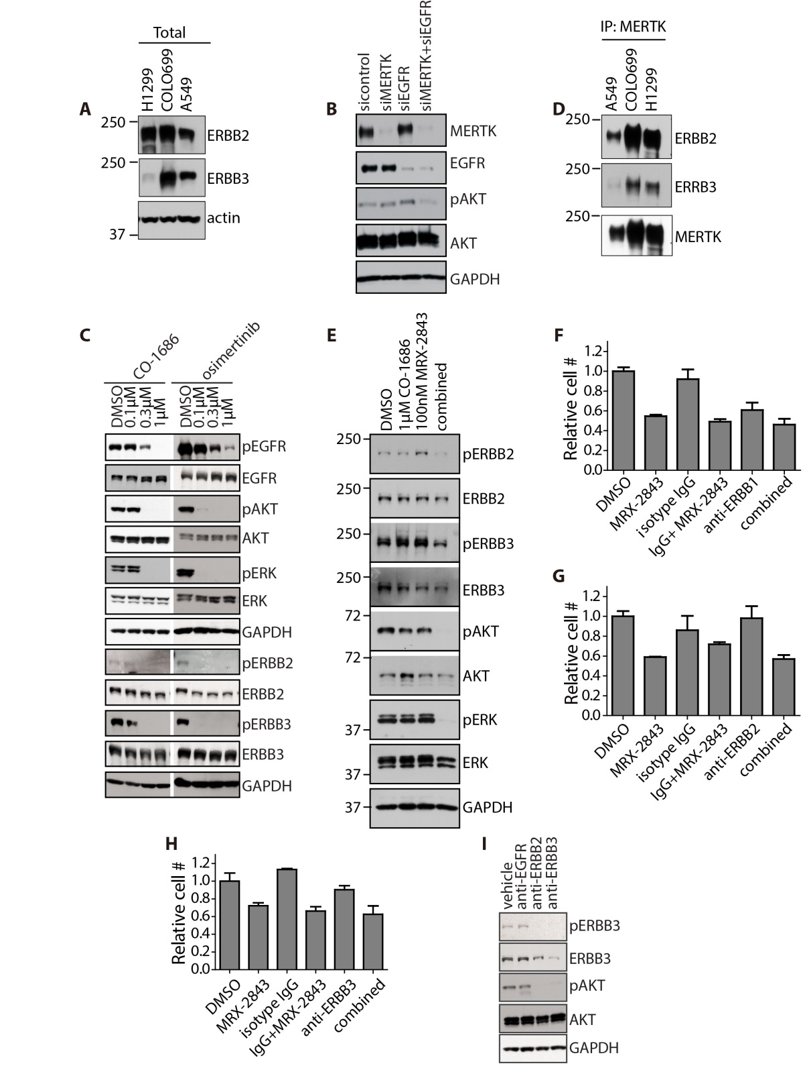
Sup4. Combined treatment with CO-1686 and MRX-2843 mediates synergistic inhibition of ERBB2/3 and ERBB2/3 interact with MERTK. (A) ERBB2 and ERBB3 are expressed in wtEGFR NSCLC cell lines. Expression of the indicated proteins was determined by immunoblot. (B) Combined inhibition of MERTK and EGFR using siRNA synergistically decreases AKT phosphorylation in A549 cells. (C) The mtEGFR PC9 NSCLC cell line was treated with the indicated concentrations of CO-1686 or osimertinib for 2h and phosphorylation of ERBB-family members and downstream signaling proteins was assessed by immunoblot. CO-1686 and osimertinib inhibited phosphorylation of EGFR, ERBB2, ERBB3, AKT, and ERK. (D) ERBB2 and ERBB3 interact with MERTK. MERTK was immunoprecipitated from lysates of the indicated cell lines and ERBB2 and ERBB3 were detected by immunoblot. (E) A549 cells were treated for 2h with MRX-2843 and/or CO-1686, alone and in combination, or with vehicle only and the indicated proteins were detected by immunoblot. ERBB2 and ERBB 3 were synergistically inhibited in response to treatment with the combination therapy. (F-I) A549 cells were treated with 2.5µg/ml of anti-ERBB1/EGFR (Novus Biologicals, NBP2-52671), anti-ERBB2 (R&D Systems, AF1129), anti-ERBB3 (R&D Systems, AF234) or isotype control antibody (ThermoFisher Scientific, 31154) alone and combined with 100nM MRX-2843. F-H) After treatment for 66h NuclightTMRed cells were quantitated using the Incucyte™ZOOM live cell imaging system. Mean values and standard deviations derived from three independent experiments are shown. (I) After treatment for 2h, cell lysates were prepared and phosphorylated and total ERBB3 and AKT proteins were detected by immunoblot. All images are representative of three independent experiments.

Sup5. Combined treatment with CO-1686 and MRX-2843 synergistically inhibits AURK and induces polyploidy in wtEGFR NSCLC cells. NuclightTMRed cells were treated with 1µM CO-1686 and/or 100nM MRX-2843. (A) Combined treatment with MRX-2843 and CO-1686 induced polyploidy in A549, H1299, H157 and COLO699 wtEGFR NSCLC cells. Images were captured with the Incucyte™ZOOM live cell imaging system after 80h of treatment and are representative of results from at least 3 independent experiments. (B) Cell lysates were prepared from H1299 cells after 2h of treatment and the indicated proteins were detected by immunoblot.

Sup6. CO-1686 does not synergize with MEK or mTOR inhibitors. NuclightTMRed A549 cells were treated for 86h with 1µM SL-327 (MEKi) or 1µM ridaforolimus (mTORi) alone and in combination with 100nM MRX-2843. A) Cell lysates were prepared after 2h of treatment and the indicated proteins were detected by immunoblot. B) Cell numbers were quantitated after 96h of treatment using the Incucyte™ZOOM live cell imaging system. The expected number of remaining cells assuming an additive interaction was calculated using the fractional product method (additive) and compared to the number of remaining cells observed after treatment with the combination therapy (combined). Synergistic interactions are defined by an observed value that is significantly less than the value expected for an additive interaction. Mean values and standard deviations derived from at least three independent experiments are shown (**, p <0.01, ***, p <0.001; ns=not significant; 1-way ANOVA).

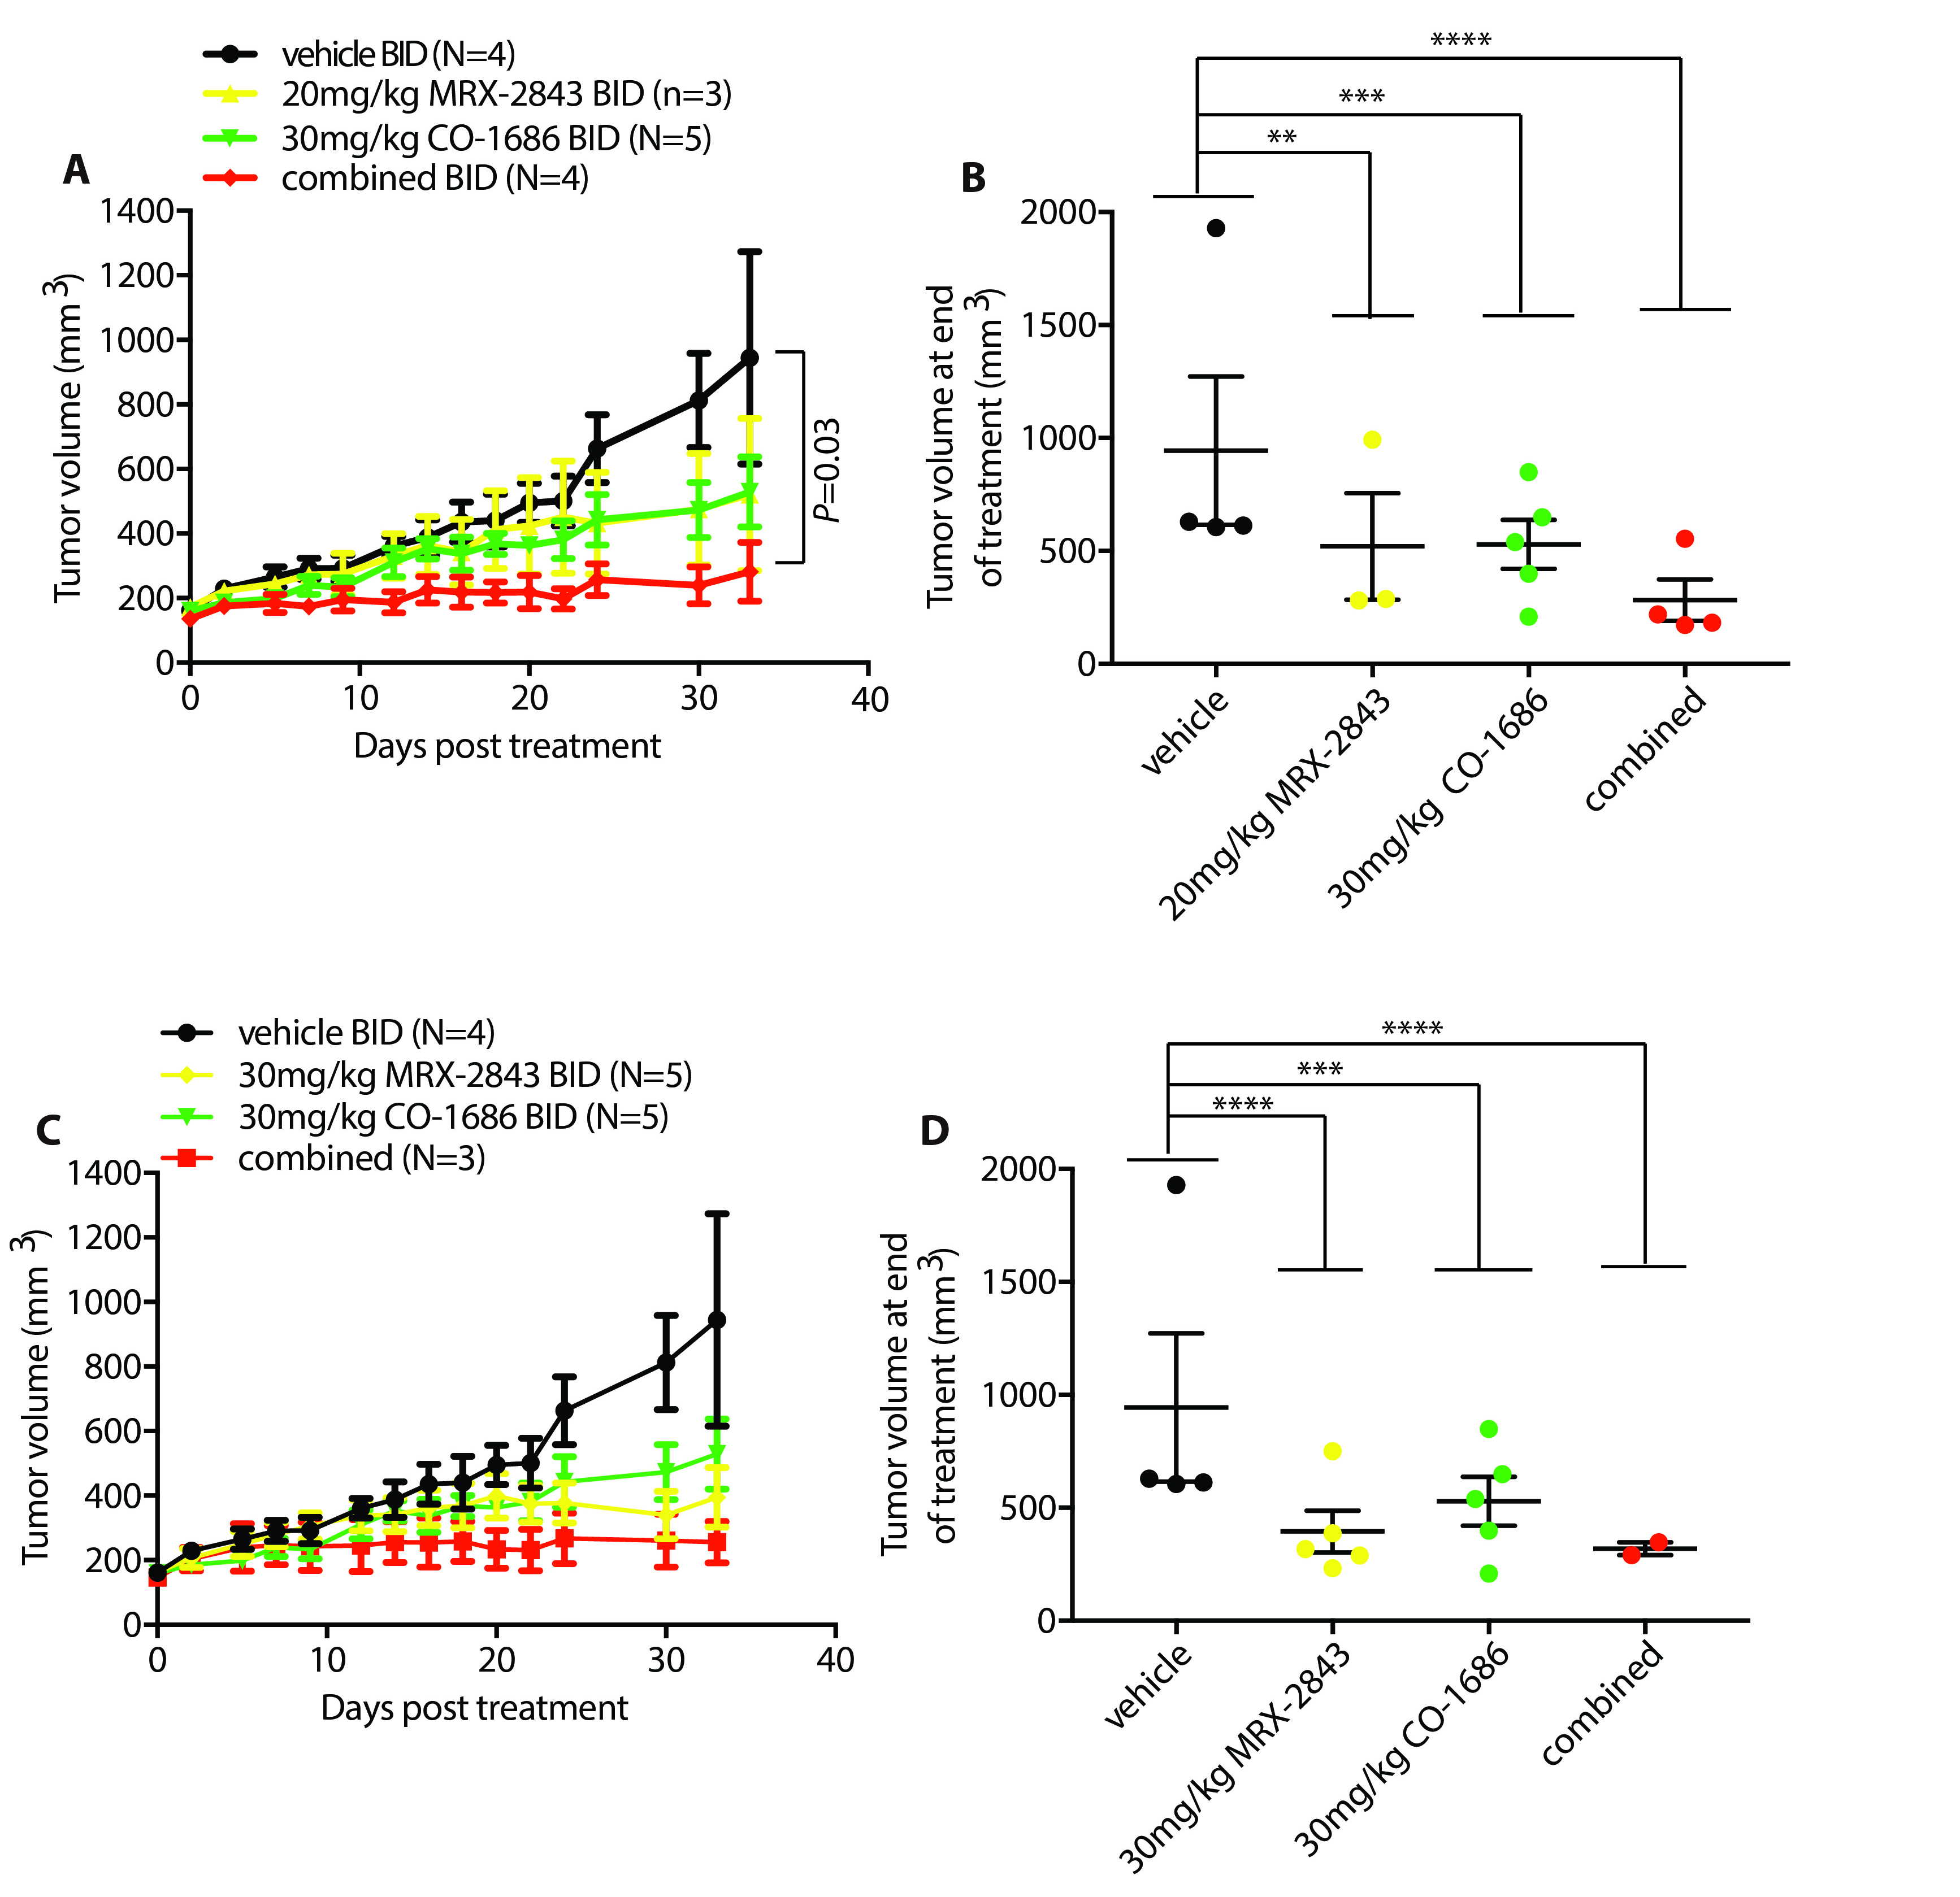
Sup7. Combined treatment with MRX-2843 and CO-1686 enhances tumor growth inhibition in vivo. A549 cells were injected subcutaneously into the flank of Nude mice and tumor volume was monitored. When mean tumor volume reached 150mm³, the mice were randomized to groups and treated twice daily (BID) by oral gavage with 30mg/kg CO-1686, 20mg/kg MRX-2843, 20mg/kg MRX-2843 + 30mg/kg CO-1686, 30mg/kg MRX-2843, 30mg/kg MRX-2843 + 30mg/kg CO-1686, or vehicle only for 48d. (A and C) Tumor volumes were measured twice weekly. Mean values and standard errors derived from a single experiment are shown. (B and D) Tumor volumes after 48d of treatment. (**, p <0.01; ***, p <0.001; ****, p<0.0001; 1-way ANOVA).
1. Zhang, W., et al., UNC2025, a potent and orally bioavailable MER/FLT3 dual inhibitor. J Med Chem, 2014. 57(16): p. 7031-41.
2. Walter, A.O., et al., Discovery of a mutant-selective covalent inhibitor of EGFR that overcomes T790M-mediated resistance in NSCLC. Cancer Discov, 2013. 3(12): p. 1404-15.
3. Pao, W. and J. Chmielecki, Rational, biologically based treatment of EGFR-mutant non-small-cell lung cancer. Nat Rev Cancer, 2010. 10(11): p. 760-74.
4. To, K.K., et al., Pelitinib (EKB-569) targets the up-regulation of ABCB1 and ABCG2 induced by hyperthermia to eradicate lung cancer. Br J Pharmacol, 2015. 172(16): p. 4089-106.
5. Zhou, W., et al., Novel mutant-selective EGFR kinase inhibitors against EGFR T790M. Nature, 2009. 462(7276): p. 1070-4.
6. Mizuuchi, H., et al., Oncogene swap as a novel mechanism of acquired resistance to epidermal growth factor receptor-tyrosine kinase inhibitor in lung cancer. Cancer Sci, 2016. 107(4): p. 461-8.
7. Cross, D.A., et al., AZD9291, an irreversible EGFR TKI, overcomes T790M-mediated resistance to EGFR inhibitors in lung cancer. Cancer Discov, 2014. 4(9): p. 1046-61.
8. Xie, H., et al., AST1306, a novel irreversible inhibitor of the epidermal growth factor receptor 1 and 2, exhibits antitumor activity both in vitro and in vivo. PLoS One, 2011. 6(7): p. e21487.
9. Zhang, J., et al., A phase I study of AST1306, a novel irreversible EGFR and HER2 kinase inhibitor, in patients with advanced solid tumors. J Hematol Oncol, 2014. 7: p. 22.
10. Sos, M.L., et al., Chemogenomic profiling provides insights into the limited activity of irreversible EGFR Inhibitors in tumor cells expressing the T790M EGFR resistance mutation. Cancer Res, 2010. 70(3): p. 868-74.
11. Red Brewer, M., et al., Mechanism for activation of mutated epidermal growth factor receptors in lung cancer. Proc Natl Acad Sci U S A, 2013. 110(38): p. E3595-604.
12. Hickinson, D.M., et al., AZD8931, an equipotent, reversible inhibitor of signaling by epidermal growth factor receptor, ERBB2 (HER2), and ERBB3: a unique agent for simultaneous ERBB receptor blockade in cancer. Clin Cancer Res, 2010. 16(4): p. 1159-69.
13. Mu, Z., et al., AZD8931, an equipotent, reversible inhibitor of signaling by epidermal growth factor receptor (EGFR), HER2, and HER3: preclinical activity in HER2 non-amplified inflammatory breast cancer models. J Exp Clin Cancer Res, 2014. 33: p. 47.
14. Broniscer, A., et al., Plasma and cerebrospinal fluid pharmacokinetics of erlotinib and its active metabolite OSI-420. Clin Cancer Res, 2007. 13(5): p. 1511-5.

