Supplementary for Pembrolizumab exposure-response assessments challenged by association of cancer cachexia and catabolic clearance
David C. Turner¹, Anna G. Kondic¹, Keaven M. Anderson¹, Andrew G. Robinson², Edward B. Garon³, Jonathan Wesley Riess⁴, Lokesh Jain¹, Kapil Mayawala¹, Jiannan Kang¹, Scot W. Ebbinghaus¹, Vikram Sinha¹, Dinesh P. de Alwis¹, and Julie A. Stone¹
¹ Merck & Co., Inc., Kenilworth, NJ USA; ² Cancer Centre of Southeastern Ontario at Kingston General Hospital, Ontario, Canada; ³ David Geffen School of Medicine at UCLA, Los Angeles, CA, USA; ⁴ UC Davis Comprehensive Cancer Center, Davis, CA, USA

Address correspondence to:
Julie A. Stone
E-mail: julie_stone@merck.com

Supplementary Methods
OS Analyses
All OS analyses were performed using the statistical software environment R, Version 3.2.4. Data for patients who were alive or lost to follow-up were censored at the time of last confirmed contact. In all three studies, patients were contacted every 2-3 months during the survival follow-up phase. In all exposure-OS assessments, melanoma and NSCLC data were analyzed separately and only pembrolizumab-treated subjects with available PK data were included. The Kaplan-Meier (K-M) method was used to visualize the distribution of OS within and across doses (function Surv, R package ‘survival’), and the differences between curves were explored using the log-rank test (function survdiff, R package ‘survival’). Data from two doses (2 and 10 mg/kg) were leveraged in order to distinguish possible correlations of CL₀ from true exposure-dependencies in OS (further detailed later in this report). Univariate and multivariate Cox Proportional Hazards (CPH) models were implemented to evaluate the impact of various OS risk factors. Complete cases of patient covariates were used in the multivariate and case-control analyses (KEYNOTE-010 and KEYNOTE-002). To assess statistical significance of the model feature coefficients, each feature’s Wald statistic and associated P value were evaluated using the ‘coxph’ function in the R package ‘survival.’ Feature selection in the Cox model was performed using stepwise Akaike Information Criterion (AIC) to mitigate the risk of overfitting. Variables for multivariate analysis were investigated in a stepwise fashion, with missing data imputed as the median using AIC penalize for including further predictors. The R ‘forestmodel’ package was used for visualizations of hazard ratios (HR) from the final CPH regressions.

Study Design
In brief, KEYNOTE-002 was a randomized, phase II study of pembrolizumab in subjects with advanced melanoma refractory to treatment with ipilimumab and BRAF and/or MEK inhibitor (if BRAF^{V600E} mutant). Patients were randomized 1:1:1 to blinded intravenous (IV) pembrolizumab at 2 or 10 mg/kg Q3W, or investigator-choice chemotherapy. KEYNOTE-010 was a multi-center, worldwide, randomized, Phase II/III trial of IV pembrolizumab at 2 or 10 mg/kg Q3W compared with docetaxel in subjects with NSCLC who had disease progression following a platinum-containing systemic therapy. Prior to randomization, subjects were stratified by Eastern Cooperative Oncology Group (ECOG) Performance Scale (0 versus 1), PD-L1 expression tumor proportion score (TPS) ≥50% and <50%, and region (East Asia versus non-East Asia). Lastly, KEYNOTE-024 was a multi-center, international, randomized, open-label, controlled trial of pembrolizumab monotherapy versus Investigator choice of pre-specified platinum-based chemotherapies in subjects with Stage IV, PD-L1 TPS≥50% expressing NSCLC. This was the first NSCLC trial to evaluate the 200 mg Q3W fixed-dosage regimen of pembrolizumab. Randomization was stratified by ECOG, histology, and region.

Pharmacokinetics Analysis
A population pharmacokinetic (PopPK) analysis was implemented using nonlinear mixed effects modeling (NONMEM) to estimate PK parameters and exposures from observed pembrolizumab concentration-time data. In general, PopPK is a model-based approach to describe the time course of drug exposure across individuals in a population by estimation of typical population-level PK values (e.g., clearance, volume of distribution) and explicit terms to describe variability, including inter-subject variability.
A two-compartment pembrolizumab popPK model was used that was previously established based on data from KEYNOTE-001, -002, and -006. This initial model used time-stationary (i.e., ‘‘static’’) CL. A subsequent model was developed by incorporating time-dependent or time-varying CL of pembrolizumab. In this model, CL was assumed to be a function of best overall response category per RECIST. The general relationships between PK parameters (clearance [CL] and volume of distribution [Vc]) and body weight were estimated by the incorporation of an allometric exponential relationship with bodyweight in the terms for these parameters:
Equation 1
Equation 2
where X_{TV} is the typical value of the pharmacokinetic parameter X, and α-X is the allometric exponent describing the association with WT (individual body weight) normalized by Median WT. The terms e^{η} described further inter-individual variation in these PK parameters beyond that accounted for by WT. Two additional parameters (Q and V_{P}) described the distribution behavior of pembrolizumab and were also adjusted for WT, using the same values for the exponents as for CL and Vc, respectively. Covariate terms that helped explain between-subject variability in PK parameters were retained in the popPK model. These patient-specific factors included gender, baseline estimated glomerular filtration rate (eGFR), baseline albumin, prior treatment with ipilimumab, cancer type, baseline Eastern Cooperative Oncology Group (ECOG) performance status, and baseline tumor burden (sum of longest dimensions of target lesions).
The popPK model was estimated to obtain individual post hoc PK parameter estimates from which individual per-subject PK values were derived for AUC (the area under the curve) as: (AUC_{6weeks,CL0} = Dose/CL₀ * [6/dosing frequency in weeks]). Because in this model CL varies over time within an individual subject, the model-estimated starting parameter value of CL (CL₀) was used to derive exposure estimates. Generally, all patients were sampled such that the extent of shrinkage for the inter-individual variability (IIV) term on CL in the final model was <15%, indicating that post hoc PK parameter estimates are reliable for subsequent exposure-response assessments. Protocol-specific details on PK collection times are provided in Supplemental Table S4.

Supplementary Figures
Fig S1. Kaplan-Meier plots of overall survival, stratified by pembrolizumab dose, demonstrate similarity of efficacy across a 5-fold dose range (2 to 10 mg/kg Q3W) in A) advanced ipilimumab-refractory melanoma, KEYNOTE-002 (Cox HR 0.98; 95% CI 0.94–1.02) and B) advanced, previously-treated PD-L1 positive NSCLC, KEYNOTE-010 (Cox HR 0.98; 95%CI 0.95–1.01). Subjects with at least one available PK measurement were included.

Fig S2. Overall pooled exposure-response patterns demonstrate trends incongruent with similarity in dose-response patterns across 2 to 10 mg/kg in A) advanced ipilimumab-refractory melanoma, KEYNOTE-002 and B) advanced, previously-treated PD-L1 positive NSCLC, KEYNOTE-010. Subjects with at least one available PK measurement were included. Line types represent exposure quartiles (AUCbins) using exposure estimates (AUC_{6weeks,CL0} = Dose/CL₀ * [6/dosing frequency in weeks]) pooled from both 2 and 10 mg/kg arms, as depicted in the inset figure legends.
A B

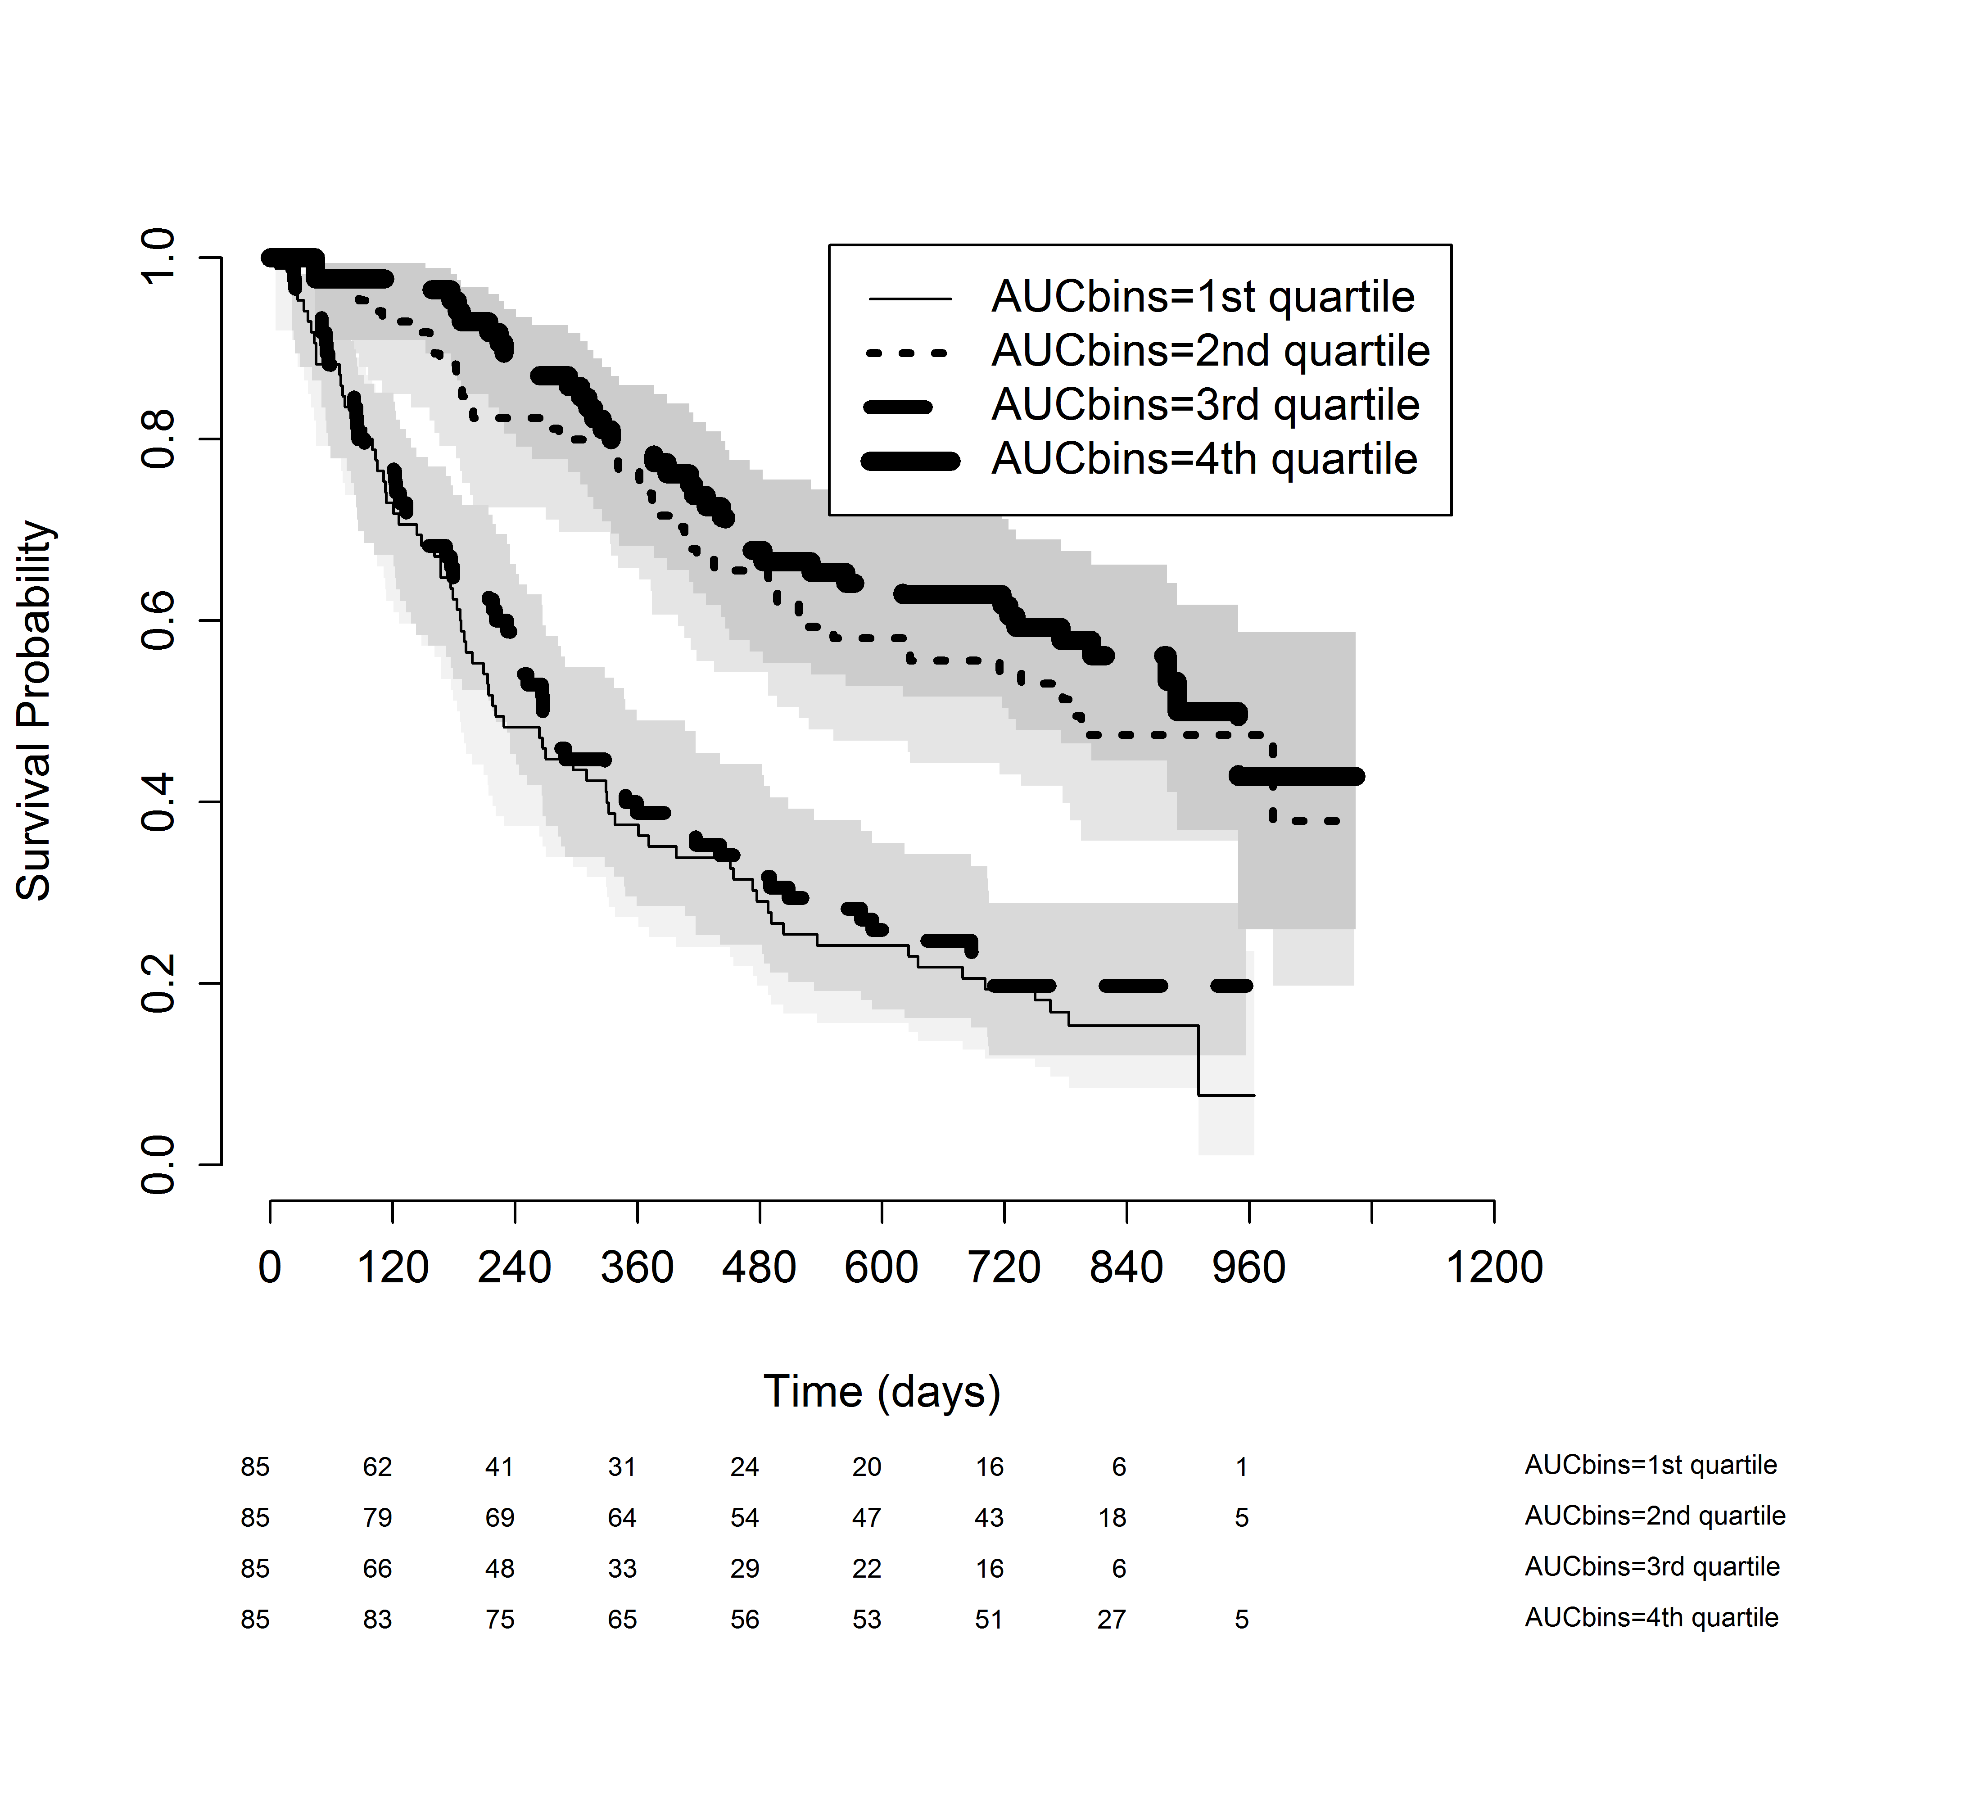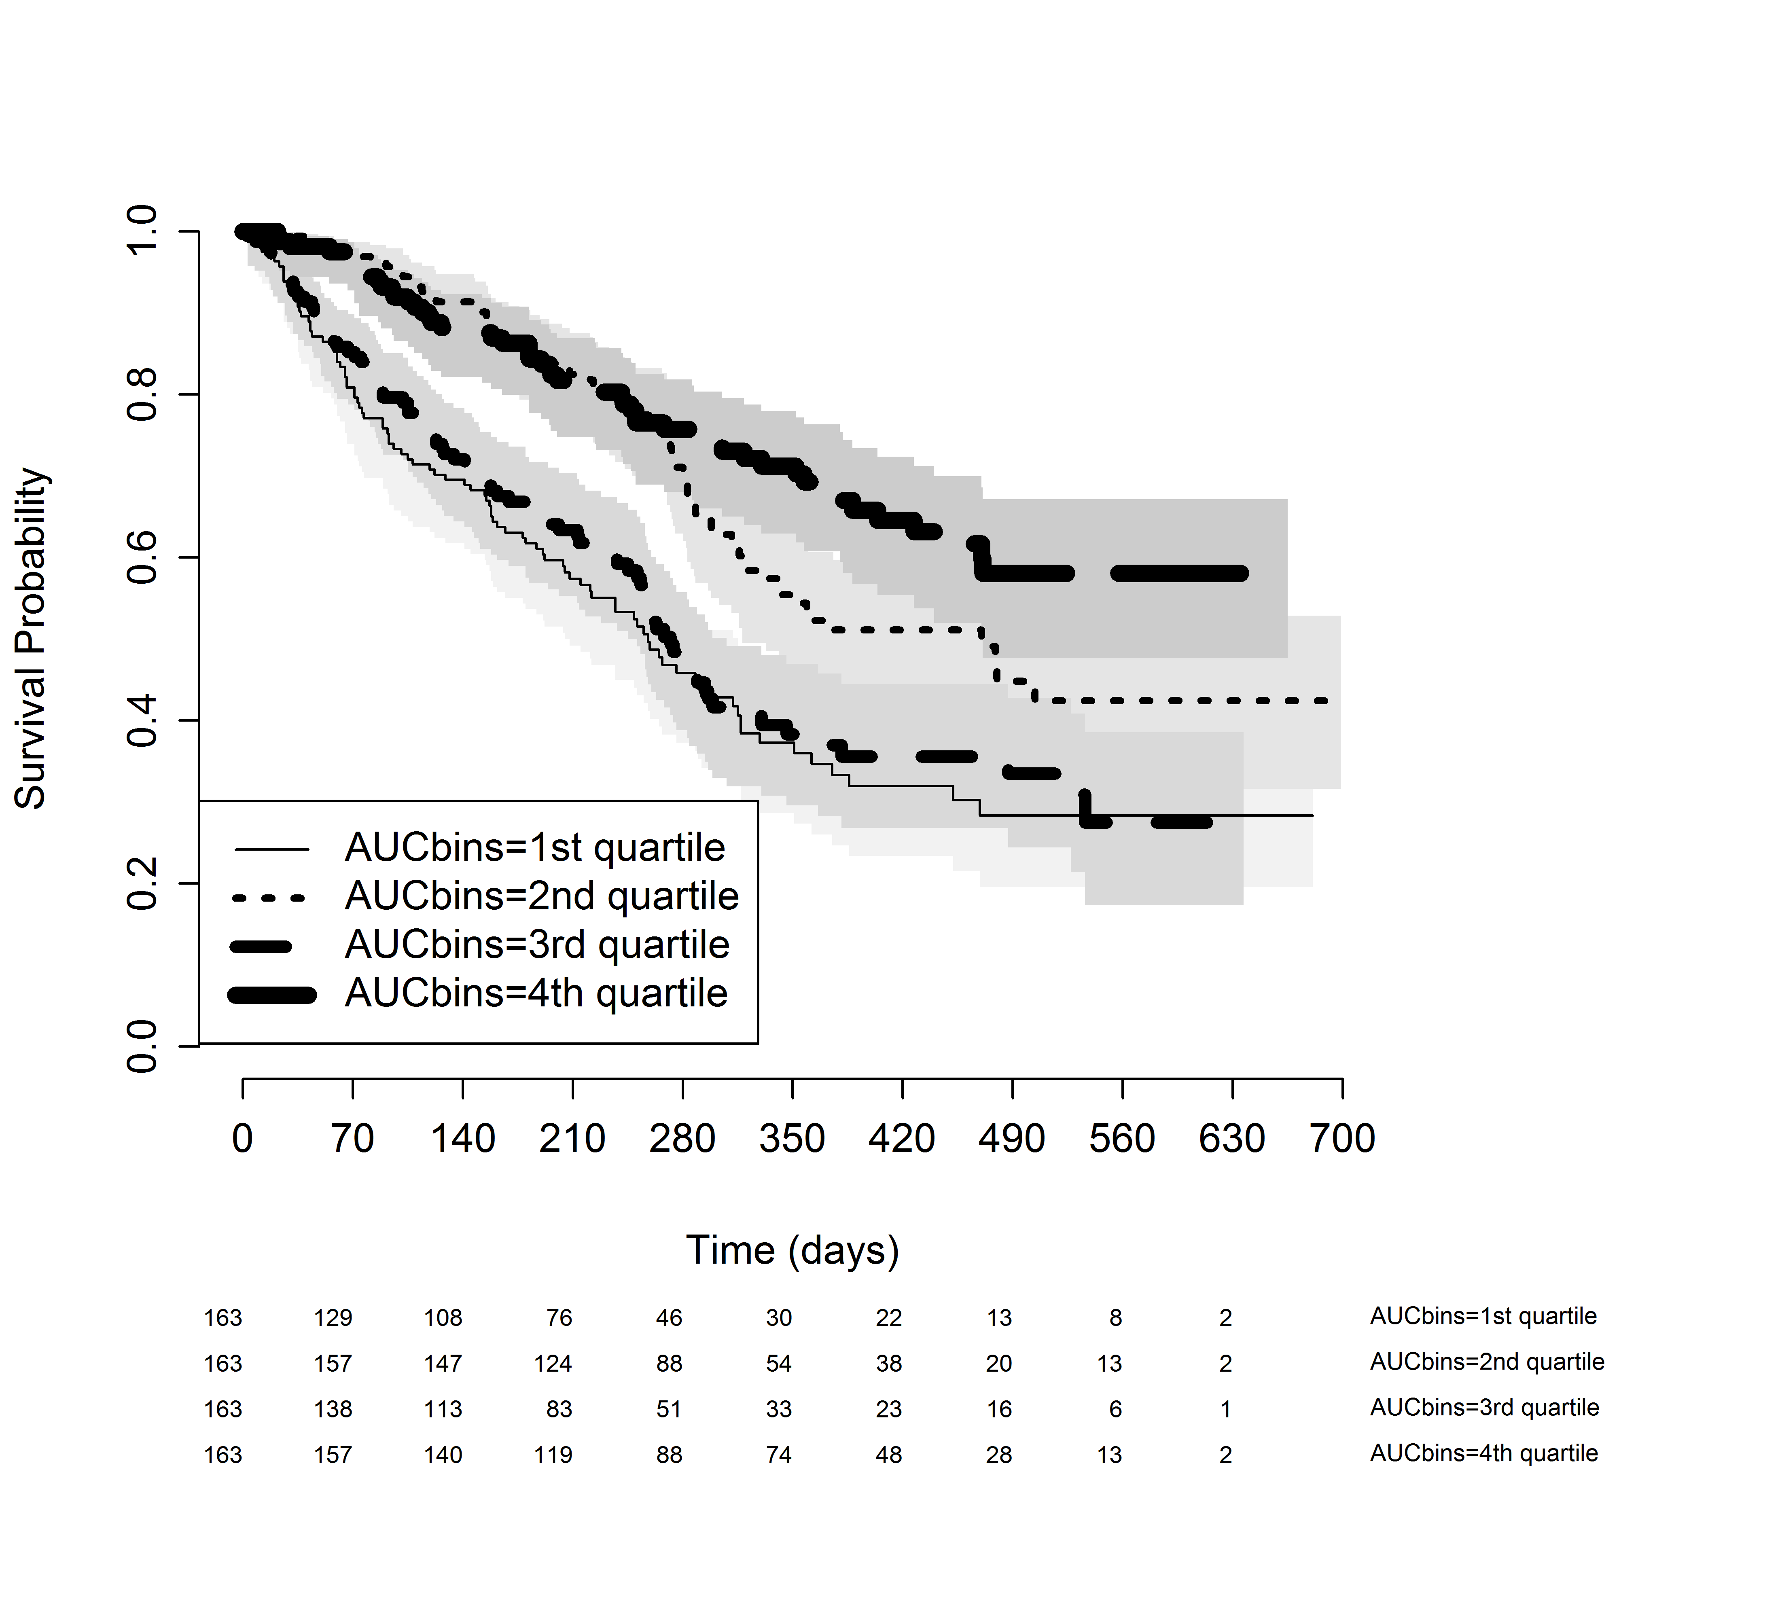

Fig S3. Similarity in OS between respective within-dose exposure quartiles at 2 and 10 mg/kg shows E-R patterns from pooled data (Fig S2 above) to be misleading in A-B) advanced ipilimumab-refractory melanoma, KEYNOTE-002 and C-D) advanced, previously-treated PD-L1 positive NSCLC, KEYNOTE-010. Subjects with at least one available PK measurement were included. HR of 4th quartile of 2 mg/kg relative to 4th quartile of 10 mg/kg = 2.2 (0.9 – 5.4) in melanoma (B) and = 2.2 (1.1 – 4.2) in NSCLC (D)
A B
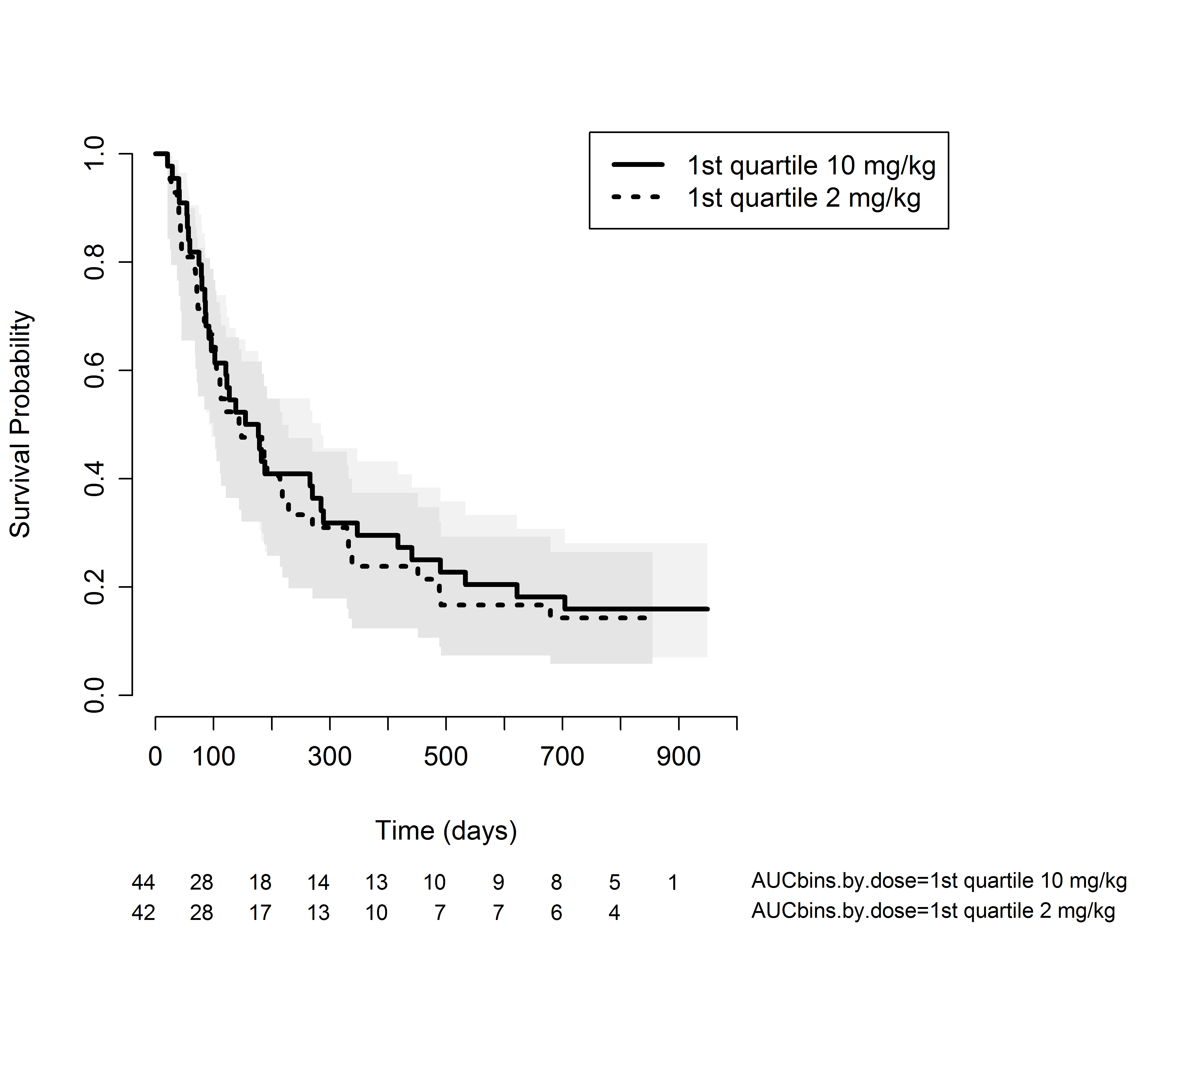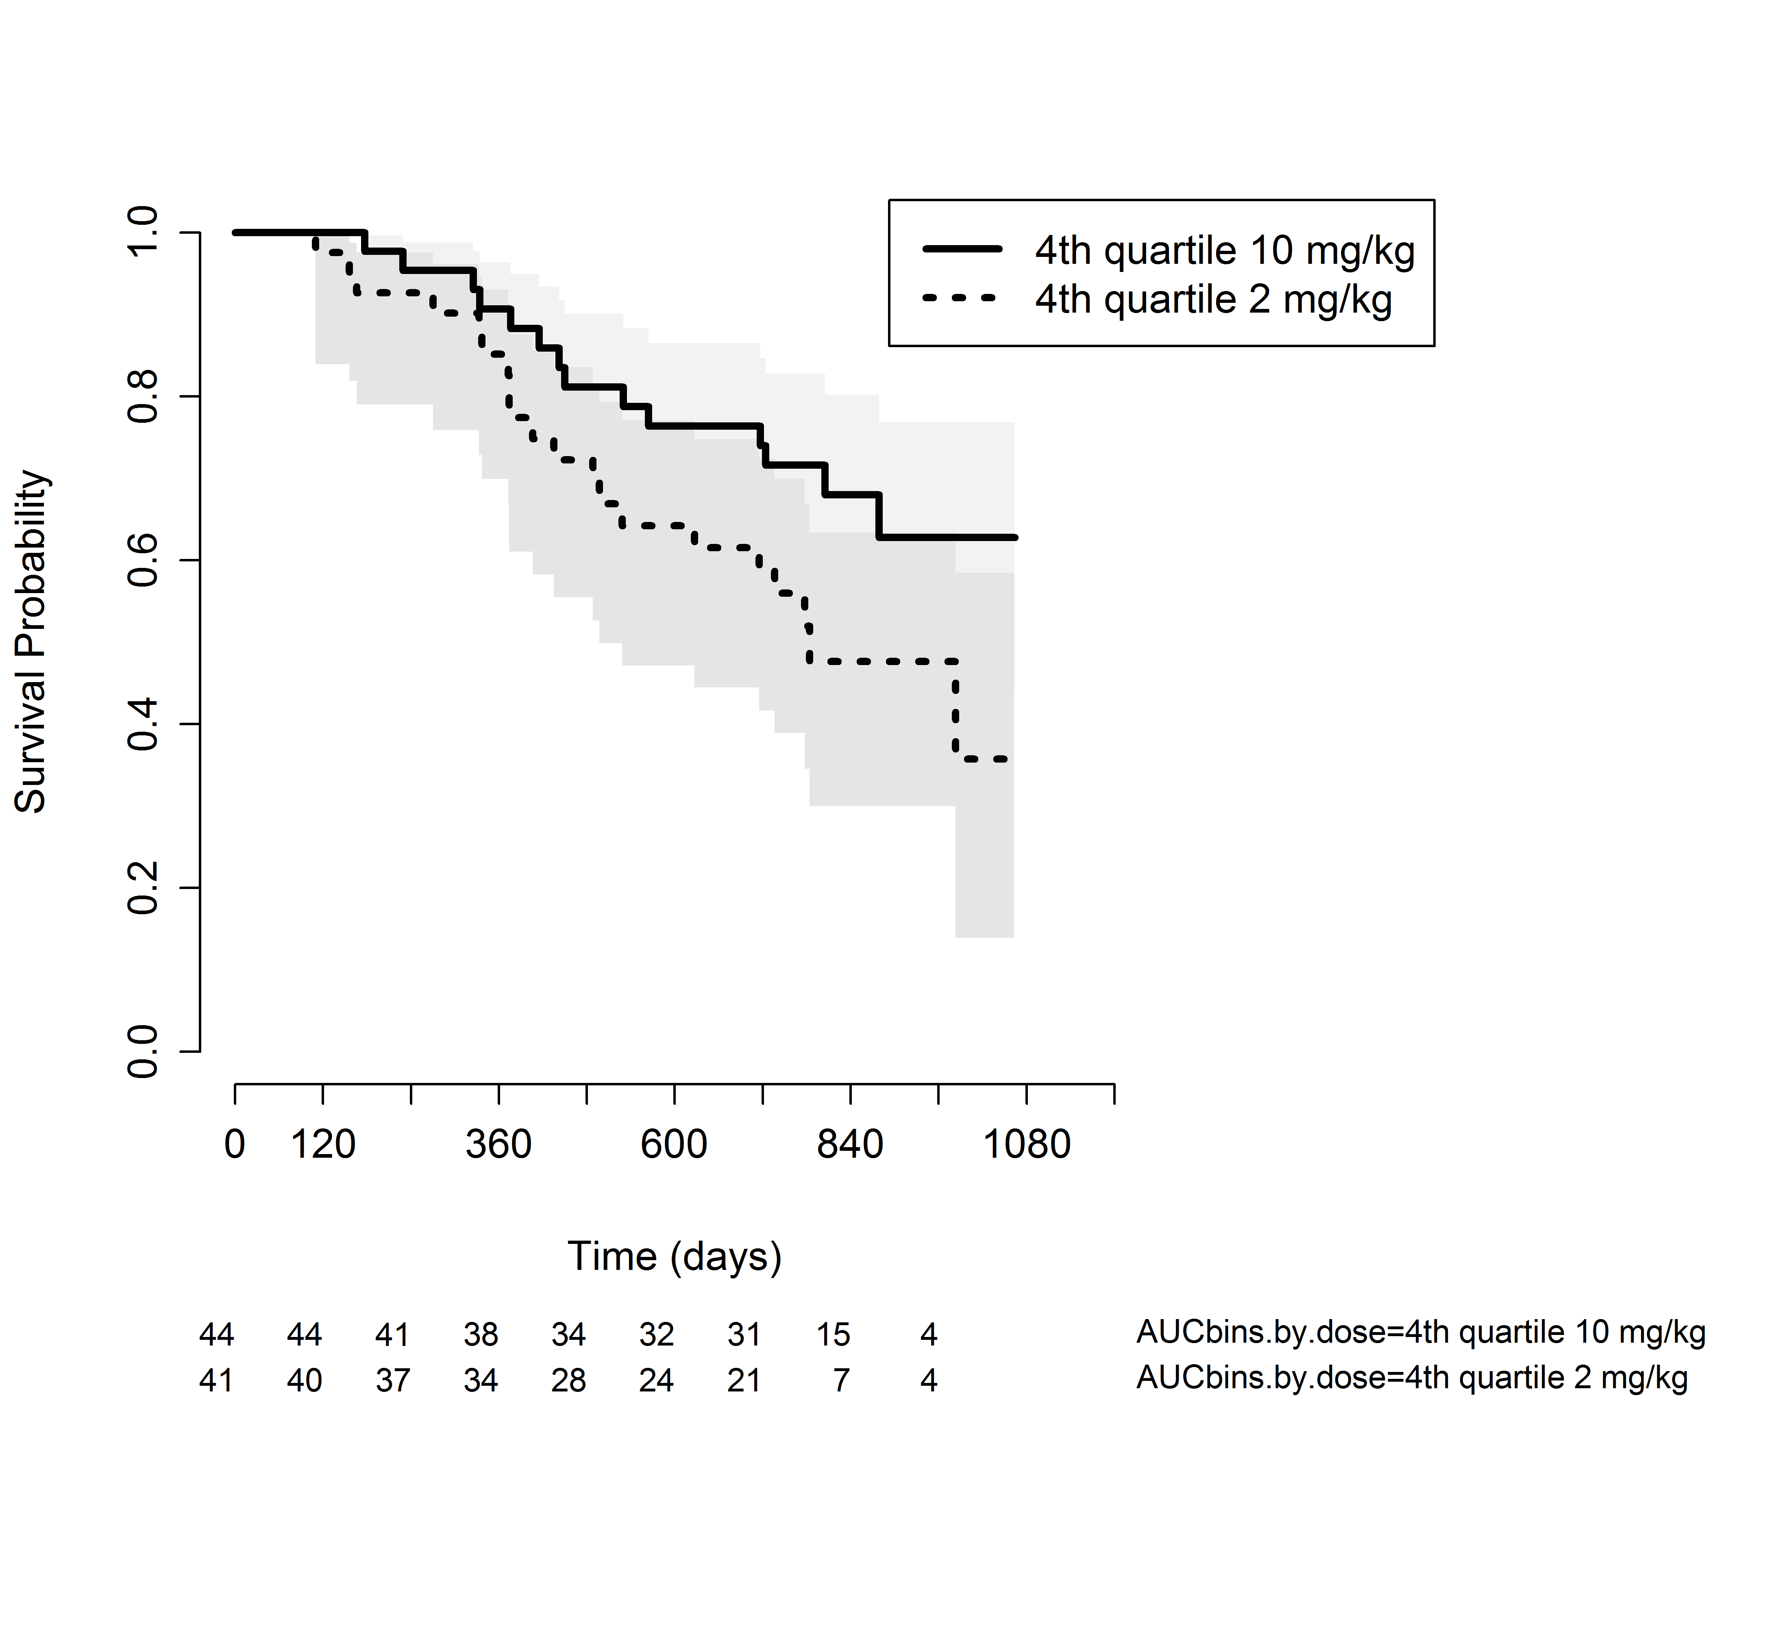
C D
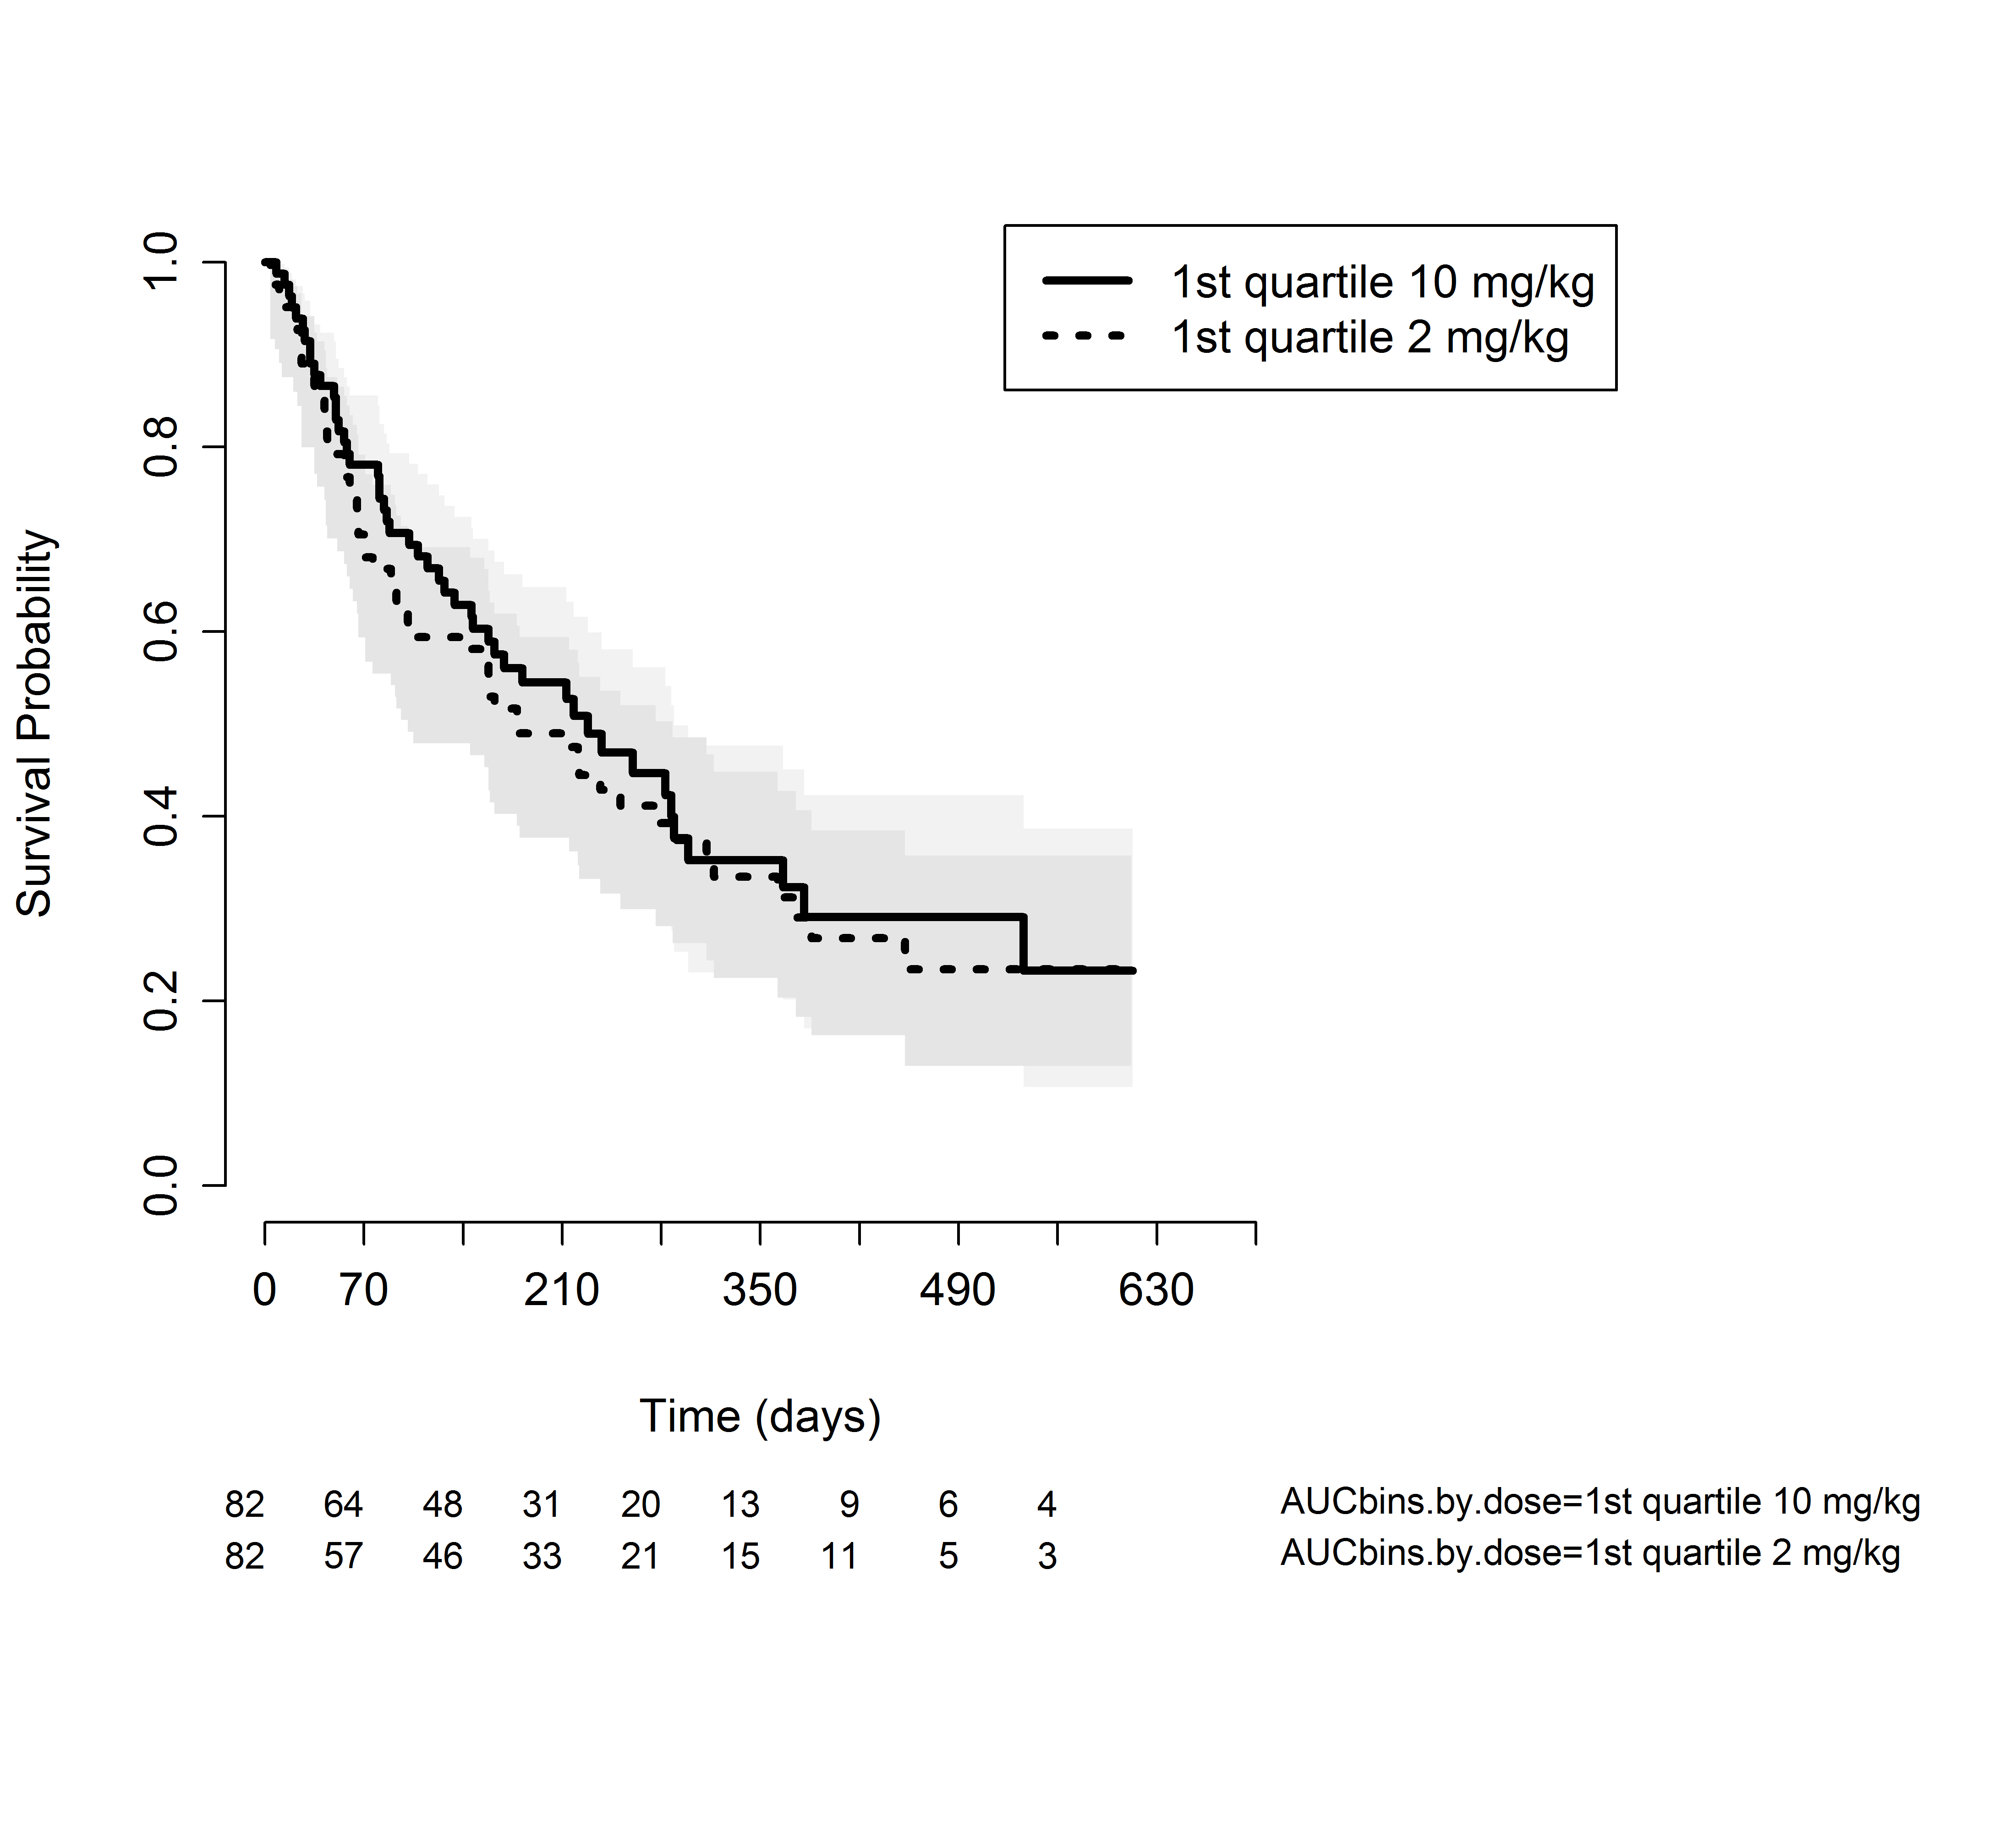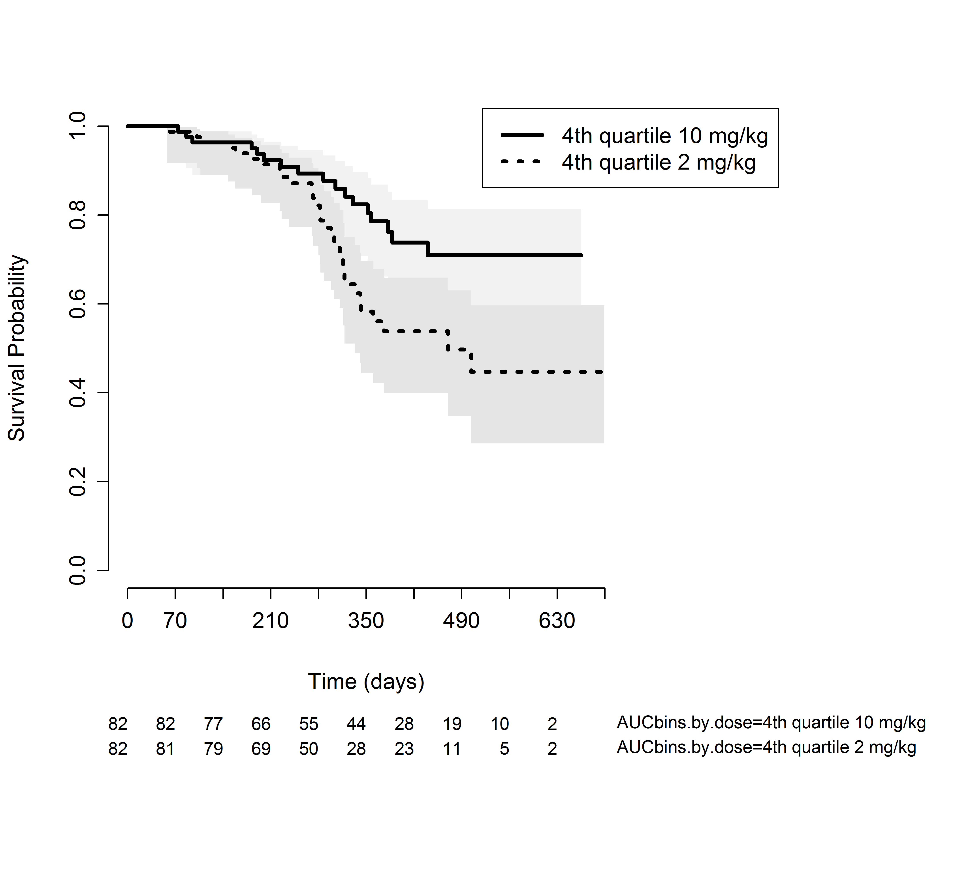

Fig S4. Kaplan-Meier plots of OS by all CL₀ quartiles in KEYNOTE-002 (melanoma; left) and KEYNOTE-010 (previously-treated NSCLC; right) using the complete case datasets.
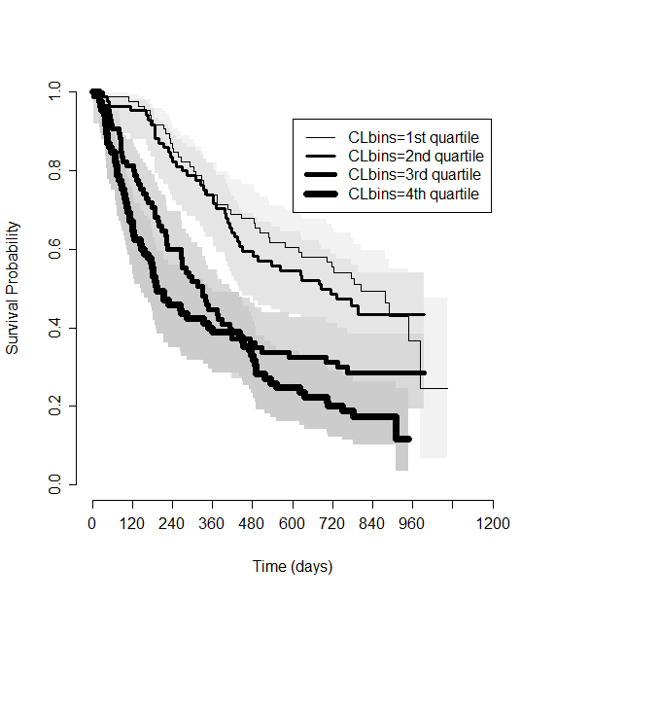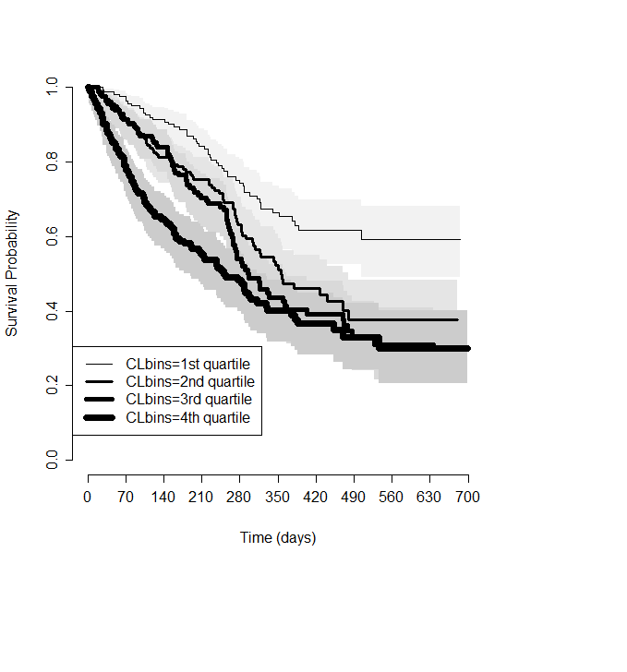

Fig S5. Kaplan-Meier plots of OS by baseline clearance (CL₀) quartiles in advanced, previously-untreated NSCLC with PD-L1 expression at least 50 percent. Pembrolizumab administered at 200 mg Q3W (KEYNOTE-024; n=152). Subjects with at least one available PK measurement were included.

Fig S6. Forest plot of Docetaxel-treated NSCLC Cox proportional hazards model-estimated overall survival hazard ratios (n=249). Complete case dataset was used.

Supplementary Tables
Supplementary Table S1. Source Profile of PK - Overall Survival Analysis Datasets (KEYNOTE-002 and -010) Used in Multivariate Cox Models.
 | KN002 (Melanoma) |  |  |  | KN010 (previously-treated NSCLC)
Screened, n = | 1107 |  |  |  | 2699
 | Investigator-choice Chemotherapy | Pembrolizumab 10 mg/kg Q3W | Pembrolizumab 2 mg/kg Q3W | Total | Docetaxel 75 mg/m² Q3W | Pembrolizumab 10 mg/kg Q3W | Pembrolizumab 2 mg/kg Q3W | Total
Randomized (non-missing allocation number) | 179 | 181 | 180 | 540 | 343 | 346 | 345 | 1034
Treated on Study | 171 | 179 | 178 | 528 | 309 | 343 | 339 | 991
With ≥ 1 pembrolizumab PK measurement | 0 | 175 | 165 | 340 | 0 | 326 | 326 | 652
Complete Case (no missing covariates)* | NA | 104 | 107 | 211 | 249 | 268 | 269 | 786

*See Methods for complete list of covariates considered per study population. NA = data beyond scope of current analyses

Supplementary Table S2. Demographics and Baseline Characteristics for Subjects with ≥ 1 Pembrolizumab PK Measurement (KEYNOTE-010/-024 and -002).
 | KEYNOTE-010;  Advanced, Previously-treated NSCLC |  | KEYNOTE-024;  Advanced, Previously-untreated (first-line) NSCLC | KEYNOTE-002;  Advanced melanoma
Characteristic | Pembrolizumab  (n = 652), No. (%) | Docetaxel  (n = 309), No. (%) | Pembrolizumab  (n = 152), No. (%) | Pembrolizumab  (n = 340), No. (%)
Age, year  Median  Range | 63  (20 – 88) | 62  (34 – 82) | 64  (33 – 90) | 62  (15 – 89)
Gender  Male  Female | 397 (61%)  255 (39%) | 191 (62%)  118 (38%) | 90 (59%)  62 (41%) | 205 (60%)  135 (40%)
Stage  I  II  III  IV | 2 (<1%)  1 (<1%)  52 (8%)  597 (92%) | 1 (<1%)  0 (0%)  28 (9%)  280 (91%) | 0 (0%)  0 (0%)  1 (<1%)  151 (>99%) | 0 (0%)  0 (0%)  4 (1%)  336 (99%)
ECOG  0  1 | 224 (34%)  428 (66%) | 102 (33%)  207 (67%) | 53 (35%)  99 (65%) | 192 (56%)  146 (43%)
Histology  Squamous  Non-squamous  Other/Unknown | 148 (23%)  474 (73%)  30 (5%) | 62 (20%)  222 (72%)  25 (8%) | 29 (19%)  123 (81%)  0 (0%) | N/A
EGFR status  Mutant  Wild-type  Unknown/Missing | 58 (9%)  549 (84%)  45 (7%) | 22 (7%)  269 (87%)  18 (6%) | 0 (0%)  138 (91%)  14 (8%) | N/A
BRAF mutation  Yes  No | N/A | N/A | N/A | 80 (24%)  260 (76%)
Region  East Asia  Not East Asia | 141 (22%)  511 (78%) | 66 (21%)  243 (79%) | 24 (16%)  128 (84%) | 4 (1%)  336 (99%)
Albumin, g/L  Median  Range | 40  (18.5 – 52) | 39  (19 – 51) | 38  (23 – 53) | 39  (19 – 79)
Platelet, billion/L  Median  Range | 276  (86 – 636) | 285  (106 – 789) | 313  (122 – 961) | 259  (101 – 735)
LDH, mkat/L  Median  Range | 3.94  (0.10 – 56.2) | 3.90  (1.65 – 23.8) | NA | 4.88  (1.10 – 62.4)
Abbreviations: ECOG, Eastern Cooperative Oncology Group; LDH, lactate dehydrogenase; NSCLC, non-small cell lung cancer
Supplementary Table S3. Comparison of Univariate HR Results using Baseline Clearance from Time-dependent PK Model Versus a Steady-state Clearance from a Static PK Model Shows the Choice of Exposure Interval is Not Expected to Impact Rank Order of Exposure Estimates and that a Modest, Time-dependent Change in Pembrolizumab Clearance Does Not Meaningfully Alter Interpretations Described in this Study.

 | KEYNOTE-002;  Advanced melanoma |  | KEYNOTE-010;  Advanced, Previously-treated NSCLC
 | Baseline CL (CL₀) from Time-dependent Population PK Model | Steady-state CL (CL_{ss}) from Static Population PK Model | Baseline CL (CL₀) from Time-dependent Population PK Model | Steady-state CL (CL_{ss}) from Static Population PK Model
Unadjusted Clearance HR  (95% CI for HR) | 2.56  (1.72-3.80) | 2.55  (1.79-3.63) | 2.64  (1.94-3.57) | 4.32  (3.12-5.99)

Supplementary Table S4. Protocol-specified Pharmacokinetic Sampling Strategy
Protocol | Peak end-of-infusion and pre-dose trough samples* | Additional pre-dose trough samples* | Additional PK samples
KEYNOTE-002 | Cycles 1 and 6 | Cycles 2, 3, 8, 12 and 16, with subsequent trough samples obtained approximately every 8 cycles (~6 months) thereafter | One sample between 1-4 days (24 to 96 hours) after Cycle 2 dosing
KEYNOTE-010 | Cycles 1, 2, and 6 | Cycles 3, 8, 13 and 17, with subsequent trough samples obtained approximately every 8 cycles (~6 months) thereafter | 1-4 days (24 to 96 hours) after Cycle 2 dosing
KEYNOTE-024 | Cycle 1 | Cycles 2, 4, 8 and every 8 cycles (~6 months) thereafter plus at 1, 3 and 6 months after last dose | 3-7 days (72 to 168 hours) after Cycle 1 dosing
*Peak end-of-infusion samples acquired within 30 minutes after the end of the infusion.
*All trough samples drawn within 24 hours before pembrolizumab administration.

