Supplementary Data

Supplementary Table 1 – Effect of varying RT regimen and dose on survival when combined with anti PD-L1 in orthotopic Balb/c mice harboring LY2 tumors.

Survival (days) | 10Gy+IgG | 10Gy+αPD-L1 | 8Gyx3+IgG | 8Gyx3+αPD-L1
Median | 26 | 33 | 34 | 38
Range | 21-39 | 21-39 | 29-35 | 38-43

Supplementary Figure 1 – Cibersort analysis of RNAseq data obtained from orthotopic LY2, MOC1 and MOC2 tumors.

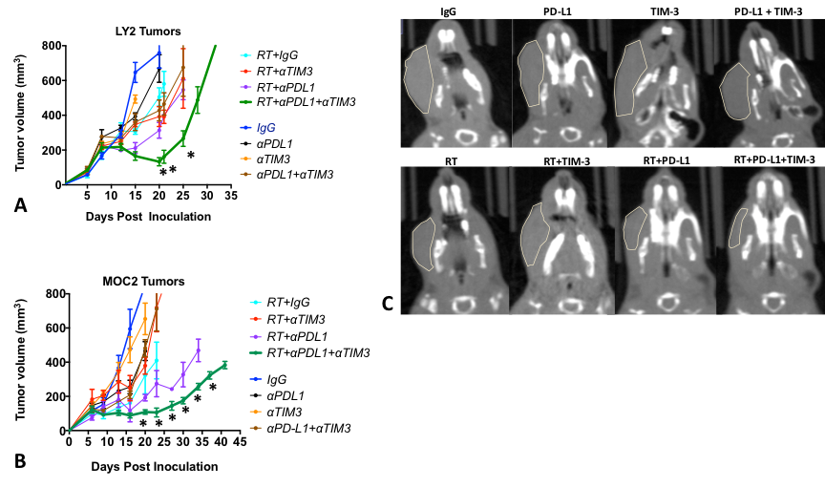

Supplementary Figure 2 – Tumor growth curves for (A) LY2 and (B) MOC2 tumors treated with anti-PD-L1 and anti-TIM-3 alone and in combination with RT. Asterisks depict points at which tumor volume was significant (p<0.05) in the RT+anti-PD-L1+anti-TIM-3 when compared to RT+anti-PD-L1 and RT+anti-TIM-3. Two-way ANOVA was performed to assess significance. (C) Representative CT scans of LY2 mice on the last day on which all mice were alive (Day 20). Yellow contours depict tumor volume.

Supplementary Figure 3 – Analysis of relative abundance of mRNA transcript levels of genes involved in Treg differentiation and homing and effector T cell function from LY2 tumors harvested 1-week and 3-weeks after initiation of RT and anti-PD-L1 treatment. Gene expression of the respective genes was normalized to beta-actin and to expression from untreated control tumors. Data is represented as fold-change relative to expression in untreated tumors and bars represent SEM of 2-3 independent samples.

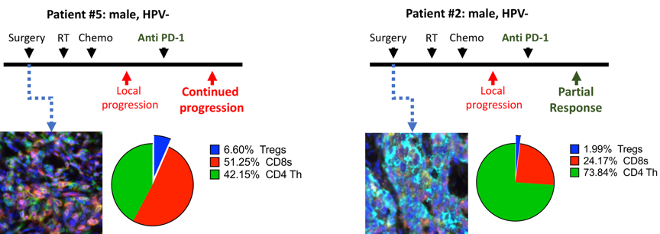
Supplementary Figure 4 – Analysis of patient samples with the Vectra immuno-fluorescence platform. Two patients with similar disease course but different outcomes were selected for analysis of immune cell profile (CD3, CD8, CD4, FoxP3, DAPI). Proportion of positively stained immune cells relative to all cells is depicted in pie charts.

Supplementary Table 2A – Effect of varying combinations of RT and dual immune checkpoint on survival in LY2 mice.

Survival  (days) | IgG | αPD-L1 | αTim3 | αPDL1+  αTim3 | RT+  IgG | RT+  αPD-L1 | RT+  αTim3 | RT+  αPDL1+αTim3
Median | 21 | 20 | 20 | 26 | 26 | 33 | 28 | 38
Range | 18-33 | 19-28 | 19-28 | 20-33 | 21-39 | 21-39 | 20-35 | 33-60

Supplementary Table 2B – Effect of varying combinations of RT and dual immune checkpoint on survival in MOC2 mice.
Survival  (days) | IgG | αPD-L1 | αTim3 | αPDL1+  αTim3 | RT+  IgG | RT+  αPD-L1 | RT+  αTim3 | RT+  αPDL1+αTim3
Median | 22 | 23 | 23 | 23 | 36 | 42.5 | 30 | 50
Range | 16-27 | 20-27 | 20-27 | 21-27 | 23-36 | 34-49 | 16-44 | 33-55

