Figure S1. Flow chart of the drug substance (N-sucDf-AMG211) manufacturing process and drug product (⁸⁹Zr-AMG211) formulation and filling process.

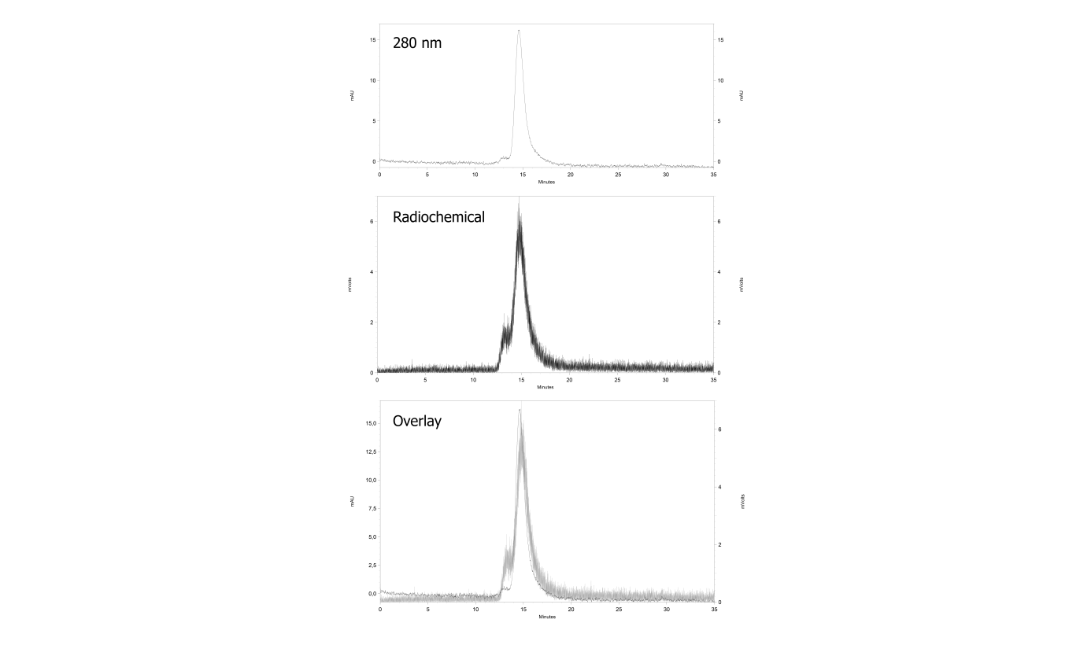 Figure S2. Quality control of ⁸⁹Zr-AMG211. Representative size exclusion high performance liquid chromatography chromatogram of ⁸⁹Zr-AMG211 with 280 nm signal (top panel), radiochemical signal (middle panel) and the overlay (lower panel).

Figure S3. Immunoreactivity of ⁸⁹Zr-AMG211. A) Representative competition assay using an effective N-sucDf:AMG 211 ratio of 2:1. Curve fit with 95% confidence interval is visualized. B) Immunoreactivity towards CEA of different ratios N-sucDf:AMG 211. Data are mean ± SD.

Figure S4. Membrane binding and internalization of ⁸⁹Zr-AMG211 after CEA binding on LS174T cells (n = 3). Membrane bound and internalized ⁸⁹Zr-AMG211 are expressed as percentage of initial cell associated activity. Data are mean ± SD.
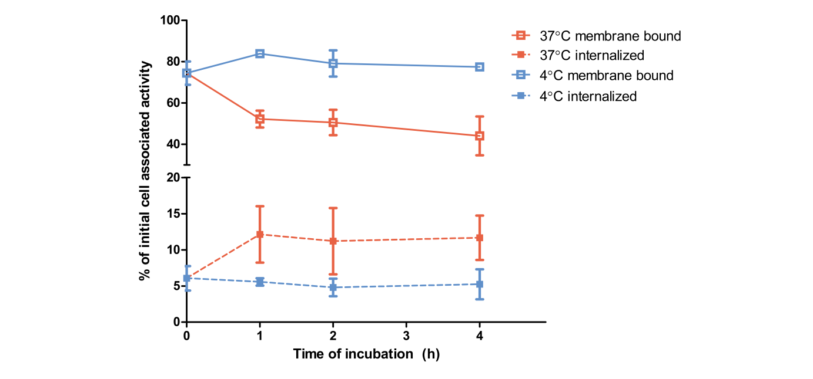
Figure S5. Expression of CEA on LS174T, BT474 and HL-60 cell lines (n = 3). Membrane expression is expressed as percentage of LS174T signal. Data are mean ± SD.
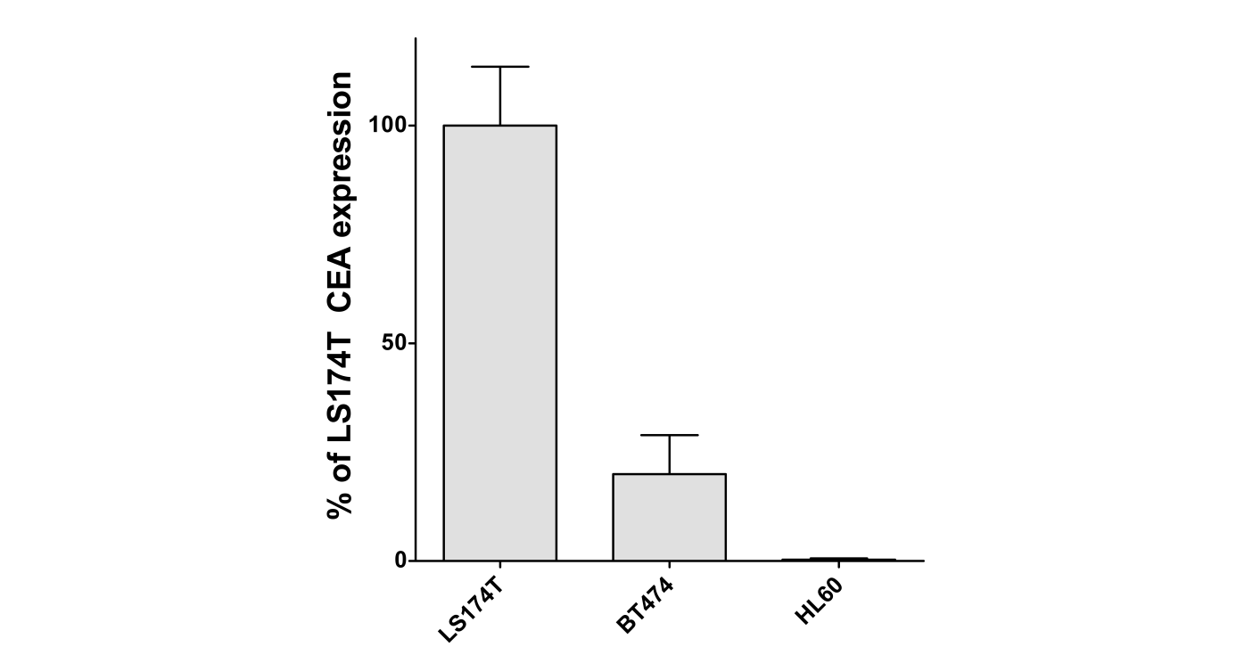

Table S1. GMP manufacturing of N-sucDf-AMG211 and ⁸⁹Zr-AMG211. Release criteria are fulfilled for batch 1, 2, and 3. In addition stability are shown for N-sucDf-AMG211 stored at -80°C for 6 months, all quality criteria are still met.
Test | Specification | Batch 1 | Batch 2 | Batch 3 | Batch 3  After 6M at -80°C
N-sucDf-AMG211
Appearance | Colourless to light yellow | Colourless | Colourless | Colourless | Colourless
Conjugation ratio  of N-sucDf: AMG211 | 1.5-2.5 | 1.6 | 1.7 | 1.5 | Not applicable
Impurities of  N-sucDf-AMG211 after conjugation | ≤ 5% | 2% | 3% | 2% | Not applicable
Filter integrity | ≤ 20% | 15% | 14% | 19% | Not applicable
Impurities of  N-sucDf-AMG211 end product | ≤ 5% | 2% | 3% | 3% | 3%
Signal reduction at 430 nm | > 40% reduced | 78% | 68% | 80% | 84%
Concentration | 1.5-2.5 mg/ml | 1.59 mg/mL | 1.80 mg/mL | 1.65 mg/mL | 1.73 mg/mL
pH | pH 4.0 - 6.0 | 5.6 | 5.7 | 5.9 | 5.8
Endotoxins: | ≤ 2.5 EU/ml | 0.687 EU/mL | 0.659 EU/mL | 0.542 EU/mL | Not determined
Sterility: | Sterile | Sterile | Sterile | Sterile | Not determined
Residual solvents (ACN) | < 410 ppm | < 100 ppm | < 100 ppm | < 100 ppm | Not determined
Immunoreactivity towards CD3 | Preserved* | Preserved | Preserved | Preserved | Preserved
⁸⁹Zr-AMG211
Appearance | Colourless to light yellow | Colourless | Colourless | Colourless | Colourless
Radiochemical purity pre-purification | ≥ 70% | 94.0% | 92.5% | 91.4% | 93.4%
Radiochemical purity post-purification | ≥ 95% | 96.8% | 98.1% | 97.6% | 98.2%
pH | pH 5.0-8.0 | 6.1 | 6.2 | 6.1 | 6.1
Filter integrity | ≤ 20% | 19% | 14% | 14% | 16%
Impurities of  ⁸⁹Zr-AMG211 | ≤ 5% | 1.5% | 2.4% | Not detectable | 2.2%
Bacterial endotoxins | ≤ 2.5 EU/mL | 0.450 EU/mL | 0.412 EU/mL | 0.532 EU/mL | Not determined
Sterility | Sterile | Sterile | Sterile | Sterile | Not determined
Immunoreactivity towards CEA | Preserved* | Preserved | Preserved | Preserved | Preserved
* Preserved immunoreactivity indicates more than 50% binding compared to unconjugated for CD3 and more than 50% immunoreactivity for CEA

