S4. Supplementary Results: Prior ADT Treatment

Prior ADT treatment was not associated with greater increases in PSADT in any treatment arm. (Supplementary Figure S4.1)

Supplementary Table S4.1 PSADT Change from Baseline, in Months, by SOD2 Genotype and Treatment Arm in ADT Naïve Patients

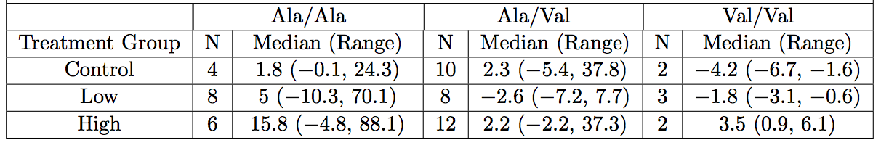

Supplementary Table S4.2 PSADT Change from Baseline, in Months, by SOD2 Genotype and Treatment Arm in Patients Who had Prior ADT Treatment

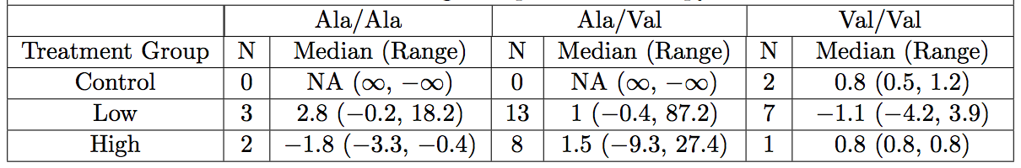

Figure Legend

Supplementary Figure S4.1 PSADT Change from Baseline in Months by MPX Treatment Group and Prior ADT Treatment

