Supplemental Figure 1. Assessment of the binding characteristics and cynomolgus monkey cross-reactivity of CD20-TCB.
Median fluorescence intensities (MFI) for binding of CD20-TCB to (A) B cells, (B) primary CD4+ and (C) CD8+ T-cells freshly isolated from human PBMCs, human (black squares) and cynomolgus monkey (open squares); binding of CD20-TCB to (D) human Jurkat T-cells, (E) cynomolgus monkey HSC-F T-cells, and (F) human mantle cell lymphoma tumor line Z-138, as measured by flow cytometry.
Supplemental Figure 2. Tumor cell lysis mediated by different CD20-targeting TCB antibodies.
Tumor cell lysis mediated by (A) three different formats of CD20-TCB based on obinutuzumab (CD20 binder), and (B) CD20-TCB (2:1 format, bordeaux curve) compared to other CD20-targeting T-cell bispecific re-synthesized in house using the available patent sequence (VH-A-1242-1250; WO2014/047231 A1), (black curve). Tumor lysis was assessed by measuring LDH release after 20–24 h of incubation of human PBMCs with tumor targets and indicated CD20-TCBs (E:T = 5:1). Upper and lower panel set correspond to two different donors (Do2 and Do 3; the results using the third donor are displayed in Figure 1A & B).
Supplemental Figure 3. T-cell and B-cell counts along with E:T ratio upon CD20-TCB treatment of primary bone marrow aspirates from patients with lymphoma and leukemia.
(A) E:T ratio, CD3+ T-cell and CD20+ B cell counts determined by flow cytometry after incubation of human bone marrow aspirates from lymphoma and leukemia patients with CD20-TCB. The average of 3-10 patients of a total of 17 patients/time point is shown. (B) Mean fluorescence intensity (MFI) of CD25 or PD-1 expression on T-cells upon incubation of human bone marrow aspirates from lymphoma and leukemia patient samples with CD20-TCB.
Supplemental Figure 4. Quantification of interactions between T-cells and tumor cells from live imaging experiments and kinetic analysis of T-cell activation and exhaustion marker expression.
(A) Quantification of interaction between T-cells and tumor cells in terms of T-cell speed, Tumor/T-cell Synapse area, and CD20-TCB fluorescence intensity at synapse between tumor cells and T-cells, normalized over the untargeted TCB control compared over a period of time of 9 hours. Student T statistical test. **** p<0.0001. (B) Kinetic analysis T-cell activation (ICOS, Ox40) and exhaustion (PD-1 and Lag-3) marker expression on CD4 and CD8 T-cell subsets as detected by flow cytometry after incubation of human PBMC with tumor targets cells Z-138, (E:T = 5:1) and CD20-TCB (1 nM) for the indicated time points. Graphs represent the % fold increase in MFI of selected markers over time as compared to controls. Averages of 3 donors are shown.
Supplemental Figure 5. Secretion of cytokines, cytotoxic granules and T-cell proliferation upon tumor lysis.
(A) Analysis of cytotoxic granules (GzB) and cytokines released by activated T-cell following tumor lysis as assessed by CBA (Cytokine Bead Array) after 20–23 h incubation of human PBMC with tumor target-cells Z-138 (E:T 5:1 or 6:1) and increasing concentrations of CD20-TCB. Triplicates of three donors are shown. (B) Analysis of CD4+ and CD8+ T-cell proliferation following tumor killing as determined by flow cytometry (CFSE dye dilution) after 6 days incubation of human PBMC with different tumor targets expressing high, medium and low CD20 levels (740000, 217000, 13000 ABCs as determined by QSC) in the presence of increasing concentrations of CD20-TCB.

Supplemental Figure 6. Assessment of the cytokine-mediated endothelial cell activation.
(A) Upregulation of E-selectin, ICAM, VCAM on human endothelial cells (HUVEC) in presence of sera derived from CD20-TCB- or obinutuzumab (Gazyva)-treated mice. HUVEC were stimulated for 6 h with pooled sera from mice treated for 24 h with CD20-TCB (0.5mg/kg), obinutuzumab (10 mg/mL) or vehicle, diluted 1:1 with endothelial basal media and adhesion molecules were measured by flow cytometry. Sera from CD20-TCB treated mice upregulated ICAM and VCAM on endothelial cells, whereas the one from obinutuzumab-treated mice did not. Data are representative of 2 independent experiments. (B) High constitutive expression of VLA-4 on T-cells upon CD20-TCB-mediated tumor cell lysis explaining the absence of further VLA-4 upregulation following CD20-TCB treatment. Triplicates of three (VLA-4) donors are shown. (C) Upregulation of ICAM, VCAM, E-selectin on human endothelial cells (HUVEC) treated with conditioned media (CM) from tumor lysis experiments in presence or absence of cytokine-blocking antibodies or corresponding control antibodies identifies TNFα as an important mediator of endothelial activation. Data are representative of 2 independent experiments. Statistical analysis: One-way ANOVA.

Supplemental Figure 7. Characterization of stem cell humanized mice (HSC-NSG) generated in house.
A
B
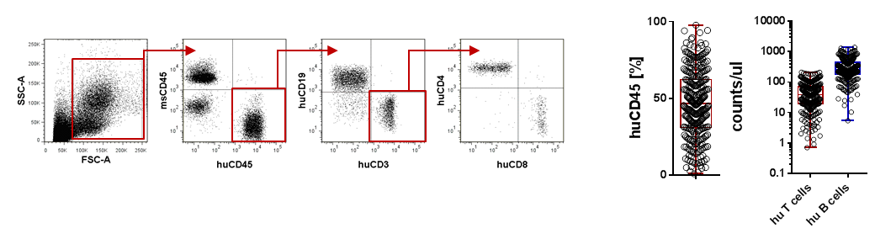
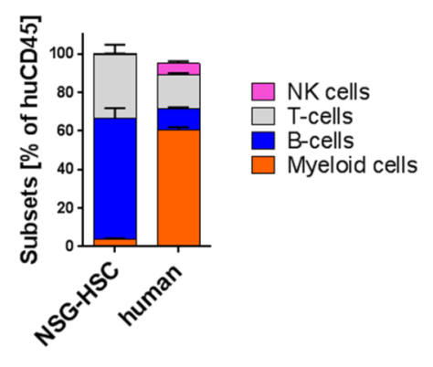

C

A) Flow Cytometry gating strategy for the characterization of human T and B cells in stem cell humanized mice (HSC-NSG) generated in house. B) Engraftment rate defined as human CD45 (huCD45) percentage of total leucocytes, human T cell (huCD3+) counts/ul and human B cell (huCD19+) counts/ul at 15 weeks post HSC injection. C) Characterization of human immune cell subsets in blood by flow cytometry. The percentage of NK cells, T cells, B cells and Myeloid cells among the huCD45+ population was analyzed at week 15 after stem cell injection in Blood of humanized mice and compared to the human blood as a reference. As shown in the graph, mainly human adaptive immune cells (T and B cells) develop in HSC-NSG mice whereas human myeloid and NK cells are very low in frequency.

