Supplementary Materials and Methods

Pathology review and assessment of inter-observer variability
A random sample of 50 DCIS specimens were reviewed by all pathologists to assess the inter-observer agreement. The concordance between the pathologists was around 85% with an interclass correlation coefficient of >0.4 for every characteristic assessed. Subsequently, slides from each included patient were reviewed by one of these pathologists, unaware of case or control status.

Immunohistochemical staining procedure
Immunohistochemical staining of ER, PR, HER2, Ki67, p16, p53, and COX-2 was performed using a Benchmark ULTRA autostainer (Ventana Medical Systems, AZ, USA). For each lesion and for each staining, a 3 µm thick whole slide paraffin section was heated at 75 °C for 28 minutes and deparaffinized in the instrument with EZ prep solution (Ventana Medical Systems). Heat-induced antigen retrieval was carried out using Cell Conditioning 1 (CC1; Ventana Medical Systems) for 64 min at 95 °C. Next, the primary antibody, indicated in Table M1, was applied to the tissue section. Additionally, for the p16 staining signal amplification was performed using the Optiview Amplification kit (Ventana Medical Systems). For the PR staining the slides were additionally incubated with normal antibody diluent (ABB999, Immunologic) to reduce the background signal. Reactions were detected using the UltraView Universal DAB Detection kit (#760-500; Roche) for visualization of ER, PR, and HER2, or the OptiView DAB Detection kit (#760-700; Roche) for visualization of Ki67, p16, p53 and COX-2. Finally, the slides were counterstained with Hematoxylin II and Bluing Reagent (Ventana Medical Systems).

Table M1. Primary antibody sources and dilutions used in this study

Antigen | Clone | Dilution | Manufacturer
ER | SP1 | Ready-to-use | Ventana Medical Systems
PR | 1E2 | Ready-to-use | Ventana Medical Systems
HER2 | 4B5 | Ready-to-use | Ventana Medical Systems
Ki67 | MIB1 | 1/250 | DAKO
p16 | JC8 | 1/800 | Santa Cruz
p53 | DO-7 | 1/7000 | DAKO
COX-2 | CX294 | 1/100 | DAKO
ER, estrogen receptor; PR, progesteron receptor; HER2, human epidermal growth factor receptor 2; p16, cyclin-dependent kinase inhibitor 2A; COX-2, cyclooxygenase-2.

Assessment of immunohistochemistry and inter-observer variability
IHC stained slides were scanned using an Aperio AT2 Slide Scanner (Leica Biosystems) and subsequently the digital images were scored by a team of 7 observers, including 5 pathologists; all were blinded of clinical outcome. All 7 observers scored ER, PR, HER2, Ki67, p16 and p53 stains. A random sample of 20 DCIS specimens were scored by all observes to assess the inter-observer agreement. The concordance between the observers was around 97% with an interclass correlation coefficient (ICC) of >0.8 for ER, PR, HER2, and p53, and an ICC of 0.7 for p16. Ki67 was excluded for further scoring because of unreliable staining results. COX-2 stains were scored by two observers (LLV, CB). To assess the inter-observer agreement, a random sample of 20 DCIS specimens were scored by both observes. With this, COX-2 reached a concordance between the two observers of 94% with a k statistic of 0.7. Consequently, the remaining ER, PR, HER2, p16, and p53 stains were distributed over all observers, and the remaining COX-2 stains were distributed over two observers (LLV, CB), in which each patient was scored by one observer.

Immunohistochemical scoring criteria
Representative examples of each immunohistochemical marker and their corresponding staining categories can be found in Figure M1. For ER and PR, the percentage of luminal epithelial cells that showed staining of any intensity was assessed, and were considered positive when at least 10% of the cells nuclei showed staining. Similarly, p53 positive staining was assessed based on the percentage of nuclei that showed moderate to strong staining. p53 protein accumulation was considered when 70% or more nuclei showed moderate to strong staining.
HER2 overexpression was analyzed according to the American Society of Clinical Oncology and College of American Pathologists (ASCO-CAP) 2013 recommendations: HER2-positive staining was considered positive if circumferential membrane staining was complete, intense, and within more than 10% of tumor cells (HER2 3+), or if circumferential membrane staining was incomplete and/or weak/moderate and within more than 10% of tumor cells (HER2 2+) for which the overexpression could be confirmed by HER2 SISH. HER2 was considered negative when incomplete membrane staining was faint/barely visible and within >10% of the tumor cells (HER2 1+) or when no staining was observed (HER2 0).¹³
For the assessment of p16 a semi-quantitative approach was used in which H-scores were generated by multiplying the staining intensity (0 = no staining, 1 = weak, 2 = moderate, 3 = intense) by the percentage of positive cells (0-100%). H-scores below or equal to 100 were categorized as score 1, H-scores between 101-200 were categorized as score 2, H-scores between 201-300 were categorized as score 3. Score 1 was considered low p16 expression and score 2 and 3 were considered high p16 expression.
COX-2 expression was evaluated according to the following criteria (adapted from Ristimäki et al.¹⁴): 1 = weak diffuse cytoplasmic staining that may contain moderate to strong granular cytoplasmic staining in less than 10% of tumor cells; 2 = moderate to strong granular cytoplasmic staining in 10-90% of the tumor cells; 3 = moderate to strong granular cytoplasmic staining in over 90% of the tumor cells. Score 2 and 3 are considered high expression of COX-2 and score 1 low COX-2 expression.

Figure M1. Representative examples the immunohistochemical markers and their corresponding staining categories

ER
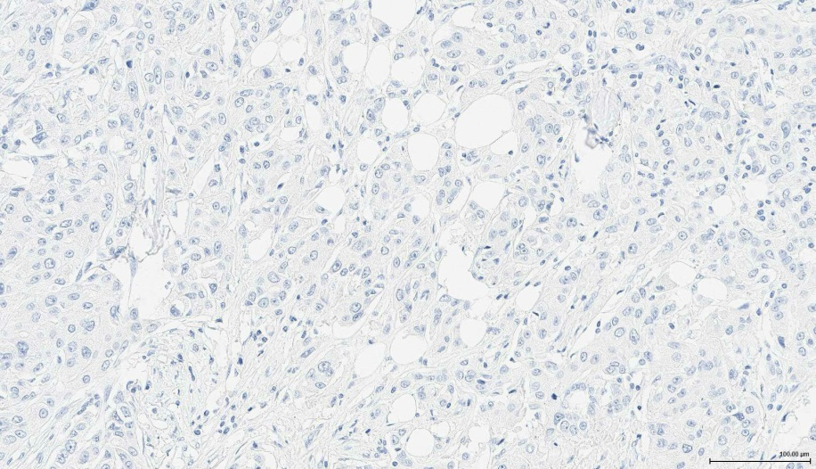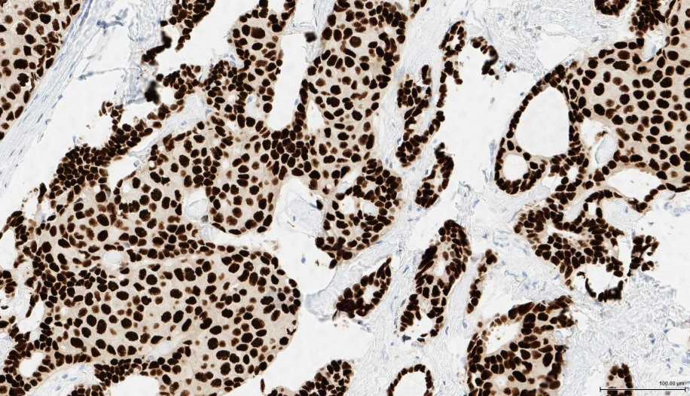
Negative Positive

PR
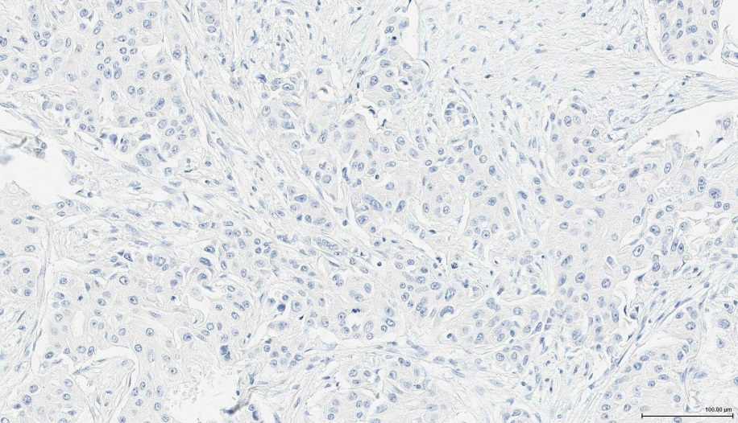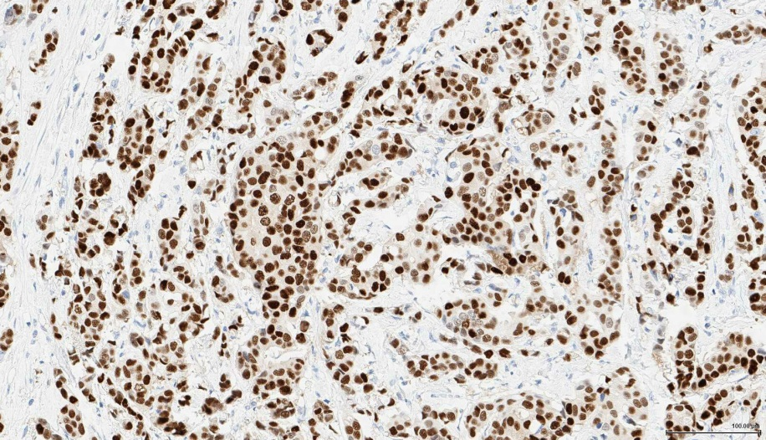
Negative Positive

Her2
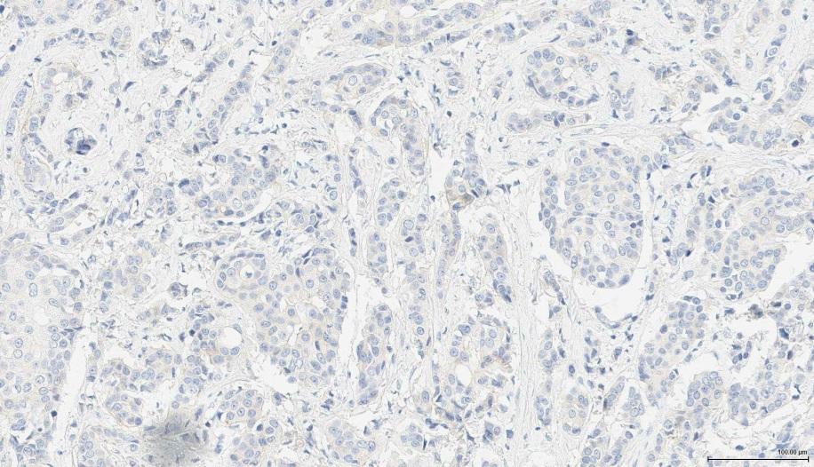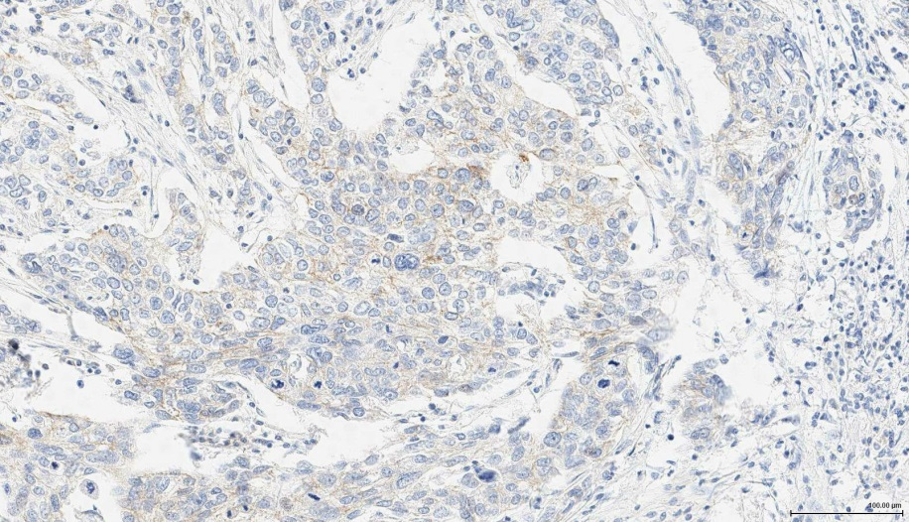
No Staining = 0 Weak Staining = 1

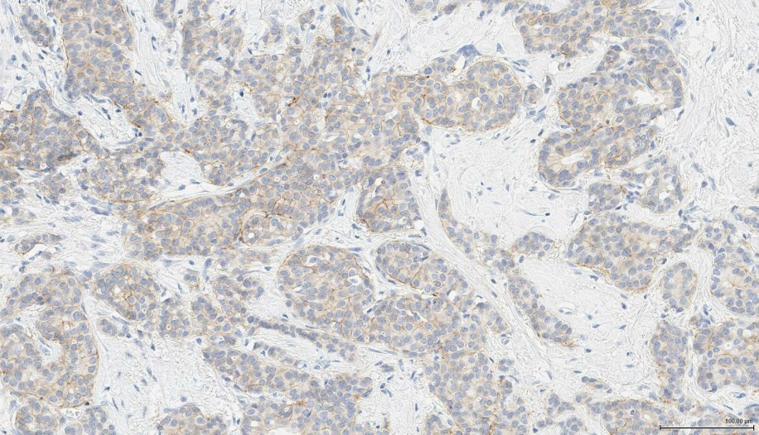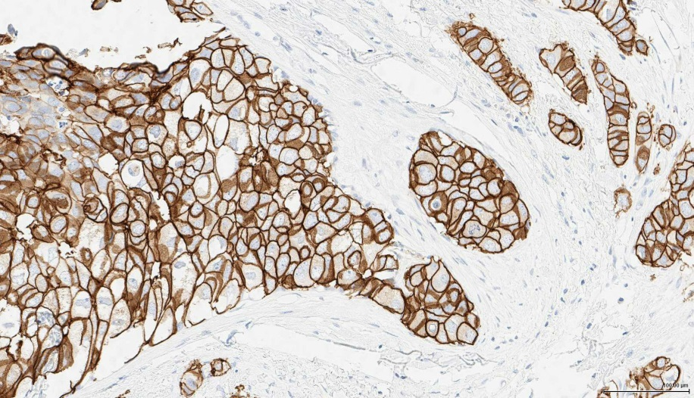
Moderate/Equivocal = 2 Strong Staining = 3

P16
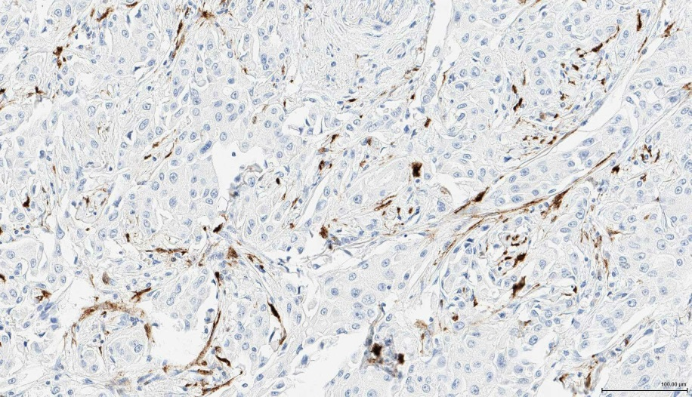
H-score = 1

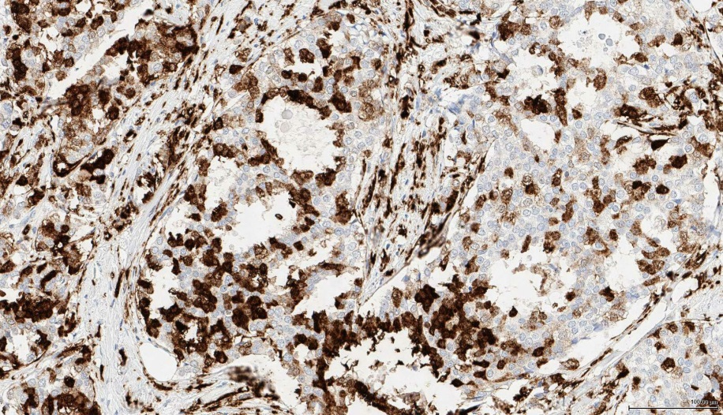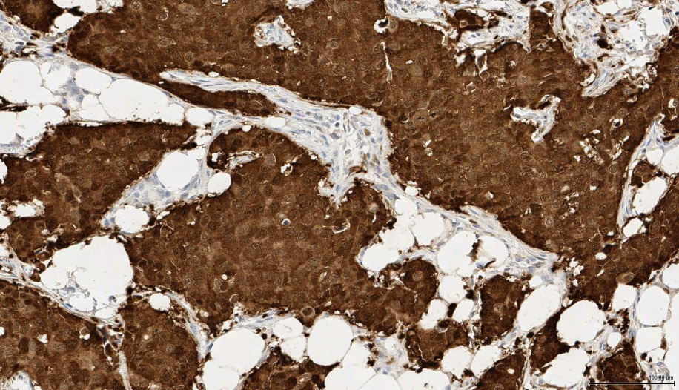
H-score = 2 H-score = 3

P53
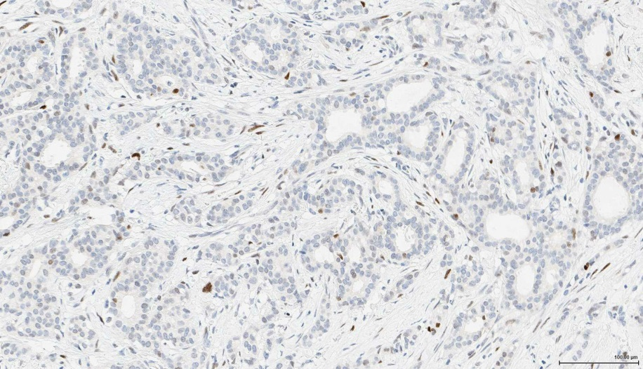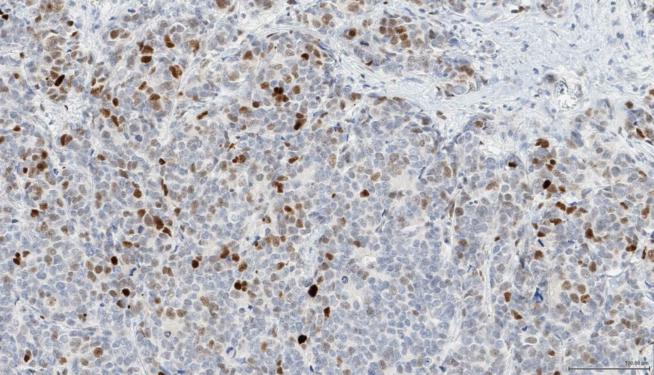
Percentage cells with moderate/strongly stained nuclei; 1-30% Percentage cells with moderate/strongly stained nuclei; 30-70%

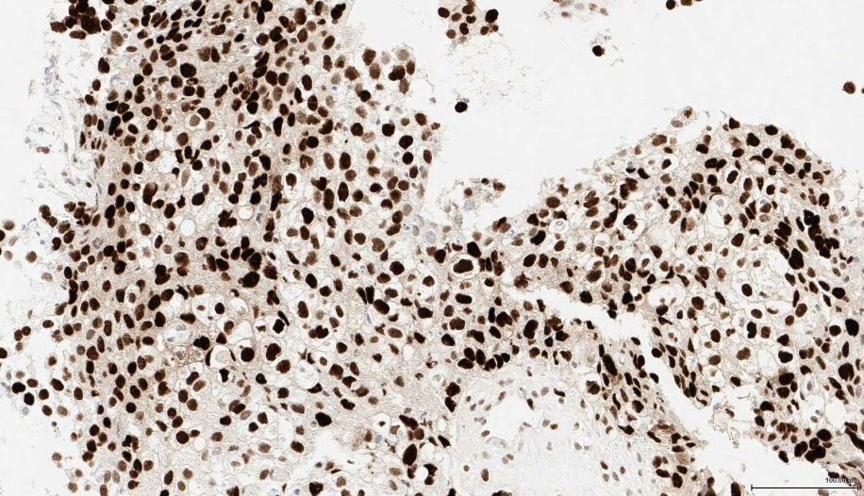
Percentage cells with moderate/strongly stained nuclei; >70%

COX-2
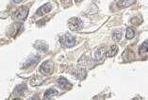
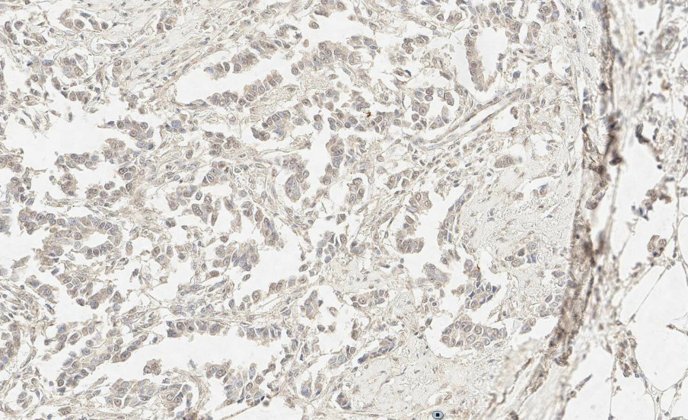
1: Weak diffuse cytoplasmic staining that may contain moderate
to strong granular cytoplasmic staining in less than 10% of tumor
cells

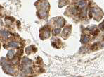
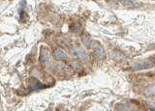
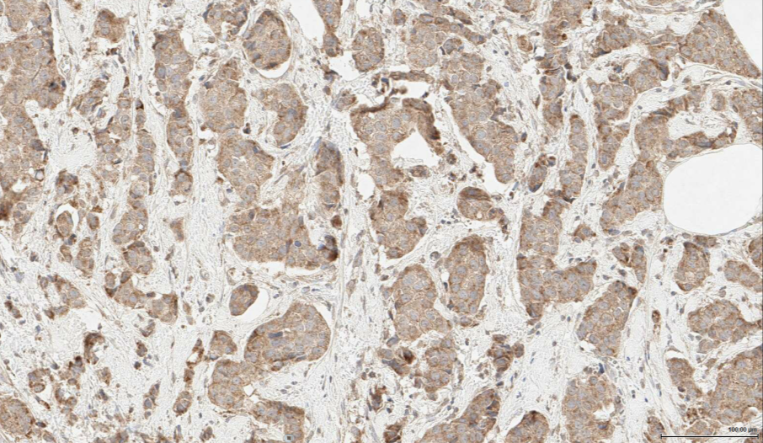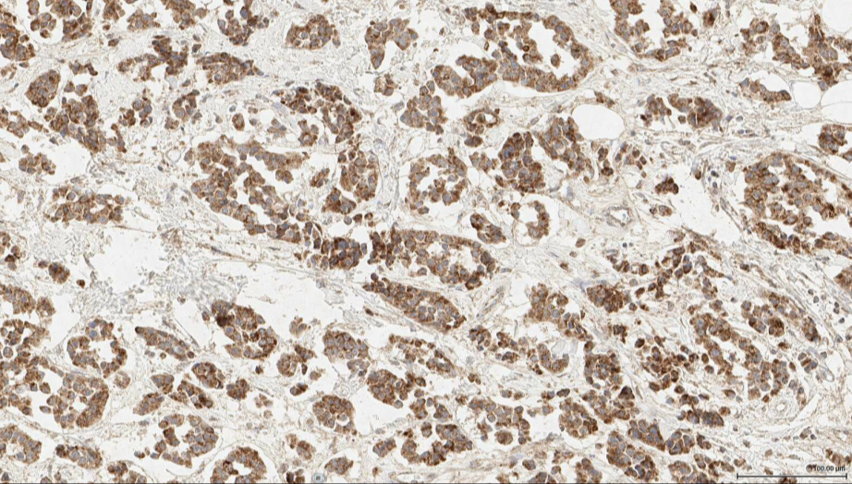
2: Moderate to strong granular cytoplasmic staining in 10-90% 3: Moderate to strong granular cytoplasmic staining in over 90%
of the tumor cells of the tumor cells

