**Supplementary material**

**Supplementary Figure S1.** OAK study simulation algorithm based on early tumor growth inhibition (TGI) data cutoffs. HR, hazard ratio; HRobs, observed HR; KG, growth rate constant; OS, overall survival; OSsim, simulated OS; PI, prediction interval; TS, tumor size.



**Supplementary Figure S2.** TGI model fit in 25 patients taken at random in POPLAR.Bullets: observations (sum of longest diameters of target lesions per RECIST v1.1; in mm); time: in weeks; red lines: individual model predictions; strip: patient numbers.

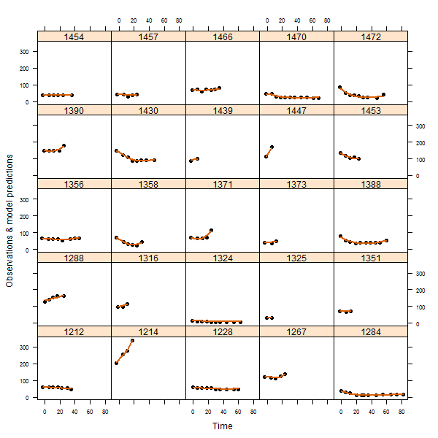

**Supplementary Figure S3.** OS by tertiles of log(KG) in POPLAR. plain and dotted lines: Kaplan-Meier estimations; crosses: censored observed values. KG, growth rate constant.

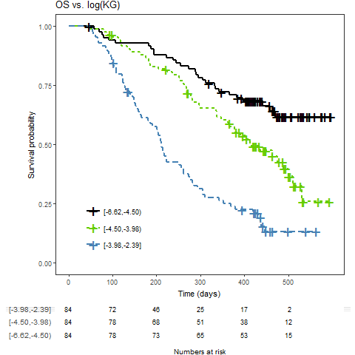

[a, b) Interval notation for log(KG), a is included and b is excluded;

**Supplementary Figure S4.** TGI-OS model prediction of OS distributions in POPLAR. Areas: 95% prediction interval of survival distributions; lines: observed Kaplan-Meier distributions with censored data (crosses).

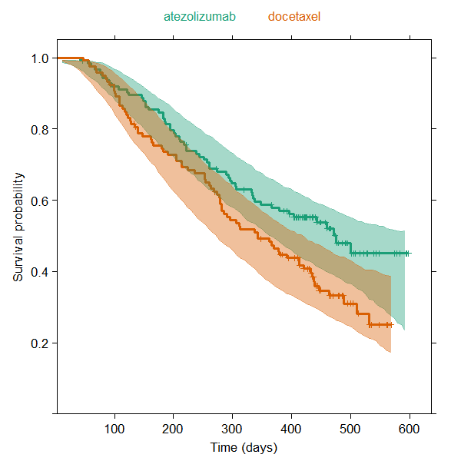

**Supplementary Figure S5.** TGI-OS model prediction of OS distributions in PD-L1–positive patients in the 2 cohorts of the BIRCH study (simulation of 1000 replicates vs observed). Area: 95% prediction interval of survival distributions; lines: observed Kaplan-Meier distributions with censored data (crosses); vertical red lines: 80% survival probability at ≈ 300 days for first-line patients vs 200 days for second-line patients. 1L, first-line; 2L+, second-line plus.



**Supplementary Figure S6.** Model-predicted and observed OS HR in OAK based on data cutoffs at times varying from 10 to 120 weeks since the first patient was enrolled. Green: predicted (median CI over 1000 replicates, prediction interval (PI); orange: observed with CI based on events at study cutoff time.

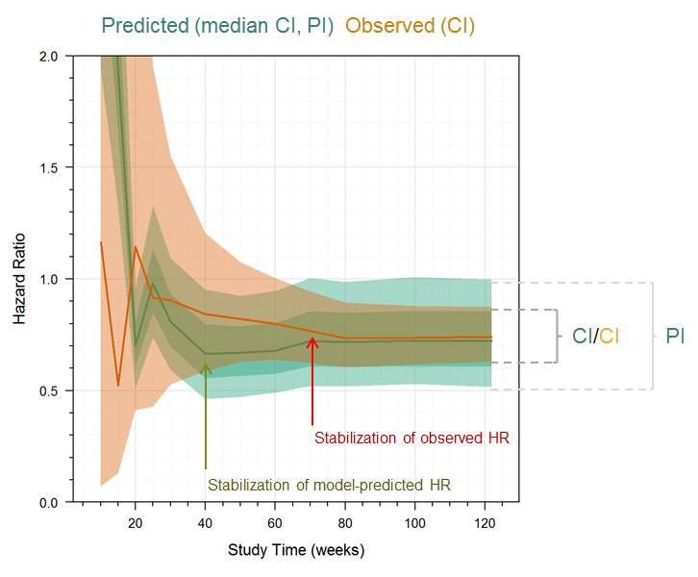

**Supplementary Table S1.** TGI model parameter estimates in POPLAR

|  |  |  |  |  |  |  |
| --- | --- | --- | --- | --- | --- | --- |
|  | NONMEM Estimates | | | Bootstrap (n=925)a | | |
| **Parameter (unit)** | **Estimate** | **RSE (%)** | **Shrinkageb (%)** | **Mean** | **CV (%)** | **Shrinkageb  Mean (CV%)** |
| KGdoce (week−1) | 0.0143 | 10.6 | - | 0.0143 | 17.6 | - |
| KSdoce(week−1) | 0.0221 | 17.2 | - | 0.0228 | 28.1 | - |
| KGatezo(week−1) | 0.0110 | 10.9 | - | 0.0109 | 11.8 | - |
| KSatezo(week−1) | 0.0147 | 16.3 | - | 0.0145 | 18.3 | - |
| TS0(mm) | 69.9 | 4.01 | - | 70.0 | 4.0 | - |
| σ2(mm2) | 39.0 | 12.5 | - | 39.1 | 16.5 | - |
| ω2KG | 0.586 | 14.7 | 15.1 | 0.594 | 16.4 | 16.3 (17.6) |
| ω2KS | 0.808 | 24.7 | 29.7 | 0.829 | 26.3 | 30.5 (6.0) |
| ω2TS0 | 0.374 | 9.67 | 3.24 | 0.373 | 9.70 | 3.25 (13.3) |

a Successful runs were defined as the number of normal completions of both the estimation step and covariance step among 1000 replicates.

b Shrinkage of parameter estimate to population values.

σ2, additive residual error; ω2, interpatient variability in the corresponding parameters; atezo, atezolizumab; doce, docetaxel; KG, growth rate constant; KS, shrinkage rate constant; RSE, relative standard error of parameter estimate; SE, standard error of parameter estimate; TS0, tumor size at time 0 (start of treatment).

**Supplementary Table S2.** Comparison of parametric distributions for OS in POPLAR

|  |  |
| --- | --- |
| **Distribution** | **Akaike** |
| Log-normal | 2080 |
| Log-logistic | 2085 |
| Weibull | 2091 |
| Exponential | 2116 |
| Gaussian | 2139 |
| Logistic | 2152 |