**Supplementary Figure Legends:**

**Supplemental Figure S1.** Pharmacokinetic day profiles of different LY3023414 doses.   
LY3023414 concentration versus time for LY3023414 doses of 20-325mg on (a) arithmetic scale (b) logarithmic scale. (c) LY3023414 concentration versus time for 450mg LY3023414. Abbreviations: DBS = Dried Blood Spot

**Supplemental Figure S2**. (a) Mean percent change from baseline in p4EBP1 concentration versus nominal time by LY3023414 dose levels for cycle 1 day 1. (b) Mean blood glucose percent change from baseline versus nominal time by LY3023414 dose levels for cycle 1 day 1. After the 4-hour time point patients were allowed to eat, and thus increase in the curves past 4-hours reflect the impact of the meal rather than effect of LY3023414 on glucose levels. (c) Mean C-peptide percent change from baseline versus nominal time by LY3023414 dose levels for Cycle 1, Day 1. Abbreviations: Adj = adjusted

**Supplemental Figure S3**. (a) Simulation of LY3023414 concentration versus time relative to EC50 inhibition of mTOR as measured by decrease in phosphorylation of 4EBP1. (b) PK/Pharmacodynamic relationship of target engagement vs LY3023414 concentration. Abbreviations: Cav = Mean blood concentration, PBMC= peripheral blood mononuclear cells, MEFL= Mean Equivalent Fluorochrome

**Supplemental Figure S4. (A)** Duration of LY3023414 Treatment. Each bar represents an individual patient. **(B)** Tumor types in patients with percent change in tumor size administered with different doses of LY3023414.

**Supplemental Table T1**: Ratio of Midazolam Pharmacokinetic parameters following administration midazolam alone and in combination with LY3023414

|  |  |  |  |  |
| --- | --- | --- | --- | --- |
|  | **Midaz** | **olam** | **Hydroxy-midazolam** | |
|  | **Ratio of AUC∞**  **+LY:alone** | **Ratio Cmax**  **+LY:alone** | **Ratio of AUC∞**  **+LY:alone** | **Ratio Cmax**  **+LY:alone** |
| N | 9 | 9 | 9 | 9 |
| GeoMean | 1.46 | 0.94 | 1.31 | 0.70 |
| CV% | 30.5 | 29.6 | 55.6 | 57.2 |
| 90% CI | (1.21 – 1.76) | (0.78 – 1.12) | (0.95 – 1.81) | (0.50 – 0.97) |

Abbreviations: AUC**∞** = area under the concentration time curve from time zero to infinity post-dose;

CI = confidence interval; CV% = coefficient of variation; GeoMean = geometric mean; N = sample size.

**Supplemental Table T2: TEAEs occurring in ≥ 10% patients regardless of causality (N=47)**

|  |  |  |
| --- | --- | --- |
| CTCAE Term, n (%) | Any Grade | Grade ≥3 or higher |
| Patients with any adverse event | 46 (97.9) | 22 (46.8) |
| Vomiting | 25 (53.2) | 1 (2.1) |
| Nausea | 24 (51.1) | 1 (2.1) |
| Fatigue | 20 (42.6) | 2 (4.3) |
| Decreased Appetite | 16 (34.0) | 0 (0) |
| Abdominal Pain | 14 (29.8) | 2 (4.3) |
| Diarrhea | 14 (29.8) | 0 (0) |
| Anemia | 13 (27.7) | 2 (4.3) |
| Constipation | 9 (19.1) | 0 (0) |
| Hypokalaemia | 8 (17.0) | 1 (2.1) |
| Cough | 8 (17.0) | 0 (0) |
| Asthenia | 7 (14.9) | 2 (4.3) |
| Urinary Tract Infection | 7 (14.9) | 1 (2.1) |
| Headache | 7 (14.9) | 0 (0) |
| Stomatitis | 6 (12.8) | 0 (0) |
| Pyrexia | 6 (12.8) | 0 (0) |
| Blood Creatinine Increased | 6 (12.8) | 0 (0) |
| Dizziness | 6 (12.8) | 0 (0) |
| Pruritus | 6 (12.8) | 0 (0) |
| Weight Decreased | 5 (10.6) | 1 (2.1) |
| Abdominal Distension | 5 (10.6) | 0 (0) |
| Paraesthesia Oral | 5 (10.6) | 0 (0) |
| Back Pain | 5 (10.6) | 0 (0) |
| Dyspnoea | 5 (10.6) | 0 (0) |
| Gastrooesophageal Reflux Disease | 5 (10.6) | 0 (0) |
| Oedema Peripheral | 5 (10.6) | 0 (0) |

Abbreviations: N = total number of population within each CTCAE grade category; n = number of patients in specified category; TEAE = treatment-emergent adverse events. TEAEs reported by preferred pooled terms. Data reported includes cohorts A, A2 and B1 only.

**Supplemental Figure S1:** Pharmacokinetic day profiles of different LY3023414

Panel A



Panel B



Panel C



Excludes one patient who had a dosing error (received 225 mg BID on Cycle 1, Day 1 rather than 250 mg BID).

**Supplemental Figure S2** (a): Time course of mean 4EBP1 phosphorylation following LY3023414 administration



**Supplemental Figure S2**: (b) Time course of mean blood glucose levels following LY3023414 administration



**Figure S2**: (c) Time course of mean C-peptide levels following LY3023414 administration.



Abbreviations: BID = twice daily; PCFB = percent change from baseline.

Excludes one patient who had a dosing error (received 225 mg BID on Cycle 1, Day 1 rather than 250 mg BID).

**Supplemental Figure S3** (a):Simulation of LY3023414 concentration versus time relative to EC50 inhibition of mTOR (as measured by p4EBP1).



**Supplemental Figure S3** (b):PK/Pharmacodynamic relationship of target engagement versus LY3023414 concentration



**Supplemental Figure S4A:** Duration of LY3023414 Treatment

Patients



█ Ongoing (at time of data cut)

█ Progressive Disease

█ Subject Decision

█ Physician Decision

█ Adverse Event

Duration of Treatment (days)

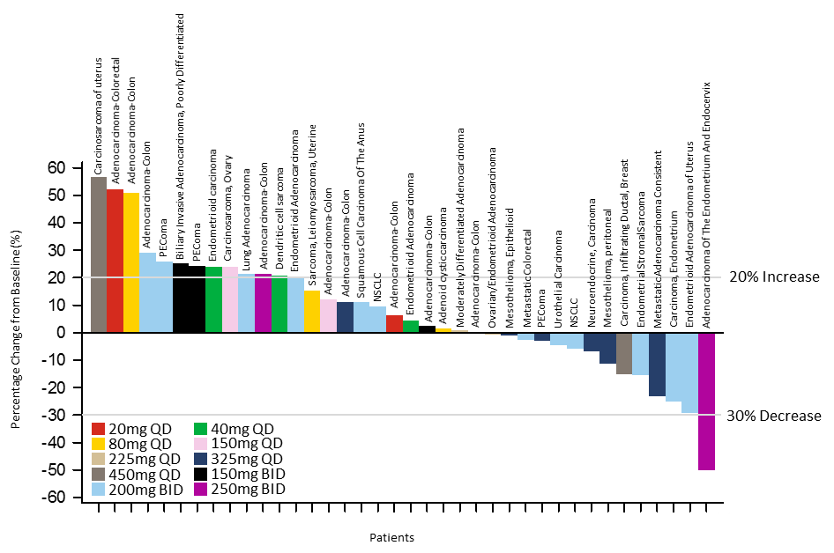**Supplemental Figure S4B:** Tumor types in patients with percent change in tumor size administered with different doses of LY3023414